Question No.1 Answer
These line can sometimes get blurred between what constitutes a project and what is really a routine or routine work. The definition of project varies from one company to another. In some cases, the word is used loosely to describe any task, exceptional or recurring. Thus, a “project” could mean any routine that demands time. That’s unfortunate because it diminishes the importance of actually planning out and managing a project.
Search Craigslist job postings for the word “project” and it’s amazing how many non-project roles are listed as projects and how many postings that need project managers are actually looking for a clerk or a data entry person.
Let’s look at a few items that separate a project from some of the routine work that gets performed that really isn’t a project.
A project is an exception
A project involves investigating, compiling, arranging, and reporting information outside the range of usual activities while routine is defined within the range of a department’s function.
Example: The manager of a customer service department prepares monthly reports identifying customer contact trends (complaints, inquiries, suggestions) as part of her routine. When she is given the task of investigating and comparing automated customer service software, she is responsible for a project.
Project activities are related
Routines for recurring tasks performed in your department are related to the activities that define and distinguish that department only, whereas the activities involved in project phases are related to one another and to a desired end result. So your project may involve coordinating work that not only takes place in your immediate department but extends to actions in other departments, as well as to outside resources.
Example: The customer service manager given the project of investigating automated systems may work with the IT manager, the marketing department, and several suppliers. Collectively, the internal and external information will help her identify the points of comparison.
Project goals and deadlines are specific
Recurring tasks may be managed with departmental goals in mind; but these goals tend to remain fixed, or move forward only with time. The same is true of deadlines; you may face weekly or monthly deadlines for completion of reports, processing, and closing. Projects, though, have singular goals that will be either reached or missed. And projects have clear starting points and completion dates.
Example: The customer service manager is told to compare prices and features of software, make a recommendation, and complete a report within three months. This project has a clear goal and deadline. In comparison, her department’s routine goals and deadlines extend from one month to another.
The desired result is identified
Routines are aimed not at one outcome but at maintenance of processes, whereas the research, development of procedures, or construction of systems or buildings on a project produce a tangible, desired result.
Example: For her project, the customer service manager is expected to deliver a conclusive report. It’s a one-time assignment, not one that will recur each month. But the routine reports her department generates will still be produced as a maintenance function of her department.
Projects are also distinguished from routines by the way in which they must operate under the three constraints of result, budget, and time. To a degree, all management functions operate within these constraints. For example, your department may be expected to perform and produce certain results; it’s subjected to budgeting controls; and its work is planned and executed under a series of deadlines.
Question No2 Answer
The Project Life Cycle refers to the four-step process that is followed by nearly all project managers when moving through stages of project completion. This is the standard project life cycle most people are familiar with. The Project Life Cycle provides a framework for managing any type of project within a business. Leaders in project management have conducted research to determine the best process by which to run projects. It has been found that following a project life cycle is critical for any services organization.
The Project Life Cycle is the standard process by which teams achieve project success. Lesser known but growing in popularity, the Professional Services Life Cycle exists because the standard project life cycle does not fit everyone’s needs. The standard project life cycle works for some project managers, but professional services need a more robust process. In professional services, unlike other businesses, their product is their people. That is, professional services lend their expertise to other companies in exchange for profit. Due to the constant involvement of clients, professional services require a unique project life cycle that involves a recurring feedback loop to ensure project success.
First, let’s dig into the standard definition of a project life cycle and then we can see how the Professional Service Life Cycle compares to the standard.

What is the “Standard” Project Life Cycle?
According to the Project Management Institute, the project life cycle is critical for any managers hoping to deliver projects to clients successfully. Let’s take a look at the steps involved.

The Project Phases Involved:
- Phase 1: The Conceptualization Phase
- Phase 2: The Planning Phase
- Phase 3: The Execution Phase
- Phase 4: The Termination Phase
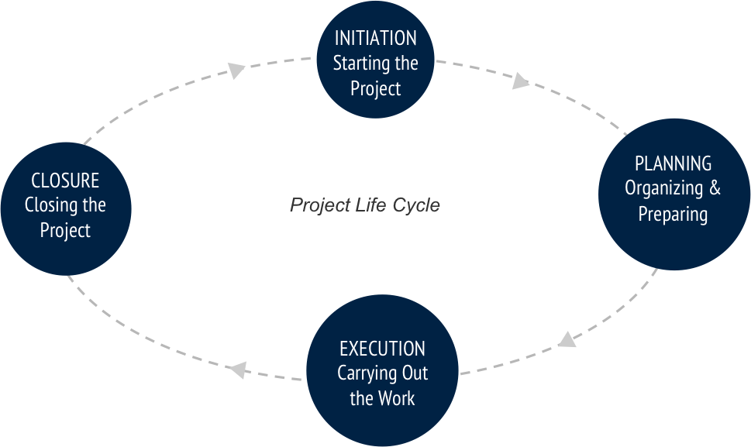

Phase #1: The Conceptualization Phase
This can also be referred to as the ‘Initiation Phase’ and is the starting point of any project or idea. For the Conceptualization Phase to begin, a strategic need for the project or service must be recognized by upper management.

Ask yourself the following questions during Conceptualization:
- What is the problem?
- Will the development of a project solve that problem?
- What are the specific goals of the project?
- Do we have enough resources to create and support the project?

The Conceptualization Phase typically involves:
- Creation of the statement of work (SOW).
- Presenting the business case.
- Creation of a business contract.

Phase #2: The Planning Phase
The second phase of the project management life cycle is referred to as the Planning Phase. Once management has given the OK to launch a project, a more formal set of plans—outlining initial goals—is established.

Ask yourself the following questions during Planning:
- What is the project purpose, vision, or mission?
- Are there measurable objectives or success criteria?
- Do you have a high level description of the project, requirements and risks?
- Can you adequately schedule and budget high level milestones?

The Planning Phase typically involves:
- Determining resource availability.
- Creating a project budget.
- Beginning to allocate tasks to certain resources.

Phase #3: The Execution Phase
The third phase is labeled Execution. This is when the actual work of the project is performed. Required materials, tools, and resources are transformed to reach the project goals. During this phase, performance is continually measured to ensure the project is successful.

Ask yourself the following questions during Execution:
- Are all resources being tracked?
- Is the project on budget and on time?
- Can resource planning be optimized?
- Are there major roadblocks that require change management?

The Execution Phase typically involves:
- Strategic planning.
- Implementation planning.

Phase #4: The Termination Phase
The fourth and final phase is called Termination Phase, also referred to as Project Closure. This phase begins once the project has been completed.

The Termination Phase typically involves:
- The disbandment of the project team.
- Personnel and tools are reassigned to new duties.
- Resources released back to parent organization.
- Project transferred to intended users.
Question No.3 Answer
I’ve made a list of the 15 core skills that I think project managers need. These are the things that should be part of your skillset because they will help you get the job done more effectively. And for the avoidance of doubt, ‘effectively’ means faster and with less effort. I certainly want that for my projects!
Here is the list of skills project managers need. As you read through, think about which ones should be your focus areas for the coming year and how you are going to take your skills to the next level.

1. Leadership
Project leadership was a hot topic this year. Being able to lead your team as well as manage them is a trend that shows no sign of abating (and that’s a good thing). It’s really important to be able to inspire others, set the vision and lead effectively, so if that’s not your strong point resolve to work on it now.

2. Negotiation
It would be lovely if everyone did what was best for the greater good at all times, but projects don’t work like that in real life, do they? Project managers with good negotiation skills will be an asset to their teams as they seek to resolve conflicts by finding the win-win scenarios for everyone.

3. Scheduling
It should go without saying that project scheduling is a core project management skill. However, speaking to people who manage project managers during end-of-year review time I have heard that some of them aren’t up to scratch in this area.
Get to grips with project scheduling because a) it’s your job and b) it will help you deliver things more successfully for others (which is also your job).

4. Cost Control
Budget management is bizarrely one of my favourite topics. I am not a natural maths whizz but I do like a well put together spreadsheet. If I understand the numbers and create my own tracking mechanism I can tell you to the penny how much my project is spending.
Cost management is a critical topic for project managers. Those without this skill will be at a disadvantage because budgets are tight. You need to show that you can deliver your project within the cost constraints and by managing the project finances intelligently.

5. Risk Management
The more mature project management gets as a profession, the more we find ourselves doing projects that are unique. The more ‘routine’ the project, the more it is likely to get outsourced or given to a functional manager who shows an aptitude for getting things done. Project managers will work on the more complex, transformative, unique endeavours that require decent risk management.
Being able to control risk (as far as you can) is a sign that you are on top of your project. Project sponsors hate surprises and good risk management is one way that you can manage that.

6. Contract Management
Part of managing your project involves managing suppliers. The vast majority of projects will have an element of supply, whether that is something as simple as the outside caterers who bring in cakes for your launch event or a full-on off-shoring system development firm.
Contract management is about being able to actively manage those procurements. Previously many project managers have been able to rely on their Finance departments to get this sort of work done (and Legal teams for managing the terms of the deal). Today, with everyone under pressure to do more with less, it’s falling to project managers to pick up the slack when it comes to procurement

7. Critical Thinking
Critical thinking is core to being able to make good decisions. You have to weigh up the pros and cons of solutions to problems before choosing the right way forward. This is what distinguishes a project manager who is good at managing issues to someone who blows issues out of the water every time.
You can build your critical thinking skills through practice and by equipping yourself with tools and approaches to help you structure arguments logically and see things from all angles before making the final decision.

8. Communication
If I had to pick one skill on this list to focus on this year it would be communication. We don’t do enough of it. Our stakeholders demand more of it. We fail time and time again to meet expectations largely because we failed to communicate effectively and often.
Think creatively about the communication channels you have got available to you including:
- Intranet
- Newsletters
- Emails
- Collaboration and social media tools
- Team meetings/face-to-face
- Web and online conferencing.
Then think about how you can apply each of these to actively serve your project next year.

9. Project Recovery
I hope you don’t have to do project recovery next year but if you are looking for a boost to your career then showing you know how to turn around a poorly performing team and project will certainly set you aside from your peers.

10. Coaching
Most of the people on your project team won’t work for you (if, indeed, any of them do). That makes it really important that you are good at managing in a matrixed environment but also that you are good at coaching. Why? Because they may not have much project experience and you’ll have to coach them to top performance.
If you are worried about not being a good coach you might be surprised to learn that coaching skills are something that might be closer in reach than you expect. If you sit with a child during homework and help them come to the right answers then you are doing a form of coaching. Some training in this area will help you apply those skills in the workplace to help your team perform their best.

11. Task Management
This is another bread and butter task for project managers. You should be able to create a task list, delegate work to others and keep on top of progress. I found this was the easiest part of project management when I started because I was naturally a list-maker. If it doesn’t come easy to you you’ll have to develop strategies to ensure you are always on top of your To Do list.
When you have cracked managing your own work you can help others manage theirs. This is the best way in my experience to make sure that projects come in on time and others take responsibility for their deliverables.

12. Quality Management
Quality management ensures that you deliver a product that is fit for purpose. What project sponsor doesn’t want that? Unfortunately project managers often don’t spend enough time on the quality angle of their projects – it’s one of those processes and set of tasks that are overlooked as an administrative overhead.
If you are a quality expert, then good for you. But if you aren’t, seriously consider upping this on the priority list for 2015. The better the quality of your deliverables, the better value you are offering stakeholders and the more satisfied they will be.

13. Meetings Management
How many of your meetings this year have overrun or finished without any clear action being agreed? How much time have you sat in meetings wondering why you were there and what time you can leave without it looking too bad? Or worse, how much time have you spent on conference calls only half listening while doing your emails or playing Candy Crush?
Being able to sense when a meeting is going off the rails and people aren’t paying attention is a key skill for project managers. It’s helped by sticking to the agenda but it’s also about being able to read the body language of people in the room to check that you are getting through the material quickly and comprehensively. Don’t let 2015 become another year of wasted time in meeting rooms.

14. Business Case Writing
With the ongoing focus on delivering business value, being able to write a business case (or at least contribute one) will be a good skill to have. Get hold of some templates so that when you are asked to finalise a business case or review one you know what should be included.
Find some business cases from past projects and evaluate what you would do differently. And make sure that your next project actually has a business case – that’s a good start!

15. A Sense of Humour
Getting through your projects largely relies on a good sense of humour and the goodwill of colleagues prepared to pick up the slack or wait another 24 hours

