
Assignment Cover Sheet

Student Name: | Annette Chilande Mulindi
Student Number: | 6452
Course: | Diploma in Public Relations
Assignment NO: | 4

Marking Criteria:
We expect the learners to write minimum one well expressed point in three lines against each allocated mark. This means one needs to write 15 lines with 5 well expressed points to get high grades for a 5 marks question.
For high grades use examples and illustrations where appropriate.
Please insert your completed assignment ( in word format) here:

Public relations as Planned Communication
1. i. Planning is important because it will focus on the important work in the organization. It is very effective when there is planning done by the organization or the Public Relations firm. Planning is a necessary because it is there to set targets for the Public Relations operations against which results can be assed, it also helps with the estimation of the workings hours and how much it would cost the client (skinner et al 2007:106).
ii. Public relation professionals do not like planning because it takes time, this means that ongoing work may or cannot be stopped while it is done(ref). planning tends to block an individual’s creativity; this means that the plan must be formulated, and this will also encourage formulated activities (2019)
iii. A SWOT analysis which consist of strengths, weakness opportunities and threats, it is used to analyze the knowledge of the organization on its internal and external environment (Sammut-Bonnici, and Galea:2019) the diagram below shows a SWOT analysis example.

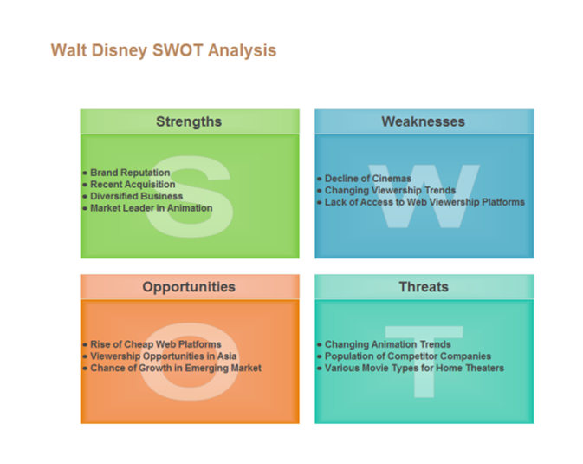
(2019)

iv. Environmental Scanning is when analysis of the environment is used to identify issued which affects the operations of the organizations which must be undertaken.
Environmental scanning is used by Public Relations professionals with tools which include media, public opinion polls or published information (Grunig :2019). Environmental scanning is basically research done by Public relations practioners so that they are better informed about their audiences need and current opinions in an organization or issues related to the organization (Grunig :2019).

2. Various approaches of Public Relations Planning
- Research the issue; this means that the Public relations professionals have to look at the situation, meaning the problem if it was not unintentional they have to figure out how they can sort it out or they can take it as an opportunity to give better clarity to the organization (Smith 19:2019)
- Objectives; what is the plan to rectify the problem or the situation that the organization is in and to make sure the problem does not happen again. The objectives are usually sorted or done by the communications manager (Smith 71:2019)
- Formulate an Action; this means that it is either proactive or reactive, meaning that reactive action is a response to influences and opportunities from its environment while proactive is when it involves both communication and action (Smith 71:2019).
- Communication: it is important to have proper communication in the organization during the planning process and this involves the three different communication processes which are information, persuasion and dialog (Smith 113:2019).

Bibliography
Skinner, C.Von Essen, L. Mersham,G. Motau, S. 2007. Handbook of Public Relations 8th Edition Cape Town: Oxford University Press Southern Africa.
Grunig J,EXCELLENCE THEORY A comprehensive look at modern public relations theory (online) Available at:https://excellencetheory.wordpress.com/tag/environmental-scanning/ [date accessed 02/05/2019].
Smith D. R Strategic Planning for Public Relations (online) available at file:///C:/Users/entrytime/Downloads/strategic_planning_for_public_relations__by_Ronald_D._Smith_APR_Buffalo_State_College.pdf [date accessed 02/05/2019]
Sammut-Bonnici, T and Galea, D (online) available at https://www.researchgate.net/publication/272353031_SWOT_Analysis [date accessed 02/05/2019]
https://nscpolteksby.ac.id/ebook/files/Ebook/Business%20Administration/Exploring%20Public%20Relations%20(2006)/12.%20Chapter%2010%20-%20Public%20relations%20as%20planned%20communication.pdf [date accessed 03/05/2019]
Disney SWOT Analysis Examples and Templates(online) available at https://www.edrawsoft.com/disney-swot-analysis-example.php [date accessed 03/05/2019]

Student Statement:

By submitting this assignment, I confirm that this is my own work.

Student Signature |  | Date

For Tutor / Assessor Use Only
Total Marks
Marks Obtained
Percentage / Grade

