
Assignment Cover Sheet

Student Name: | David Berks
Student Number: | 25275
Course: | Advanced Diploma in Construction Management Level 5
Assignment NO: | 4

Marking Criteria:
We expect the learners to write minimum one well expressed point in three lines against each allocated mark. This means one needs to write 15 lines with 5 well expressed points to get high grades for a 5 marks question.
For high grades use examples and illustrations where appropriate.
An environmental impact study also known as an EIS is an imperative part of site selection and planning. As it sounds the report / study looks into the impact on the ecosystem and infrastructure of the site location and surrounding areas. This study will need to be completed prior to any start on site and is normal completed int the consultation stage. Inevitably there will be impact on the ecological system however this does not result in a rejection to the proposal. Once the EIS is complete it should show how the negative will be addressed and the resulting positive effects the development could result in.

The type of factors that a EIS looks are;
- Air quality
- Water quality and quantity
- Solid wastes
- Noise
- Radiation from nearby radio-active sources
- Hazardous conditions
- Energy supply and natural resources depletion
- Protection of environmentally critical areas i.e. flood plans, wet-lands, beaches and dunes, unstable soil, steep slopes, aquifer recharge areas
- Land use in coastal areas
- Redevelopment in built-up areas
- Density and congestion mitigation
- Neighborhood character and continuity.

If we look at Air Quality and Noise. Any road or motorway scheme would have an impact on both these ecological factors. The Air quality due to the pollution of increased vehicles and the noise of vehicles during the day and night especially if the road is close to a housing community.
A new housing estate for example will increase the number of vehicles and traffic in area however the economically impact of increased population in an area could be demand as positive to the retail sector for example.

The basic criteria when judging suitability for construction on sites is key as the impact of the wrong decision could be costly. Cost of the project and accessibility are two effects that site location will have on any project. If a site were selected in an area with limited road access then additional costs would have to be factored, to first gain access to the site through packages of work. This of course would also have ecological impacts if, for example it was in the middle of a heritage area.
If the site was in an area with limited road access then it may also have limited supply of physical resources such as, water, power and materials. Again, the cost to get supply into the site may counteract the benefit and profit.
Climate factors such as temperate, humidity, solar radiation, rainfall and wind, also provide site selection criteria. In the United Kingdom, these factors would not be as daunting as they could be in other countries where climate is far more extreme. Wind and Rainfall could however provide issues if the site was located in a mountainous region.

The final criteria are the soil quality and the contours of the site. Good foundations are what every building or structure is built on and if foundations cant be constructed the site is destined to fail. Also, the land contours would provide the issue again if located in an undulated area.

Topographic is the arrangement or accurate representation of the physical features of an area. Therefore, the topographical information or data is always going to be considered when selecting a site to build. Many large organisations will have a topographically engineer who will survey potential, current and established sites to provide feedback on the topographic aspect of sites.

The typical features of the geology of an area that would be shown in a Topographical report would be;

- Elevation above sea level
- Orientation of the site
- Slops in percentage format.
- Surface Waters
- Hills and Valleys
- Hood plains, swamps, and quick sand.

iv. Which type of buildings should be constructed on rocky sites?

The main type of building schemes that are constructed near or around rocky sites are tunneling projects. The tunneling could be for a road or rail project, both falling under the infrastructure sectors. A good example of such a scheme would be the Hindhead tunnel. The Tunnel is 4 miles long and was constructed to improve road safety and improve air quality. Paul Arnold and Paul Hoyland (2011) 'Constructing the Hindhead Tunnel', Ingenia Online, (48), pp. 29.

The rock was heavily fractured and needed complex geologic data to ensure the safe tunneling. The Geology of the tunnel is below.

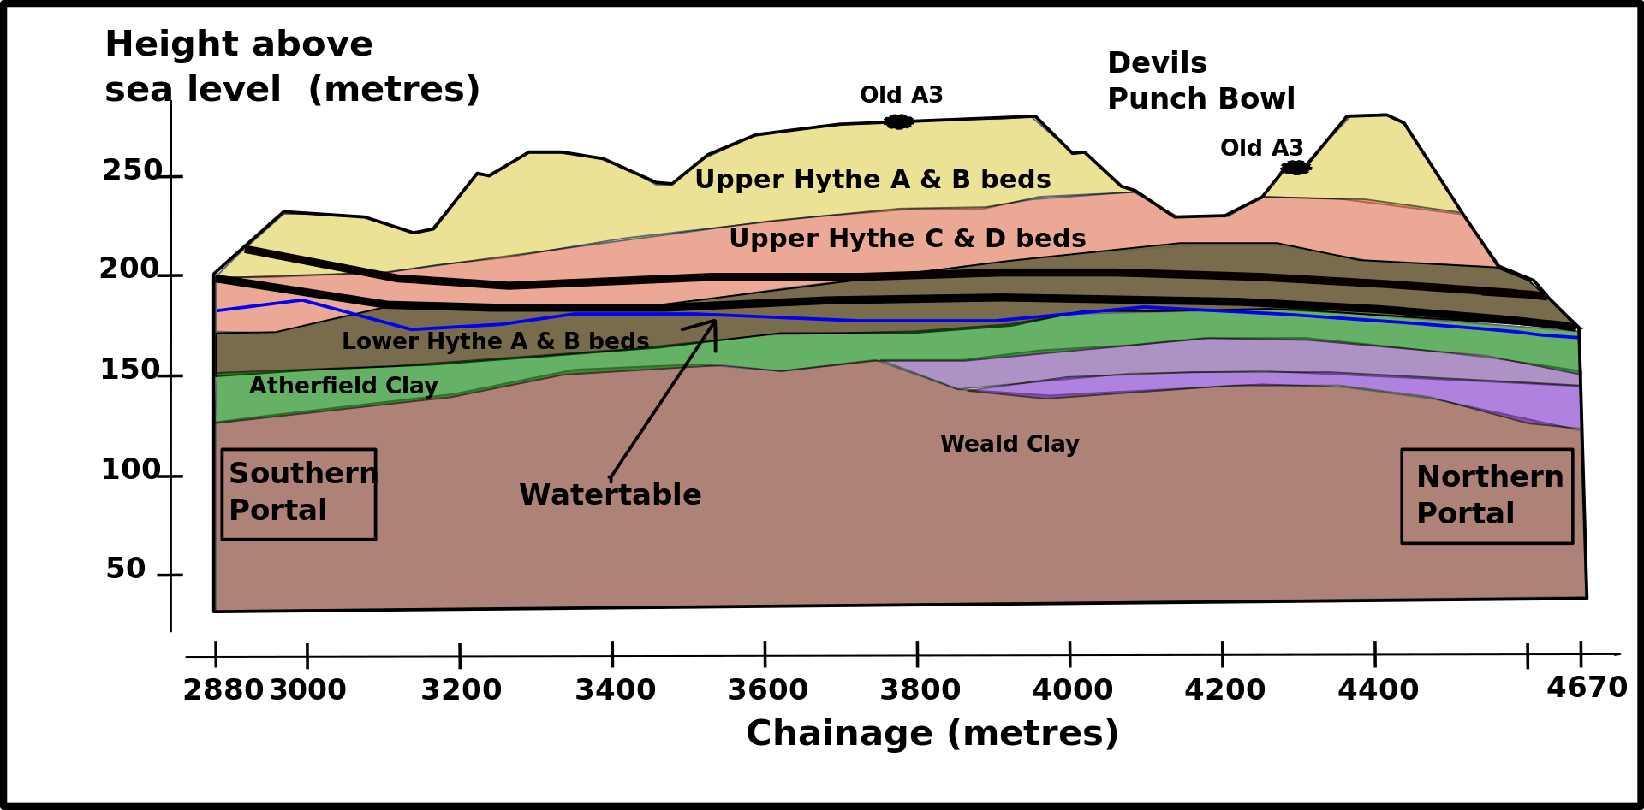
(12/04/2019) Hindhead Tunnel, Available at: https://en.wikipedia.org/wiki/Hindhead_Tunnel (Accessed: 25/06/2019).

Other project constructed around rocky sites would be a Dam project. The British Dam Society (2019) Types of Dam, Available at: https://britishdams.org/about-dams/dam-information/types-of-dam/ (Accessed: 25/06/2019).
Arch Dams need good rock for their foundations and are built in a ‘arch’ shape, hence the name. These structures are built to resist the force of the water and therefore require the very strongest foundations in the rock.

As found during research, the Town and Country Planning (use classes) order categories uses of land and buildings. Planning Portal (2019) Use Classes, Available at: https://www.planningportal.co.uk/info/200130/common_projects/9/change_of_use(Accessed: 05/05/2019).

List below is some examples of Class of buildings and uses;

Class D – Non Residential Institutions
Class D1.
This covers many ‘Public’ services, such as medical or health services. Public libraries, Premises for Educations and Museums.

Class C – Hotels, Hotels and Dwelling Houses.
Class C2
Residential institution such as care homes, hospitals, nursing homes and boarding schools.

Class C1 covers deals with hotels and guesthouses. Premises that do not offer care as part of there services. These premises need to be a regular hotel that offers rooms for hire rather than any form of care or special needs assistive care.

Class A – Shops covers a variety of everyday commercial uses. These are divided into sub categories,
A1, Shops and Retail outlets.
A2, Professional Services.
A3, Food and Drink
A4, Drinking Establishment
A5, Hot Food and Takeaway

A department store for example would mainly occupy A1 however the shops within the department stores will have multiple Classes.

References

Paul Arnold and Paul Hoyland (2011) 'Constructing the Hindhead Tunnel', Ingenia Online, (48), pp. 29.

(12/04/2019) Hindhead Tunnel, Available at: https://en.wikipedia.org/wiki/Hindhead_Tunnel (Accessed: 25/06/2019).

The British Dam Society (2019) Types of Dam, Available at: https://britishdams.org/about-dams/dam-information/types-of-dam/ (Accessed: 25/06/2019).

Planning Portal (2019) Use Classes, Available at: https://www.planningportal.co.uk/info/200130/common_projects/9/change_of_use(Accessed: 05/05/2019).

Student Statement:

By submitting this assignment, I confirm that this is my own work.

Student Signature |  | Date | 25/06/2019

For Tutor / Assessor Use Only
Total Marks
Marks Obtained
Percentage / Grade

