
Assignment Cover Sheet

Student Name: | Anastasiia Golovkina
Student Number: | 32893
Course: | Advanced Diploma in Human Resource Management Level 5
Assignment NO: | Managing Performance and Appraisal: Assessment № 3

Marking Criteria:
We expect the learners to write minimum one well expressed point in three lines against each allocated mark. This means one needs to write 15 lines with 5 well expressed points to get high grades for a 5 marks question.
For high grades use examples and illustrations where appropriate.

- What is Appraisal?
- Appraisal is the performance of characteristics or judgments of people.

- Outline the goals of an effective performance appraisal.
Purpose of the appraisal process
The aim of appraisal is to achieve better work performance from employees. The following elements of a good appraisal process includes:
- Individual job objectives are linked to organisational goals.
- The organisation’s expectations of an employee’s performance are discussed.
- Performance is contrasted against objectives, and feedback is provided to the employee.
- The employee is coached on how to achieve job objectives/requirements.
- The employee’s strengths and weaknesses are analysed.
- The types of development activities that might help the employee to make better use of his skills and thus improve performance in his current job are identified.
- Performance expectations are clarified for the employee by providing a communications structure.
- The employee who has been trying to perform well is given encouragement.
Employees are provided with the opportunity to indicate their career aspirations on a formal basis.

- Explained the steps involved in the appraisal process.
The performance appraisal process typically consists of several steps:
- Establishment of a common understanding between manager and employee regarding work expectations
- Assessment of work performance against work expectation on an ongoing basis
- The formal performance and development appraisal discussion
- Agreement of an individual performance plan, including agreement on how the performance is to be monitored and measured
- Formal documentation of the agreements reached at the appraisal
- What are the benefits of an appraisal programme?
Figure 1. presents the process from resource management.
From the course material provided, advantages from performance appraisal can be classified into the three ways: For Organisation, appraisers and for person being appraised the benefits.
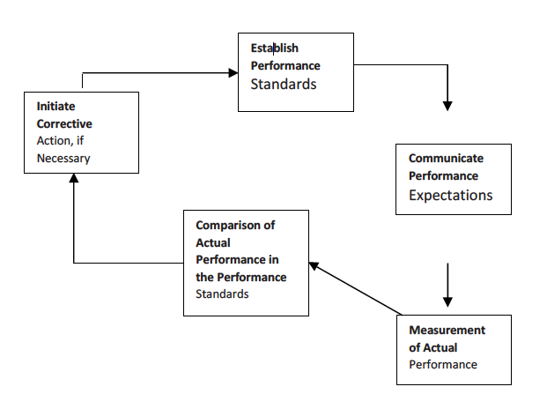
Considering each individually:
Organisation’s benefits are:
- Improved organisational performance because the organisation’s objectives and values have been effectively communicated. More cohesiveness, loyalty, and improved relationships between management and staff will also flow on.
- Employees perform tasks better and more efficiently.
- Identification of training and development needs.
- Creation of a culture that seeks to continually improve and succeed.
Appraisal’s benefits are:

- To be able to come up with ideas for improvement.
- The linking of team and individual goals and targets to departmental and organisational goals.
- The clarification of manager expectations of teams and individuals.
- A chance to form a more productive relationship with staff and to attain mutual trust and understanding.
For the person being appraised the benefits are:
- Improved motivation.
- Job satisfaction improvement.
- Self-esteem achievement as for employees.

- Write short notes on the following appraisal methods:
-Critical incident methods.

Following this strategy, person in charge is focusing on the employees behaviour, i.e. deciding if the work proceeded effectively or vice versa. This technique based on the description of the event, and does not rely on the assignment of ratings or rankings, although it is occasionally coupled with a ratings type system. The use of critical incidents is more demanding of the manager since it requires more than ticking off things on a form in fact, managers ought to write a proper report. On the other hand, critical incidents can be exceedingly useful in helping employees improve since the information in them is more detailed and specific than in methods that involve rating employees.

-Behaviorally - anchored rating scales.

Behaviourally anchored rating scale is a measuring system which rates employees or trainees according to their performance and specific behavioural patterns.
BARS is designed to bring the benefits of both quantitative and qualitative data to employee appraisal process as it mechanism combines the benefits of narratives, critical incidents and quantified ratings.
This rating also includes graphical analysis (or rating scale). The behavioural examples are then interpreted into appropriate performance dimensions. Those that are put into the dimension, for which they were generated, are kept. The last group of behaviour examples are then put into a numerical scale to a level of performance that each is seen to represent. The examples that are viewed as having a high agreement on performance effectiveness by the assessor are kept and used as anchors on the performance dimension.
This method has several advantages, such as:
- It tends to reduce rating errors.
- It assesses behaviour and not traits.
- IT makes it clear to the employee and the assessor which behaviours show good performance and which show bad performance.
Case Study
Performance Objectives
Problems
- Absence of store staff
- Deterioration in staff morale, largely due to unpopularity of the previous manager,
- who left suddenly a month ago
- Sales have been falling since a rival have opened a store on the same site.

Specific

- Goals focus on results, from the case study, “Falling sale”, had to be identified on the morale staff improvement.
- Goals include imperative verbs (such as ‘reduce’, ‘develop’, ‘maintain’ or ‘negotiate’) so the employee knows that action is required.

Measurable

- Results are assessable either qualitatively or quantitatively. Assessable goals include words like ‘on time’, ‘on budget’, ‘meets quality standards’, ‘required quantity’ or ‘to completion’.

Agreed

- One way to achieve this is for you to show the employee performance agreement, and for the employee to develop a set of objectives based on this and what they think meets the business’s objectives. Companies’ employees then discuss these proposed objectives and come to an agreement. This also ensures that employees’ objectives are effectively linked to yours and the corporate strategy or business plan.
- It is important to note that there may be non-negotiable objectives that are set by the agency or mandated by the Government and must be included in the performance agreement.

Realistic

- Objectives are designed to challenge employees but must be realistically within reach, otherwise they may not be motivated to achieve them.
- The objectives should cover areas within the control of the employee or that they have influence over.
- The objectives should not be set too far below the employee’s capabilities, which can demotivate them.

Time-based
- Each goal has a completion date, so the employee can plan their work.
- Multiple deadlines are staggered.

Student Statement:

By submitting this assignment, I confirm that this is my own work.

Student Signature |   Anastasiia Golovkina | Date | 16/05/2019

For Tutor / Assessor Use Only
Total Marks
Marks Obtained
Percentage / Grade

