
Assignment Cover Sheet

Student Name: | Amanda Clacey
Student Number: | 35532
Course: | Diploma in Event Management Level 4
Assignment NO: | Unit 5

Marking Criteria:
We expect the learners to write minimum one well expressed point in three lines against each allocated mark. This means one needs to write 15 lines with 5 well expressed points to get high grades for a 5 marks question.
For high grades use examples and illustrations where appropriate.
1.i) Public events usually involve a variety of safety requirements imposed by local councils and other government departments. The permits required in order to meet those requirements can include food vending permits, road closure permits, fire permits and health and safety permits to name a few.
ii) It is important to conduct a pre-event briefing with the participants to discuss any issues relating to the event such as, timetables, communications and risk assessments. These meetings are vital to locate and resolve any issues that could arise.
iii) A well-managed ticketing process is essential to conduct a safe and well-organised event as this is your chance to provide various information to the guests. You can provide different arrival times to manage crowd flow, provide maps so guests can plan their event paths, etc.
iv) A site plan is a detailed map of the venue of the event. A site plan is essential as it provides the quick location of areas. Workers are able to locate their area of the event so they can plan where to drop equipment and where to set up, rapid response to incidents is easy to provide and stakeholders are able to plan their own activities within their section.
2. The benefits of conducting a debriefing after the event is vital to evaluate the successes and failing of the event. The experiences can be positive or negative, but with all the now known knowledge, the success of the next event will be greater. Breaking down any issues that arose will allow for you to work out why it happened and how to ensure it doesn’t happen at the next event. It will also allow for you to plan for if the same issue arises at the next event and how to quickly solve it. Successes will also be discussed, praised and noted down for the next event. The information gathered at this meeting can be, but not limited to:
- Timetables
- Security issues
- Emergency situations
- Crowd control
- Access routes
- General successes of event
3. Outline plan for my event
Why is the event being conducted?
To provide the local bootcampers with a fun/relaxed weekend.
Event Summary
Name of event: WestFest 202
Date/s: 29th-31st August 2020
Time/s: 2pm (29th) to 2pm (31st)
Contact Person: Amanda Clacey
Position: Event Co-ordinator
Mobile: 07525003142
Email: mandiclacey@gmail.com
Event description: A festival of fun! Camping, eating and playing games!
Event vision: A local event, where guests can pitch up their tents and spend the weekend relaxing, playing games, children can run free and all food is provided for the ultimate chilling weekend.
Event strategic long-term objectives: To provide families with a weekend to look forward to.
Event operational short-term objectives: To provide all food and facilities within the required budget, to provide enough space for social distancing, to take into account how the event with run with covid 19 risk
Name of the event’s sponsoring organisation/s Event Committee: Frances Westerman – providing venue, Robert Westerman – BBQ Chef, Belinda South, Martin Druce and Alex Westerman – Set up and serving staff
What strategy is being used to involve local businesses? Bracknell Bootcamp UK – providing some games
D. Event Attendees Target markets: People who attend Bracknell Bootcamp UK and their families
Marketing objectives for each target market listed above: to attract additional attendees for following years.
Marketing and promotional strategies to achieve each target market objective: Ticket pricing to cover the costs of event. Provide a lanyard ticket for each participant.
Funding strategy for current year: £20 per adult for Weekend Pass, £15 per adult for 1 Night Pass and £10 per adult for BBQ Pass. Children are half price. This provides enough to cover the costs or=f food, toilet hire, hand sanitiser etc.
Funding strategy for future years: Assess current budget and raise with inflation
Draft budget
INCOME Year 1 – Ticket Sales £500
Portaloos - £150
Food bill - £300
Miscellenious - £50
Performers/Participants: Mr A providing all music and karaoke via a PA system, Volleyball provided by Alex Westerman, Rounders provided by Bracknell Bootcamp UK and childrens games provided by Amanda Clacey
Appropriate Timelines: The event will run for the whole weekend. From Saturday at 2pm to Monday at 2pm. Priority pitching will open at 1.30pm for priority guests to start pitching their tents.
Site plan
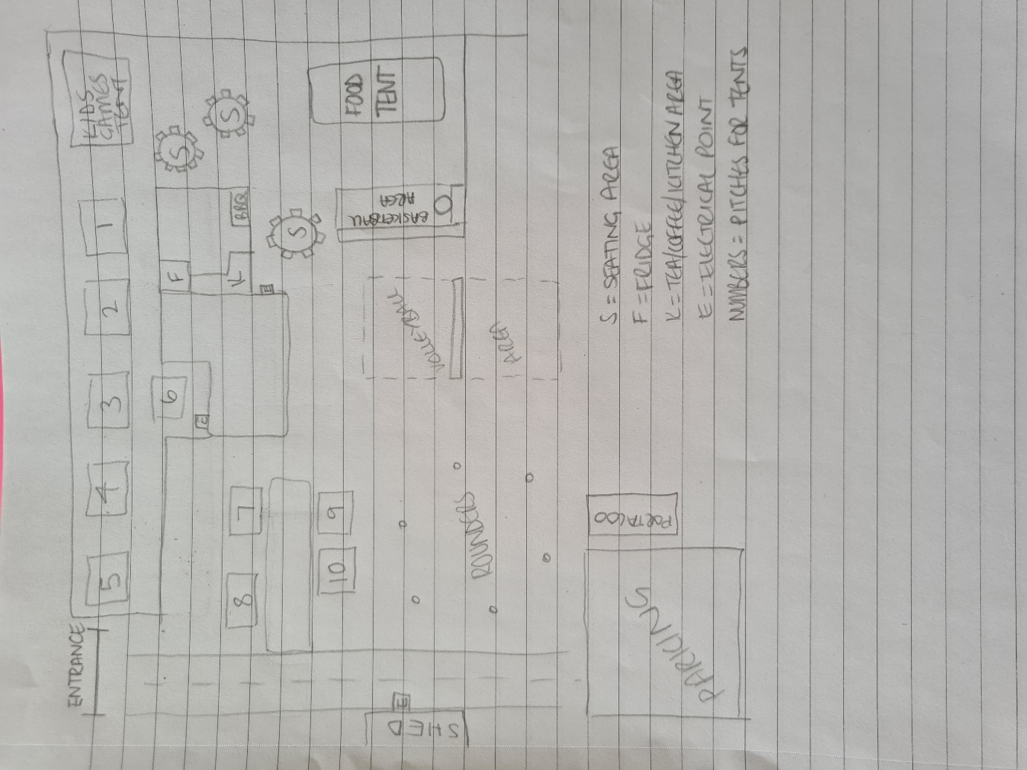

Facilities plans: 1 male and 1 female portaloo, outside tap, 3 outside electrical points.
Waste management plan – toilets to be delivered on Thursday 28th August and collected on Tuesday 1st September.
Parking plan – all cars to be parked in the parking area. Guests will be shown parking area by one of the assistants.
Evaluation Financial measures of success: Once completed the event has £10 left in the kitty. It is a non-profit event so funds will be rolled over into next years kitty.
Expected outcomes: Enough food provided for everyone, social distancing adhered to, enough shelter to be provided, everyone to have had fun.
Actual outcomes: All expected outcomes where achieved.

Student Statement:

By submitting this assignment, I confirm that this is my own work.

Student Signature | Amanda Clacey | Date | 18/9/2020

For Tutor / Assessor Use Only
Total Marks
Marks Obtained
Percentage / Grade

