
Assignment Cover Sheet

Student Name: | Marlene Grant
Student Number: | 12435
Course: | Diploma in Forensic Accounting (Level 4)
Assignment NO: | 09

Marking Criteria:
We expect the learners to write minimum one well expressed point in three lines against each allocated mark. This means one needs to write 15 lines with 5 well expressed points to get high grades for a 5 marks question.
For high grades use examples and illustrations where appropriate.
Question 1
- Outline the factors on which fraud risk assessment depends
The factors on which Fraud risk assessment depends are:
- Nature of the business
- The environment in which it operates
- The effectiveness of its internal controls
- The ethics and values of the company and its employees
Nature of the business
- The company's organizational structure and management personnel
- The sources of funding of the company's operations and investment activities
- The company's operating characteristics, including its size and complexity
- The sources of the company's earnings
- Key supplier and customer relationships.
The environment in which it operates
The auditor should obtain an understanding of the company and its environment in order to understand the events, conditions, and company activities that might reasonably be expected to have a significant effect on the risks of material misstatement. Some organizations are more

vulnerable to theft and fraud than others. People steal in good times and if the economy is bad they will steal even more.

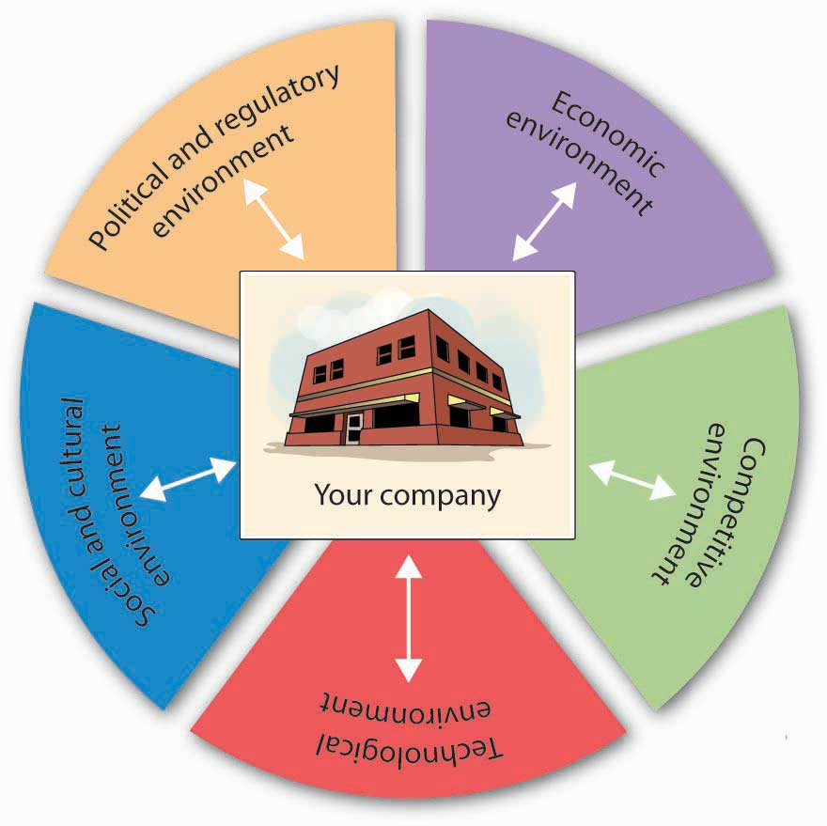
The Environment

The effectiveness of its internal controls
The audit committee should be satisfied that proper control policies, procedures and activities have been established and are operating as intended. An effective system of internal controls hinges on the right tone set at the top of the company. The board and audit committee should send out a clear message that internal control responsibilities must be taken seriously.
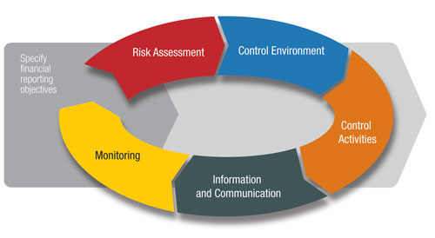
Control Guidance

The ethics and values of the company and its employees
Obtaining an understanding of relevant industry, regulatory, and other external factors encompasses industry factors, including the competitive environment and technological developments; the regulatory environment, including the applicable financial reporting framework and the legal and political environment; and external factors, including general economic conditions.


Ethics and values

- What are the main concepts about risk assessment?
There are five main concepts about risk assessment:
- Fraud Risk Governance
- Fraud Risk Assessment
- Fraud Control Activity
- Fraud Investigation and Corrective Action
- Fraud Risk Management Monitoring Activities
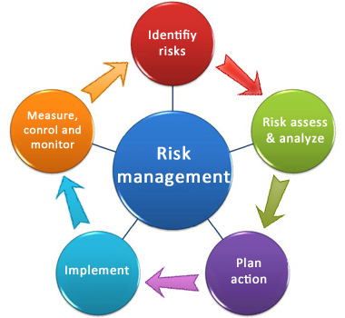
Risk Assessment

Fraud Risk Governance
The organization establishes and communicates a Fraud Risk Management Program that demonstrates the expectations of the board of directors and senior management and their commitment to Control high integrity and ethical values regarding managing fraud risk.

Fraud Risk Assessment
The organization performs comprehensive fraud risk assessments to identify specific fraud schemes and risks, assess their likelihood and significance, evaluate existing fraud control activities, and Risk implement actions to mitigate residual fraud risks.

Fraud Control Activity
The organization selects, develops, and deploys preventive and detective fraud control activities to mitigate the risk of fraud events occurring or not being Control detected in a timely manner.

Fraud Investigation and Corrective Action
The organization establishes a communication process to obtain information about potential fraud and deploys a coordinated approach to investigation and corrective action to address fraud Information & appropriately and in a timely manner.

Fraud Risk Management Monitoring Activities
The organization selects, develops, and performs ongoing evaluations to ascertain whether each of the five principles of fraud risk management is present and functioning and communicates Fraud Risk Management Program deficiencies in a timely manner to parties responsible for taking corrective action, including senior management and the board of directors.

- What are the internal factors that should be considered for fraud risk assessment?
Internal factors that should be considered for fraud risk assessment are the following:
- Do employees understand what constitutes fraud?
- Do employees know where to seek advice when faced with uncertain ethical decisions, and do they believe that they can speak freely?
- Has a policy of zero-tolerance for fraud been communicated to employees through words and actions?
- Is there an anonymous reporting channel, such as a third-party hotline, available to employees?
- Do employees trust that they can report suspicious activity anonymously and/or confidentially and without fear of reprisal?
- Do reporting policies and mechanisms extend to vendors, customers and other outside parties?
- Is possible fraudulent conduct aggressively sought out, rather than dealt with passively?
- Does the organization send the message that it actively seeks out fraudulent conduct through fraud assessment questioning by auditors?
- Are surprise fraud audits performed in addition to regularly scheduled audits?
- Is continuous auditing software used to detect fraud and, if so, has the use of such software been made known throughout the organization?
- Are performance goals realistic?
- Have fraud prevention goals been incorporated into the performance measures against which managers are evaluated and that are used to determine performance-related compensation?
- Has the organization established, implemented and tested a process for oversight of fraud risks by the board of directors or others charged with governance (e.g., the audit committee)?
- Are strong anti-fraud controls in place and operating effectively, including the following?
- Proper separation of duties
- Use of authorizations
- Physical safeguards
- Job rotations
- Does the internal audit department have adequate resources and authority to operate effectively and without undue influence from senior management?
- Does the hiring policy include the following (as permitted by law)?
  - Past employment verification
  - Criminal and civil background checks
  - Credit checks
  - Drug screening
  - Education verification
  - Reference checks
- Are employee support programs in place to assist employees struggling with addiction, mental/ emotional health, family or financial problems?
- Is an open-door policy in place that allows employees to speak freely about pressures, providing management the opportunity to alleviate such pressures before they become acute?
- Are fraud risk assessments performed to proactively identify and mitigate the company’s vulnerabilities to internal and external fraud?

- What is ‘inherent risk’?
Inherent risk is the risk of a material misstatement in the financial statement arising due to error or omission as a result of factors other than the failure of controls.

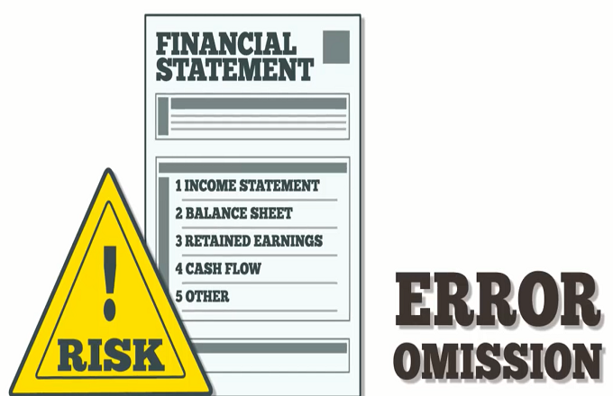
Inherent Risk

Inherent risk is considered to be more likely under the following circumstances:
- Judgement
- Estimates
- Complexity
Judgment
A high degree of judgment is involved in business transactions, which introduces the risk that an inexperienced person is more likely to make an error.
Estimates
Significant estimates must be included in transactions, which makes it more likely that an estimation error will be made.
Complexity
The transactions in which a business engages are highly complex, and so are more likely to be completed or recorded incorrectly.
Example: John Brown Company is struggling financially, in order for him to meet certain covenants he omitted certain transaction in order to so.

- Define the term ‘residual risk’
Residual risk represents the amount of risk that exist in the absence of controls. As the name implies, it's the risk which remains after taking controls in to account. We all know that risk cannot be eliminated completely, controls are designed to mitigate the risk to an acceptable level.

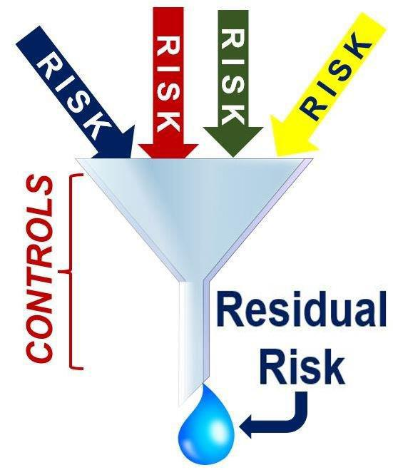
Residual Risk
Residual risk is the risk that even after all procedures have been followed correctly and after checking some level of risk still remains which may materially affect the financial statements.

2. Prepare a fraud- risk assessment check list for any business of your choice
Fraud Risk Assessment Checklist for Telecommunication Company

COMPONENT | Yes | No
Does an information security policy exist?
Is the security policy disseminated to all employees at time of hire?
Who is responsible for the security policy, does it have an owner?
Is the implementation of security policy reviewed independently on a regular basis?
Is there a written code of conduct?
Do employees have a communication channel for asking questions when ethical situations arise?
Are responsibilities for the protection of assets clearly defined?
Are risk from third party access identified and appropriate security control implemented?
Is there a maintained inventory or register of all the assets?
Do employees signed confidentiality or non-disclosure agreements?
Do all employees of the organization receive information security training?
Does the organization have adequate internal control mechanism?
Are password required to access the computers?
Are controls adopted to minimize risk from potential threats such as theft?
Are the equipment protected from power failures?
Are there any backup generator?
Is regular maintenance carried out?
How frequent is maintenance done?
Can equipment/software be taken offsite without appropriate authorization?
What checks are conducted to detect unauthorized removal of property?

References
- Silverstone Howard, Sheetz Michael (2007) Forensic Accounting and Fraud Investigation for Non-Experts. (John Wiley & Sons Inc.).
- Thomas w. Golden, Steven L. Skalak and Mona M. Clayton (2006) A guide to Forensic Accounting Investigation. (John Wiley & Sons Inc.).
- Kass-Shraibman Frimette, Sampath S. Vijay (2011) Forensic Accounting for Dummies. (John Wiley & Sons Inc.).
- Singleton, T., et al.(2006) Fraud Auditing and Forensic Accounting

Student Statement:

By submitting this assignment, I confirm that this is my own work.

Student Signature | Marlene Grant | Date | May 29, 2019

For Tutor / Assessor Use Only
Total Marks
Marks Obtained
Percentage / Grade

