
Assignment Cover Sheet

Student Name: | Amritpal
Student Number: | 24525
Course: | Human resource management level 5
Assignment NO: | 5

Marking Criteria:
We expect the learners to write minimum one well expressed point in three lines against each allocated mark. This means one needs to write 15 lines with 5 well expressed points to get high grades for a 5 marks question.
For high grades use examples and illustrations where appropriate.
What is an appraisal

Is a formal management system to evaluate the quality of an individual’s performance in an organization?
The appraisal is usually prepared by the employees’ immediate supervisor. The procedure typically requires the supervisor to fill out a standardized assessment form that evaluates the individual on several different dimension and then discusses the result of the evaluation with the employee.

Outline the goals of an effective performance appraisal

- Help supervisors to observe their subordinates more closely and to do a better coaching job
- Motivate employees by providing feedback on how they are doing
- Provide back-up data for management decisions concerning merit increases, promotions, transfers, dismissals, and so on
- Improve organization development by identifying people with promotion potential and pinpointing development needs
- Establish a reference and research base for personnel decisions

Explain the steps involved in the appraisal process

Step 1: Establish performance expectations and standards
Appraisal processes start with establishing standards and expectations.
This first step is for then manager to determine whether the performance of the employees is satisfactory as well as the levels of contribution towards goals and objectives of the organization.
For the organization to achieve better results, it is ideal to ensure that the expectations and standards that are set are clear, concise, comprehensible, realistic and in measurable terms. It is also advisable that you make the formulation of these standards an all-inclusive affair by involving your employee too as a way of preventing vagueness and also enhancing unity in the job environment.

Step 2: Providing regular feedback
This is simply about establishing effective communication between the organization and the employees regarding standards and expectations. It is an important aspect because it helps in ensuring that employees perform their roles by the goals and objectives of the organization. Feedback can be provided formally or can be communicated informally.
Employees need to get feedback regarding standards expected of them, and if possible, the standards can be revised to reflect the feedback acquired from your workers.

Step 3: Measure actual performance
This stage incorporates measuring of employees’ actual performance based on information obtained from different reports such as written, oral and statistical as well as through personal observation. This is the stage that calls for a careful choice of the ideal methods that are used in measuring performance.
It is of utmost significance to ensure that you do not make appraisal judgment based on what you feel towards the employee. It is only appropriate to make a sound measurement of findings, facts, and objectivity. The essence of this is that what is measured supersedes the way it is measured hence the need for ensuring that objectivity is adhered to.
You also need to have in mind that measuring of employees’ actual performance needs to be a continuous activity that should be carried out throughout the year hence to identify all the parameters effectively.

Step 4: Compare actual performance with standards
The next thing you need to do is comparing the actual performance with the anticipated or standard performance. This comparison is essential because it makes it possible for you as the manager or evaluator to identify the deviations of your employees from the established standards.

Step 5: Discuss results of appraisal
As a manager, the next thing you need to do is to ensure that you communicate the feedback of appraisal to your employees on a one-on-one basis.
feedback is a better approach of allowing employees to understand their strengths and weaknesses. This ultimately has an impact on how they will perform in future depending on how you communicate the feedback whether positive or negative.

Step 6: Come up with corrective measures
This is the final stage in appraisal processes. Initiating some effective corrective measures should be executed according to the results of the appraisal.

What are the benefits of an appraisal program?
The following are some of the benefits: -
Motivates employees
Performance appraisal has a significant effect on the levels of satisfaction and motivation of the employees. It offers employees recognition for all their efforts within the company. The simple existence of the appraisal program in a firm indicates to a worker that the firm is truly concerned with their individual development and performance. This alone has a positive effect on a worker’s sense of belonging and commitment.
Employee testing
Evaluation is one of the major objectives of performance review. It is of great importance to evaluate workers objectively to develop and encourage them. Through performance appraisal, the managers find out the efficiency levels of each employee and how best to utilize it. This leads to better management and fosters good communication between employees and their supervisors.
Recruitment
The data received from a performance appraisal are useful for monitoring if an organization’s recruitment practices are functioning effectively. For instance, how well is the performance of workers employed in the previous two years? Appraisal data is also vital for monitoring if the changes made in a firm’s recruitment strategies have been successful. It provides clear information whether the overall quality of employees is staying steady, declining or improving.
Training
Performance review provides a great opportunity for a manager to determine individual training requirements. It makes training more relevant through clearly associating it with performance results as well as future job aspirations.
Performance appraisal is time consuming since a manager must spend close to one hour with every employee prior to writing the review. This can be burdensome if the organization has many employees.

critical incident method

- The critical incident method of performance appraisal involved identifying and describing specific events (or incidents) where the employee did something well or something that needs improvement.
- It's a technique based on the description of the event and does not rely on the assignment of ratings or rankings, although it is occasionally coupled with a ratings type system.
- The use of critical incidents is more demanding of the manager since it requires more than ticking off things on a form -- the manager must write things out
- It is an effective relationship building tool because the manager must spend more time in the work area observing and interacting with employees, rather than in the office. This gives managers the opportunity to get to know each worker, to provide coaching and guidance; and to get feedback on what is working well and what is not.

example of this method: -
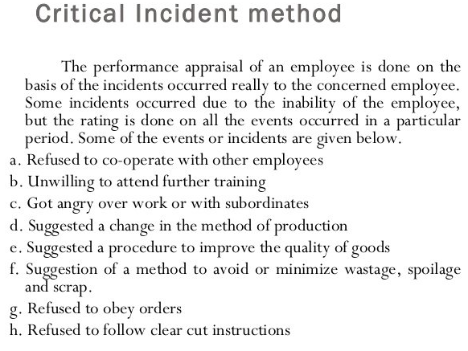

Behaviorally anchored rating scales
- Behaviorally Anchored Rating Scales are used to rate employee performance. On a scale from five to nine, employees are appraised based on quantifiable ratings, critical incidents of performance and overall narratives. All of these are combined in order to give someone either a poor, moderate or good performance rating.
- BARS were created due to the rampant dissatisfaction that was associated with more subjective appraisal methods.
- The primary benefit of using BARS is that they are more accurate than other systems.
- There is far less chance for BARS to be affected by leniency, discrimination or unreliability because a focus is being placed on specific behaviors an employee does as opposed to rating someone on generalizations.
- Behaviorally anchored rating scale can help improve organization's performance because they:
- Are reliable as the appraisals remain the same even when different raters rate them.
- Have clear standards upon which an employee is appraised.
- Are very accurate in the appraisal method and therefore increase reliability.
- Give an objective feedback.

Example of rating scale
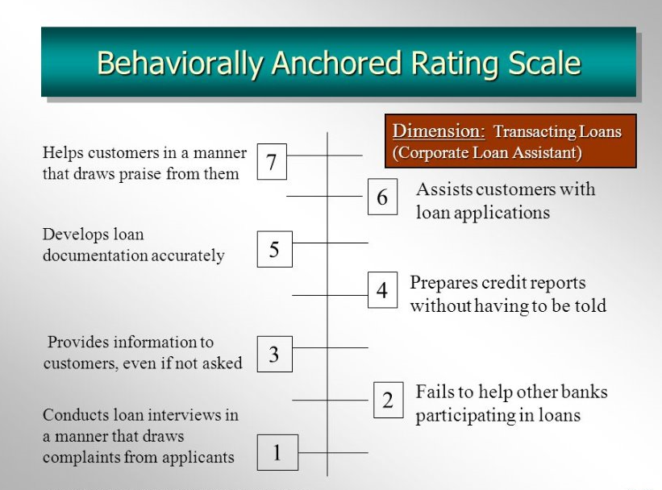

Case study

Instructions to the manager

The following need to be addressed in the annual performance appraisal for this year.

The following are key areas which this store has been failing in, please set smart objectives for the annual appraisal performance for the 20 employees to address the following issues: -

A growing absence problem among the store’s staff

Deterioration in staff morale, largely due to unpopularity of the previous manager, who left suddenly a month ago

Sales have been falling since a rival have opened a store on the same site.

Objectives need should be designed to be specific, measurable achievable and relevant to the above key areas and time bound -please set realistic time frames with the employees to achieve the objectives and for yourself to resolve the issues at hand.

Checklist for the Performance Appraisal

Preparation
Collect the information which you will require
- How they have performed against last year’s objectives
- How they have managed their resources
- Problems they have had, and how they have addressed these
- Their strengths and weaknesses
- Their likely training / development needs
- Any changes to their job / objectives through the year
- Any problems with relationships
- Evidence of self-development over the year

Prepare the Environment
- Choose an appropriate room
- Allocate enough time
- Inform the appraisee well in advance
- Ensure there will be no interruptions

Prepare the Appraisee
- Explain the appraisal process in advance
- Allow them time to adequately prepare
- explain to them how to get the most from the appraisal interview

Reflect on the skills you require for effective appraisal interviewing
questioning, listening, giving and receiving feedback, problem solving, note taking, being fair

The Appraisal Interview
Introduction
- explain the purpose of the interview
- explain the stages of the interview
- recap on the situation at the last (or interim) appraisal
- state the benefits which you hope will be achieved by the appraisal
- encourage the appraisee to use the notes which they may have prepared
- ask the appraisee about their expectations of the appraisal
- agree areas of discussion based on both your agendas

The Main Part of the Interview
Employees gives view of how the year has gone
Prompt questions:
- what have you done most effectively or has given you most satisfaction during the year?
- what have you done least effectively or has given you least satisfaction during the year?
- have you come across any obstacles - in the job situation, or in your own knowledge and skills that have prevented you from working as effectively, or with as much satisfaction as you would have wished?
- if so, how might these be overcome or avoided?

Review each specific objective
- was each action carried out within time and effectively?
- was appropriate training and support given - if not, why not
- were there constraints out with the individuals control e.g. lack of resources, sickness etc.
- did the individual timeously identify potential problems with achieving the objective and actively seek solutions
- ? application of a performance rating

Agree Objectives for this Year

Identify the appraisee’s training and development needs
- how does the appraisee see their future career, and what are their aspirations
- your perception of the future for the appraisee
- areas where specific training is required to assist them to do their job / meet their objectives
- area of professional development required to maintain / enhance professional skills
- areas of development they wish to undertake which may be of more benefit to them than the Company

Concluding the Interview - summaries:
- solutions identified to problems
- specific job objectives agreed
- actions to be taken forward by both you and the appraisee
- agreement about reviewing objectives through the year
- actions in relation to training and development activity
Record the Appraisal Outcomes

The manager

I have set the following objectives to be included in the annual performance appraisals for this year to resolve some of the key issues the store is facing.

Objectives for: - A growing absence problem among the store’s staff

Objective 1 - A clear attendance policy/ absence procedures
an understanding of what is expected and what is acceptable.
Time frame – ongoing 6 monthly reviews
Measurement -ensure all employees know procedure

Objective 2
Offer of childcare vouchers.
Childcare voucher incentives to all employees with children
Timeframe – to start in January 2020
Measurement -To reduce absenteeism which may be brought on due to family commitments

Objective 3
Introduction of shift swaps
To put in place a board where all employees can post days they need off, where other employees can trade days off or shift swaps
Timeframe – to commence in February 2019
Measurement – to reduce employee absence to less than 10% by next 6 months

Objective for: Sales have been falling since a rival have opened a store on the same site.

Objective 1
Customer service
Need to improve computer product knowledge -via ongoing training /coaching
Establish if training is required

Is further training required?
Time frame -ongoing
Measurement – to achieve more sales and retain customer satisfaction of delivery of product knowledge by the end of the financial year

Objective 2
Marketing sales
Promotional campaigns to pull customers to the store over rivals – all employees to engage in promotions
What promotional ideas do you have?
How can we improve as a company?
Time frame – monthly campaigns
measurement – increase of sales and to beat rival competition

objective for: boosting staff morale

objective 1
employee promotions /recognition of hard work
What are your personal goals, and what can we do to help you achieve them?
timeframe -ongoing review
measurement to improve motivation and job satisfaction
example: -
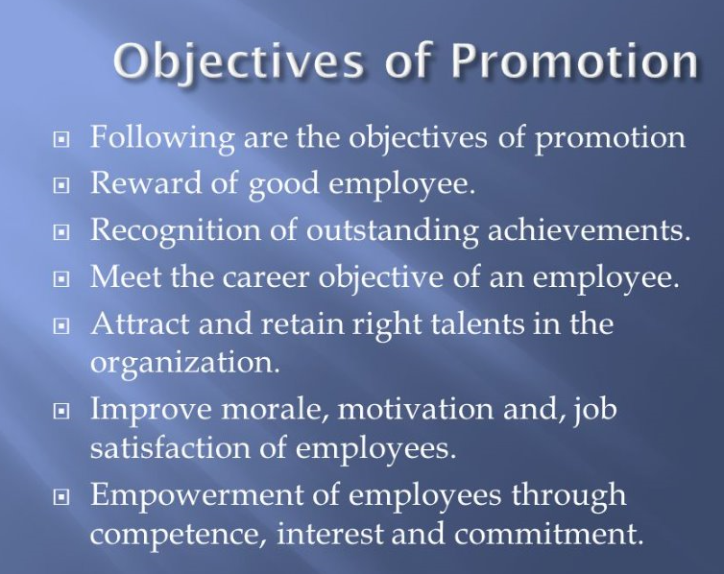

Objective 2
How would you rank your energy level?
Timeframe – arrange weekly
Measurement - for brief “walking meetings” throughout the week.

Objective 3
Do you feel appreciated in your team?
Introductions of team nights out
Timeframe -team activities to be carried out every 4 monthlies
Measurement to improve team relationships and boost morale and team spirits.

I will Make sure that I will communicate with the employees on how they feel about their performance and the goals they’ve been set. Encourage them to be open about the targets I have set and will ask them for feedback. I will be also sending out regular Pulse surveys to get a sense of how they feel about the goals that have been set.
I will also act upon any suggestions the employees come forward with as this will also help boost morale and improve the work environment.

Ref:
Intrafocus
cipd

Student Statement:

By submitting this assignment, I confirm that this is my own work.

Student Signature | Amritpal kaur | Date | 10/10/19

For Tutor / Assessor Use Only
Total Marks
Marks Obtained
Percentage / Grade

