
Assignment Cover Sheet

Student Name: | Sara Spiers
Student Number: | 1486
Course: | Diploma in Wedding Planning (Level 4)
Assignment NO: | 12

Marking Criteria:
We expect the learners to write minimum one well expressed point in three lines against each allocated mark. This means one needs to write 15 lines with 5 well expressed points to get high grades for a 5 marks question.
For high grades use examples and illustrations where appropriate.
Please insert your completed assignment ( in word format) here:

- What are the different parts of wedding invitations? Give details using illustrations.
When looking at a wedding invitation from a guest’s perspective, the first thing they see is the outer envelope. This is the part which encapsulates all of the components of the invitation and is the first impression guests will have. The outer envelope can be plain white which can save the couple money and keep the surprise for the invitation inside or alternatively, it can match the invitation inside to continue on the theme. Some couples also include an inner envelope if they require a response from the guests. This envelope is never sealed and should be able large enough to fit the other invitation components.

The most important part is the invite card which contains all of the information the guests’ need for the wedding including the date, times, location(s), dress code, and who to RSVP to. Another important element is the reception card. This is optional as the invite card can include details of the reception, however, a reception card would be required for the guests who are only attending the reception and not the ceremony. Following on from this, the couple can choose to include a response card which acts as a RSVP and also an option for the guest to detail their menu choice if applicable and any dietary requirements.

Additional elements can also include a registry card for gifts and as a personal touch, a guest song choice card. These are entirely optional but add something extra to the invitation, bearing in mind that this will be an additional expense.
- Name different printing styles used for wedding invitations.
The four main printing styles for invitations are engraving, letterpress, thermography and flat. Engraving is the classical style which is much more formal looking. This is achieved by creating a metal plate with the wording etched into it which is pressed onto an inked plate. It is then pressed onto the paper which leaves the impression which is raised on the inked side and indented on the opposite side. The process which is the opposite of this is known as letterpress. It is a much more expensive style of printing and it isn’t widely available.

Thermography is the most common style of printing and is relatively quick and cheap to produce. Much like thermography, the lettering is raised, however, no impression is left on the back of the invitation. The ink is set with powder and heat which causes a reaction to raise the ink. Similarly, flat printing is also inexpensive as it is a much less laborious process. Flat printing is used when graphics, photographs or images are used and do not lend well to raised printing.

- Which types of fonts are considered for wedding invitations?
The type of font used depends entirely upon the style of invitation or the overall theme of the weddings. Couples can choose from classic or contemporary fonts. Classic fonts are often used for more traditional weddings. The font is usually a calligraphy which highlights the formality of the occasion.
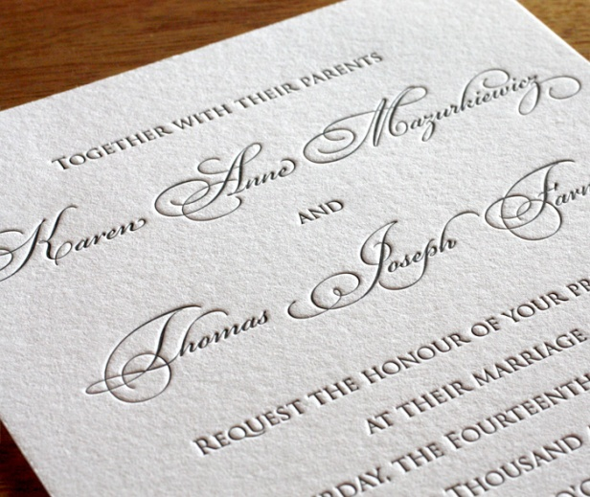
Contemporary fonts, however, are more common in modern weddings. Although not all modern weddings are informal, the use of contemporary fonts in the invitation generally gives an informal impression. Often, classic fonts are combined with contemporary fonts which can give a slightly more informal impression to the occasion.
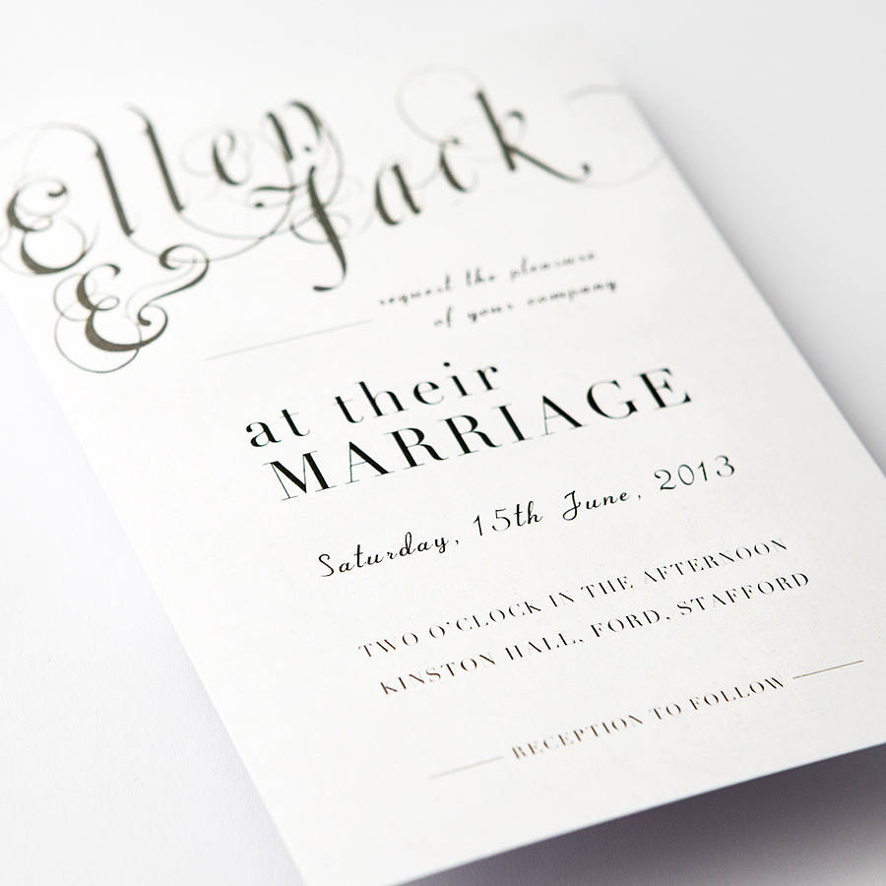
- What is seating stationary? For which purpose is it used?
Seating stationary is the type of stationary which is used in relation to where guests will sit for the wedding breakfast. This includes a table plan, table numbers, menus and place cards.

The table plan is used to show guests which table they are sitting at. This can be ordered by table with a list of the names of the guests at that table, or alphabetically for larger weddings which makes it easier for guests to find their name and table number.
Table numbers are used to highlight each table to make it easier for guests to find their table. Wedding venues often provide numbers on card and table number holders as part of the wedding package.
Place cards are used if you want to plan where each guest will sit. This is entirely up to the couple. Some don’t use place cards and allow guests who have been allocated to a particular table to choose their own seating arrangements.

Menus are sometimes used to allow guests to choose what they would like from their meal which is usually a choice between two dishes, although more often than not, it is used to inform guests what is on a set menu that the couple have chosen for all guests.
- What is the importance of wording for wedding invitations?
The wording of the invitation is important as this is the main channel of communication about the wedding to the guests. The information it provides must be clear and easy to understand and not misconstrued in any way. The wording must clearly state who it is getting married, the date and time of the ceremony, the location and any themes which may impact on the dress code. It also must clearly state whether the guest is invited to the ceremony and reception, or just the reception. Any confusion around this area might cause difficulty with the venue if guests turn up to the ceremony when they were only intended to be attending the reception. This will also prove costly in providing additional meals for guests who have unexpectedly turned up at this part of the wedding.

The wording should also mimic how formal the event is. This allows guests to know in advance what to expect on the day and in turn influences their behaviour.

- Collect from sample invitations for themed weddings. Produce a report about your collected invitations – write descriptions about the theme it is about.
- 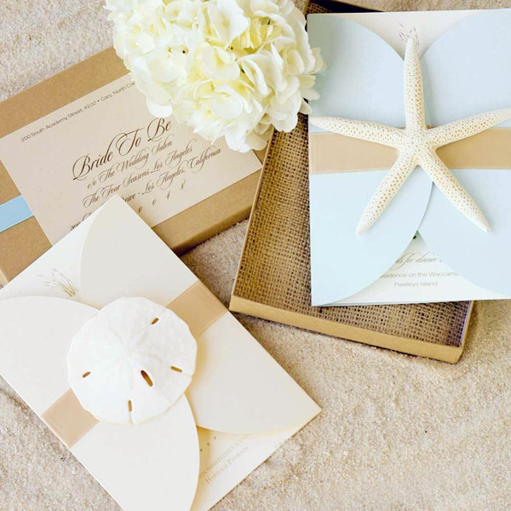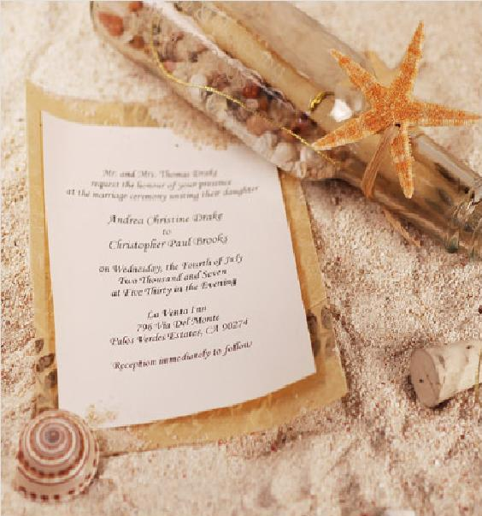
This invitation is to a beach wedding. The theme is clearly displayed through the use of natural colours (creams, browns and whites), sea shells and netting within its box, and the distinctive blue stripe across the lid represents the sea.

- 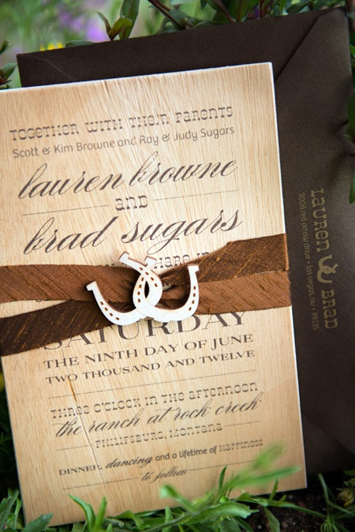
A country western theme is evident here with the style of this invitation. The brown, neutral theme ties in with the colour of the leather and even the horses found on the ranch. Similarly, the brown straps tie in with the girth, head collar and reins used on the horses. This is often a popular theme as it ties in closely with the horseshoe, which is thought to be a symbol of luck and has obvious connotations to a ranch.
Also, some parts of the font used resemble the font of saloons and poster signage in country western films, however, it is made slightly more formal by using a classical font for the couple’s names. This gives the impression that although the wedding will be taking place on the ranch, some elements will be more formal.
- 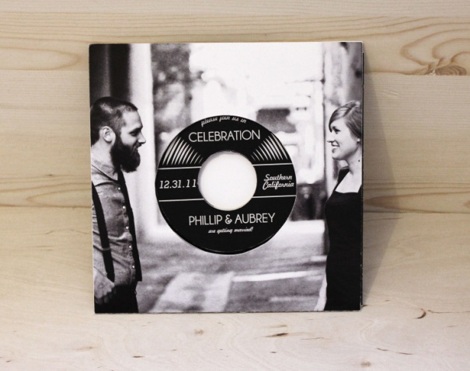
This invitation implies that the wedding is a musical theme. The use of the vinyl conveys this and the information about the wedding is printed onto the ‘vinyl’ as though it is the album title and songs. It also has a very personal touch by using an image of the couple, shot as though it is an album cover, as the vinyl sleeve.
- 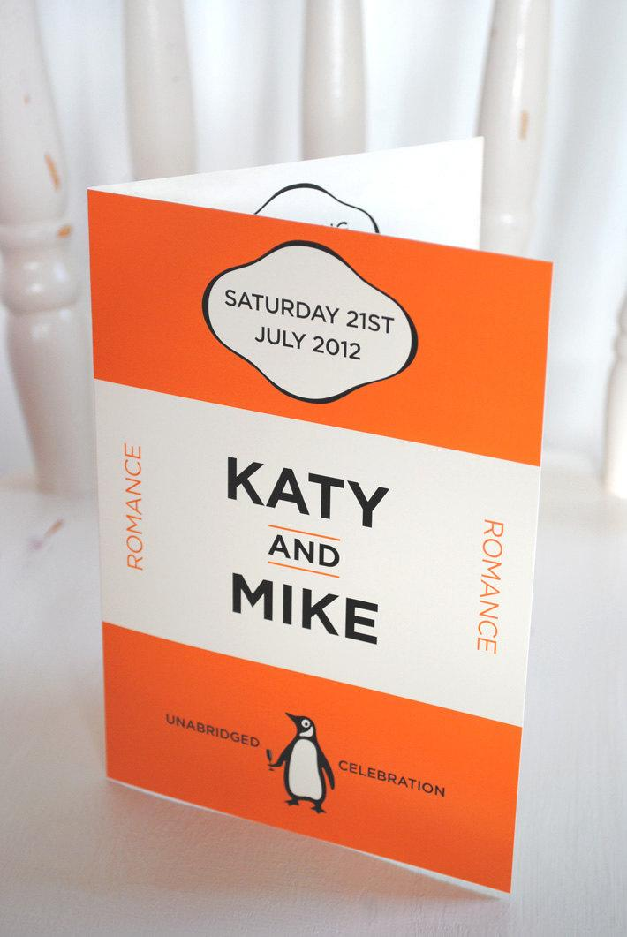
This invitation gives the impression that the couple has a mutual love for the Penguin Books, in particular the first editions which all have this distinctive orange cover. Although the invitation itself is quite simple, it is bright and eye catching and gives the impression that guests shouldn’t judge a book by its cover, or in this case, judge the wedding by its invitation. There may be surprises in store.
- 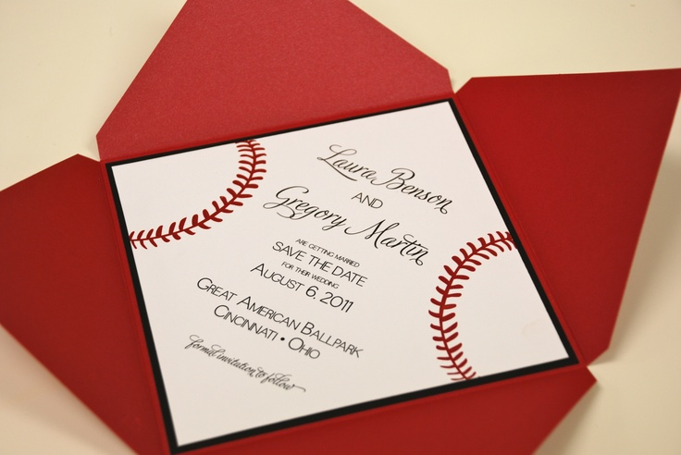
The baseball theme is evident in this invitation through the mimicking of the red stitching on a white background. It ties in with the venue, a ballpark, with the style and the informality of the invitation; however, it is again made slightly more formal by using a classical font for the couple’s names.

Student Statement:

By submitting this assignment, I confirm that this is my own work.

Student Signature | Sara Spiers | Date | 08/07/2016

For Tutor / Assessor Use Only
Total Marks
Marks Obtained
Percentage / Grade

