
Assignment Cover Sheet

Student Name: | Anna Chigaeva
Student Number: | 8539
Course: | Logistics and Supply Chain Management Level 4
Assignment NO: | 10

Marking Criteria:
We expect the learners to write minimum one well expressed point in three lines against each allocated mark. This means one needs to write 15 lines with 5 well expressed points to get high grades for a 5 marks question.
For high grades use examples and illustrations where appropriate.
- Give short answers for the following questions: (12)

- What are the aims and functions of warehouses?

The most general aim for warehouse is being distribution centres and logistics
centres. Sometimes, there is an explanation that distribution centres as hoarding finished goods on their way to end customers, while logistics centres store a broader mix of products at diverse points in the supply chain.
A WAREHOUSE is any site where material is stocked on their way to supply chains. Apart from storeroom, warehouses can be used for a lot other activities.

In general, the objectives of a warehouse are to sustain the broader logistics function by giving a mixture of high shopper service and low costs.

More exact aims include:

• Providing necessary storage at key points in a supply chain;
• Giving secure storage of the type needed by materials;
• Keeping all materials in good condition and with minimal damage;
• Giving high customer service;
• Doing all necessary activities efficiently and with low costs;
• Getting high productivity and utilisation of resources;
• Controlling all movements of materials effectively and without errors;
• Sorting materials arriving and quickly transferring them into storage;
• Picking materials departing, quickly transferring them out of storage and consolidating
deliveries;
• Being able to store the whole range of materials needed;
• Being flexible enough to deal efficiently with variations in stock levels;
• Allowing for special conditions and rotation of stock, etc.; and
• Giving safe working conditions and compliance with regulations.

- What is the difference between public and private warehouses?

Private warehouses are owned or leased by a business as part of its own supply chains. The business runs its own warehouses to sustain its major operations. This gives greater control over a middle part of logistics and allows incorporation of warehousing with the broader activities of logistics.

A public warehouse is run as a self-governing business, which makes money by charging users a fee. There are a lot of types of public warehouse, including bonded warehouses, cold stores, bulk storage, tankers, and various speciality stores. The facilities accessible are usually so flexible that an organisation can obtain within reason, any facilities that it requires. There are also a lot of arrangements for their use. The main advantage of public warehouses is their flexibility.

- Explain the advantages of public warehouses.

The benefits of public warehouses are:

• Flexibility to deal with changing demand, possibly due to seasonality;
• Ability to supply skills and knowledge that the business does not have internally;
• Access to the newest equipment and practices;
• Avoiding big capital investment, giving higher return on investment;
• Easy access to a wider geographical regions;
• Allowing immediate tests of working in new areas;
• Use of economies of scale to lessen warehousing costs;
• Consolidating loads with other organisations to decrease transport costs;
• Certain high quality and well-organized service; and
• Flexibility to deal with varying conditions, removing risks from dated practices and technology.

- What are manual warehouses?

Manual warehouses only work if the items are small and light enough to lift. Shelves must be low enough for them to achieve and close together to decrease the distance walked. This is most likely the easiest planning to visualize, and is still one of the most frequent. Items are stored on shelves or in bins. People go around and choose items from the shelves, and put them into some kind of container for movement – like a supermarket trolley.

- What are automated warehouses?

Automated warehouses are very high investment in apparatus, and is only actually worthwhile for extremely big stores that shift large amounts of materials. Automated warehouses include the following components:

• Storage regions that can be accessed by mechanical equipment; these often make use of narrow aisles up to, say, 40 M. tall to get an elevated density of materials and reduce the distances moved.
• Equipment to shift materials around the warehouse; these are typically automated guided vehicles (AGVs)
• Equipment to mechanically choose materials and place them into storage, including high speed stacker cranes that can arrive at any point in the thin aisles very fast.
• Equipment to move materials between the diverse types of equipment; these mechanical
loaders and unloaders may include industrial robots.
• A warehouse administration system to record material locations, and manage all movements.

vi. What are the main materials used for packaging?

There are five chief materials for packaging:
• Glass is simple to clean, reuse and reprocess, but is easily broken, comparatively expensive and hard to make;
• Plastic is light, strong and simple to clean, but can be costly and hard to create or reuse;
• Cardboard is light, inexpensive, and can be recycled, but has slight strength and poor
toughness;
• Wood is strong, tough, easy to use and can be reused, but it is weighty, bulky and tricky to clean; and
• Metal is strong and tough, but it is weighty and can be costly.

The choice of these – or other materials – depends mainly on the kind of products, movement and protection required.

- Outline the activities that take place in a warehouse. (9)

The following list of activities that are usually included in ‘warehousing’.
• Receiving goods from upstream sellers;
• Identifying the goods, matching them to orders and finding their planned use;
• Unloading materials from delivery vehicles;
• Doing any essential checks on quantity, quality, and state;
• labelling materials (usually with bar codes) so they can be recognized;
• Sporting goods as essential;
• Moving goods to mass storage area;
• Holding them in stock until required;
• When required, moving materials from mass storage to a smaller picking store;
• Moving the materials to a marshalling area;
• Assembling materials into orders;
• Packing and packaging as necessary;
• loading delivery vehicles and dispatching the order; and
• controlling all communications and connected systems, such as, inventory control and finance.
• Picking materials from this store to meet orders;

- Describe, in detail, the general layout of a warehouse. Using examples and illustrations. (9)

The necessary elements in a warehouse are an arrival bay or dock, where goods coming
from suppliers are delivered, checked, and sorted -
• A storage area, where the goods are kept as stock;
• A departure bay, or dock, where customers’ orders are assembled and sent out;
• A material handling scheme, for moving goods around; and
• An information system, which records the site of all goods, arrivals from suppliers, departures to consumers, and other applicable information.

Below is illustration of basic layout example.

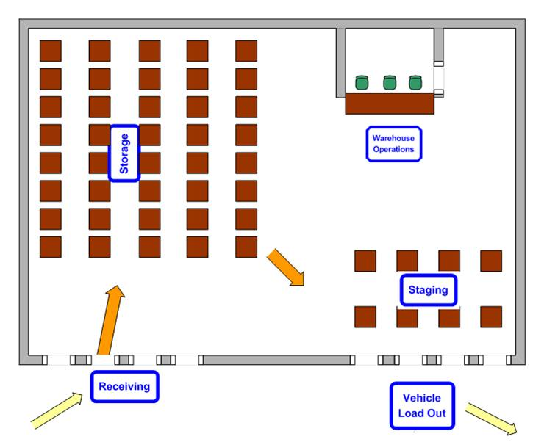

Student Statement:

By submitting this assignment, I confirm that this is my own work.

Student Signature | Anna Chigaeva | Date | 20/12/2017

For Tutor / Assessor Use Only
Total Marks
Marks Obtained
Percentage / Grade

