
Assignment Cover Sheet

Student Name: | Raymond Wilson
Student Number: | 5297
Course: | Diploma in Risk Management
Assignment No: | 6
Marking Criteria:
We expect the learners to write minimum one well expressed point in three lines against each allocated mark. This means one needs to write 15 lines with 5 well expressed points to get high grades for a 5 marks question.
For high grades use examples and illustrations where appropriate.
Assessment 6 Risk Assessment, Evaluation & Management Total Marks: 30

1. Short Questions: (14)
I. What are the principles of assessing risk?
Employers have a legal obligation to carry out risk assessments and they are required to assess what activities and situations can harm people, how badly they could be harmed, and how probable is it that harm will occur. The Basic steps (principles) in a risk assessment can be identified as;
- Identifying hazards using an pre-arranged process and record same.
- Assessing the risk of harm
- Assessing existing control measures, to see if they are adequate
- Assessing if extra controls are needed
- Reviewing later on, to see if the controls are working
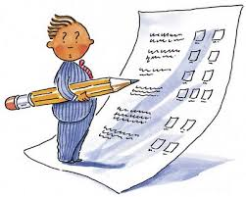
A brief summary of those principles are as follows;
1. Identifying hazards – Firstly identify all the significant hazards in the job (e.g. falls from height, electricity, asbestos, slips, trips & falls, manual handling). What makes a hazard particularly important is if it has the capability to kill or lead to serious injury. It is important here to ensure that a structured record, usually a risk register type document, is instigated to capture the identified risks and so that other actions can be captured later in this process.
2. Assessing the risk of harm - Companies need to assess how likely it is that their employees (and others, such as other contractors or the public) might be harmed by such a hazard, example being: would they be working at height all day, every day or just once a month?.
3. Assessing existing control measures - Each significant risk needs to be analyzed and a decision made as to what controls must to be put in place to remove or reduce that risk (e.g. having written safety procedures or method statements, only working on ‘dead’ circuits to remove the chance of electrocution, or using personal protective equipment, such as eyewear when drilling, to reduce the risk of eye injury).
4. Assessing if extra controls are needed When you have taken the existing or planned controls into account, how much risk of harm remains? If the risk is still significant, more effort must exerted to reduce the risk (e.g. doing the work another way, or giving more training, or additional personal protective equipment etc.).
5. Reviewing - It is important later on, to see if controls put in place are working. Jobs often change as they go along, sometimes in unexpected ways and when they change, there is a chance your risk assessment should change too. Once you have conducted a risk assessment and introduced the necessary controls, make sure that your control measures are suitable for what is actually happening ‘on the tools’.

II. What is the importance of risk assessment?

A comprehensive risk assessment will help any organization understand the kind of threats it can be exposed to, the possible extent of damage and therefore the required steps for damage control. A good Risk Analysis and Assessment helps throw insight into how each functional area of a business would be impacted in the event of an incident, accident or disaster and therefore, it also helps in prioritizing recovery plans based on the criticality of the functions.

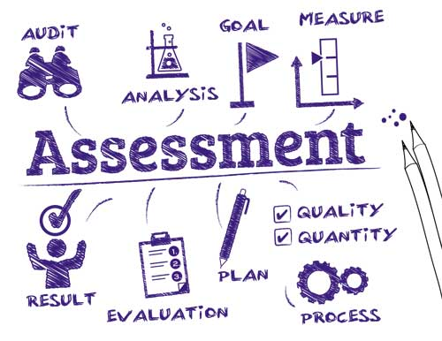
The most important function of a risk assessment process is to pre-determine the possible scenarios of a “disaster” (Note; I have used this term based on all incidents, accidents can be a disaster for a company based on loss of life, reputation, credibility, monies etc.) all and then steps that the organization will take to recovery in the event of each. Listing out disasters is a challenging task, the list will never seem to be comprehensive enough and it will need constant updating. One way of handling this effectively is by using a good tool that will help you cover all kinds of disasters while working on risk assessment.
Another important role that Risk Assessment, as illustrated above, performs is ‘thinking through’ the worst-case scenario: the complete destruction of a business’s main or head office, its lifeline. It helps the business evaluate the extent of damage and think through the recovery process in the event of this worst-case scenario.
While performing Risk Assessment, the most important outcome is to determine how any event or mishap would affect the business, the infrastructure and the company in general. A good risk assessment should have plenty of “what-if” scenarios. Risk Assessment may also involve testing “in place” procedures, which must be conducted in a proper method and environment for measuring the results effectively.
Risk Assessment is probably the most important part of planning business continuity in the event of a disaster. The better it encompasses all risks, types of and solutions in detail, the better prepared your business is when disaster strikes.

III. Which activities take place in risk assessment process?

If a Risk Assessment process had to be broken down into steps, the five phases below would more or less cover it;
- Identify the risks to your company, and be proactive and examine all the risks and the potential damage it could cause. Go through case studies to understand the extent of damage such incidents have caused in the past.
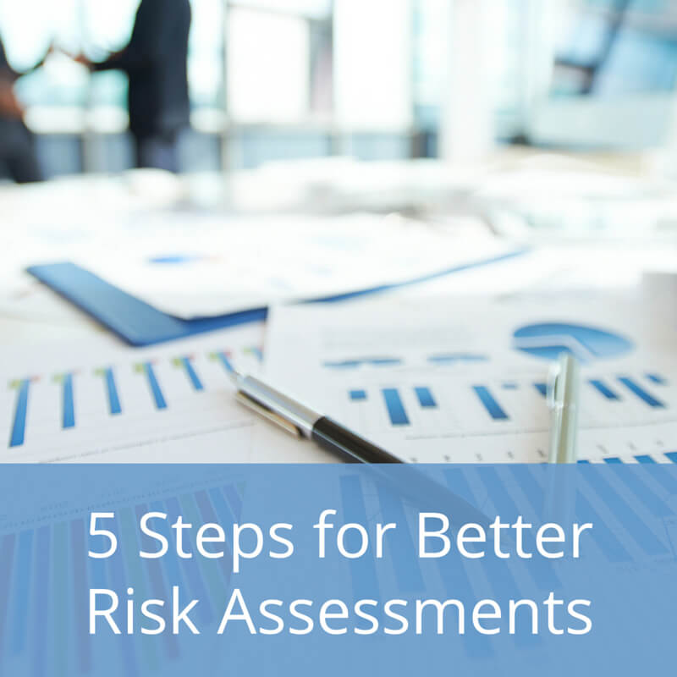
- Establish facts as to what or who might be harmed and how. Infrastructure, Intellectual property, people…..exactly determine what kind of harm might be caused to each of these factors in the event of a disaster, and in the event of a worst-case scenario.
- Evaluate and prioritize the risks and get a fix on precautionary measures.
- Document all the analyses and deductions identified in detail and all the implications from the Risk Assessment exercise
- Review the Risk Assessment plan periodically and make the necessary updates to suit ongoing circumstances.
The activities detailed above must be comprehensive and incorporated into an all-encompassing risk register that is developed in the identify risk stage. The people involved need to be knowledgeable and make informed and well-reasoned valuations of the risks
involved (it helps if Risk Management expertise is available to assist with the assessment if available) so that consistent definitions of impact and probability are agreed.

The also needs to be an adequate timescale allotted to the assessment process and any financial considerations are appropriate and allowed for.

IV. What is meant by ‘risk appetite’?

Risk appetite is the level of risk an organization or business is prepared to accept or be exposed to. Constraints associated with Risk Appetite are not easy to define; as every organization is distinctive and differ in how they can tolerate different levels of risk. It is important, however for the organization to establish a common understanding of risk and be prepared for the likelihood and impact of known threats. Organizations should define their maximum level of risk tolerance in each area of risk before taking appropriate action.
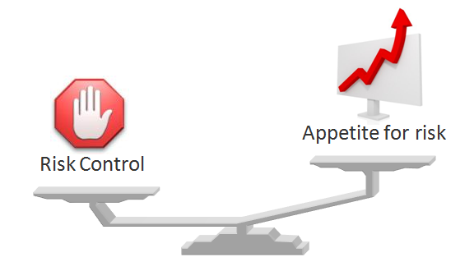

Categories for attitude towards risk are, in industry terms, risk seeking, risk neutral or risk adverse. A company’s appetite for taking on risk or the amount of risk that a business is prepared to tolerate may change regularly depending on such features as the approach of the elected board members, ongoing observed financial exposure to identified risks, and to present state of the business (financial) as well as the general health of the economy the business operates in.

Organizations sometimes express their risk appetite through the creation of a risk appetite statement, a document that helps guide organizational risk management activities. The statement should be based on a review of the perspectives and concerns of all stakeholders and address the implications of current corporate strategies and practices.
V. Outline the activities that take place in risk management process.

Businesses today face many risks, therefore risk management needs to be a pivotal part of any business' strategic management plan. The businesses that identify these risks will be better prepared and have a more cost-effective way of dealing with them.

The Risk Management process helps companies to identify and address the risks facing the business and in doing so increase the likelihood of successfully achieving business strategies and objectives as well as significantly improving the corporation probability.

A risk management process involves the following steps;
- Step 1 – Establish the context methodically
- Step 2 – Identify the risks by methodically identifying the risks surrounding your business activities
- Step 3 – Analyze the risks and assessing the likelihood of an event occurring
- Step 4 – Evaluate the risks by understanding how to respond to these events
- Step 5 – Treat the risks by putting systems in place to deal with the consequences

Throughout each step it is important that there is discussion and communication with everyone in the organization’s set up (refer to the diagram below).

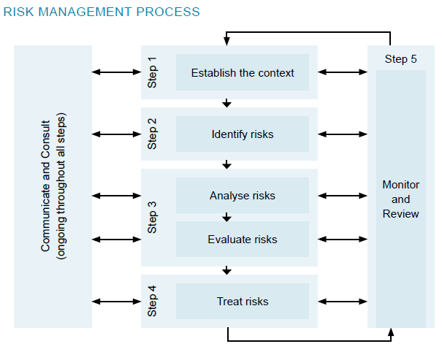

As a direct result, the process of risk management will improve decision-making, planning and prioritisation and helps companies to allocate capital and resources more efficiently by
allowing them to anticipate what may go wrong, minimising the amount of firefighting that they may have to do and ultimately prevent a disaster or serious financial loss.

Risk management takes on a greater emphasis a business decides to try something new, for example launch a new product or enter new markets. Two obvious risks for companies to consider would be competitors following them these markets, or breakthroughs in technology which can make a new product redundant.
VI. What is influence diagram technique? How it is used for decision analysis?

An influence diagram (ID), quite simply, is an illustrated representation of a problem and serve as graphical tools for visualizing and scrutinizing complex systems. Decision-making teams often require a thorough understanding of often-complicated networks of interrelated dynamics that control system behavior in order to make consistently good decisions.

By graphically representing different system interfaces, ID’s help facilitate teams to grasp behaviors far more effortlessly than with unaided insight. It also presents a methodology for analyzing these interactions to gain system insight for improved decision-making and an spontaneous way to identify and display essential elements like decisions, uncertainties, and objectives, and how they influence each other through interaction.

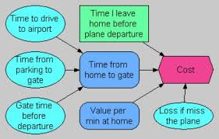

As illustrated above, ID’s can be simple in nature as directly below covering domestic travel or a more interlinked complex version as shown below on the “snap shot” version which relates offshore drilling activities. Note: The shape of the information boxes normally denote differing data such as Square = Decisions, Diamonds = Values, Circles = Uncertainty/Chance events and double circles = known outputs from timed inputs. Some models may use variations of these shapes and are normally identified on a legend section within the diagram.

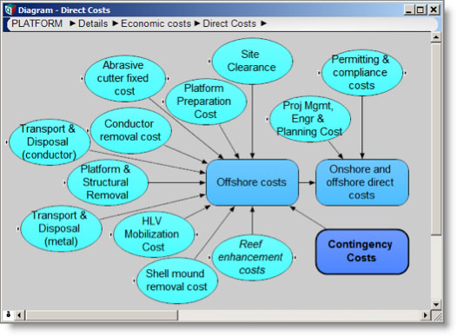

These diagrams can be applied in various areas of data analysis such as Sensitivity Analysis, Mathematical Modelling, Model Fidelity, Improvement Initiatives and for Quantifying risk and uncertainty.
The influence diagram illustrates the dependencies among variables more visibly than other similar techniques thus, an overall concluding aspect that can be derived is that the influence diagram is much better than any other decision-making technique and;
- It aids in understanding quantitative relationships in math model.
- Influence Diagrams divide a system into logical entities or components- one per node- that can be a single value.
- Further on, smaller sets of calculation nodes can be selected and tested in isolation.
- Modularity helps to maintain and upgrade Influence Diagrams easily.
- Influence Diagrams function as open windows into system understanding rather than being black boxes.

2. Discuss the following inputs of the risk assessment process: (8)
a) Risk register

Risk registers are a direct production of a company’s project risk management plan. The project manager will normally use his team members to provide discipline input and seek assistance from other stakeholders and even clients if need be. The risk register (or risk log as it sometimes referred to) is vital as it records identified risks, their perceived severity, and the actions steps to be taken. In today’s age of computer reliability there are obviously software companies who have developed packages/suites to be used for this purpose however the register need only be a simple document or spreadsheet. The most effective format commonly used is a table, as this allows a great deal of information to be viewed on just a few pages.
The register itself provides a framework in which identified problems, that threaten the delivery of the anticipated benefits, are captured. Managers should continually review the risk register and ensure the identified risks are kept to acceptable levels through actions instigated to reduce the probability and the potential impact of specific risks.

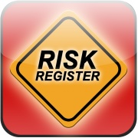 It is important to ensure the risk register is visible to project stakeholders so they can see that risks are being addressed. They may flag risks previously not identified and may also give other options for risk mitigation.

As for the register structure, there is no standard list of components that should be included in its formatting.

The Project Management Institute Body of Knowledge (PMBOK) and PRINCE2 make recommendations for risk register topics, but they are not mandatory. Some of the most widely used components however are as follows;
- Dates - As the register is a “live” document, it is important to record the date that risks are identified, modified or closed.
- Description of the Risk - A written detail that describes the risk/risks identified.
- Risk Type (business, project, stage) - Classification of the risk;
- Business risks relate to the delivery of achieved benefits
- Project risks relate to the management of the project such as schedule and resources needed
- Stage risks are risks associated with a specific stage of the plan.
- Likelihood of Occurrence - Provides an calculation on how likely it is that this risk will occur. Examples are: L-Low (<30%), M-Medium (30-70%), H-High (>70%).
- Severity of Effect - Offers an assessment of the impact that the event of this risk would have on the project and/or company.
- Countermeasures - Activities to be taken to prevent, reduce, or transfer the risk identified.
- Owner - The person (or individuals) accountable for ensuring that risks are appropriately engaged with countermeasures identified.
- Status - Indicates whether this is a current risk or if risk can no longer arise and impact the project. Example classifications are: C-current, O-ongoing or E-ended.

b) Profit & loss account
Gross profit, or loss, for a business is established through a trading account and net profit is determined by deducting all indirect expenses (business operating expenses) from the gross profit through the profit and loss account. Clearly this will provide figures on the anticipated profit for a specified period, such as quarterly or year ending as exampled below. If a company is forecasting low profits margins it may be exposed to numerous related risks in terms of business stability and operating constraints.
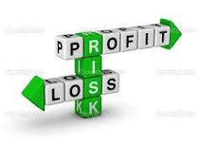The particulars required for the preparation of profit and loss account are made available from a developed trial balance sheet and only indirect expenses and indirect revenues are considered in it.
Profit is shown on the credit side of the account and loss is shown on the debit side of this account. All indirect expenses are transferred on the debit side of this account and all indirect revenues on credit side. If the total of the credit side exceeds the debit side, the result is "net profit" and if the total of the debit side exceeds the total of the credit side, the result is net loss. As the net profit or net loss of a certain accounting period is determined through profit and loss account, so its heading is as the following example;
Name of Business (Project details if applicable)
Profit and Loss Account for the year ended 31.12.2016
(based on accounting period ending on 31.12.2016)
There is no hard and fast rule as to the sequence in which the items of expenses are shown in profit and loss accounting but generally, the items of expenses are shown in the following order;

Office and Administration Expenses – These are associated expenses related to the management of the business e.g. salaries of office staff, office rent, office stationary, office electric charges, office telephone etc.

Selling and Distribution Expenses - These are the expenses which are directly or indirectly connected with the sale of goods or the products of the company. These expenses vary with the sales i.e. they increase or decrease with the increase or decrease of sale of goods. Advertisements, carriage outward, salesmen's salaries/ commission, discounts, traveling expenses, bad debts, packaging expenses, warehouse rent etc. are prime examples.

Financial and Other Expenses - All other expenses, excluding those detailed above, fall into this category.

c) Balance sheet

The company balance sheet, similar to the one illustrated below, is a report that summarizes all of an entity's assets, liabilities, and equity as of a given point in time.
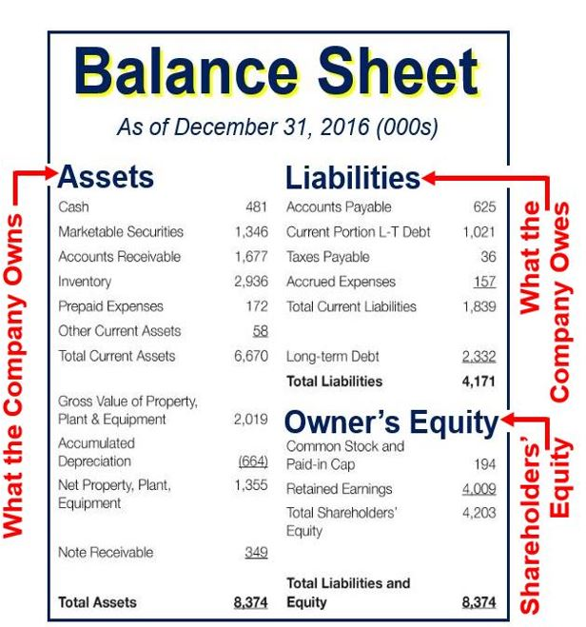
It’s a format that is typically used by lenders, investors, and creditors to estimate the liquidity of a business and is one of the documents included in an entity's financial statements. Of all the company financial statements, the balance sheet is stated as of the end of the reporting period, while the income statement and statement of cash flows cover the entire reporting period and are issued monthly, quarterly, bi annually etc.
Typical line items included in the balance sheet (as illustrated above and by general category) are;
- Assets - Cash, marketable securities, accounts receivable, inventory, and fixed assets
- Liabilities - Accounts payable, accrued liabilities, taxes payable, short-term debt, and long-term debt
- Owners’ (shareholders) equity Stock, retained earnings, and treasury stock
The exact set of line items included in a balance sheet, in addition to the basics above, will depend upon the types of commercial transactions with which a business is involved. Generally, the line items used for the balance sheets of companies located in the same industry will be of similar format, since they all deal with the same types of transactions.
The prime aim is to ensure the total amount of assets listed on the balance sheet should always equal the total of all liabilities and equity accounts listed. If this is not the case, a balance sheet is considered to be unbalanced, and should not be issued until the underlying accounting recordation error causing the imbalance has been located and corrected.
Balance sheets should be examined on a regular basis to ensure the reliability of the estimates with reference to the strength of the assumptions made and the accuracy of the input data itself. The balance sheet, if produced accurately, will provide an warning of the vulnerability of a business to impending financial pinch points, late payments and even bad debt.

3. Write short notes on the followings: (8)
a) Risk reduction
Risk reduction (or as sometimes referred to as risk mitigation or responses), is any strategy that reduces the impact or probability of a risk, hypothetically to zero. The following are a few examples taken across a number of spectrums;

Health And Safety - Requiring workers on a construction site to use safety equipment to mitigate the risk of injury.

Exchange Rates - A British car manufacturer reduces exchange rate exposure to the Japanese Yen by paying his Japanese part suppliers with yen from their sales in Japan.
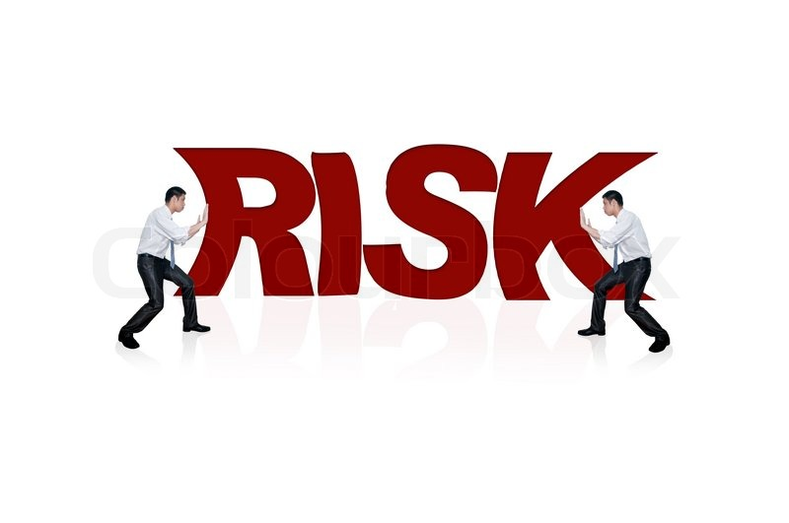

Customer Service - A hotel chain can reduce the risk of bad customer reviews by empowering its staff to handle customer complaints on the spot. For example, staff are able, through consultation with their supervisor, to upgrade a customer's room upon receiving a reasonable or justifiable complaint.

Quality - A computer component manufacturer reduces the risk of expensive and damaging failures or recalls with rigorous quality assurance processes.

Dispute Risk - A company intending to build a new road bypass system reduces the risk of disputes/complaints by sending representatives to neighbors of a site to explain the schedule and what will be done to keep noise and environmental impact to a minimum.

Weather Risk - A solar power company reduces weather risk by scheduling critical maintenance tasks during the months with the least sunlight (winter months) in a particular region.

Financial Risk - An infrastructure company reduces interest rate risk and refinancing risk by selling long term bonds when rates are low.

Project Management - A project manager reduces project risk by breaking a project into small regular milestones that can be delivered on schedule.

b) Risk transfer

Risk management is a technique whereby one party (transferor) pays another (transferee) to assume a risk that the transferor wishes to escape from.

Risk transfer to a third party is normally carried out using a legal agreement. The following are common examples of such transfers;

Insurance - An insurance policy transfers a specific set of risks such as the fire and flood risk for a particular asset. The transferor pays a premium for this policy

Derivatives - A derivative is a financial product that derives its value from the value of an underlying entity such as an asset or interest rate. They are often purchased by businesses as a hedges against financial risks such as exchange rate risk.

Outsourcing - Outsourcing a project or process typically transfers a variety of risks to another partner. Such transfers are specified in contract terms. For example, liability penalties may be put in place that are triggered if a project or process doesn't meet a set of minimum requirements or is delivered later than agreed.



Transference of risk isn’t the norm in day to day business and tends to be more common in projects or financial agreements where there are several parties involved by essentially, transferring the impact and management of the risk to someone else. For example, if you have a third party contracted to write your project manuals/specifications, you could transfer the risk that if there is errors in them the liability and consequences are over to the third party involved. They will then be responsible for managing this risk, perhaps through additional training or even transferring some of that potential risk to others as well.
Normally transference arrangements are written up into project contracts whereupon insurance is usually taken as a specific kind or a comprehensive type policy to cover many eventualities depending on the agreements involved. If you are transporting equipment as part of your project, for example, and the van is in an accident, the insurance company will be liable for providing new equipment to replace any that was damaged.

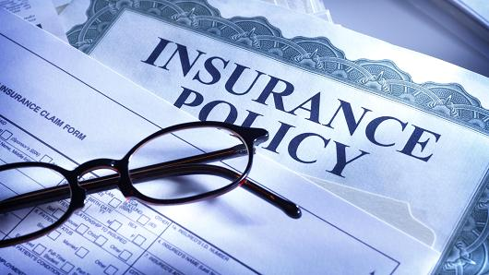

The project team acknowledges that the accident might happen, but they won’t be responsible for dealing with sourcing replacement kit, moving it to the right location or paying for it as that is now the responsibility of the insurance company.

Student Statement:

By submitting this assignment, I confirm that this is my own work.

Student Signature | Raymond Wilson | Date | 25th Mar 2017

For Tutor / Assessor Use Only
Total Marks
Marks Obtained
Percentage / Grade

