
Assignment Cover Sheet

Student Name: | IORDAN BALTATU
Student Number: | 11918
Course: | SITE ORGANISATION
Assignment NO: | 5

1.

- What do you understand by the term ‘site organisation’?

Site organisation is a detailed and well thought out process which ensures a healthy and safe construction site throughout its build.
Some of the key points are:
- Construction site management traffic:
- Ensures that moving vehicles do not present a hazard to people working on, or visiting, the site.
- Protecting the public on construction sites:
- Details the specific measures for protecting members of the public on site and preventing access by unauthorised people, including children.
- Materials storage and waste management on construction sites:
- Guidance on storing materials safely to prevent hazards and make sure that waste is removed and disposed of safely.
- Welfare on a construction site:
- How to meet your legal requirements for welfare facilities on construction sites, for example providing toilet and washing facilities, drinking water, rest areas, changing rooms and lockers.
- Administration on a construction site
- The paperwork you need to manage the site legally and safely.
- Temporary services- food, drinks, ATM etc.;
- Temporary housing for labourers if applies;
- Access to site and site roads-part of the site traffic management;

- Highlight the importance of preparing the site road to make it suitable for the movement of heavy construction equipment.

Each year within the construction industry, approximately ten people die as a result of being struck by vehicles on site. In addition, there are hundreds of preventable accidents and injuries. Accidents occur from groundworks to finishing works and managers, workers, visitors to sites and members of the public can all be at risk.Inadequate planning and control is the root cause of many construction vehicle accidents.
It is very important to prepare site roads for the movement of heavy construction equipment as we can avoid any risks or hazards for the people working in site. Heavy plants or heavy equipments needs special attention as they can damage the roads that aren’t properly build. Rough roads are more often used by onsite traffic, while water bound or bitumen roads are suitable for on-off site traffic. Roads must be maintained to prevent potholes and ditches from developing and damaging vehicles.
iii. List the precautions to be taken for the storage of cement at a construction site.

If moisture is kept away from cement, it is found that cement will maintain its quality for an indefinite period. Absorption of 1 to 2% of moisture has no appreciable effect on quality of cement. But if moisture absorption exceeds 5%, the cement becomes totally useless. Hence, when cement is to be stored for a long period, it should be stored in air-tight containers
The lose cement may be stored indefinitely in air-tight containers. But it is advisable to avoid storing of cement in jute bags for a period longer than 3 months. If it is unavoidable, the cement should be tested to ascertain its properties.
The walls, roof and floor of storage sheds should be of water proof construction. A minimum number of windows should be provided and they should be kept tightly shut. The floor should be above ground. For determining the size of storage shed, it is found that 20 bags or 10 kN of cement will require about 1m³ of space.
The cement bags are stacked in piles. It is advisable to form a pile of maximum 10 bags. There should be a clear distance of about 300 mm between the piles of cement bag and exterior walls of building. In between individual pile a passage of 900 mm should be provided for easy access and at least 450 mm from the external walls. Use tarpaulins or water proof paper at the top and bottom of piles, while storing cement for long period.
While removing cement bags from pile of sufficient height, then steps should be formed by taking out two or three bags from front piles. Cement should be removed in order of its storage period, i.e. the rule of first in, first out should be followed.

- What would you do to prevent scaling and rusting of structural and reinforcing steel?

Steels should be stored in such a way, so as to avoid distortion and to prevent deterioration and corrosion. Steels of different classes should be stored separately. Follow the guidelines given below while storing steel on site.
- Store bars of different classes, sizes and lengths separately to facilitate issues in such sizes and lengths to minimize wastage in cutting from standard lengths.
- Paint the ends of bars of each class in distinct separate colors.
- Coat steel reinforcement with cement wash before stacking to prevent scaling and rusting.
- If reinforcement bars must be stored for a long period, then stack it above ground level by at least 150 mm.
- How does exit control help in site protection?

- make sure there is a reasonable length of time for all the occupants to escape to a place of safety once a fire has been detected.
- ensure there are enough exits and that they are in the right places. The type and size of exits should be suitable and sufficient for the number of people likely to need to use them.
- in the event of fire anywhere in the workplace, make sure at least one route from any part of the premises remains available
- all escape routes must be easily identifiable, free from any obstructions and adequately illuminated
- all staff should be instructed and trained in using the means of escape
- instructions about the means of escape should be displayed for employees
- means of escape arrangements should be included in the emergency plan.

2 . Discuss the advantages of providing fences for construction sites.
There are advantages providing fences for construction site such as:

1. Durability
One of the many advantages of security fencing for construction site is that it is much more durable than standard fencing. Constructed out of steel and usually applied with a galvanised coating, your security fencing will last for decades. This makes security fencing very cost-effective as you won’t have to worry about repairing or replacing a rundown fence.

2. Security
Security fencing is almost completely impermeable to outsiders, with the material being strong, exceedingly difficult to damage and unclimbable by design. Indeed, just the appearance of the fencing can present a formidable sight that would deter would-be thieves immediately! This makes security fencing the ultimate security measure you can take to protect your business.

3. Parking
Security fencing can ensure that parking is always protected from opportunist motorists looking for a space and protect the cars from the potential damages that can incur if parking in a publicly accessed area.

4. Safety
Having secure premises has lots of safety benefits; whether it’s keeping animals and children away from busy roads, monitoring access to your premises or ensuring that the valuable belongings are safe, security fencing will enable to feel completely protected.

5. Low maintenance
Security fencing is low maintenance in terms of both cost and time. The initial investment is entirely affordable, and because it is such a robust material it will bear up against volatile weather and attempts to gain entry remarkably well, neither rusting, corroding or denting in any way. We can leave the fence knowing that it will continue to look neat and secure for the foreseeable future.

2. Discuss the advantages of providing fences for construction sites.

Heras Fencing
Widely popular and commonly used to create a temporary barrier while work is in progress, heras fencing is a good option for short to medium term projects. One of the main benefits of this type of fencing is its low weight, which provides a system that’s easy to transport and deploy wherever it’s required.
Anti-Climb
For construction sites this type of fencing comes in an anti-climb variety; eliminating any footholds or areas where it might be easy for a potential intruder to gain access to the site. This type of heras fencing is available for purchase or hire, which allows a cost effective decision to be made based on the time requirement for these fencing panels. Entry level anti-climb heras fencing stacks up as follows (per panel):
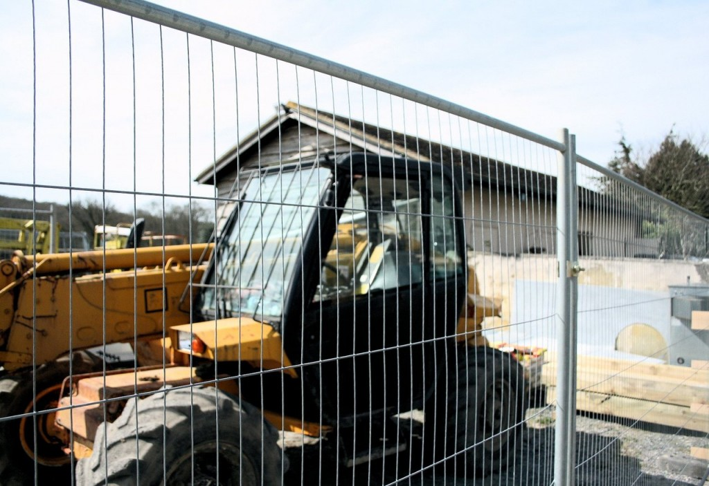
Height: 2,000mm
- Width: 3,500mm
- Weight: 13.8kg
These fully galvanised panels are most suitable for light security where it’s necessary to stop members of the public entering the site unintentionally or otherwise. For a slightly more robust but just as easily deployed solution SafeSite Facilities offer a heavy duty variation of the popular anti-climb heras fencing panels. These are slightly heavier at 15.9kg each; making use of Smartweld technology for added strength and durability over products of less rigorous construction techniques.
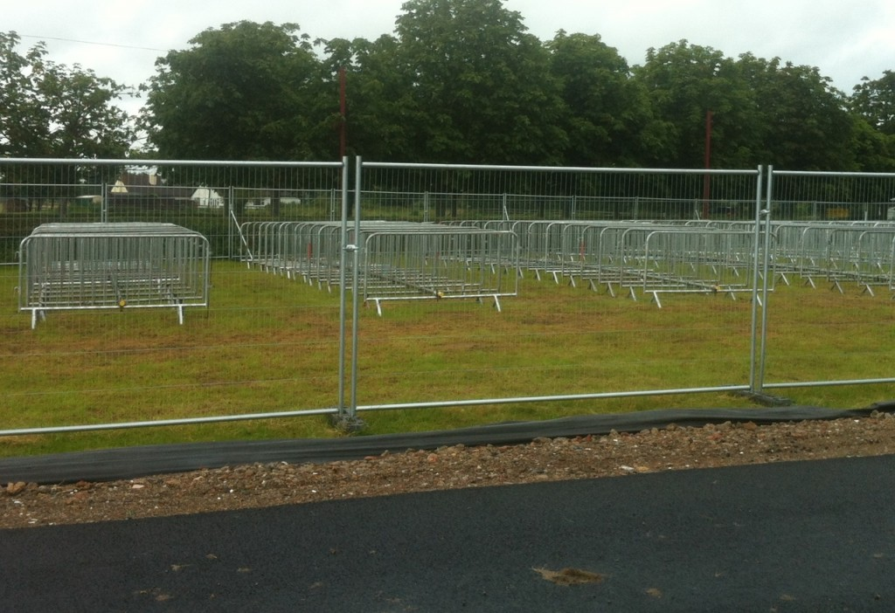
In the world of heras fencing our heavy duty round top anti-climb panels are the best you can get. Additional corner bracing and the option to reinforce this fencing system with concrete blocks provides a flexible and robust perimeter for your construction site. This type of temporary fencing can be used long term and represents the best security fencing available where mesh fencing is required.
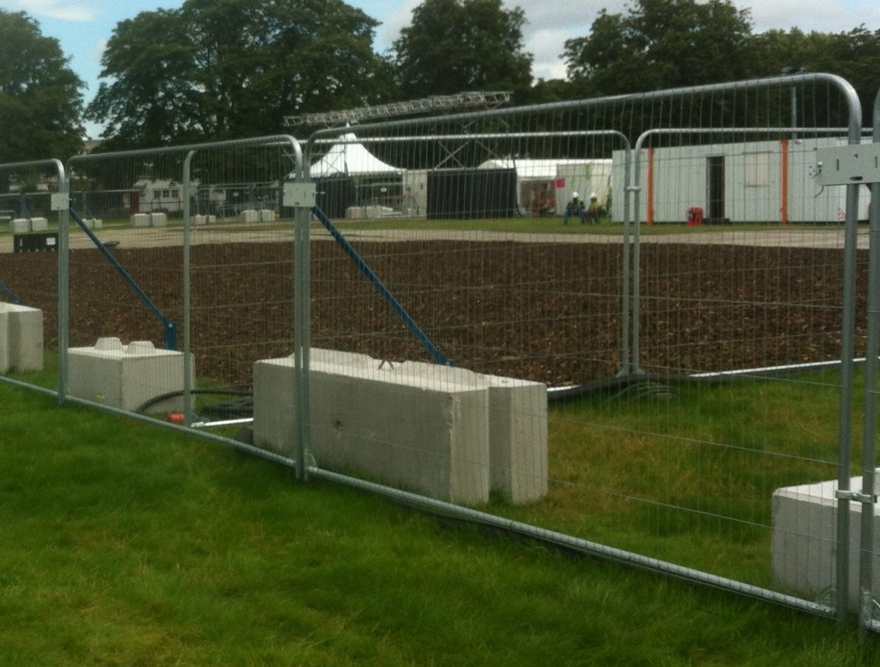
Access Gates
Of course while the main purpose of security fencing is to keep people out it’s also necessary to make access to the site as easy as possible for those working within the perimeter. Our temporary heras fencing gates come in a wide range of sizes to allow vehicle and pedestrian access where necessary.
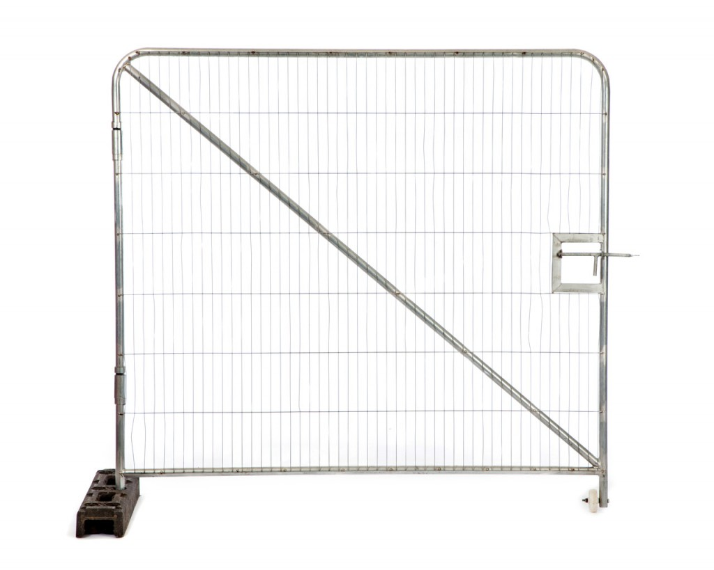
These gates use the same anti-climb galvanised steel mesh panels as the standard fencing options with secure locking mechanisms which make use of your own padlocks for simple site security. The panels are similar in weight to the non-gated fencing and make for easy loading and installation with a two man team.

Construction Hoarding
One of the key differences between heras fencing and construction hording is the visual barrier provided when using hoarding. This eliminates many of the threats associated with opportunistic crime where a casual thief or vandal may see something of value within the site when mesh fencing panels are in use. Hoarding for construction sites come in two main materials; timber or steel.
Timber Hoarding
Timber hoarding, along with cost benefits over permanent options, can be installed in concrete to provide greater rigidity and a permanent-like structure with which to protect a building or construction site. The panels are installed using bracing techniques and can withstand a great deal of pressure; making them one of our most popular fencing options where security is vital.
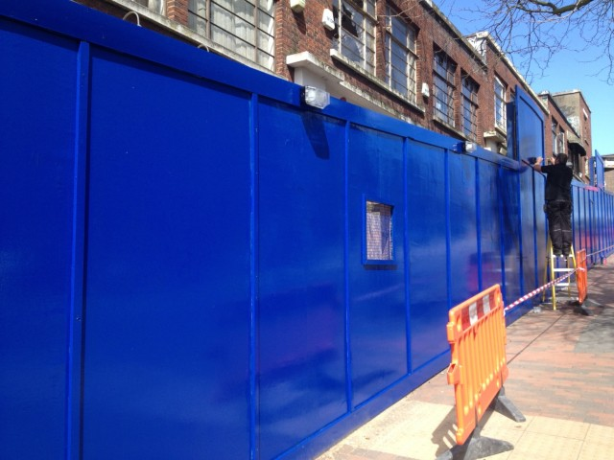
A major advantage of timber hoarding, which would generally be in use for longer term projects such as housing developments, is the ability to customise the fencing specifically to the site allowing for an “air-tight” perimeter. This tailoring extends to the look and design of the panels, which can be hired or purchased to match particular brand colours if desired.
Additional customisations include the ability to fit anti-climb devices and any number of vehicle or pedestrian gates to the hoarding. All timber is ethically sources and panels may only be removed via machinery.
Steel Hoarding
Steel hoarding represents the most robust of all fencing options for a construction or building site. These modular panels can be used in a number of different situations and are of particular value when dug-in timber hoarding is not an option.
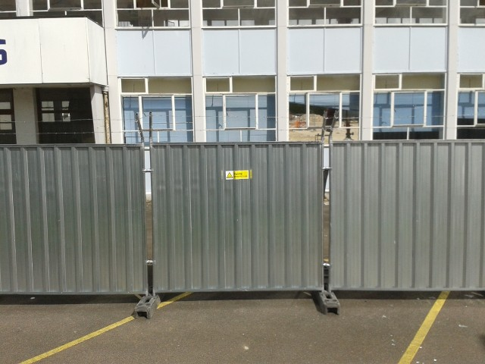

The galvanised steel panels are often more cost effective than tailor made timber hoarding and provide your site with a lightweight fencing option, which can be easily installed by a small team. Like the heras fencing options, pedestrian and vehicle gates can be quickly incorporated where required and are compatible with all mesh fencing as well; so you need not use steel hoarding exclusively on a site in areas where it’s not required.
This type of hoarding is also compatible with water-filled barriers, where a heavy duty base is preferred. Again water-filled barriers are easy to manoeuvre when empty, simply requiring a water source on site for a heavy duty alternative to the standard freestanding steel hoarding panels. The panels themselves can be linked to form a seamless perimeter around a construction site, completely obscuring anyone’s view of work being carried out inside.
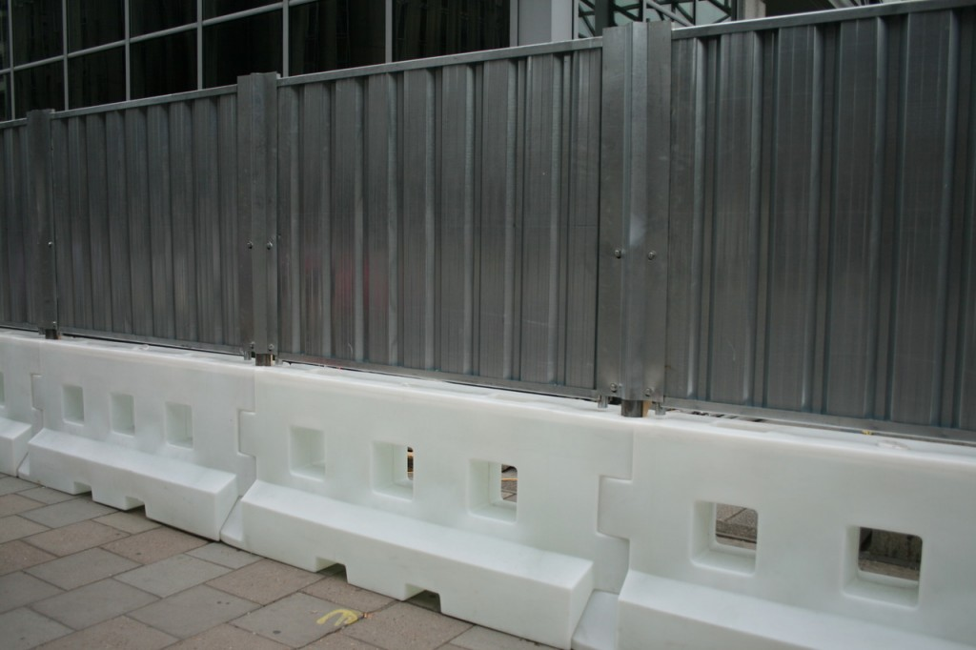

Optional extras, also available for purchase or hire, include the addition of barbed wire or mesh tops to increase the height of the barriers and provide a greater deterrent to would be trespassers. Stronghoard is another option within the realm of steel hoarding, which makes use of additional bracing and concrete blocks to provide an even more robust perimeter for your site.
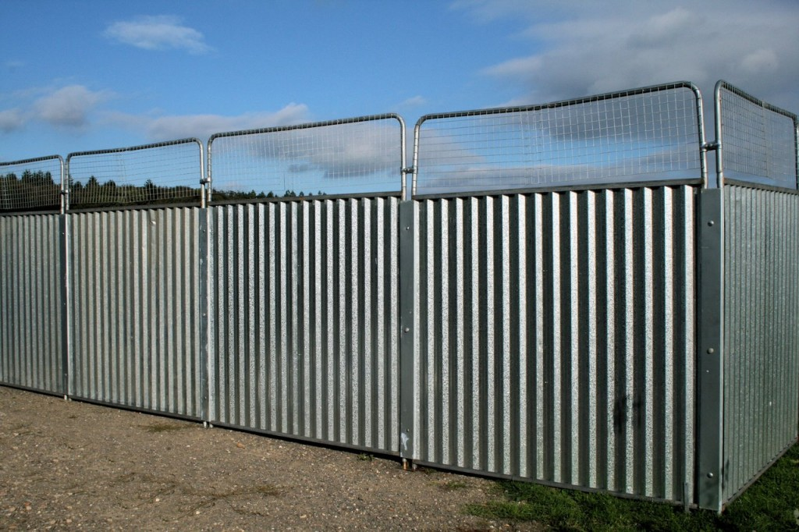

3. How is the provision of site electricity different from building electricity?

Electrical installation in buildings requires necessary design, planning taking into consideration the whole requirement of the activities to be carried out in the building. There are some steps to be follow such as:
- Layout of working drawings;
- Layout conduits for underground supply lines before concreting or paving;
- Physical marking of layout of wiring in all units/ rooms
- Providing and laying complete wiring
- Testing of installations
- Consumer meters to be provided
- Submission of test reports to electric supply company;
- Etc…

Site electricity is about providing electricity for power tools, lights, transformers used in sites to start and complete the project. These can be provided from diesel generators or other power suppliers specially designated at 110V;

REFERENCE:

www.hse.gov.uk

www.civilblog.org

www.healthyworkinglives.com

www.safesitefacilities.co.uk

Student Statement:

By submitting this assignment, I confirm that this is my own work.

Student Signature | Iordan baltatu | Date | 18.02.2018

For Tutor / Assessor Use Only
Total Marks
Marks Obtained
Percentage / Grade

