
Assignment Cover Sheet

Student Name: | Sarah Newman
Student Number: | 25954
Course: | Advance Diploma in Public Relations Level 5
Assignment NO: | 5

Marking Criteria:
We expect the learners to write minimum one well expressed point in three lines against each allocated mark. This means one needs to write 15 lines with 5 well expressed points to get high grades for a 5 marks question.
For high grades use examples and illustrations where appropriate.
1i. State the advantages magazines have as a medium for publicity.
Magazines can be dedicated to niche markets, businesses, professional groups and other industries meaning content can be targeted to the publics which the organisation wants to influence. A magazine can be used to inform external publics such as stocks and shareholders, suppliers or other public groups.
Magazines can be effective as a long-term, easy access reference material for people to read whenever they like. Readers may pass issues on to friends, they are read at doctor or dentist surgeries, inflight magazines are read by passengers and magazines are often left out for library visitors.
Stewart (1994) tells us of another advantage of using magazines as a publicity medium, which is that content can complement the magazine’s editorial calendar.
Larger publications create these for the benefit of advertisers who need to know which topics will be featured in which issues and it can therefore be possible to determine where a story might fit best. She also says that niche market magazines can have very loyal audiences, which gives messages in magazines an added advantage.
Features in a magazine can be a way of showing the personality of a company through its’ writing style and tone of voice.
And finally, magazines, especially weekly ones, have short lead times for features so they can be pitched to appear in an upcoming copy to complement the pace of the organisation, if a speedy method of communication is appropriate for the company’s goals.

1ii. State three essential criteria for the success of a news-release.
- Timing is the first essential criteria for the success of a news-release. It needs to be just right for it to be noticed as it will be competing with content from other organisations. It needs to be relevant for the key messages it wants to get across at that time. The date for release should be clearly indicated and it should be released in good time for publication, to help reporters deliver what the PR professional is aiming to achieve.

- The second essential criteria is keeping the news-release easy to use so it cuts through many other news releases and catches the eye of a reporter. It should have a compelling concise headline/subject line, an informative lead paragraph and be written in straightforward, informative writing. It should be newsworthy, error-free and be written in a good, journalistic style with a clear call to action. It should be brief and unambiguous and laid out clearly, with ample white space - ideally on one side of a page.

- Accuracy is the third essential criteria. Materials supplied to the media should be factual, clearly stating the name or organisation, address, and telephone number along with the sender's name and role plus details of accessible contacts and background information. It should be signed off/authorised by the right person in the organisation and it should also have extra, relevant facts and figures to help the reporter.

1iii. What do you understand related to mass media? Indicate some of the major media forms used by the publicists.
Wikipedia tells us that mass media refers to a ‘diverse array of ways to reach large audiences’. It’s a way to convey information or messages to big numbers of people who are scattered over large geographical areas. The type of media chosen for publicity will depend on the objectives of the communication, the nature of the audience, the budget available, and the content of the message.
There are variety of techniques available:
- Broadcast media transmits information electronically such as via films, radio, recorded music or TV.
- Digital media covers internet and mobile mass communication.
- Internet media includes services such as email, social media sites, websites and internet-based radio and television.
- Outdoor media are billboards; blimps; flying billboards (signs towed by planes); bus stops signs or posters placed inside and outside buses, commercial buildings, shops, sports stadiums, underground carriages or trains.
- Print media are books, comics, magazines, newspapers or pamphlets.
A PR practitioner needs a knowledge of all techniques to deploy them effectively. The method and timing chosen will be determined by the PR practitioner in consultation with the organisation’s management.

1iv. How can the radio be used as a publicity medium?
Radio can be deployed effectively to achieve the objectives of PR programmes with the added advantage that it is mobile compared to TV broadcasts. It can be used by people on the move and content can be localised to the area in which it is being broadcasted as well as targeted based on the genre of the radio show.

Through a good knowledge of the people a PR practitioner wants to reach, they can pinpoint the right radio show to use to reach a greater number of their publics.

Radio content can be a cost-effective publicity medium as there are fewer cast and crew costs and no printing costs. Radio can also be effective as listeners use their imagination to understand the message through the practitioner painting a picture for the listeners, which makes the communication land better. Radio content can be remembered by being funny, touching or via a catchy jingle or funny voice.
Radio news releases should be written in a style befitting radio without much editing by the announcer. If it’s newsworthy the items can be broadcast at intervals throughout the day reaching more people. Programmes can also be sponsored by companies who want to create publicity for their brands.

1v. What are the important pre-requisites for making a news clip for television?
The first step in preparing a new clip for TV is to pick a news topic that is relevant, timely and worth reporting.

The story can be presented in an “inverted pyramid” manner, with the most important news placed at the start and the not so important content below in descending order to enable the editor to quickly create the ideal sequence. After filming, add voice cast, music, and text to complete the news file. Another option is to send an edited already-made film with written scripts or instructions describing the components for a newsreader to read. The news clip should not be more than 90 seconds.

According to the BBC in Tips on how to make a video news report (2010), the steps to follow when creating a news clip are
- Keep it simple
- Plan how to start and end the report which keeps the story moving in the right direction
- Cover what, why, who, where and when
- Film the clip – with good sound - in five parts: introduction, first interview, second interview, extra shots and conclusion.

For crisis communications, media crews may approach an organisation to cover an event which the PR practitioner would assist by giving them background information about the crisis. Crisis content must also include management’s viewpoints.

1vi. What are the advantages and limitations of exhibitions as a public relations’ tool?
Exhibitions are among the most effective ways of communicating with the public and can be big international trade fairs or smaller, local community events.

According to Smit, L (2002) exhibitions are a tool to create awareness and enhance reputations. They are also a way of presenting products, organisations or services offered directly to the public with the intention of generating sales. They are designed to promote an organisation’s reputation and showcase its products and services to increase investment and profitability.

During exhibitions, interest is heightened leading to customers making further inquiries and placing orders in a relaxed environment. The attendees are likely to already be interested in the material being displayed so the audience is easily targeted with relevant content.

Limitations of exhibitions include the expense needed to set them up such as the high costs of booking facilities, arranging logistics and setting up catering and hospitality. Also, exhibitions are a way for competing firms to assess the performances of each other, so it may be an opportunity for an organisations’ competitors to find out more about the hosts.

1vii. What is 'Open House'? How is it conducted?
Organisations use open house sessions as a way of building stronger relationships with communities, stakeholders and the public. During open house sessions, companies invite visitors to have a tour of their facilities to see how things are done.

Open house sessions can showcase a company, a flagship property or a new set up or way of working to increase engagement, understanding, investment in and recruitment interest for the company.

To ensure a successful session, trained hosts should be available to answer questions and provide visitors with hospitality before or after the tour, whichever is the most appropriate.

The visitors can be escorted around the premises, meet some of the employees, attend talks about various aspects of the company and may be invited to join in a Q&A session. It is also common for companies which manufacture products to give away gifts to the visitors to promote goodwill.

2. Indicate some of the major tools of media relations
There are many tools in media relations and the type of tool chosen depends on the objectives of the publicity, the nature of the audience, the budget available and the content of the message to send.

The IPR (2002) tells us that some of the most common tools include Press releases, newsletters - or other printed/emailed material/literature - Public events, Social media and other technology, as well as TV and radio channels, all of which have been explored in more detail below:
The Press and press releases: The press can be an effective medium for sharing information with high impact. Many stakeholders such as governments, private and public sectors make use of this method to send information to their respective audiences.
Press releases are used to distribute news for organisations and are one of the oldest and most effective PR tools. The oldest press release is thought to have originated in 1906 after a train crash in New Jersey when the rail company’s publicity expert, Ivy Lee, issued a press release detailing what happened. It was published by newspapers in the way he wrote it and is believed to be the first of its’ kind.
Another method of using the press as a communication tool is through a letter to an Editor which can promote an organisation’s image. Editors also publish feedback from the public, especially letters having a strong point of view well argued.
To be effective and have a chance of cutting through with journalists, a press release needs to be interesting, factual, newsworthy and timely. They are used if no discussion between the media and the PR person is needed.
Wikipedia tells us that a press release is made up of nine structural elements –
- A letterhead or logo
- Media contact information such as name, number, email address etc
- A headline to grab attention
- A sub-headline that describes the news in more detail
- The dateline that has the release date
- An introduction that generally provides who, what, when, where and why
- The body of the news
- A boilerplate – generally a short "about" section, providing background on the issuing company, organization, or individual, and
- A close generally the "###" symbol or "ends".
A longer press release is an editorial or feature article which is a good way to provide publicity that promotes products and services of a company. Feature articles can also be used to highlight problems and recommend solutions from the organisation. It’s important that news features do not look like promoting sales or like an advert.

Alternatively, press briefings can be used to release important news to all media at the same time. Press briefings do not require the same elaborate arrangements as exhibitions or open houses. They can be used to clarify situations or events and to provide accurate information to press people. They can be used if the news is crucially important or requires discussion between the media and the PR person. It is important to have good ongoing relationship with the press, not only during press conferences, to establish friendly relationships.

Printed or emailed material/literature: Firstly, newsletters can be sent by post or by email and Wikipedia describes them as a report containing news of the activities of a business or an organisation that is sent regularly to all its members, customers, employees or people who are interested in the organisation or its’ products and services.

Newsletters generally contain one main topic of interest to its recipients and are a way of maintaining a strong relationship with the organisation’s public. They can take many different forms - product announcements, educational resources, company news, employee interviews and so on. Newsletters are a common way for PR specialists to share news and general information that may be of interest to the target audience rather than merely promoting products/services.

Other publicity literature comes in the form of house journals, brochures, booklets, annual reports and direct mail, etc. These are also used to inform the public about the company’s activities and to persuade them to use their services or products.
Brochures include pamphlets, flyers, or folders and is a multi-panelled page providing information on a subject. A booklet has more pages than a brochure and it is normally stapled and not folded. Reasons for using brochures and booklets include explaining a new concept, product or service; to promote sales indirectly or to ask for support or donations. Brochures and booklets are relatively cheap and quick to produce though can be costly to post out if that’s the distribution method.

Direct Mail is another media relations tool for written material, which can be addressed to a selected group of people. It is cost-effective and flexible as the messages can be increased or decreased depending on circumstances. Direct mail is personal, friendly and the PR professional can control the content and the time to send the message.

Public events: To attract public attention and keep publics engaged with an organisation or individual, PR professionals can take advantage of public events and the opportunity to speak publicly. This helps them to directly reach the public attending the event and indirectly reach a much larger audience. Kitchen (1997) describes corporate hospitality, and being involved in public speaking, to entertain and inform customers, distributors, suppliers, journalists, investors and other people who can help them in their business endeavours. It’s also a way to show the organisation’s human face.

A PR professional will prepare, and possibly deliver, formal speeches which are normally newsworthy and of interest to the public and quick ways to convey information. The speaker needs to be competent and media trained, able to deliver the messages in a well-controlled way and can grab the attention of the listeners. If the speech is in response to a crisis the speaker needs to be dignified and take the matter seriously. The time and venue should be arranged to ensure maximum effect.
Social media and other technologies: Social media networks are utilised by a growing number of PR professionals to set up a direct communication with the public, consumers, investors and other target groups.
These channels are highly interactive through which individuals, communities, and organisations can share, co-create, discuss, and modify user-generated content or pre-made content posted online. This can lead to high levels of engagement in an organisation and is a direct channel to ask questions and receive answers. It can be an effective communication tool for corporations, entrepreneurs, non-profit organizations, advocacy groups, political parties, and governments.
There are a variety of technology options to choose from such as email, teleconferencing, fax, intranet, instant messaging or video conferencing while locally based companies may rely mostly on posters, bulletin boards, and face to face contact. More firms are switching to new technologies because costs to use them are falling and they’re more readily available.
TV and radio channels: Information that is communicated as a part of a regular TV or radio programme achieves a much bigger impact than advertisements as, so the IPR (2002) tells us, most people consider this type of information more trustworthy and meaningful.
TV is an important tool for mass publicity because it appeals to all senses. It also creates dramatic effect and arouses interest and can serve as an ideal way to communicate news about an organisation to a wide audience. The news is usually supplied by the PR professional to a representative from the TV station or PR may be approached by the TV station to provide them with feature news. For crisis communications TV crews may approach an organisation to cover the event and the PR professional would assist by providing background information about the crisis.

To prepare publicity material for TV it’s important to pick a news topic that is worth reporting and select a producer to film the event. The news clip should be no more than 90 seconds and presented in an “inverted pyramid” manner i.e. the most important news at the start and the not so important ones placed below in descending order. The editor can then quickly create the ideal sequence. Another option is to send an already-made film with written scripts or instructions for a newsreader to read.

Radio can also be used effectively to achieve the objectives of PR programmes with the added advantage that it is mobile compared to the TV. News releases should be written in a style befitting radio without much editing by the announcer. Radio programmes may also be sponsored by the companies to create publicity for their brands.

Q3. Activity – (a) Read the illustration provided of news items accompanying the section on Press Release. Now, look through some issues of national or financial dailies for spotting news-items based on news releases.
From the Sunday Express, 12 May 2019:
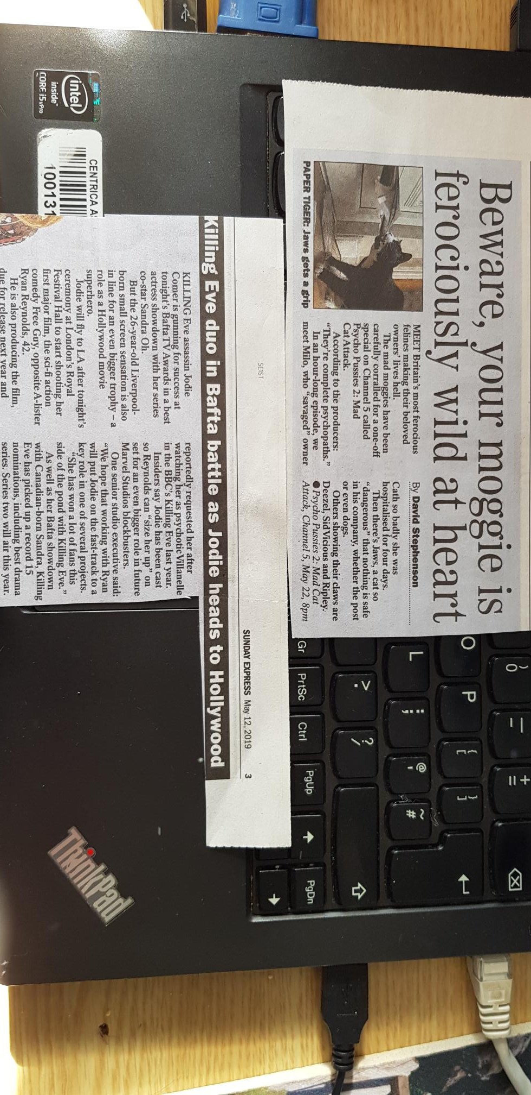
Page 3 - Killing Eve duo in Bafta battle as Jodie heads to Hollywood. This article appears to have been based on a press release. It has been published in time for the Bafta’s (the evening of May 12th), it’s a short article being c.250 words, it raises awareness of new films including a future Marvel Studios blockbuster - the brand of Marvel comic heroes which is undergoing great success - and it also draws attention to the next series of Killing Eve that will air this year.

Page 18 – Beware your moggie is ferociously wild at heart. This article raises awareness of a TV show coming up on May 22nd. It explains what the show is about, it makes it sound interesting and unusual, it names the cats on the show to personalise them and make it more appealing to the readers and it provides the day, channel and time the show will be broadcast.
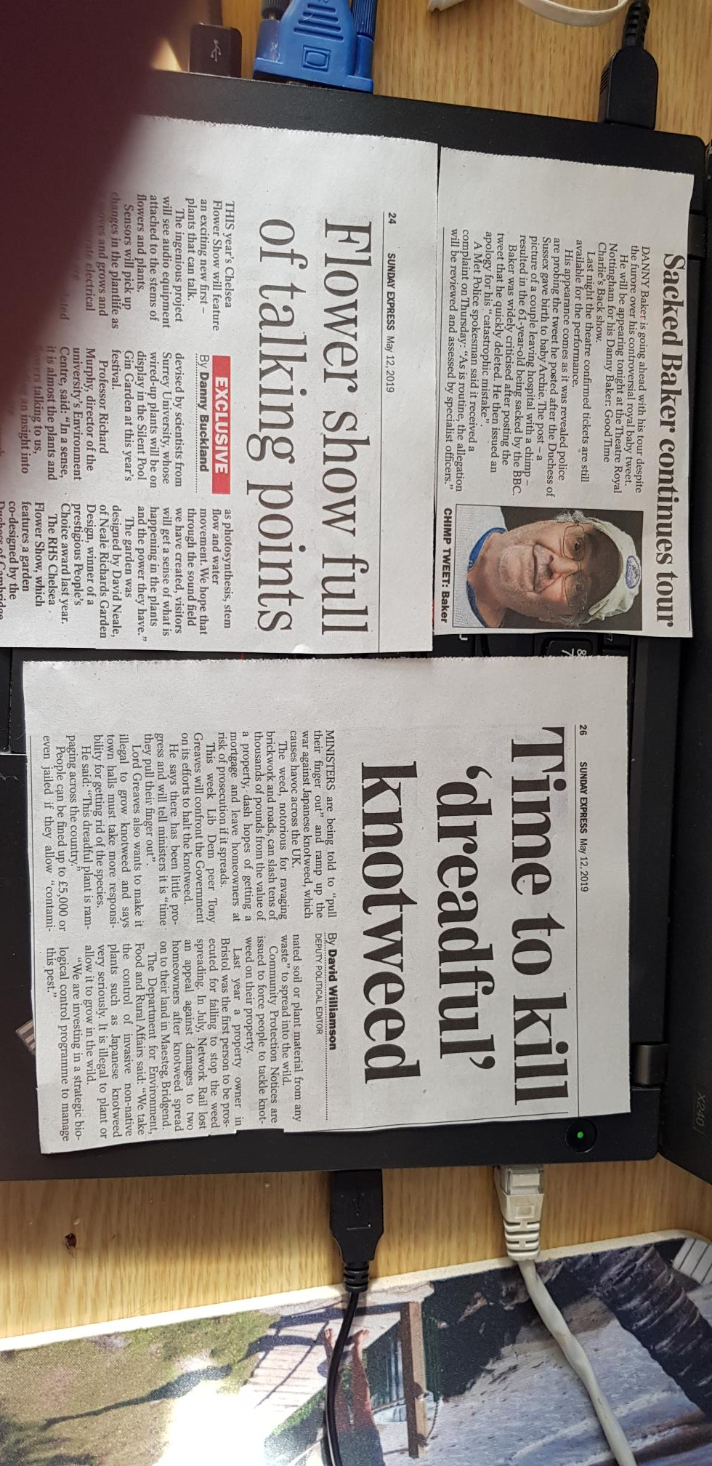

Page 12 – Sacked Baker continues tour. This press release appears to have been provided by Danny Baker’s agent or by the theatre where his tour taking place. The article confirms he is still on tour despite being sacked, tickets are still on sale and it contains a reminder of the controversial tweet he created with a summary of his apology.

Page 24 – Flower show full of talking points. This article tells us about a feature at this year’s Chelsea Flower Show. It’s been printed in good time for the show that runs later in May. It contains a quote from a professor which adds to its’ credibility. It tells us that the designer won an award last year which gives more authority and creates more interest in his 2019 show, and the article provides the dates the flower show will be open.

Page 26 - Time to kill ‘dreadful’ knotweed. This article would appear to be a press release from the Lib Dems. It talks about an issue they are confronting the Department for environment, food and rural affairs on this week so it’s timely. It has a quote from a Lord to give it more trustworthiness. It recaps the legal side of the knotweed issue i.e. “people can be fined” and recaps recent court cases to increase the impression of the seriousness of the issue.

And from The Independent online, 120519:
Volunteer police constable, 74, catches 29-year-old criminal after foot chase through gardens. This article tells of successful police work following criminal activity. It celebrates a volunteer police officer in a way that could inspire new recruits. It has a quote from a senior Essex police manager to add gravitas.

ITV blames Brexit for tumbling ad sales. This article appears to be from ITV as, while it says profits are falling, it talks about ITVs plans to strengthen itself and reminds readers of several upcoming TV series that are expected to be successful. It carries statistics to support the point it’s making. It has quotes from a chief executive which has been balanced with a quote from an equity analyst. It gives, what is seen as, an honest account of ITV’s financial position and their clear plans for recovery.

Climate crisis: Germany, Italy and Poland reject call for net zero emissions by 2050, leaked paper indicates. This article talks about a paper put together by eight European countries about climate change. It is timely as it is reported ahead of a summit in the coming week. It has facts and figures to give it added credibility. It has quotes from senior representatives balanced with quotes from environment campaigners.

(b) Make a list of news-worthy events for an organisation on which news releases could be sent.
Kathleen Hanover (2019) tells us that the new business thrives on headlines like "newest," "biggest," "fastest," "smallest," "deadliest" and so forth. She says news is what is new, unique or different.
Examples of these are listed here:
- Starting a new business or introducing a new product which will interest the public and entice them to find out more, hopefully buying the products or services.
- Celebrating an anniversary or major milestone, or receiving an award, or being recognised through the company, product or executives – all of which demonstrates strength in their field of expertise and can build confidence.
- Introducing a unique strategy/approach, or announcing a reorg or restructure, or opening up/closing branches or offices, or expanding/reducing the business – all of which show the company is future focused and garners a sense of trust, honesty and confidence in the actions the company needs to take.
- Changing the company or product name which will help the public make the transition with the organisation.
- Issuing a statement of a company’s position on a local, regional or national issue shows its position, demonstrates its values and shows what the company wants to support.
- Announcing a public appearance on television, radio or in person which will appeal to the people who like the company/executive involved and may also get the attention those who don’t.
- Launching a website or technological tool which can help customers more easily reach the company.
- Gaining a new, significant or celebrity customer or executive to the board will give a feeling of trust and security in the company.
- Establishing a unique vendor agreement or strategic partnership demonstrates growth and forward-looking plans.
- Announcing the results of research or surveys the company has conducted to show their expertise in an area.
- Sponsoring a charity, workshop, seminar or a show on TV or radio can bring the company into the day to day world of their publics, and people can see how their interests are aligned to the company’s.
- Making public statements about a political issue or future business trends will show the company’s standpoint on issues and what it supports.
References
- http://news.bbc.co.uk/1/hi/school_report/resources_for_teachers/8472052.stm viewed 060519
- Brentwood Open Learning college. Public Relations tools and methods 5.
- Hanover, P (2019) When and why should you send out a press-release
- https://www.independent.co.uk/news/uk/home-news/police-chase-volunteer-74-benfleet-essex-basildon-crown-court-keith-smith-a8910361.html viewed 120519
- https://www.independent.co.uk/news/business/news/itv-advert-sales-brexit-love-island-broadcasting-revenues-a8904261.html viewed 120519
- https://www.independent.co.uk/environment/climate-change-environment-eu-brexit-germany-italy-poland-net-zero-emissions-leak-a8904541.html viewed 120519
- http://www.ipr.org.uk/pr-tools-and-techniques.html viewed 100519
- Kitchen, PJ (1997) Public Relations principles and practise
- Stewart, J (1994) Pros and Cons of Free Publicity in Newspapers, Magazines
- Smit, L (2002) Exhibitions - a public relations tool
- https://en.wikipedia.org/wiki/Press_release viewed 100519
- https://en.wikipedia.org/wiki/Mass_media viewed 060519

Student Statement:

By submitting this assignment, I confirm that this is my own work.

Student Signature | Sarah Newman | Date | 14/05/19

For Tutor / Assessor Use Only
Total Marks
Marks Obtained
Percentage / Grade

