
Assignment Cover Sheet

Student Name: | Valodia Amaral
Student Number:
Course: | Advanced Diploma in Logistics and Supply Chain Management
Assignment NO: | 2

Marking Criteria:
We expect the learners to write minimum one well expressed point in three lines against each allocated mark. This means one needs to write 15 lines with 5 well expressed points to get high grades for a 5 marks question.
For high grades use examples and illustrations where appropriate.
Please insert your completed assignment ( in word format) here:

Assignment : 2 1. Give short answers for the following questions:
I. Outline the activities involved in logistics.
Activities Involved In Logistics Logistics is all about mobility of materials and their storage via supply chain. It includes the following activities if you inspect the supply chain.
o Procurement or Purchasing. o Inward Transport Or Traffic o Receiving o Warehousing Or Stores
o Stock Control o Order Picking o Materials Handling o Outward Transport o Physical Distribution Management o Recycling, Returns, and Waste Disposal o Location o Communication
II. what is meant by term ‘ cross docking ’ ?
Cross docking is a logistics procedure where products from a supplier or manufacturing plant are distributed directly to a customer or retail chain with marginal to no handling or storage time. Cross docking takes place in a distribution docking terminal; usually consisting of trucks and dock doors on two (inbound and outbound) sides with minimal storage space. The name ‘cross docking’ explains the process of receiving products through an inbound dock and then transferring them across the dock to the outbound transportation dock
In simple terms, inbound products arrive through transportation such as trucks/trailers, and are allocated to a receiving dock on one side of the ‘cross dock’ terminal. Once the inbound transportation has been docked its products can be moved either directly or indirectly to the outbound destinations; they can be unloaded, sorted and screened to identify their end destinations. After being sorted, products are moved to
the other end of the ‘cross dock’ terminal via a forklift, conveyor belt, pallet truck or another means of transportation to their destined outbound dock. When the outbound transportation has been loaded, the products can then make their way to customers.
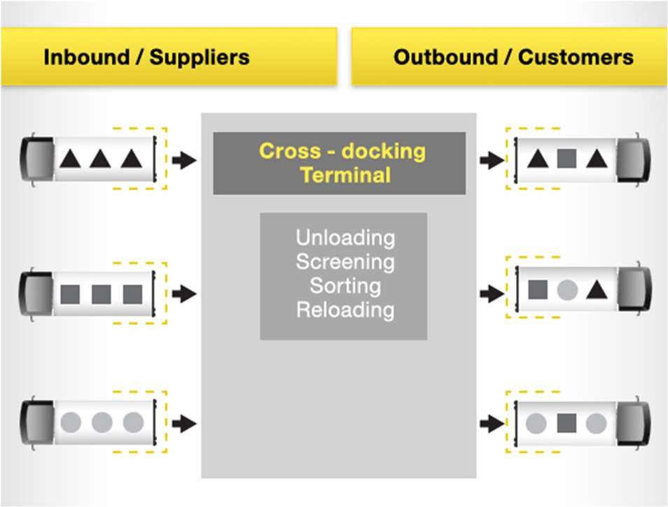
- Briefly describe the main aims of logistics. Logistics looks after the entire supply chain. This function is also termed as supply chain management. Researchers have been debating upon the scope of logistics and supply chain management, since long. Usually logistics is supposed to have narrower scope having being restricted to a single organization than supplies chain management that is supposed to be associated to more than one related organizations. However, this paper will refer the both as same. This assumption has also been taken by Institute of Logistics and Transport that has given the following official definitions.
- Which Activities are included in stock control procedures? Activities which are included in stock control procedures are regulations for inventory. It also monitors the stored material, the overall cost, stock level, order timing, customer service, order sizes, and so on
- What is the importance of communication in supply chain ? Along with flow of materials, the smooth flow of communication is also essential. The entire supply chain runs through communication and passing information regarding customer demands, products, need of material movement, stock levels, problems, timings, costs, and so on. According to many logistics managers, maintain the coordination and communication for effective movement of goods is very challenging. Many researchers and authors have described supply chain as the processing of information not just movement of materials. Sometimes other activities like sales forecasting, customer service management, production scheduling, third party operations, overseas liaison and so on can also be included in logistics. The boundaries should be clear between functions, but there is a need to recognise that they all work together to result in an efficient flow of materials.
- How are logistic activities organised in different sizes of organisations? Logistics in organisations appear in different forms. The arrangement of activities varies from organization to organization but there is without doubt no single ‘best’ way. The scale of logistics activities also depends upon scale of organization. A small organization might have just one person to look after the things while in large scale organization, over hundreds of workers might be there under the department. Sometimes, organizations that lack physical and financial resources for in house logistics department outsource this function to outside third parties.
VII. How do logistics affect the price of products?
Logistics can actually justify the pricing of products by ensuing that it is readily available in the market, speedy delivery and shorter lead time. Thus it helps to make organization’s appealing products to get premium price It should be noted the first two indicators were related to lower current assets while the other three were related to higher profit. These indicators together raise ROA and have positive impacts on share price, borrowing and ROI.
- “Logistics are essential for every organisation.” Discuss this. Logistics is the backbone for any organization as without it no movement of material occurs, no production is achieved, no product is delivered and thus it leads to zero customer satisfaction. The logistics related costs vary from material to material type, however by using latest logistics technologies; cost can be reduced to minimum.
- What are some ways in which logistics can improve on issues related to environmental protection? There is rising concern about, water pollution, air pollution, energy consumption, urban expansion, and waste dumping. Logistics does not hold a good standing for environmental safety – demonstrated by the releases from weighty Lorries, employment of green field locations for warehouses, calls for new road building, utilization of wide-ranging packaging, ships unlawfully flushing their energy tanks, oil spillages from tanker accidents, and so on. On the optimistic side, logistics is shifting to ‘greener’ practices. Businesses use more energy efficient means of transport, control drain emissions, recycle packaging, switch to environment friendly options of transport, boost recycling through reverse logistics, add security features to ships, expand brown- field sites, and so on. They ever more make out that careful administration can bring both ecological protection and lesser costs. A fair evaluation may be that logistics is making development on environmental issues, but it would need some time.
Case Study
- a) Why do all the logistics costs seem to be rising at the same time when the quantity of the order is reduced? ‘Because It is more efficient to transport larger quantities in to the company’. ‘If quantities reduce the average order size, the transport costs will rise. As we have to pay for expensive express deliveries of materials that production classify as urgent. If lower the order size, there will be more shortages ,more express deliveries and even higher costs.
- b) What do you think are the basic problems in McDonald Timbers? According to me the basic problems in McDonald Timbers are
  - poor sales forecasts by the marketing department .
  - seriously underestimated demand.
  - planned production is too low . c) What would you recommend Christo do? I would recommend Christo to do following things
    - He should be aware from all the updates of McDonald Timbers.
    - Christo should keep him update from the sales and transportation. • He should keep in touch with company workers as well as customers.

Student Statement:

By submitting this assignment, I confirm that this is my own work.

Student Signature | Valodia Amaral | Date | 6/05/2019

For Tutor / Assessor Use Only
Total Marks
Marks Obtained
Percentage / Grade

