
Assignment Cover Sheet

Student Name: | Andrew Fisher
Student Number: | 28049
Course: | Advanced Diploma in Construction Management Level 5
Assignment NO: | Assignment 10

Marking Criteria: We expect the learners to write minimum one well expressed point in three lines against each allocated mark. This means one needs to write 15 lines with 5 well expressed points to get high grades for a 5 marks question.
For high grades use examples and illustrations where appropriate.
In the construction industry a large part of our costs for into materials and equipment, getting the right price and the right time is critical.

Getting the right supplier(vendor) is also critical as the better the supply, the less the downtime. Vendor management is about creating a relationship with suppliers, monitoring them and getting the best possible deal for each project.
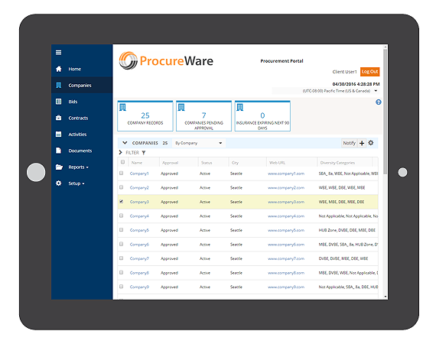

1. Due Diligence Standards
Know the supplier with whom you are doing business. Determine their good standing and licensing to conduct business. Learn about their reputation and gather documents to show they are a well-managed and compliant operation.

2. Assess the risk
As you gather the various due diligence documents, start looking for gaps or areas that may cause concern. Use a rating system to be objective and consistent. Where you identify risks, determine what you can do to address and minimize exposure.

3. Ongoing Monitoring
- How will you manage this vendor going forward?
- Are there performance metrics that will require regular reporting?
- Is there some sort of quality of service you need to measure?

4. Contract Standardization
Be sure that the vendor has certain obligations, such as notifying you of a breach or changes in ownership. Make sure each party’s roles and responsibilities to one another are clearly defined.

5. Board Involvement
Senior management and the board of directors must be kept informed of the status of your vendor management program. Inform, seek guidance and approval when needed.

Vendor rating
We will always have good suppliers and poor suppliers and some will make mistakes on occasion. The only true way to identify who is right on each occasion is by creating a table or rating system which can put the better suppliers to the top and the poorer suppliers to the bottom using previous experience and gathered evidence.
A data base with prices, previous supply experience locality would be the ideal way of doing this as the QS can quickly chose the more suitable supplier based on these principals.

ISO 9001 is the most widely recognised quality management system standard in the world. It demonstrates your organisation’s commitment to supplying a product or service that consistently meets your customers’ requirements.
UKAS accredited ISO 9001 certification is frequently a condition of being a supplier to large companies, Local Government departments or Government funded bodies (e.g. NHS, MOD).
The emphasis of ISO 9001:2015 is on maintaining well defined operating processes and striving to continually improve what you do – to the benefit of your customers, your staff and your organisation. It does not require you to change any of your operating processes but simply ensure that they are consistent and controlled.
A good Quality Management System is built around the business and not around the standard. It should be easy to maintain and set up so you can focus on your business needs and not on ISO 9001.
The ISO 9001 process provides a robust framework for improving every organisation’s quality system by adopting seven quality management principles:
- Customer focus
- Leadership
- Engagement of people
- Process approach
- Improvement
- Evidence-based decision-making
- Relationship management

https://www.isoinabox.co.uk/ 2019

In the UK we have a legal responsibility to abide by all laws. These laws are there to protect. Materials and equipment come with their own risks and may need to be covered by legislation. Companies have to follow contracts, abide by planning laws and building control.
The dangers of equipment and materials need to be known by those purchasing and storing them to keep those in contact safe, this may mean stores personnel may need extra training and licenses to handle these items.

Question ('Training is the best method to shorten the learning curve." Discuss)
Although I agree training reduces the learning curve, not all people learn in the same way. Some students on a course may learn more and become more proficient by hands on the job training while others may be able to complete training in a classroom before getting hands on. Training needs to be planned in the right way, skill scans and pre assessments are paramount to a successful training course. For most the training first method works but not for all. When we learn about procedures, material attributes, equipment use and the actual vendor management system, we can make more informed decisions on the correct materials, how they are used, the availability and costs, this can reduce overall site costs and quicken the job by having proficient workers use the material to its best. We also need to consider previous experience, abilities and complexity of the items to be mastered as site personnel may struggle to learn the new systems. Once proficient then we need to keep up assessment to prevent complacency.

Student Statement:

By submitting this assignment, I confirm that this is my own work.

Student Signature | A M Fisher | Date | 15/11/2019

For Tutor / Assessor Use Only
Total Marks
Marks Obtained
Percentage / Grade

