
Assignment Cover Sheet

Student Name: | Mrs Amanda Fallon
Student Number: | 6659
Course: | Diploma level 4 Business and Administration
Assignment NO: | Assessment 7

Marking Criteria:
We expect the learners to write minimum one well expressed point in three lines against each allocated mark. This means one needs to write 15 lines with 5 well expressed points to get high grades for a 5 marks question.
For high grades use examples and illustrations where appropriate.
Please insert your completed assignment ( in word format) here:

ASSESSMENT 7
i/ Discuss the relationship between time management and the effective performance of individuals in an organisation.
Time management is the process of planning and exercising conscious control over the amount of time spent on specific activities - especially to increase effectiveness, efficiency or productivity.
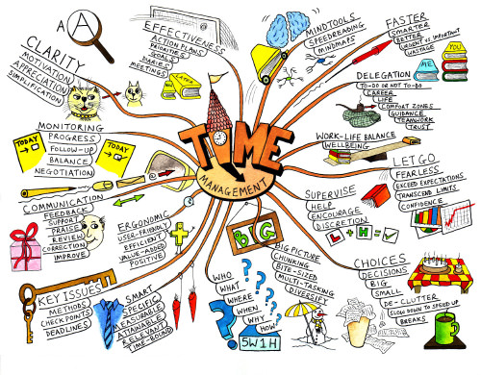
Time is valuable and limited and therefore needs to be used wisely. People who use good time management techniques will achieve more each day in the most efficient way. Therefore goals need to be set to achieve the needs of the business and prioritising the tasks necessary to accomplish them. This is the planning process. If a person knows what is expected of them on a daily basis and the time constraints to do each job then they should be able to prioritise the workload, to effectively achieve all that is expected of them. They should also be able to put up a do not disturb sign if work has to be done urgently. By using your time in the correct manner, you will be more efficient, you will achieve more each day and in a more relaxed manner, helping your work colleagues to meet their deadlines as well. You should always take the first half hour of every day to plan your activities for the day and you should also allow for interruptions within the day. If you didn’t manage your time appropriately, you will forget important events, you will hold up production lines, you will constantly feel under pressure and all of this will affect your job role efficiency, which in turn could affect the company reputation. Time management can affect job performance, by not having enough time to manage all the workload a person can become stressed and company deadlines can be missed, which in turn affects the company’s reputation. Staff who feel in control of their time will be more satisfied within their job role.

ii/ How do managers use appropriate skills to resolve the conflicts?
Conflicts mean: to come into collision or disagreement; becontradictory, at variance, or in opposition; clash: to fight or contend; do battle.a fight, battle, or struggle, especially a prolonged struggle; strife. Controversy, quarrel. Conflicts between parties, discord of action, feeling, or effect, antagonism or opposition, as of interests or principals, conflict of ideas. A striking together, collision, incompatibility or interference, as of one idea, desire, event or activity with another, a conflict in the schedule.

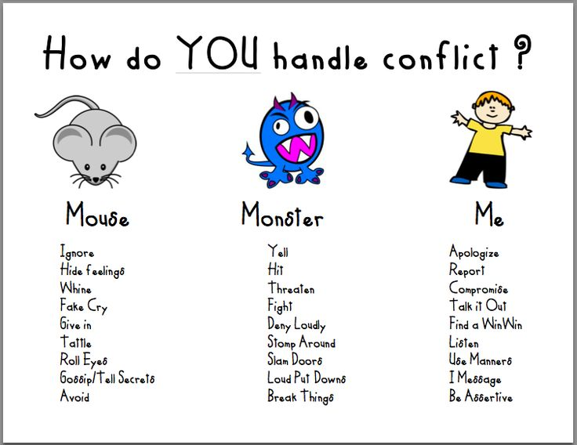

Managers can deal with conflicts in many ways but the best way to resolve the conflict is to listen to each party without discrimination. They need to assess the situation and talk about it with each party. They then need to reach a decision that is in the interest of everyone concerned. When a conflict takes place people normally becoming loud, aggressive and tempers flare. The manager will need to help the people involved to separate their emotions from the problem and build a mutual respect and understanding in a cooperative way. The manager will need to be impartial and understand their differences so that each party feels respected and understood and their opinions valued. The manger must behave courteously and get everybody else to act in the same manner. The best way to do this is to follow a few steps: make sure good relationships are priorities, separate people from the problems, listen carefully to different interests, listen first, talk second, set out the facts, and explore a resolution together. If however time is of the essence (as in a crisis situation) a manager will need to show his authority and make quick decisions. He will need to stay calm in any situation and take charge immediately controlling the emergency, giving directions and keeping his team calm too. Hopefully by managing the crisis immediately the least amount of damage will be caused. With any conflict a manager needs to take control of the situation early to stop it from spiraling out of control and to keep good relationships within the team. He needs to use respectful discussion and negotiation and make it clear that people need to be able to work together happily and without resentment so that the team can function properly. All of this will need to be done within the company’s regulations and policies.

iii/ What is the importance of problem solving skills for managers?
Problem solving is: The process of working through details of a problem to reach a solution.
The process of finding solutions to difficult or complex issues.
Problem solving involves overcoming barriers or obstacles that prevent an achievement of the goals.
When you resolve conflict effectively, team members can develop a stronger mutual respect and a renewed faith in their ability to work together.
It expands people’s awareness and gives them an insight into how they can achieve their goals without undermining others.
It leads to an improved self-knowledge by making them examine their goals and expectations and by understanding others views

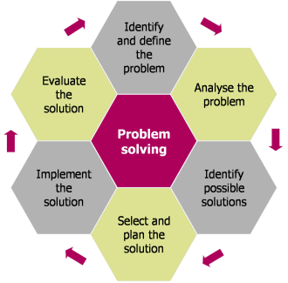
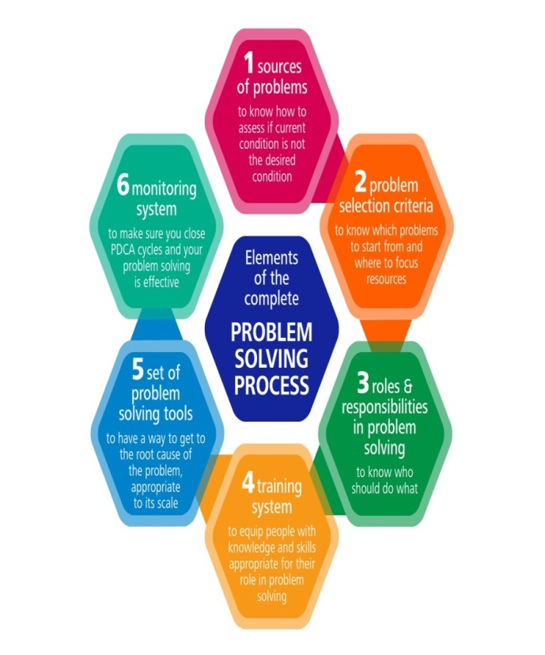
A good manager will have the ability to solve problems in the most effective manner, and in a calm manner, without these skills the workplace could become dysfunctional. The skills are essential for keeping harmony amongst the teams of workers and making them enjoy their job. If the skills are not used properly it could lead to staff walking out leading to a shortage of staff, which in turn could affect deadlines. If a problem is not sorted correctly the company may be sued by an employee or another company if a product or service is not delivered on time, this could then also cause a cash flow problem with invoices not being paid. It is therefore important to have problem solving skills to keep a harmonious workplace by making appropriate decisions. Problems can be large or small but it is important to find a solution to solve them. Solving problems will lead to success, it is therefore a good idea to have a good process in place to approach the problem and solve it quickly and effectively. Such as: define the problem, generate an alternative, evaluate and select alternatives and implement the solutions.

iv/ How does the good diary management support effective time management?
Diary management is: a personal record of daily events, appointments, observations, etc. a book for keeping such a record. An online diary such as Microsoft Outlook is generally used nowadays for work appointments.
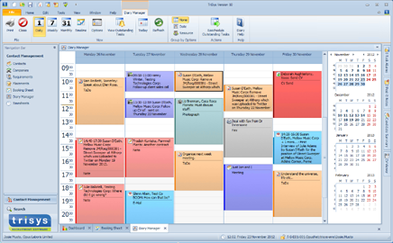

By having a diary system it is easy to see what your commitments are for the day, you can then prioritise any other work around the meetings already booked. Using a diary means that meetings are not missed and the correct amount of time is allocated to each appointment. It also allows others to book appointments for you in your absence and ensures nothing is double booked which would cause embarrassment. By keeping a diary you can effectively use your time each day, knowing exactly when and where you will be and for what purpose. This also helps with annual leave to ensure appointments aren’t booked whilst you are away. By keeping an up to date either in paper form or online allows you to allocate your time effectively without missing anything important and it also records important data such as telephone numbers, names and addresses. It can mean the difference of success or failure; because from the moment you wake how you spend your time will dictate how much money you will make and how much you will achieve. Some online diaries also have reminders about important events such as people’s birthdays which don’t need specific action but may need to be taken into consideration. By having colour coding for certain activities also helps with quick recognition and if you regularly meet with clients you can also book recurring meetings. You can also pencil in tentative appointments and set a reminder to confirm these. All of this will make sure you work effectively using your time wisely.

v/ How do you know when you are stressed?
Stress is: a state of mental or emotional strain or tension resulting from adverse or demanding circumstances. A state of mental tension and worry caused by problems in your life, work, etc. Something that causes strong feelings of worry or anxiety.
Stress is your body’s way of responding to any kind of demand or threat, the body’s defenses’ automatically go into what is known as fight or flight mode. Some stress can be good for you and helps you stay focused and alert. However beyond a certain point stress can be damaging to your health, your productivity, your relationships, your mood and your general quality of life. You will know when you are stressed because your mood will alter you will probably become snappy and argumentative and you will become tired as your sleep will be disrupted this will then lead to your work suffering as you will not be able to concentrate as clearly. You will start to make mistakes which could be costly and you won’t be working as efficiently. Your immune system will also be compromised causing you to be ill more frequently and you will possibly get a lot of headaches. Feeling constantly stressed and under pressure could make you start taking time off of work and perform poorly.

vi/ Outline the effective measures to control stress.
If you constantly find yourself feeling frazzled and overwhelmed then it’s time to take action by recognising symptoms and taking steps to reduce the stress causing it. Stress happens when you feel that the demands being placed on you (such as work) exceed your ability to cope.
The first thing you should do is tell your superior the issues you are having, they can then look at the situation and offer advice or help. They may be able to delegate some of your workload for example allowing you time to catch up.
Other ways to help control the stress are to simplify your to do list, prioritise your workload and stay flexible to possible changes. Try delegating some of your tasks. Make sure you plan the workload which helps with making the right choices which in turn leads to less stress.
Reflect upon past problems, stress issues look at how you managed the situation and decide if there was anything you could have done better if the situation arises again.
Then personal things you can do to help your own well-being are to laugh and spend time with friends and family, take regular exercise which releases endorphins and to avoid stimulants such as caffeine whilst having a balanced diet. Try to get as much sleep/rest as possible by doing this you will have more energy and a clearer mind to cope with the issues causing the stress and you need to lower your inner perfectionist. Also say No (where possible) to extra jobs being placed upon you. Sometimes you also have to learn to say no to outside pressures as well.

2. “Time management is, in part, a tool for stress reduction.” Discuss
If you manage your time correctly you will have a more balanced life. You will achieve more each day and in a more productive manner. The more you achieve the less stress you will suffer. If you manage your limited time in an efficient way you will not be up against it all the time and therefore your stress levels will be reduced. If you plan appointments etc you will know exactly where you should be and when, which in turn will mean you will allocate enough time to get everywhere and won’t be running late, again another stress cause. You must allow down time as well, this is important to keep a happy work life balance, by spending time on activities that you enjoy and resting. If you manage your time correctly you will be able to fulfil all the plans you have for the day effectively. You will achieve more and in the correct manner without too many mistakes. You should allow enough time for each job and prioritise. Allow yourself enough time in the morning to have a healthy breakfast and to get to work on time this starts the day stress free. You only have so many hours in each day so make a list of jobs to achieve and a list of relaxation activities, family time and sleep/rest. By doing this on a daily basis you will achieve all the set goals in a focussed, alert and calm way, achieving the best possible outcome. Time management allows to you to see what needs to be done, it what time scale and allows you to plan appropriately. It also shows you if you need to delegate or say no all of which helps to reduce the stress and stop you feeling overwhelmed.
Therefore time management is crucial to keep a person focussed, happy and de stressed.

CASE STUDY

i/ Identify and list Alison’s time management problems.
Alison doesn’t have a diary system to write in all of her activities either in a paper diary or on her phone/laptop.
Alison doesn’t allow for interruptions such as phone calls
Alison didn’t prioritise her assignment with her social life
Alison didn’t leave herself reminders to bring paperwork home from work
Alison wasn’t organised as she hadn’t done any preparation for the coursework and therefore left it until the last minute which meant she couldn’t get help from her tutor.
Alison was also stressed as she over slept and then didn’t have the proper nutrition for the day as she missed breakfast.
Alison also wasn’t taking care of her health over the weekend by skipping breakfast before softball and then celebrating late into the night
Alison began having negative thoughts about the assignment saying it wouldn’t be her best work as she would have to rush it.
Alison can’t say “no”

ii/ List five strategies and explain how Alison could use these to overcome her time management problems.
Firstly Alison should set herself up a diary management system of some sort. This could be a paper diary, an online Microsoft Outlook system or even a diary on her mobile phone. This would allow her to see exactly what she has planned for each day and will allow her to arrange study time and social time appropriately.
Alison should set her alarm several times or have another alarm clock to ensure she wakes on time and is not late for work, which in turn would reduce her stress of running for a missed bus and being late for work, which in turn makes the whole day start badly and she is then playing catch up from the start.
Alison needs to learn how to prioritise her work load and social life activities because her project should be at the top of the list as she has a fast approaching deadline. By making the assignment a priority it would allow her to finish the project on time to a high standard without rushing or stressing and allowing time for her to receive any help needed.
Alison needs to learn how to say “No” by saying no to visiting friends, she would have read her book on the Friday night and would therefore not be panicking about the completion and would therefore not be having negative thoughts about it not being her best work.
Alison could tell her friends that she has to complete an assignment so that they do not disturb unless there is an emergency. She could then switch her phone to silent mode to allow her to concentrate properly enabling the project completion.
If Alison did all of the above she would be an organised person using her time efficiently and effectively, she would achieve a good work/life balance with as little stress as possible. By being organised she would not be rushing in the morning which would aid her nutrition which in turn would keep her healthy and happy.

Student Statement:

By submitting this assignment, I confirm that this is my own work.

Student Signature | Amanda Fallon | Date | 13/06/17

For Tutor / Assessor Use Only
Total Marks
Marks Obtained
Percentage / Grade

