
Assignment Cover Sheet

Student Name:
Student Number: | 22628
Course: | Diploma in Wedding Planning Level 4
Assignment NO: | 1

Marking Criteria:
We expect the learners to write minimum one well expressed point in three lines against each allocated mark. This means one needs to write 15 lines with 5 well expressed points to get high grades for a 5 marks question.
For high grades use examples and illustrations where appropriate.
- Give short answers for the following questions: (15)

- What does wedding etiquette mean?
Wedding etiquette refers to a mandatory set of rules and practices dictated by either social convention or a authority pertaining to weddings.

ii. What is a sake - sharing ceremony and in which culture it is performed?
A sake-sharing ceremony is a traditional Japanese ceremony where both the bride and groom, together with their respective sets of parents, take three sips from three flat, stacked sake cups.

iii. Why is a civil ceremony important in Russia?
Russia does not recognise church weddings as being official, therefore vows must be exchanged at a Russian civil ceremony.

iv. Outline the main skills required to be a wedding planner.
- An honest sense of humour
- Sound organisational skills
- Strong interpersonal skills
- Imagination
- Persistence

v. What is the role and scope of wedding consultancy in the modern world?
The role and scope of a wedding consultant can be varied, oftern offering various comprehensive packages. This can involve simply offering advise to those who wish to take control of planning their own wedding or being responsible for in planing parts of or entire weddings.

- Write short notes on the following: (8)

- Traditional English Wedding Reception
English wedding receptions involve several traditions, taken from different periods of the countries history. The wedding cake will be a fruitcake filled with raisins, cherries, ground almonds and topped with marzipan. This is served to guests at the reception alongside a groom’s cake which originated in the Tudor period. Whilst this cake was traditionally served as a fruitcake, a more contemporary grooms cake will be usually made of chocolate.

A type of Victorian reception is known as a “ribbon pull” which involves the bridesmaids receiving a charm made of sterling silver which are connected by a ribbon. These are placed in between layers of the cake. The bridesmaids will gather and pull on one ribbon. This is to symbolise good fortune.

Another Tudor tradition was the tying of shoes to the back of wedding car. Traditionally, reception guests would throw shoes at the couple as they left the church as a symbol of good luck. Today, the shoes are simply tied to the honeymoon car. The English consider rain on a wedding day to be good luck.

- German Wedding Traditions
Traditional German celebrations last for three days. Prior to this, a civil ceremony must be conducted and is attended by only close family and friends. A large wedding reception will be held the following evening attended by a wide variety of guests. Old plates will be brought to be broken at the party as as sign of good luck. The married couple will then sweep the broken dishes together as a symbolic act that nothing else will ever be broken in their home again.

The religious wedding ceremony takes place on the third day. Traditionally, the bribe will have flower girls, but no bridesmaids. As the couple leave the chapel they would throw coins at the waiting children. Following the ceremony, another reception will be held, where the best man will “steal” the bride from the reception and take her to a local pub. Here they will drink champagne and wait until the groom finds them, at which point he must pay for all their drinks. Later in the evening the doors are blocked with garlands and ribbons by the couples friends. The groom will have to pay some kind of penalty in order to be able to leave with is bride. This normally takes the form of another party.

Activity Make a collage of pictures from old wedding magazines(or through search engines)showing wedding traditions and customs of different cultures.
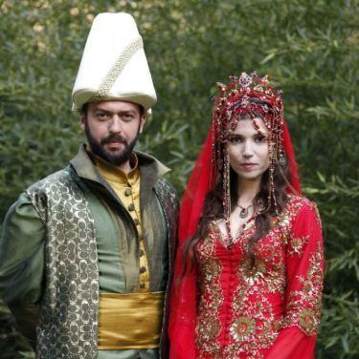

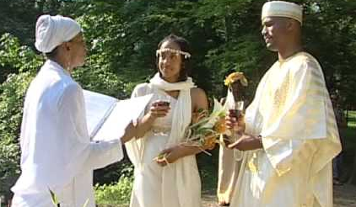


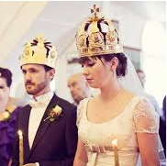

Student Statement:

By submitting this assignment, I confirm that this is my own work.

Student Signature | Lawrence Green | Date | 31/07/18

For Tutor / Assessor Use Only
Total Marks
Marks Obtained
Percentage / Grade

