Funmilayo Oshindele
Unit 1 assignment
- a. How did the First World War influence fashion? Which types of changes were brought about by it?

Ans :

Before the outbreak of the 1st World War, women wore narrow hem-lined skirts and corsets. Wide-brimmed hats were also fashionable then. The outbreak and length of the war (4 years), changed the way women dressed. Due to the shortage of materials, and the need for women to take over men’s jobs as their contribution towards the war effort, women’s clothing became more streamlined, simple and included trousers. Skirts became A-lined in imitation of the military uniform. Skirts also became shorter due to the shortage of materials. Thus allowing for ease of movement. The corsets were also discarded and replaced by the brassier and as a result of the shorter skirts worn by women, cami-knickers became popular. Evening gowns also became shorter.

The military look also gradually became part of clothing designs. Military style tunic jackets were worn, and belts and epaulets were used to accessorize jackets. Less jewellery were worn during this period and silk stockings were accepted as a symbol of luxury. Ladies wore low cut shoes, simple hats and hairstyles. By the end of the first World War, the lavish clothing of the Edwardian period was no longer acceptable.

b. Describe the characteristic feature of the 20th century’s fashion scheme.
Ans
The beginning of the 20th century, marked the end of the Victoria era, and the start of elongated dresses and skirts. Skirt silhouettes were slim at the hips with their fulness confined to below the knee. The 1900s also saw the popularity of the S-bend corset, which was worn to all occasions. This corset thrust the hips backward and the chest forward. The corset was worn with puffed filly blouses which were embroidered with extravagant decorations such as broad ribbon ties and lace collars.
The 1910s can be regarded as a decade of radical styles. The hobble skirt and lampshade came into fashion. Clothes were masculine and macho, though characterised by rich and exotic touches of flare. These Edwardian designs were also playful and innovative. There was less boning in the bodices, and early Art Deco inspired prints were popular. During this period, women wore short bob haircuts. They also wore skirts and dresses that were above the ankle. The fashion trend during this period was mainly influenced by the 1st World war, with women wearing military style double breasted jackets. The hobble skirt which was regarded as being very fashionable was worn by women until 1915.
The 1920s which were regarded as the Jazz or ‘flapper’ Era, can be described as the period during which the modern era of women’s fashion was introduced. During this period, there was an abandonment of the restricting fashion of past decades in favour of more comfortable clothing which enabled free movement. Skirts and trousers were made with attention being given to the comfort women craved. The constrictive clothing which were worn during the 1800s and early 1900s were abandoned in favour of loose breathable fabrics such as silk. Waistlines dropped and dresses became unfitted. Simplicity was the key, with hemlines rising within a 3 year period. Dresses were simple in construction but detailed. Accessories became popular with women using matching headbands, pearls and statement pieces. The “Cloche hat” which was initially invented in 1908 was brought back to the fashion scene .

Fashion in the 1930s was heavily influenced by the progress made in the 1920s. Clothes were relaxed and more daring until the great depression. The great depression of the 1930s, led to women moving backwards and wearing more conservative articles of clothing which emphasised traditional feminine features. Hemlines returned to their natural position. Zippers were used on clothes, whilst costume jewellery was popularised by Channel. By the late 1930s, shoulder pads became fashionable. This was the grand era for Haute Couture, with movies influencing women.
Fashion in the 1940s was heavily influenced by the 2nd World War. Fabrics such as silk, commonly used during the 1920s and 30s were discarded (due to shortages) in favour of cheaper materials, which were readily available. Clothes became more practical, masculine and rougher versions of the 1930s fashion. Clothes were made with the most minimal fabric, with few pleats and no trimmings. Skirts were little below the knees and straight. Blouses, jackets and dresses were fitted with shoulder pads. They were worn with boxy jackets and broad padded shoulders. The rationing of fabrics also led to women wearing shorter dresses (during the 1930s, dresses were mid-calf length. By the 2nd World War they had risen up to knee length). Necklines were square, slit, sweetheart, keyhole, shirred, cross-front or V. Dress tops were modest and revealed very little skin. Trousers became part of women’s clothing.
During the 1950s, the feminine shape and look re-emerged, and women’s figures were celebrated in clothing designs and accessories. The hourglass silhouette stayed. Clothes had tight waists and high hemlines. Conservative colours were discarded in favour of vibrant florals and repeating patterns were used to highlight a lady’s beauty and physic. The fashion trends of the 1950s set the tone for the classic and timeless looks which are still prevalent now.
Fashion trends in the 60s broke a lot of rules and allowed for fashion innovations that are still worn today. The decade was characterised by ladies wearing A-line dresses that showed off their legs and gave the illusion of extra height. During this decade clothes were made with vibrant prints, and ladies wore pearls, pillbox hats and go-go boots. The hippie look was embraced by the youths. They also had show stopping hairstyles.
Fashion in the 1970s was about individualism and the development of women’s fashion and fashion statements. Clothes were used as a symbol of independence and free thinking. Flared jeans and platform shoes characterised clothing styles this decade. Vibrant colours, psychedelic prints and chic vintage handbags also characterised the 70s. Fashion during this decade was further characterised with the mini skirts and bell-bottom pants popularised by hippies.
The 80s was the era of big hair and big shoulder pads, vibrant colours, silks and furs. This was the era of tights, leotards, sweatpants, velour tracksuits and ripped jeans. This was also the decade of power dressing, with ladies wearing power suits with big shoulder pads, designer wear and opulent dressing and high-heeled shoes. Fashion during this decade was funky and bright.
Fashion during the 1990s moved away from the opulence of the 80s. during this decade, fashion was characterised by the minimalist look. Fashion was influenced by rock and grunge music, with ladies wearing causal daywear such as jeans and T-shirts. The plaid was also used in mainstream fashion.
- Write brief note on the works of main fashion designers in the 1970s.
Ans:
Fashion during the 1970s introduced ideas and trends that became essential wardrobe items. Designs such as the wrap dress and pant suits were made popular by designers who are regarded as major icons in the fashion industry because of their ability to create influential works of art that left a major impression on the fashion industry. These designers include: Vivienne Westwood, Diane Von Furstenberg, Halston and Yves Saint Laurent.
Vivienne Westwood:- she is believed to be responsible for the merging of high fashion and punk. Westwood is a British designer who played a big role in punk rock’s influence on fashion both in the UK and USA. She began by designing clothes for the Punk boutique SEX (which was owned by Malcolm McLaren, manager of the Sex Pistols, with whom she was romantically involved) in the 1970s. Westwood is synonymous with bondage pants, platform shoes and punk.
Diane Von Furstenburg:- known for her 1972 creation of the kimono-inspired jersey wrap dress and making it a wardrobe staple. Although the wrap dress is regarded as her trademark design, she also helped establish the standard for ease and comfort in women’s clothing. She is regarded as the “most marketable since Coco Chanel.” In 2005, she was given a Council of Fashion Designers of America Lifetime Achievement Award.
Halston:- He is regarded as the definitive designer of the 1970s and was famous creating the draped jersey dresses and one-shoulder style dresses. Although he was famous for creating evening wears, he is also credited with the creation of the lean trouser suits and using ultra-suede fabrics for clothing lines. He designed turtlenecks, knitwear, sweaters, sweater sets, boxy square jackets and wide-legged jersey trousers. He is further regarded as one of the first major designers to license his name thus making his clothes accessible to everyone. He died in 1990.
Yves Saint Laurent:- He is credited with spurring couture’s rise from the ashes of the 60s as well as making ready-to-wear collections reputable. Laurent was able to adapt his style to reflect changes in fashion. His made women’s comfort a priority whilst ensuring they were elegantly attired. He introduced the tuxedo suit for women and brought non-European cultural references into his designs. He is further credited with making trousers an acceptable dress and work wear for women.

- How did the Nineteenth Century influence the fashion industry? What major changes came about in the fashion industry in the early Nineteenth century and why?
Ans ;
The industrial revolution was at its height during the 19th century and it had a profound influence on the fashion industry. Prior to industrialisation, clothing and fabrics were handmade for own use. Members of the working class made their clothing from homespun fibres, as they had neither the money nor the time to waste. For members of the working class, garments were patched, resized, remade and handed down until there was nothing left to use.
Members of the upper classes on the other hand could afford to and did use luxurious imported fabrics with elaborate adornments. They also employed skilled artisans to help beautify their fabrics. People owned a few outfits to get by and got a lot of use out of them. There wasn’t a business model for clothing because production time was lengthy.
Furthermore, fashion was practically none existent. Clothes were simply made. Ladies clothing consisted of low shouldered clothes that came together in a low waist, with bell shaped bottoms. Special outfits were made as off-shoulder. Light crocheted shawls were used as fashionable accessories.
The arrival of the industrial revolution changed everything. The revolution led to factory production of textiles and clothing. Machines that were capable of mass producing knitted and woven materials that were of finer gauge than could be produced on homespun looms were invented. This change led to cheaper clothing and allowed more dress makers to sell their products in shops thus leading to what can be termed the beginning of readymade clothing. Thus making lighter materials available for dress manufacturers. The invention of the sewing machine further made it possible to quickly produce articles of clothing.
As part of the industrial revolution, there was improvement in transportation, which made it possible to ship cloths cheaply and easily. Improvements in communication made it possible to see what fashionable people were wearing both in their country and abroad, and this made people more fashion conscious, leading to them purchasing clothes for style rather than necessity. These changes made manufactured clothing desirable and widely available at affordable prices.
Thus it can be concluded that the industrial revolution made people more fashion conscious and allowed them buy clothes for style rather than necessity.

Activity
Look through some old magazines; cut out pics showing the fashion trends of the last two decades. Also find some photos from the latest fashion shoots and compare them. How does modern fashion dresses differ from those of the past? Discuss in a report.

Ans : 1990s fashion
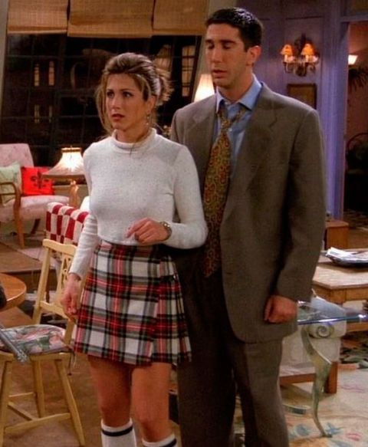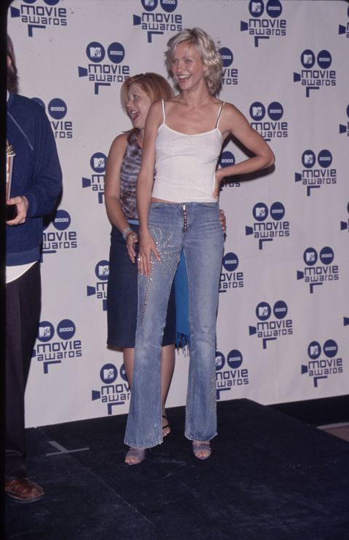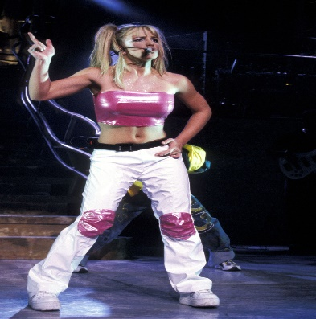
Tartan ruffle skirt Flared trousers Boob tube
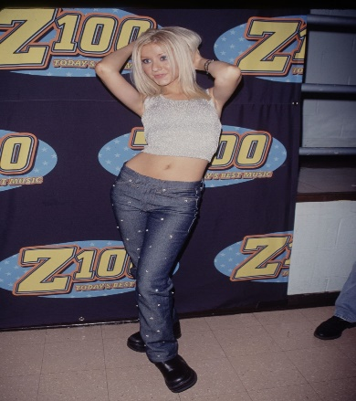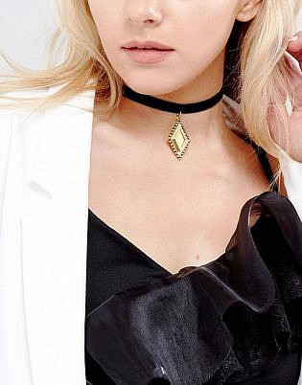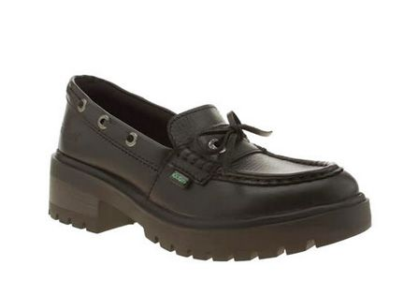
Hip huggers Chokers Kickers
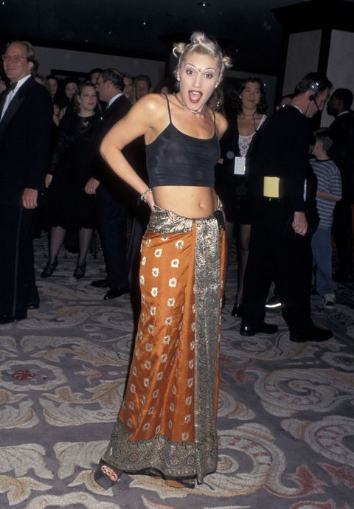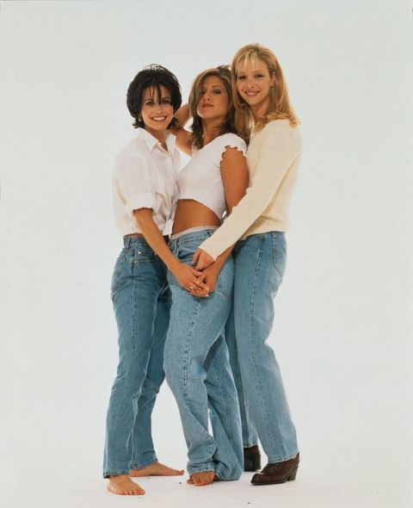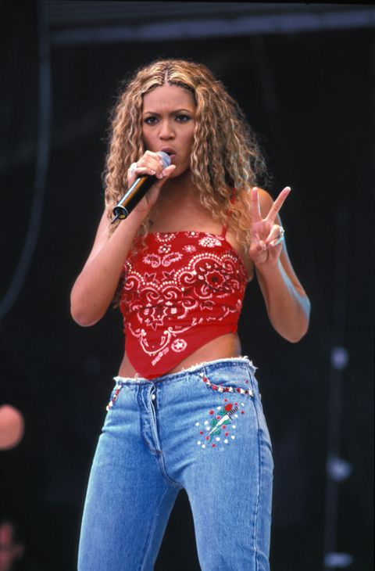
Sarong as skirts Baggy jeans Handkerchief tops

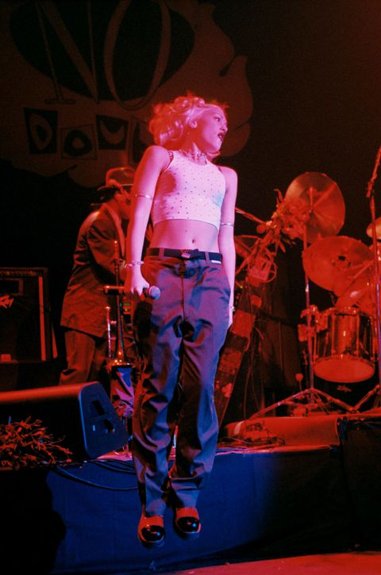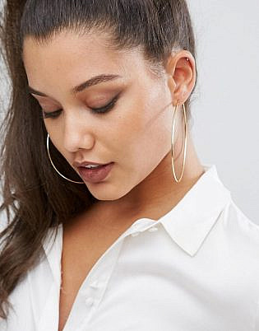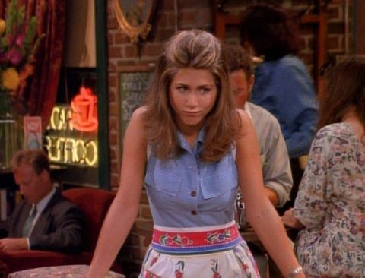
Cargo trousers Hoop earrings Denim
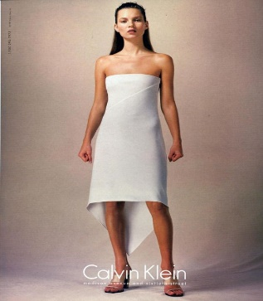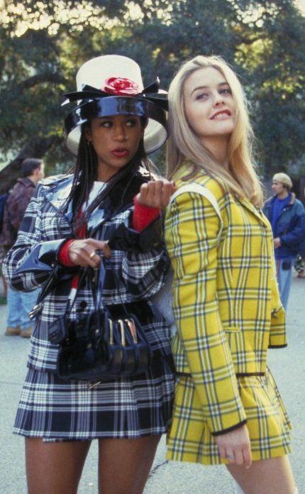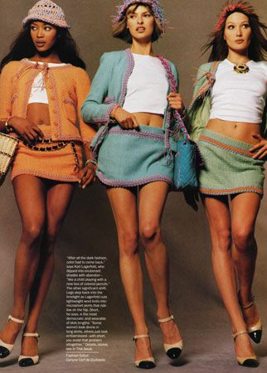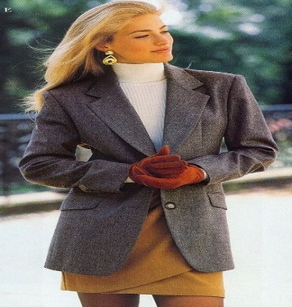
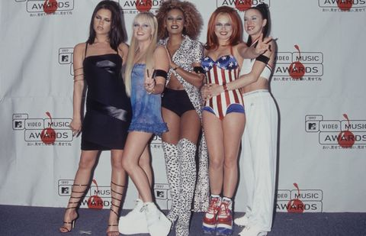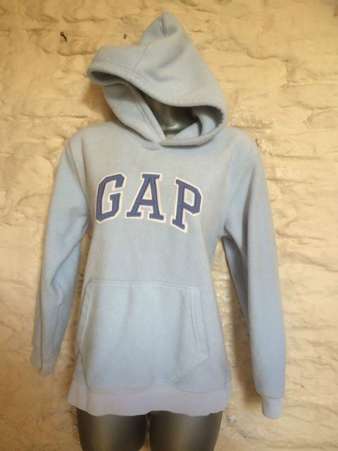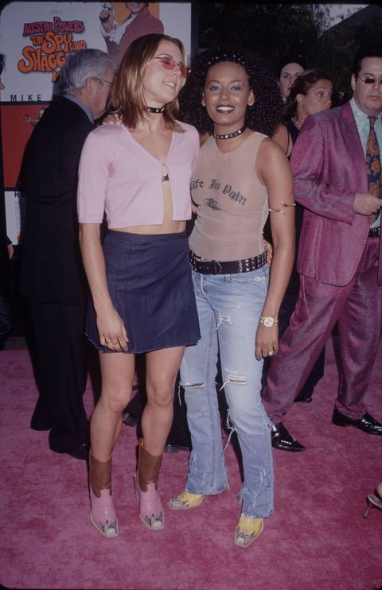
Platform trainers Gap Hoodies Studded belts
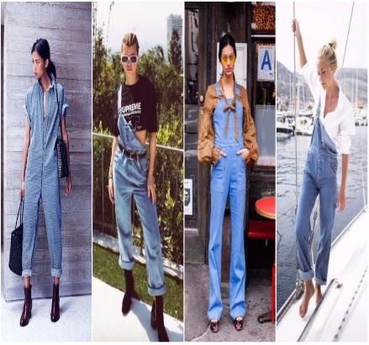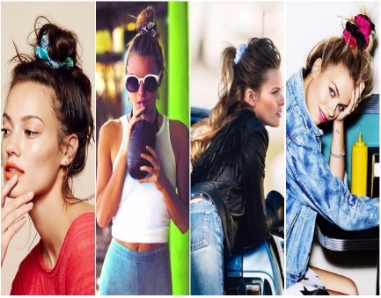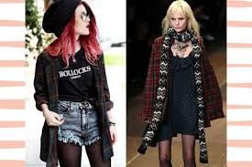
Denim overalls Scrunchies Grunge look

Fashion in the 2000s
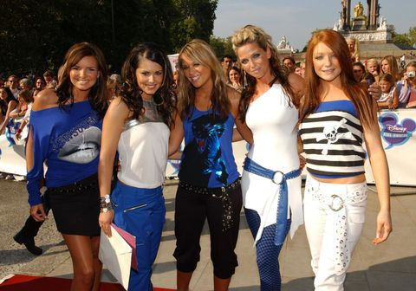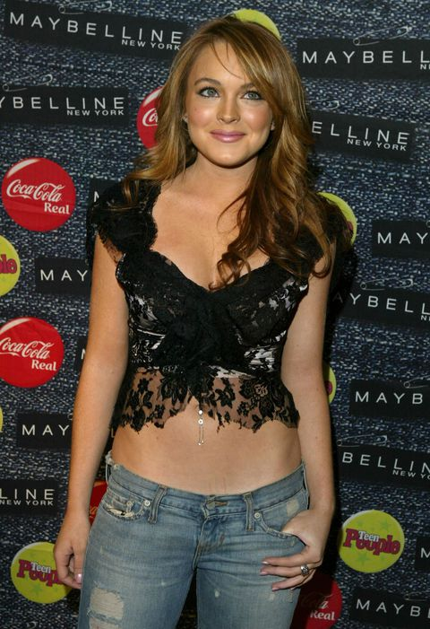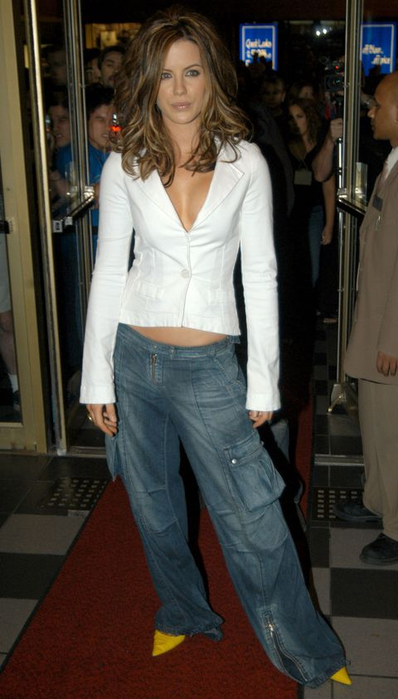
Low slung loop belts Belly button jewellery Denim cargo trousers

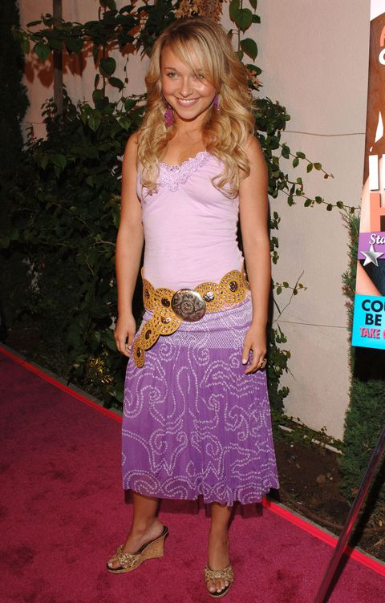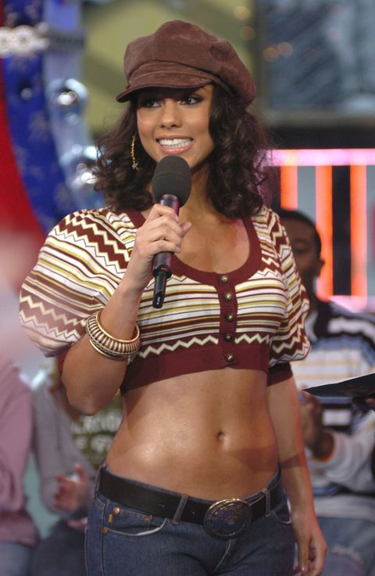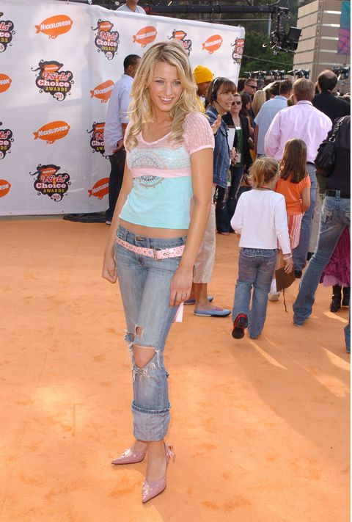
Disc belts Baker boy hats Hipster jeans
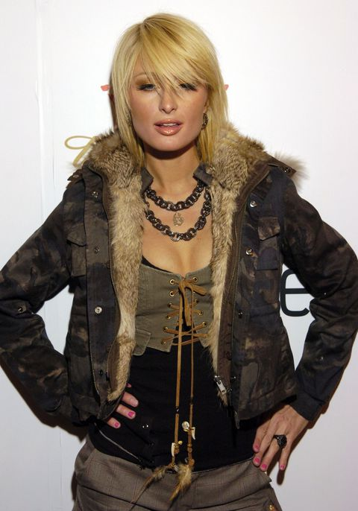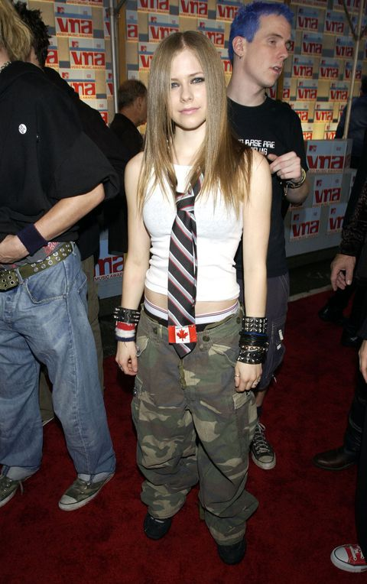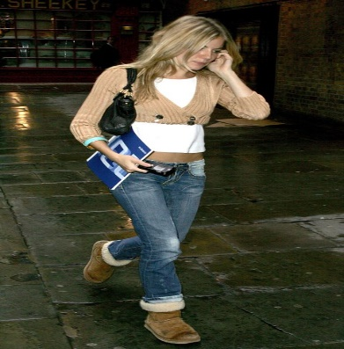
Camo: jackets, skirts, shirts etc Ties Cropped jumpers and cardigans

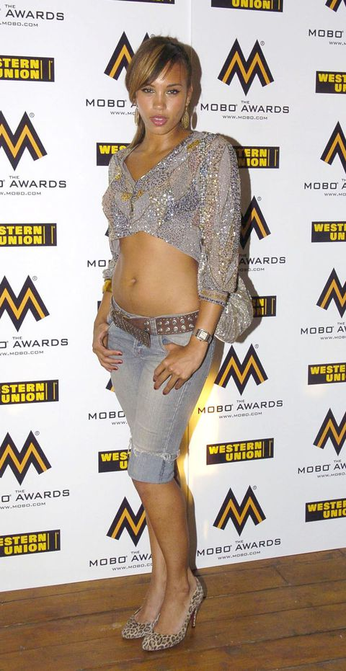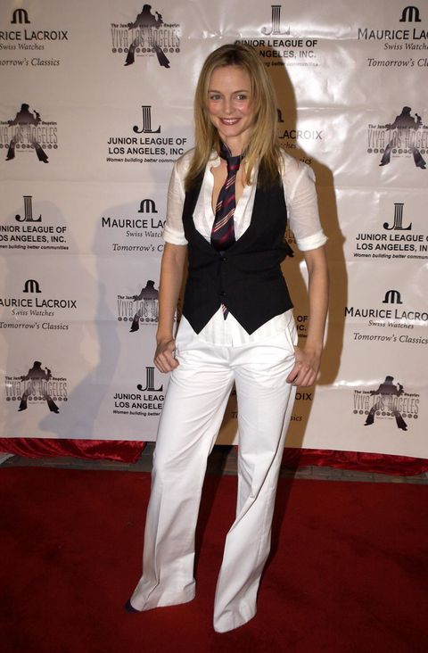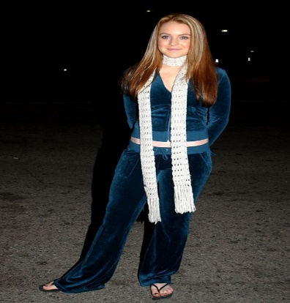
Pedal pushers Waist coats
Velour tracksuit and pointless scarves

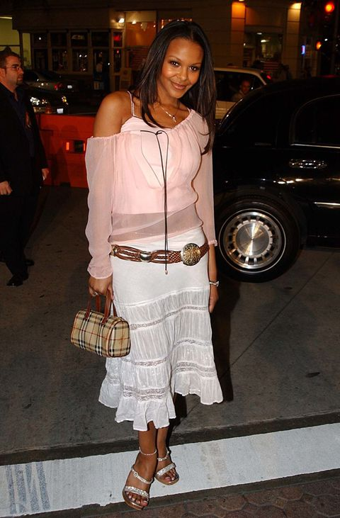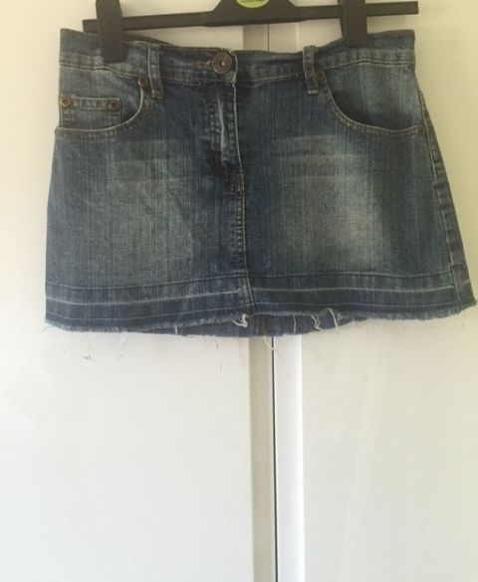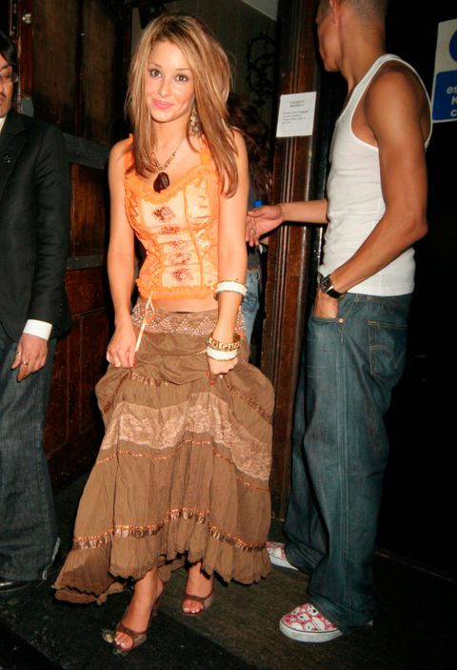
Gypsy skirts
Burberry – Hats, scarves and bags
Denim belt skits

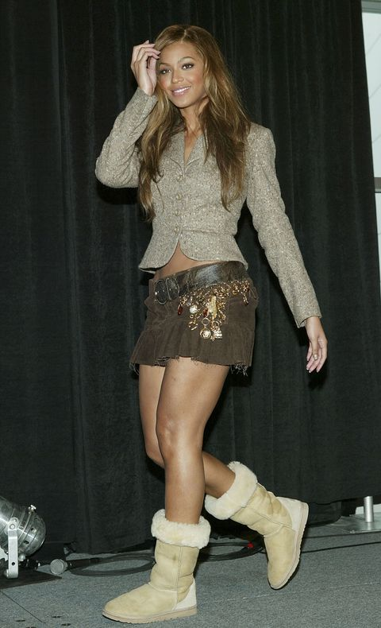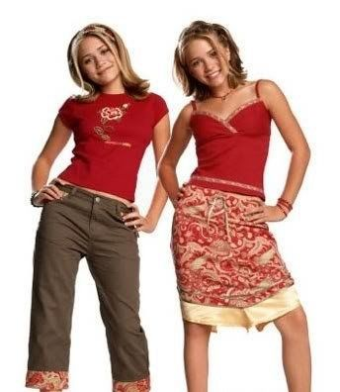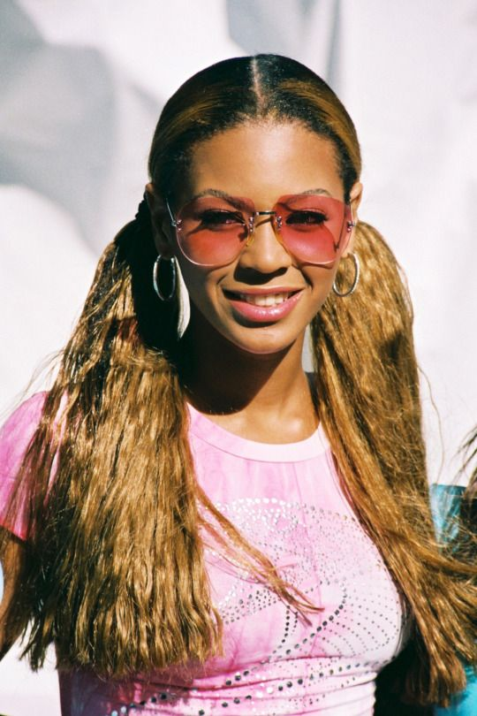
Ugg boots

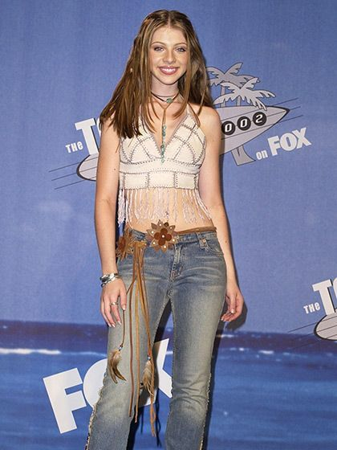

Latest fashion shoots
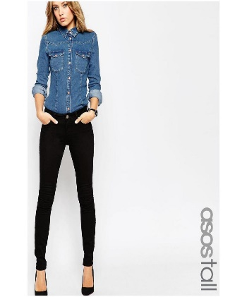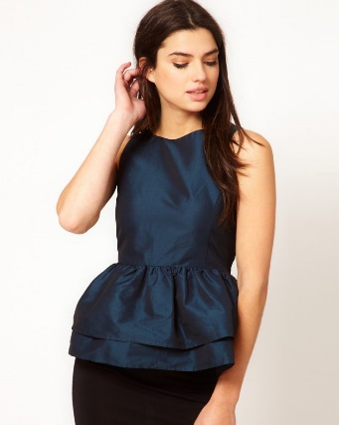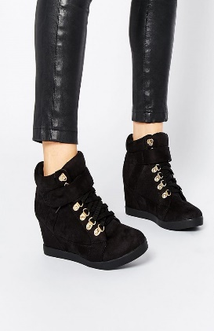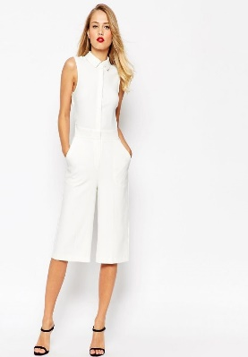
Skinny Jeans Peplum top Wedge sneakers All white outfit

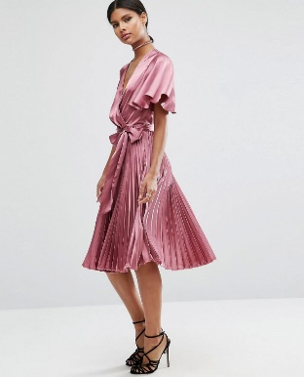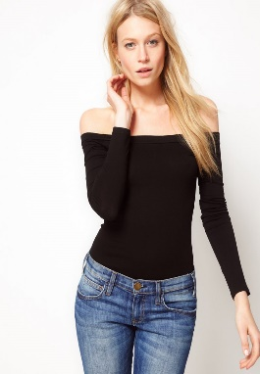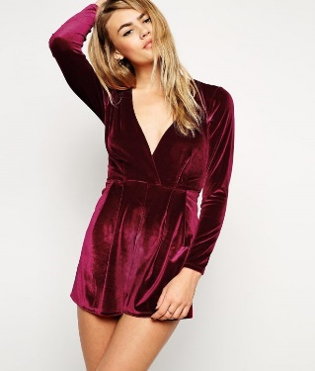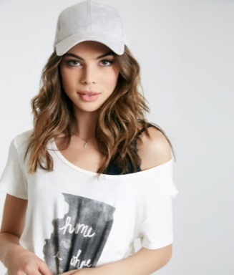
Pleated dress Off shoulder top Velvet dress Athleisure

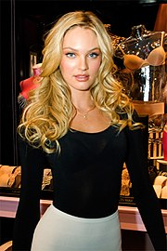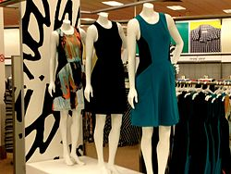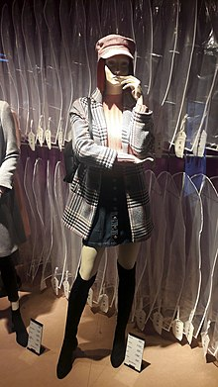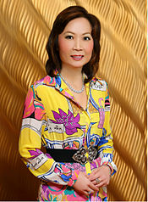

The 90s can be regarded as a later version of the 1960s, as the earlier decade had its first revival period during the 90s. Even though the loose and oversized silhouettes of the 80s remained, the 90s also embraced mini skirts, mini-dresses and tight clothes. The 90s also had some touches of space age fashion with a lot of white, metallic, ultra violet and references to cosmology.
As with all decades, different styles were true to different groups of people. To divide it roughly, the 90s had the elegant minimalistic fashion and the street style fashion. The former was about simplicity with clothes minus details, a colourless palette and silky fabrics but also some velvet and leather. The lines, and if details existed, were straight and geometric. The colours were mainly white, black, beige, grey and some tones of metallic. The clothes were rather defined and followed the silhouette of the body that should be slim and toned (the beauty ideal)..
As for the street style fashion it was quite the opposite. It was oversized, it was sporty, had some colours and an attitude. The most important material was denim but also leather and fleece. Light pastels were common, but black, white and denim were even bigger. In centre of the street style look was t-shirts with prints and oversized sweaters in a bold colour. Bomber jackets were a thing and same for the boots. The 90s were the first proper decade where sneakers got a major fashion status.
A third style one can define is the school girl style. Plaid, crop tops, high waisted mini skirts, knee socks and blazers. There was the turtlenecks and also denim overall if going for the leisure style. The style lands somewhere between elegant (but barely) and street style. A 90s perspective on the 1960s style with short lengths and high socks substituting for the A-line dress and knee high boots.
The 1960s part of the 1990s was all about the short mini skirts, dresses, crop tops and high knee socks. As explained earlier, the fashion had a touch of space with white, black, velvet, silver and metallic shades. Chokers were a major piece to count on and worked for the street style life as well. As for the street style fashion, denim jackets, bomber jackets, animal prints, oversized t-shirts, boots and also a fair share amount of crop tops. A lot of plaid as in plaid shirts and oversized sweaters. With the attitude. This was the grunge fashion.
As for the more elegant life. Slip dresses, blazers with matching miniskirts, and long coats were common. Often without prints, but houndstooth, some dots and funky prints were popular too. The office set of blazer and pencil skirt as we know it today, emerged from this decade. A basic blazer in a neutral shade hitting the hips and a matching pencil skirt hitting the knees and matching shoes. That set up is still a common go-to for people who work in an office environment. The elegant life had a lot in common with the 1980s empowered and elegant women with blazers, turtlenecks, gloves and gold details.
Instead of dividing the 00s into different styles, it’s easier to focus on the early years of the decade and the later years as that’s where the change happened. The early 2000s’ style is reminiscent of the late 90s in many ways with a lot of the styles being done, but in a more extreme version. The years began with sweet colours, glitter, denim and also activewear. The crop tops were shorter, the waist of skirts, shorts and pants was insanely low. (Low as in, it was trendy to let your underwear show). Halter neck tops and bandeaus in tropical prints or bright and awkward colours were a popular match.
There was also a sort of boho vibe with a lot of paisley patterns, asymmetrical tops and skirts and also a fair amount of maxi skirts. A kind of office wear was still trending, but done less formal. Like, trouser suits but with colourful tops underneath, or blazers but paired with distressed denim. A style that’s going for the office look but is matched with the cute style of the early 00s.
The late 00s saw a distinct change in fashion. Gone was the revealing fashion and here was the Tumblr fashion. This fashion style was made up of the hipster/grandpa/nerdy fashion including a lot of high waisted skirts with shirts, oversized glasses and scarves. The overall feeling was kind of a grandpa style with dove shades of peacock blue, forest green and orange. The fashion had a very fall vibe with a lot of knitted fabric and oversized silhouettes.
The early years of the 2000s saw clothes such as: crop tops, vests, blazers, halter neck tops, v-shaped jumpers, low waisted jeans and skirts. Layered tank tops in different colours were popular and were matched with cargo trousers. Popular accessories were: bandanas, sunnies and layered necklaces. Another major accessory, or statement, was the handbag and the designer logo. The early and mid of the 2000s saw an explosion of designer logos as they were a status symbol. They were on bags, scarves, belts, caps and on the clothes too. Another important accessory was the belt, it was focused and placed by the hips, this went for any outfit regardless if you wore a crop top or a dress over the jeans. The latter outfit was immensely popular and related to the emergence of asymmetrical fashion with skirts and tops going flowy.
The flowy life also worked for the bohemian style that was trending. A lot of crochet, maxi skirts, colourful clothes and prints were a must. Often with too many accessories as long necklaces, bracelets and a belt to go for the waist. The tunics, the vests and the maxi lengths all went for this style. Cargo trousers, or oversized ones in general, were common choices to pair with a tee shirt for daily wear. Office wear was mainly pinstripes, trouser suits, colourful tops and jumpers that were the go-to pieces. Often with shiny pumps and a statement bag to highlight it.
The Tumblr fashion and mainstream fashion emerged during the later half of the decade. 2008 can be regarded as its starting point. Lauren Conrad can be regarded as starting this trend with her basic, yet cute, style where she used cute skirts, blouses, blazers, dresses and tights. She went for skinny jeans most of the time and kept the fashion simple with a leather jacket, scarf or a trench. Often quite colourless and more in sophisticated shades of navy, beige and black. Flannel shirts grew in popularity and so did the use of boots and socks. Cardigans, as we know them today, also emerged and became a fashion staple to count on. The Tumblr version made it more cosy with fall colours and a lot of knitted pieces. Tights in lace or with a print, as in dots or hearts, were major!
Unlike the 1990s and 2000s that had a distinct style, such can not be said of the present fashion trends. Though, today’s fashion is not new, it is different from that of the last two decades. Most of the styles worn in this decade have been worn before but never channeled in this manner. Thus although off shoulder styles were worn in the 19th century, they were worn with statement sleeves. They weren’t worn as blouses, but as heavily embellished gowns. Also although the midi skirt was worn in the 40s, it was not worn in contemporary styles as silver metallic. Rather, it was worn in practical colours such as brown and green. Leather was worn in the 50s, but not in popping colours and embroidery but in classic black and sometimes white.
From this it can be seen that fashion now is more about eclecticism. With fashionistas taking elements from the past and mixing them with current trends to create something new. This mixing of the past with current trends gives the illusion that fashion is going backwards when in actual fact it is moving forward. The 90s and 2000s were focused in a certain direction. When elements of the past were taken, they were taken from a particular decade with little or no modifications. Thus fashion now accepts the use of styles from past decades without the wearer feeling out of place.
Thus the fact that designers are borrowing styles from previous decades, makes it more accepted to dress more eclectic. To take some influences of the boho style and add some edge by the leather jacket. Or take the distressed denim and go for a lace crop top. Fashion of today is about contrasting different elements from different styles and create something new from it.

