
Assignment Cover Sheet

Student Name: | Marta Grzybowska
Student Number: | 33374
Course: | Certificate in interior design
Assignment NO: | 02

Marking Criteria:
We expect the learners to write minimum one well expressed point in three lines against each allocated mark. This means one needs to write 15 lines with 5 well expressed points to get high grades for a 5 marks question.
For high grades use examples and illustrations where appropriate.
Please insert your completed assignment ( in word format) here:

- It is important to define what will be the function of the room so interior designer could plan a project. Sometimes they need to change the structure of the room, they also need to plan what furniture to place there, what kind of lightning fit in the room. Sometimes people do many different activities in one room so it is very important to plan the space so it will be as much functional as it can. For example kitchen is not only the space to cook but also place where all family eat their meals or where children do their homework.
- It is important to consider natural lightning which room receives to make a decision what colour to put on the walls and ceilings, what kind of artificial light to use, also what kind what colour of textiles and what textures to put into the room. It is very important because different dose of natural light can change our perception of seeing colour in interior. It is also important to know that the light will change during the day so it is very important to choose the right colour depending on which side of the house/flat the room is place, how big is the window. If the room is on the south side of the building we should choose a colder colours for the walls because sun light will be shining through the windows for most of the day and the light will make colours stronger. The room from the north side should be painted in more bright and warm colours because there is no sun light coming through the day. Cold colours would become gloomy.
When we are choosing colours for the room from the east side we have to consider that the sunlight will be shining on that side only in the morning, leaving room dark through the rest of the day so colours should be the same bright and warm. Room on the west side will look good in cold colours because warm ones would be to intense.

- In natural light colours of fabrics and walls seems to be more bright, cold and more intense.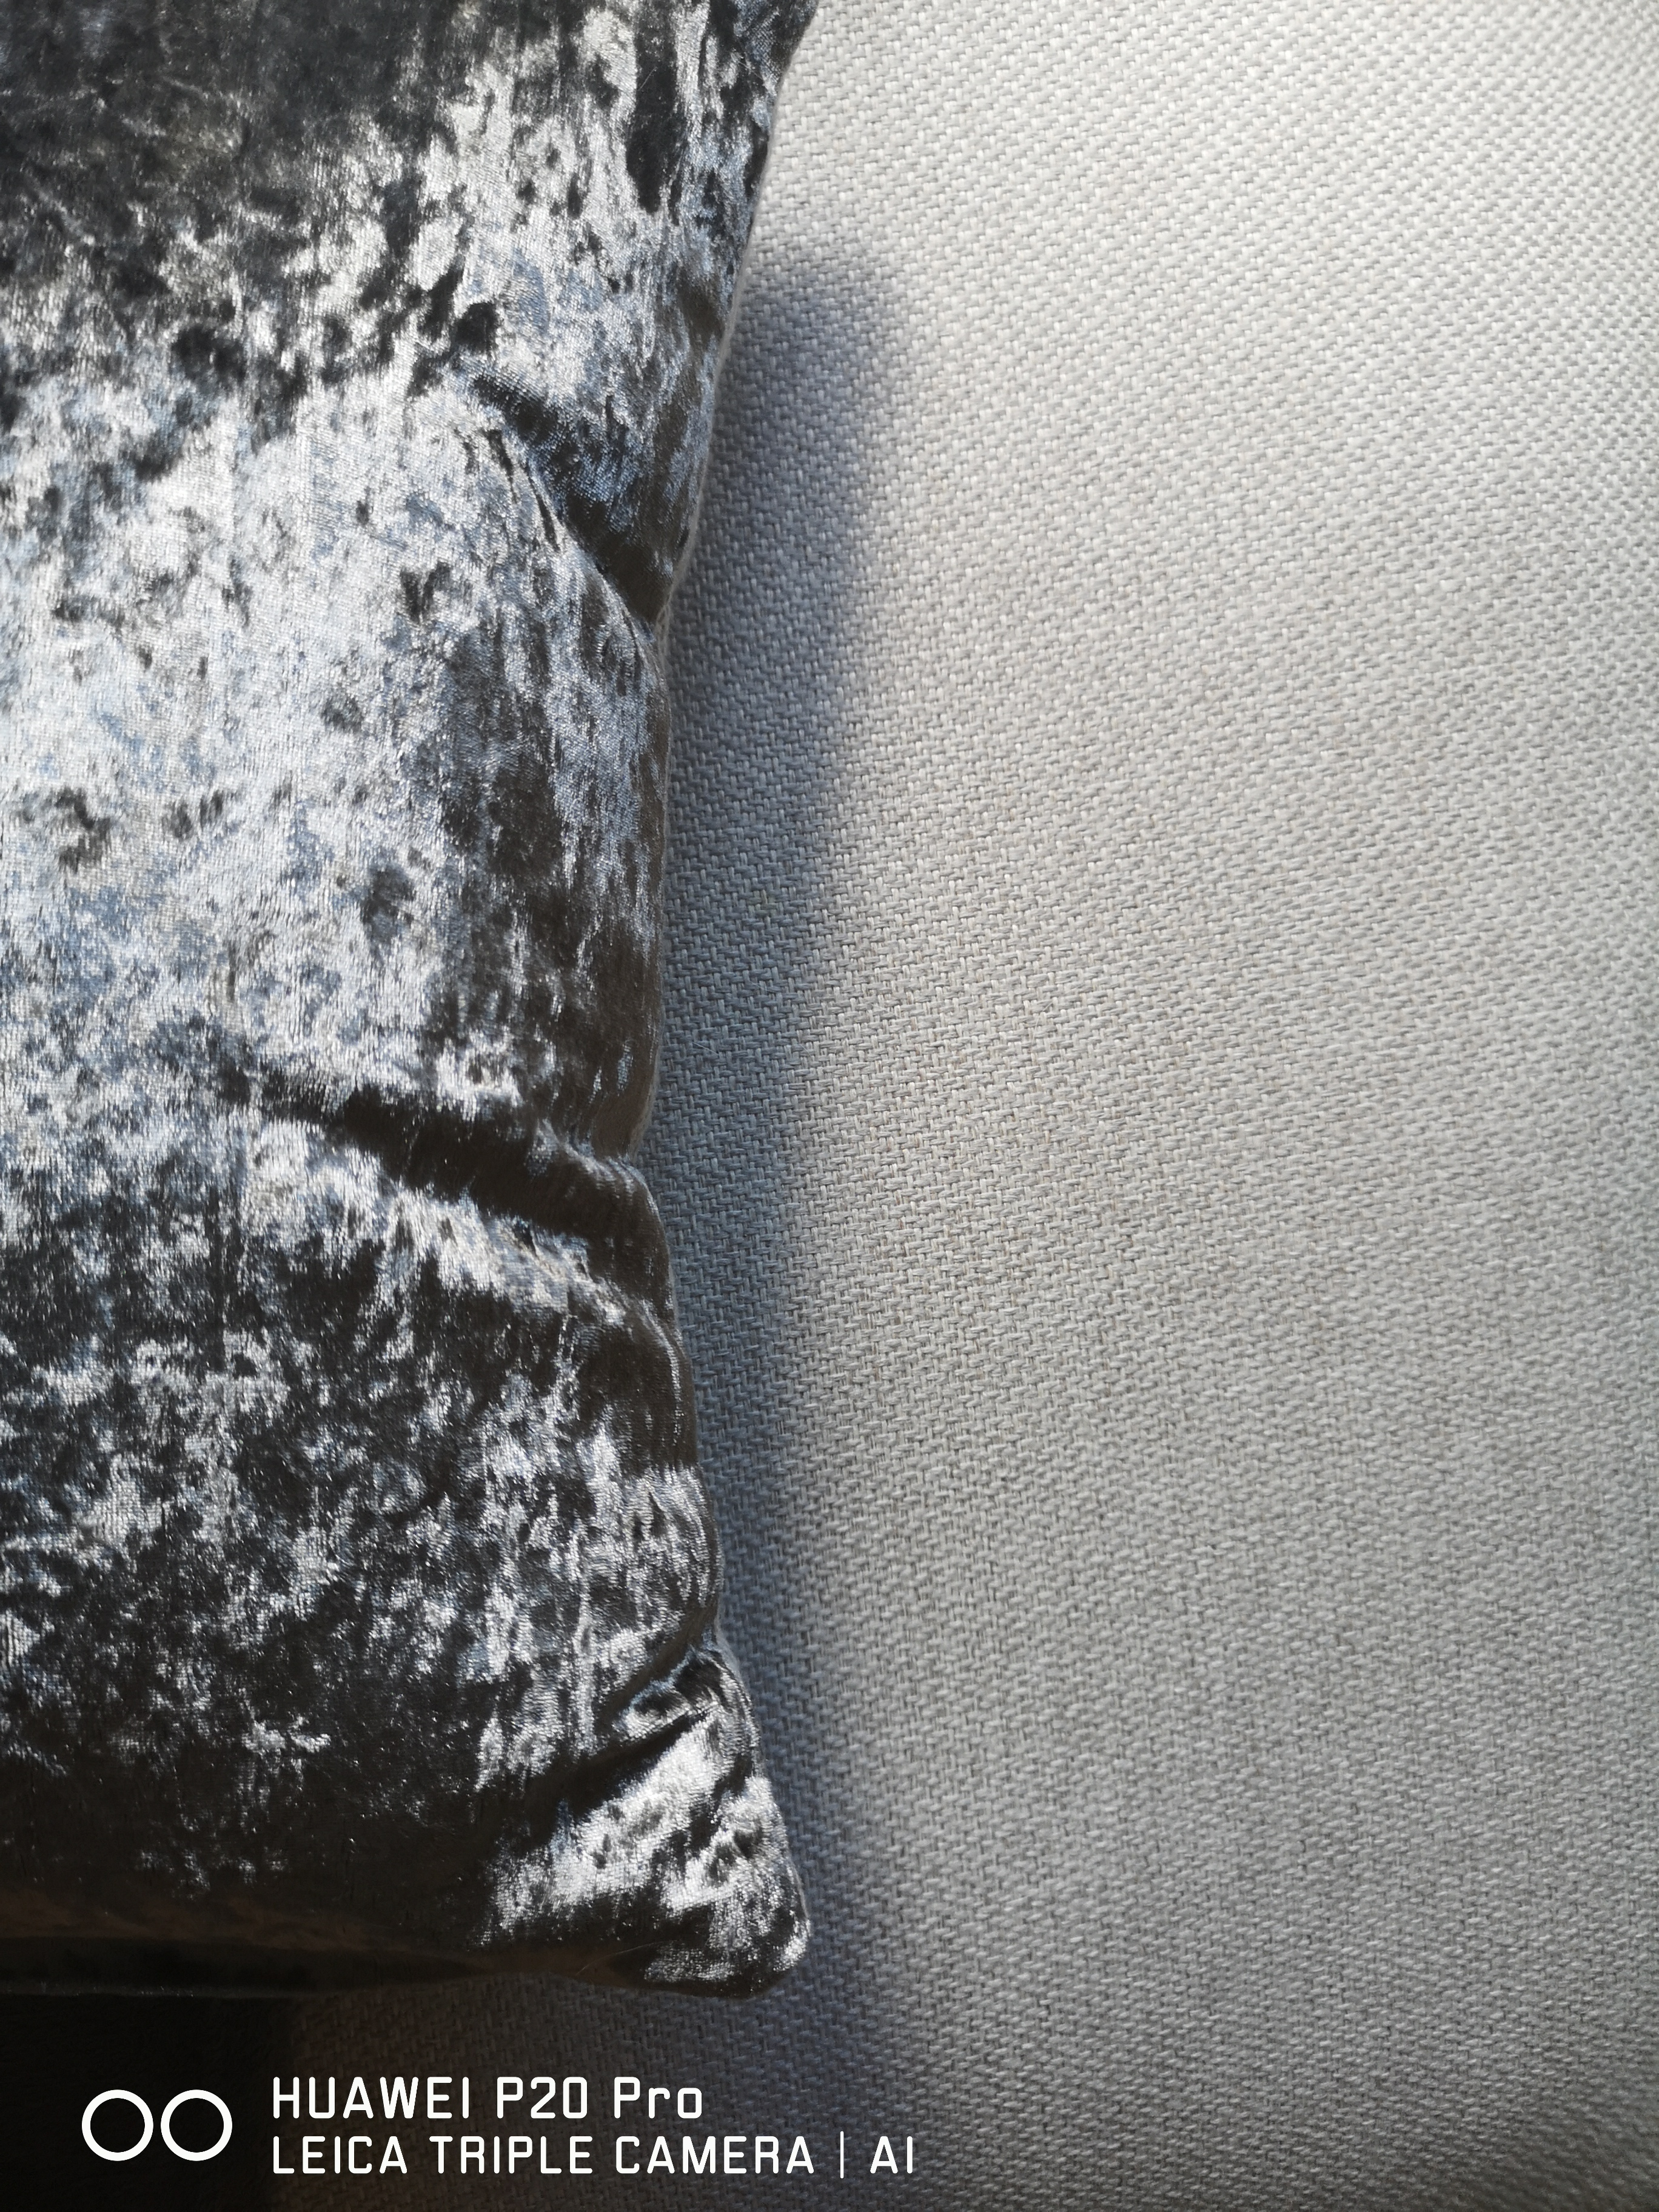



In artificial light they are more warm and darker.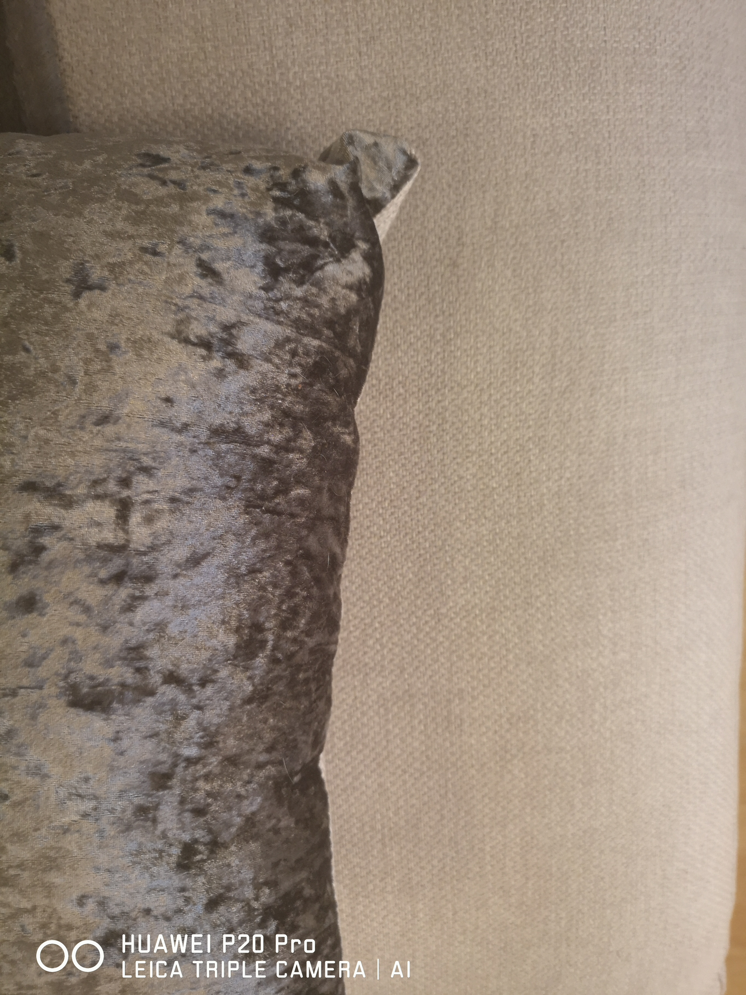



Student Statement:

By submitting this assignment, I confirm that this is my own work.

Student Signature | Marta Grzybowska | Date | 27.07.2019

For Tutor / Assessor Use Only
Total Marks
Marks Obtained
Percentage / Grade

