
Assignment Cover Sheet

Student Name: | Joanne Kerr
Student Number: | 8937
Course: | Diploma in Interior Design Level 4
Assignment NO: | 3

Marking Criteria:
We expect the learners to write minimum one well expressed point in three lines against each allocated mark. This means one needs to write 15 lines with 5 well expressed points to get high grades for a 5 marks question.
For high grades use examples and illustrations where appropriate.
Q.1. Short Questions
- It is important to establish the purpose of a room to ensure that the end design and outcome is truly fit for purpose – not just beautiful, but also functional. A space that is able to facilitate and inspire all of the activities that take place there. According to the Royal Association of British Architects British homes are getting smaller, therefore our rooms are naturally having to ‘multitask’. In most cases we no longer have dedicated spaces for eating / sleeping / sitting the way we once did. We also lead busy, multifaceted lives – many people study from home, exercise at home, and start small businesses from home… And we consider how lives change – babies arrive, grown children leave for university etc. The purpose of a room can change over time therefore understanding your clients and how they need to live now (and in the future) is crucial to any design. For me, having a piece of floor space to do yoga is crucial – and I have arranged my kitchen / lounge (and furniture) in a way that makes this yoga purpose a reality for me.
- If all the rooms in a house are painted in the same colour it gives the perception of it being a larger space. The reason for this is that our eyes look for contrast, so by using the same colour scheme on all the walls it connects the room’s together, creating more visual continuity, which creates the illusion of greater space. This sense of space can be further enhanced using lighter (and light reflecting) paint and colours.
- Using a single flooring style can have a similar effect in creating the illusion of space. The eye will be drawn naturally from one room to another without interruption. Hard surfaces also tend to create a better sense of space, rather than carpet – which tends to have a cosying effect. Using clear lines or geometric patterns can also draw the eye in a direction and create openness and space.
- Bulky curtains tend to encroach into small rooms and make them feel smaller – often because they take up essential space needed by furniture and other items (heating being common one). Window treatments that sit within the window frames look simple and clean and don’t have these issues. Simple in-frame blinds that blend in with walls and don’t break the line of sight can create a sense of expansiveness and also do not block the windows in any way, maximising light.

- There are a number of tricks that can make a small room appear larger:

  - Choose appropriate furniture. Often a large two seater sofa can work better than a three seater sofa in small room. Perceptually it creates more space, whilst not actually losing much from a functional perspective. In my own flat I had a very small space for dining but wanted to be able to fit four people for dinner comfortably. I had my dining table made narrower than standard with benches that sat underneath when not in use. It’s functional, and looks like a normal table, whilst making the room look considerably bigger when not in use.
  - Also look for fitting options – fitted kitchens are ‘cleaner’ on the eye and can integrate appliances in smart ways to free up counter space. For example, integrated microwaves in range hoods/above oven or a half sized built in fridge allowing for additional storage above.
  - Large mirrors. Large mirrors can not only bounce light around a small room, but also create a sense of greater depth – drawing your eyes into the ‘distance’.
  - For a more radical option, see if any walls can be removed. This can be costly and more challenging (particularly if the walls are load bearing, or if you are in a flat/leasehold), however this is a great way to open an area up both functionally and visually. Open plan kitchen/living rooms can create a much greater visual space than the two small separate rooms.
Q.2.
Social islands are multiple seating areas that can work well in very large rooms – breaking up the space into more intimate mini zones. Starting with function you need to understand how many people are likely to socialise at each ‘island’. These islands can then be defined through the use of furniture – anything from facing sofas, to a couple of armchairs and side tables Area rugs are a good way to define each social island and floor lamps and side tables can further create a sense of intimacy. Whilst overall the islands need to work as a collective they can have their own distinct characters and feel – some might be more formal, while others more relaxed.

Case Study

There are a number of things Lucy can do to improve her large living room with challenging lighting:

Firstly, I would embrace the dark corner and give it a purpose. Whilst I don’t know how Lucy lives and uses the room (which would be my first question to her), I think this could be a spectacular ‘library’ or other quiet zone where low lighting could be a bonus.

I would consider floor to ceiling built in bookshelves – maybe even with a ladder that slides along. This corner could embrace the dark, with dramatic floor lamps and statement armchairs. It could have its own purpose and make a benefit out of its limitations. On cold and rainy days Lucy could curl up with a good book. Or it could equally be a cosy spot for music or other relaxing pursuits. TV watching is generally done in the dark/low light – and actually having a TV near windows can make it harder to see. If Lucy watches TV as an occasion/destination (aka Netflix binge), rather than having it on constantly as background viewing, the dark corner could become the home cinema corner with the focus being on dedicated TV watching – low lighting, comfy furniture and less distraction.

I would also consider painting or wallpapering a wall within the dark corner to further create separation and use of this zone.

The big challenge I see for the rest of the room is that the normal approach to ‘shrinking’ large rooms, like darker tones on the ceiling and walls, could actually just make the large room darker, given the fact it only has one window. We want to make it more useable, not dingy and I think just going dark isn’t the right approach.

I think that a more sensible approach would be creative zoning. Particularly using rugs and large scale art to define areas. If the dark corner is now a cosy relaxation zone, the rest of the space can be divided up for more social purposes. For example a large floor rug could provide a zone for two facing couches and a coffee table for entertaining. There could also be space for a formal dining table.

For flooring I would consider using carpet as this tends to have a ‘shrinking effect’ on room sizes and creates a cosiness that feels appropriate in this situation (and then use area rugs on top).

We need to ensure that no light is blocked when considering window treatments as this will make the situation worse. Drapes would be a natural solution to shrink the room and could make more of the window– provided that when they were open they sat outside the actual frame.

I would suggest warm and neutral tones overall but use dramatic and large scale artwork at each social island to add some warmth and personality to each area. I also think oversized furniture and cushions could help create a more cosy setting.

Whilst not idea images, the following two try to demonstrate how I would zone and use complementary but distinct decorations to separate areas.

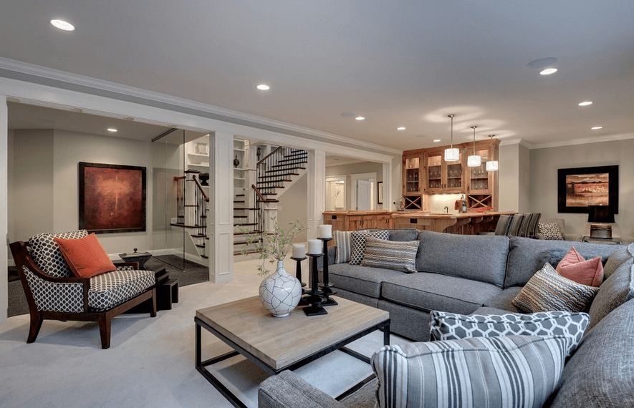

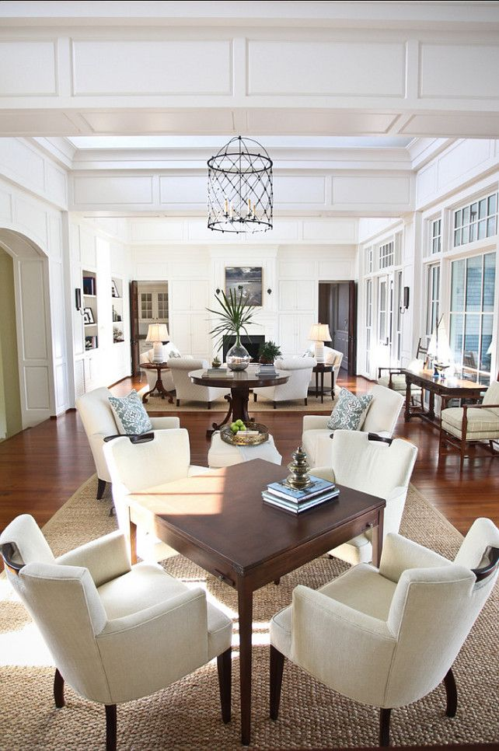

Source: Pinterest

And an example of how I envisage the dark corner turned into a cosy library.

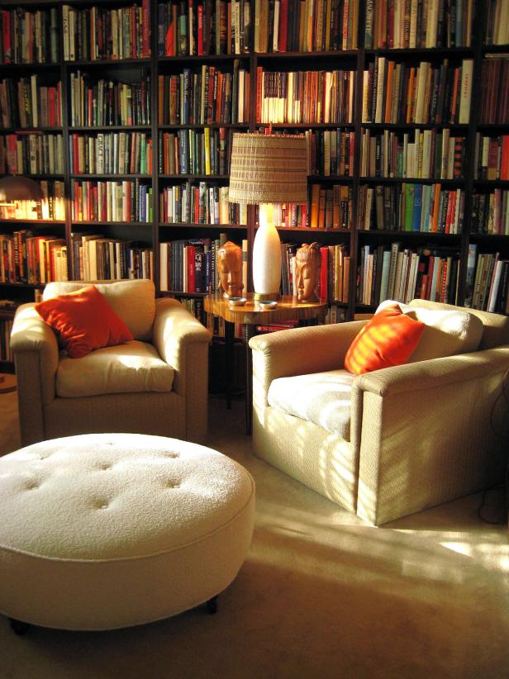
Source: http://photos.hgtv.com/photo/large-home-library-with-plush-club-chairs

Student Statement:

By submitting this assignment, I confirm that this is my own work.

Student Signature | Joanne Kerr | Date | 15.09.17

For Tutor / Assessor Use Only
Total Marks
Marks Obtained
Percentage / Grade

