
Assignment Cover Sheet

Student Name: | Simon Tickner
Student Number: | 31842
Course: | Certificate in Advanced Skills For Practical Trainer Level 3
Assignment NO: | 1

Marking Criteria:
We expect the learners to write minimum one well expressed point in three lines against each allocated mark. This means one needs to write 15 lines with 5 well expressed points to get high grades for a 5 marks question.
For high grades use examples and illustrations where appropriate.
Please insert your completed assignment ( in word format) here:

Assessment 1 Total Marks: 30
1: Short Questions (10)
- What is the difference between classroom learning and self-directed learning?

Classroom learning is traditional training that typically takes place in a class room, is structured by the teacher who has set a clear path to achieve pre-determined learning objectives, agendas and content. Classroom learning typically takes place in organisations and is used to teach a multitude of content such as systems, regulatory modules such as health and safety or company policies.

Self-directed learning is where the delegate takes responsibility for their development and the trainer becomes the facilitator towards the delegates objectives. An example of this would be to ask delegates to research coaching techniques prior to the training session and facilitating a group discussion based on this, sharing their views on great coaching methods and picking up key points they want the trainer to discuss in more detail in future sessions. Another example of self-directed learning would be as part of a personal development plan or when setting up a training contract, the delegate can plot their own course, set their own SMART (Specific, measurable, achievable, realistic and time-bound) objectives to develop themselves. Self-Directed Learning allows the organisation to promote a learning organisation, encourage critical thinking and drive the engagement of self-development.

It’s possible to mix the types of learning by designing the content but asking the delegates at the start of the session what objectives they want to achieve or making additional and non-mandatory eLearning modules available outside of the classroom for those who want to develop themselves further.

- What is Experiential Learning Cycle?

The Experiential Learning Cycles was created by David Kolb in 1984 and has been expanded on over time, as research on learning styles, personality types and the way we work has evolved.

The theory is that for effective learning to take place, delegates must go through the full cycle. Different parts of the cycle will appeal to each persons preferred learning styles and personality types, increasing their engagement with that section of the cycle, but for effective learning to take place, everyone must go through all four stages.

There are 4 stages to the Experiential Learning Cycle; Experiencing, Processing, generalization, and applying.

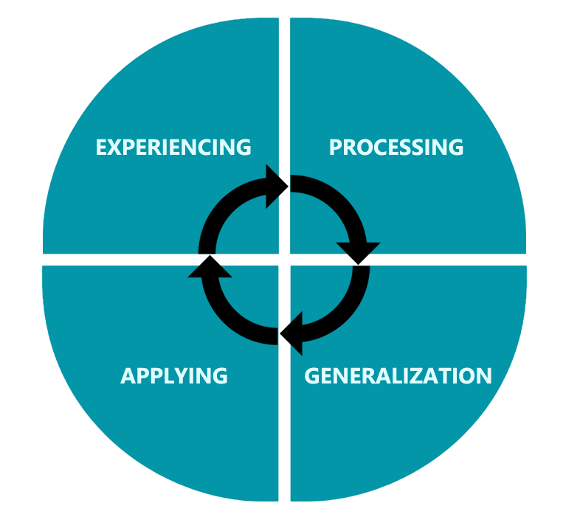
During the Experiencing phase, learners ‘experience’ the desired subject. For example, if the session was to learn about stakeholder analysis and stakeholder management, delegated would be introduced to the stakeholder analysis template and be given an explanation about what it is and how it works. Delegates would then be asked to consider stakeholders from previous projects (past experiences to draw from) and evaluate where they would place the stakeholder on the chart and how to manage the stakeholder based on their position within the chart.

The next stage is processing where delegates reflect on their current experiences or observations using their knowledge of stakeholders. The trainer at this stage can ask key questions to stimulate this reflection such as “who were they?”, “What was their interest?”, “how much power did they have?”, “what are the benefits of stakeholder analysis?” and “what are the risks of not using stakeholder analysis?”

The third step is generalizing where teams discuss their reflections from stage two. They can discuss how they might use stakeholder analysis in future. The teams can list how they think they can utilize it and get the best out of it.

Finally, there is Applying. Typically this is done best in a live environment, outside of the training room but can be somewhat achieved by realistic scenario work. In the stakeholder analysis example, delegates could be given case studies and examples of fictional stakeholders that they have to place on the stakeholder analysis grid and advise how they would manage them in a project environment.

- Explain the trainer’s role in training.

The trainers role is an exceptionally varied one and can change based on the learning taking place, organizational culture, facilities and needs of the learners. I am going to talk through the role of the trainer in three parts; induction, on-going and skills required.

Whilst having a varied role and skillset, the role of the trainer on a larger scale is to ensure compliance that employees are efficient in their role to secure business success and track the value of the training delivered.

During induction, the trainer’s role is to be the face of the company, to embody the values of the organization in order to set expectations and lead by example. The trainer needs to work with human resources and the operation to ensure that they get the best out of individuals and build a functioning team.

During ongoing training, the trainer will conduct needs analysis to understand gaps, root causes and identify opportunities to upskill employees. These workshops can very from systems work, soft-skill boosts, compliance, performance or theory based sessions. The trainer will use the training cycle to understand needs, design content, deliver and calculate value of the training. The trainer should encourage self-directed learning to help embed a learning culture and get the best for adult learners.

To be an effective trainers, you need to have excellent communication skills, including body language and movement around the room. The trainers facilitation skills can help guide conversations, test learning and challenge behavior. When designing content, the trainer should be aware of different learning styles, the four stages of the Experiential Learning Cycle tp write effective and tailored content.

A good knowledge of theories such as the GROW coaching model and Maslow’s hierarchy of needs (pictured below) is needed to ensure engagement and lead effectively in every situation. By adhering to Maslow’s Hierarchy, the delegates are more likely to focus on the training as their basic needs are met and trainers can use the GROW model to help learners meet objectives and be coached through a situation. Passion and the ability to manage relationships at all levels and a project are essential.

Maslow’s Hierarchy of Needs:
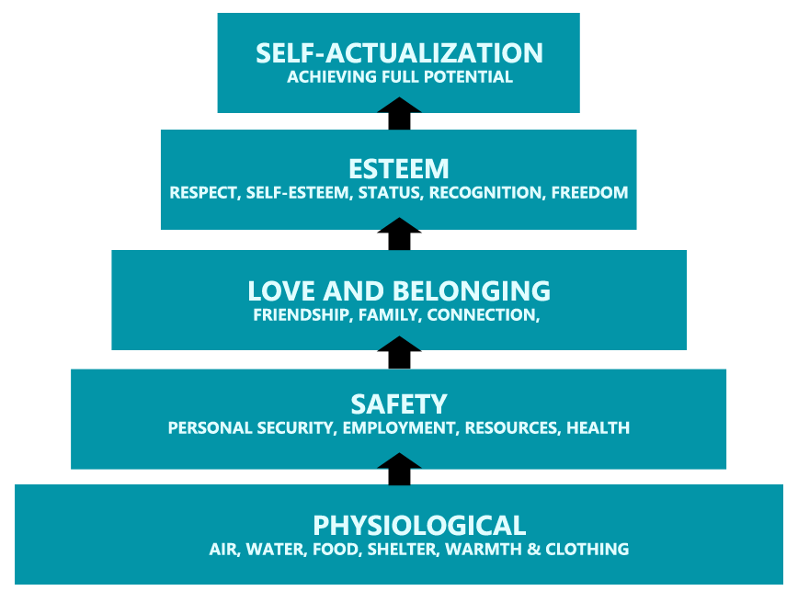

Grow Model:
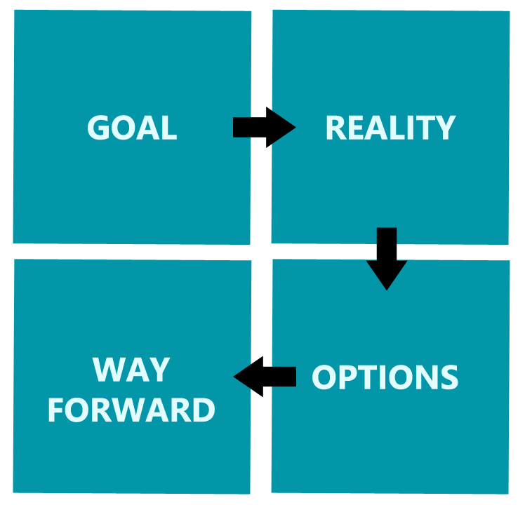

2. Discuss various Learning styles in detail. (10)

Learning styles are believed to help delegates learn more efficiently providing you cater the training to their preference. Delegates can feel more engaged whilst their preferred learning style is being utilized. By understanding and applying each learning style in the training, the trainer has the best chance of engaging delegates throughout the training. On a learner level, the more they understand about their preferred learning style, they can learn how to get the best out of their training and also develop their least preferred learning styles.

There are many views on different learning styles, including different focuses such as the Myers-Briggs personality model, the VARK (visual, auditory, reading and kinesthetic) model and Keirsey’s temperaments and learning styles. By understanding learning styles, the trainer can tailor the learning to each style and coach directly based on individual preferences.

Prior to discussing Keirsey’s temperaments in more detail, I am going to discuss the VARK model. Visual learners prefer to take in information via visual methods such as PowerPoint presentations, flipcharts, handouts and takes notes. The train can help visual learners by creating imagery in the training room, utilizing flip charts and making paper available for delegates to make notes on. Auditory learners tend to engage more when listening, so the trainer can utilize discussions and read content out loud, where using eLearning, have an option that the content is read to the delegate. For reading preferences, the trainer can make available content such as sharing a session plan after the training, providing handouts and allowing them to take notes. Kinaesthetic delegates are hands-on learners and are engaged by movement. You can engage these learners by getting them to move around the room to different sections of the learning journey or having test accounts set up for systems work.

When considering Keirsey’s temperaments, he looks at what people say and do.

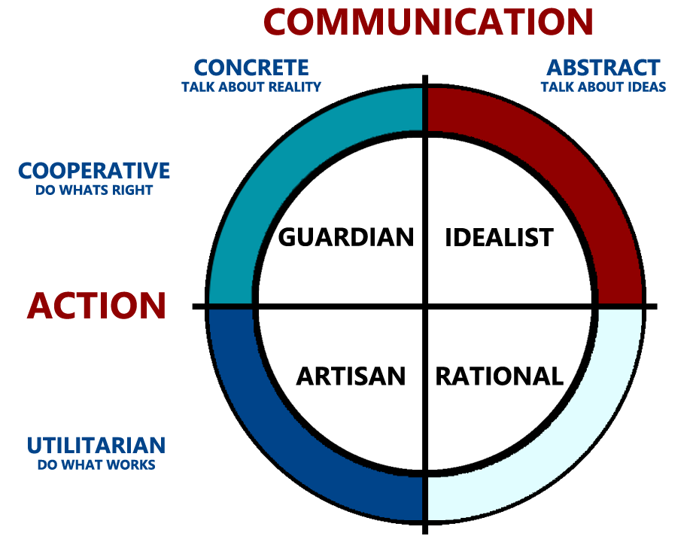

By understanding different temperaments or personality types, you can understand the preferences for learning. The four temperaments are Guardian, Idealist, Rational and Artisan.

The Guardian learning style is best at the Experiencing and Applying stages of learning. These learning solutions enjoy being hands on and making gut decisions rather than making careful analysis. In Daniel Goleman’s book Emotional Intelligence Why it Can Matter More Than IQ (1996), he points out that gut instincts are actually learned experiences, tying in with Kolb’s theory that the ‘Experiencing’ phase is a preference as it can often draw on past experiences. To become more well-rounded, the Guardian could focus more on the Processing and Generalization steps to help the individual analyse data in a more methodical fashion rather than relying on the gut. As Guardians like to be hands on, they can get frustrated as the observer but by focussing on what others do, they may learn new perspectives that they had not previously considered. By working on long-term plans and analysing data, the guardian can see more of the bigger picture and increase their understanding of analytics.
The Idealist tends to talk about ideas and act on what they think is right. They work best with the experiencing and processing steps of the experiential learning cycle. They deal well with viewing different perspectives and have a tendency to see the human side of problems, being very empathetic. To become more well-rounded the Idealist can work on collecting and analysing quantitative data, looking into trend analysis and being objective. The Idealist could improve by putting themselves forward for more hands on experience.

The third learning style is the Rational ones, who are best at the experiencing and generalization steps, dealing well with statistical data. This learning style can create theoretical models and bring out logical data in order to solve problems. To become more well-rounded, the Rational one can work on their experiencing and applying stages in order to help them act quicker in situations instead of focussing on data. They can do this by quickly acting on their theories instead of thinking further and continually analysing data. The Rational learning style could spend more time on Emotional Intelligence activities to gain a broader understanding of their own and others emotions. By adding skills in the realm of emotional intelligence, influence and the personal side of problems, the Rational one will gain a more well-rounded approach to learning.

The final learning style in Keirsey’s temperaments model is known to be very resourceful. They prefer the Application and Generalization steps of the Experiencing learning cycle, and due to this tend to excel at finding the practical application for ideas, concepts and theories. They enjoy problem solving and are strategic in nature, often believing that there is always a ‘best-way’ to do something. Due to this, they can increase their learning power by exploring other people’s point of view and understanding the importance of understanding non-quantitative data, which will help them understand the bigger picture to what is important. The Artisan could focus more on the experiencing and processing steps to develop an understanding of other people’s values and beliefs, avoiding judgements in order to see new perspectives. The Artisan can benefit by honing their skills in gathering non-quantitative data, being open to others opinions, listening skills and considering the wider implications of a situation.

By utilising the trainers knowledge of different learning styles throughout the designing and facilitation of a learning solution, the trainer has the best chance to engage learners throughout the process. It is important that the trainer uses a variety of different materials and methods to engage learners and help them through the learning cycle.

3. Discuss the competencies that are required to teach adult learners? (10)

Trainers need to be versatile in their role and should understand the key competencies they need to operate within to effectively train adult learners to achieve the desired objectives.

The first competency is to recognise the average adult learner in order to tailor the trainer, this considers motivation, needs, capability and learning styles. All of these elements need to be considered throughout the training from the initial design to accommodate learning styles to the training room itself, to ensure the heat, light, availability of refreshments are all considered. The trainer also needs to ensure an open and honest environment is cultivated within their facilitation and coaching sessions.

The next competency is to understand adult learning theory as well as teaching children, the differences involved in order to apply the right learning techniques.

Third is to understand the impacts of groups, organisations and communities on learners, such as working towards strengths, influencing personalities and opinions towards learning. This preparation can allow the trainer to cater learning and manage behaviours.

The next competency is to describe and utilise the 4 stages of adult learning and assess the impacts of each stage within the particular learning being implemented. For example, if the session plan advises to use the full group for the discussion but one or two extraverts take control, this can mean the introverts do not get the most out of the processing stage, so the trainer could consider splitting the groups into smaller teams based on this, helping the introverts effectively move through the 4 stages.

As mentioned above, not all delegates will instinctively share, so the trainer will need to know how to encourage learners to participate in the training. You can do this by directly asking questions to specific people or asking them to summarise what another learner has said in the room.

The trainer should be able to conceptualise the role of the trainer, teacher, facilitator and instructor in order to move between roles based on the situation, much like situational leadership, to get the most appropriate outcomes from the training. To do this, the trainer must feel comfortable in all roles and move between them as necessary.

Trainers need to foster open, trusting and respectful relationships with delegates. People are more inclined to listen if they like you, so understanding body language, using matching and mirroring techniques is important to build working relationships quickly.

The trainer can utilise Maslow’s Hierarchy of Needs to create a physically and psychologically comfortable environment. This theory looks at peoples basic needs to higher level needs, for example if you are hungry or thirsty, you are not going to listen to the trainer as you will be thinking about the break to get a drink and something to eat. So from the basic view, the trainer can ensure the temperature is comfortable, drinks are readily available, and breaks are frequent. Going up through the hierarchy, the trainer can create safety by discussing fire exits if needed, establish a community by getting everyone involved, fostering a respectful environment and highlighting the development available within the session.

If delegates are not engaged, it will likely mean they do not learn. The trainer therefore must engage learners in the content but also take control of their learning experience. Self-directed learning and understanding their own needs for the training will help them gain buy-in for the session taking place.

Just like being engaged, the trainer should understand the reasons for using different materials, methods and techniques to achieve the learning objectives. For instance if doing a body language workshop, providing written handouts may not be as effective as watching a video or a live demonstration. The trainer must not only know the theory but be skilful in the application of the materials, group sizes and techniques and utilise new technology such as virtual reality to benefit the learning objectives.

The trainer will also need to use their leadership and facilitation skills when planning and evaluating the training by including the learners. This can be beneficial as the learners may be subject matter experts on the systems or have already identified skill gaps within themselves, department or organisation. When evaluating the training the trainer can do this in two stages with the learners. The first stage should happen immediately after the training for initial impact and the second should take place four weeks after the training to see if the learning worked in the actual application of the training. This feedback should be taken into consideration constructively in order to create more effective learning solutions in the future.

Like sitting down with subject matter experts, the trainer will need to engage with other stakeholders such as resourcing and planning to schedule the training, operations to identify needs, potential HR and IT if real system access is needed. The trainer will also need to use influencing and negotiations skills to gain the resources required.

The trainer can also use promotion and publicity in order to promote their brand, department and the impact of their work. They will also need to closely manage the budget provided.

With these core competencies, the trainer will be able to influence across the organisation, design and deliver valuable training and be able to demonstrate the value that has been added in order to increase their reputation and move towards business objectives.

Student Statement:

By submitting this assignment, I confirm that this is my own work.

Student Signature | Simon Tickner | Date | 03/03/2019

For Tutor / Assessor Use Only
Total Marks
Marks Obtained
Percentage / Grade

