
Assignment Cover Sheet

Student Name: | Harrison Mayglothling
Student Number: | 33699
Course: | Advanced Diploma in Business Administration Level 5
Assignment NO: | 2

Marking Criteria:
We expect the learners to write minimum one well expressed point in three lines against each allocated mark. This means one needs to write 15 lines with 5 well expressed points to get high grades for a 5 marks question.
For high grades use examples and illustrations where appropriate.
Q: 1: Short questions:

- Define the term “Management”.
According to the business dictionary The activities associated with running a company, such as controlling, leading, monitoring, organizing, and planning. Management is the process by one individual of getting a group of individuals to work together within a certain frame of time, with limited resources, to accomplish a set goal or objective. One who manages is known as a manager. In a business firm, as in any other office form, there is a hierarchy of superiority in the working order. A manager generally has a team of people working under her/him, who specialize in the same department, and are brought together to work either for a long term, or a short term, to achieve a previously designed objective.

II. List different levels of management.

There are certain levels of management with varying degree of authority and responsibilities. Some managers decide about the objectives of the business as a whole, some managers perform functions to achieve these objectives in different departments, like production, sales, etc, and some of the managers are concerned with the supervision of day-to-day activities of workers. Managers performing different types of duties may, thus, be divided into three categories:
- Top-Level Management
- Middle-Level Management
- Lower-Level Management

Below I have found an image which I believe illustrates and explains well the different levels of management.

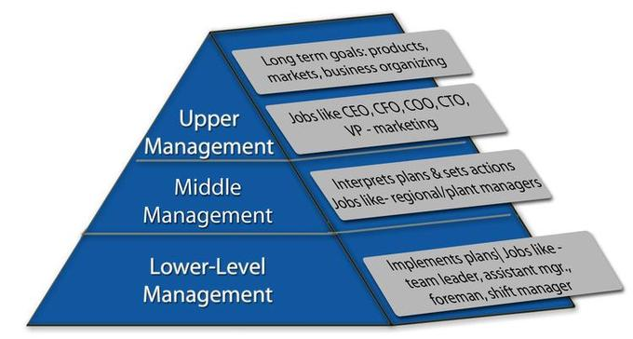
Source: https://courses.lumenlearning.com/boundless-business/chapter/types-of-management/

III. Define the term “equity” as a principle of management.

Equity as a principle of management helps motivate workers to perform their duties by maintaining a proper mix of fairness, justice and kindness.
As it pertains to a person, equity is defined as the quality of being fair and impartial, or equitable. However, in the world of finance and accounting, the term equity generally refers to the value of a group of assets after deducting the value of liabilities, or the value of an ownership interest in a business, such as shares of stock held.

IV. State the various functions of management.

Below I have bullet pointed the various functions of management according to my research and given a brief explanation of each one.
- Planning requires the ability to see into the future and picture the goals that the organization would like to achieve. Then it is up to the manager to set a specific time frame within which the team would work to accomplish the task, a budget, and determine the amount of resources required and the way to go about achieving these goals.
- Organizing is important to stay on track and to avoid mistakes. After determining the objectives, the manager then organizes her team, and distributes the work amongst her men. Then she could control and oversee

- the work of every member of the team and check if everything is going as per the planning.
- Commanding is when the manager communicates his expectations with every subordinate and their involvement in the work. A manager must delegate the work amongst his subordinates and then instruct and inspire them to work to their best of their abilities. It is important for the manager to treat her subordinates with respect and not overburden them with work.
- Coordinating is essential for any organisation. It is the job of a manager to see that two subordinates aren’t working for cross purposes, or that there isn’t a duplication of assigned tasks. Every department should complement each other, and work with harmony to achieve their goals.
- Controlling is an important task in the manager’s workload. She must make sure that the standard of work is up to the standard of the company and that every member of her team is following the policy of work of the company.

V. Match the expression given in column 1 with These given in column 2

Column 1 Column 2
a) Management as a discipline i) team of managers b) Management as a process ii) code of conduct for professionals
c) Management as a group iii) developed and grown through
practice and research
d) Management as a profession iv) series of inter-related activities

My matching answers:
- – ii
- – iv
- – i
- – iii

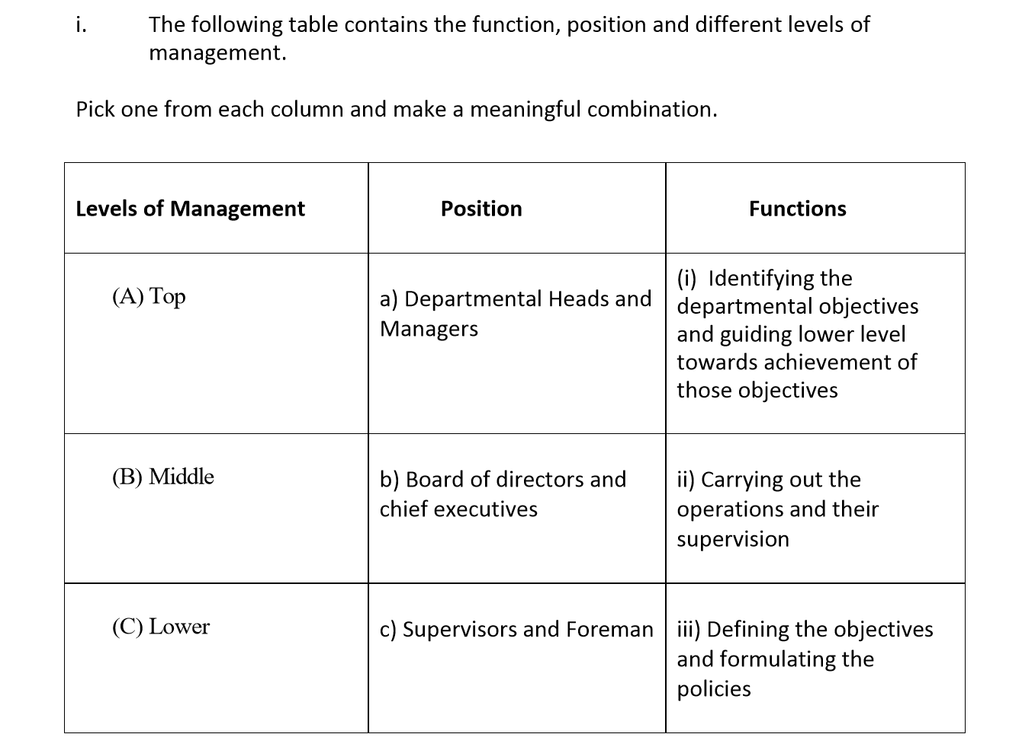

Below I have put the levels of management, position and functions into the correct order
Answer:

Top – board of directors and chief executives – defining the objectives and formulating the policies

Middle – Departmental heads and managers – identifying the departmental objectives and guiding lower level towards achievement of those objectives

Lower – supervisors and foremen – carrying out the operations and their supervision

“Planning is looking forward; whereas controlling is looking back”. Explain the statement.

The statement makes sense when you look at the characteristics of each function. For example when planning you are looking at the organisation of something that has not happened and trying to work out the process so it will run as smoothly, efficiently and effectively as possible, where as controlling is looking at something that is an ongoing past tense activity that needs to be overseen, supervised and directed in a way to improve, run perhaps more efficiently or create better results. Planning requires the ability to see into the future and picture the goals that the organization would like to achieve. Then it is up to the manager to set a specific time frame within which the team would work to accomplish the task, a budget, and determine the amount of resources required and the way to go about achieving these goals.
Controlling is an important task in the manager’s workload. She must make sure that the standard of work is up to the standard of the company and that every member of her team is following the policy of work of the company.

The directors of Vision Tech have reorganized their business. William Davis is now Chairman, Vijhay Singh finance manager, and Irene Rogers is the floor in charge (supervisor).
Keeping in view the above situation answer the following questions:

- What is meant by the hierarchy of management?

hierarchy should be maintained in all businesses where subordinates report to one manager, who in turn reports to one higher level manager and so on. For example we have top, middle and lower management this is a management hierarchy. William Davis is within the top level of management as a chairman followed by Vijhay Singh who falls into the middle level as she is in charge of a department. Irene Rogers falls into the supervisory or lower level management as she will be in charge of operations and supervise other members of staff within the business.

- How does William Davis know about any problem on the factory floor

William Davis will know about any problems on the factory floor because the issue will be reported up through the business hierarchy. For example the first person on the factory floor to note the issue will be Vijhay Singh who will then report it to the head of her department within the middle management sector. This in turn will then be passed up into top level management where it will be reported to the chairman.

- Who determines the objectives for the business?
As top level management William Davis will be the one who sets the objectives for the business. However The objectives of the business as a whole are translated into departmental objectives for the middle level management. The heads of the departments then work out their own strategies so as to achieve these objectives. Middle-level managers are particularly concerned with the activities of their respective departments, Therefore Vijhay Sing will have her own objectives to consider creating for the department she falls in charge of.

- Who will ensure that the work is carried out properly and on time?

Every level of management will have their own way of overseeing things, however the person that is going to be constantly overseeing the work done in front of them on a day to day basis is Irene. She as supervisor will be driving the workforce directly in front of them and therefor be the main individual who ensures this happens.

Student Statement:

By submitting this assignment, I confirm that this is my own work.

Student Signature |  | Date | 11/06/19

For Tutor / Assessor Use Only
Total Marks
Marks Obtained
Percentage / Grade

http://www.businessdictionary.com/definition/business-management.html
Lecture notes
Lecture notes
Lecture notes
https://www.thebalancesmb.com/the-business-definition-of-equity-393287
Lecture notes
Lecture notes

