- Define the following terms and concepts as described in the module:

Sales promotions: Sales promotion is the process of persuading a potential customer to buy the product. Sales promotion designed to be used as a short-term tactic to boost sales

Advertising: is the use of paid space or time in media to promote a particular product or event.

Publicity: The promotion and exposure of information regarding people and social events through various forms of communication media.

Formal fashion show: It is the formal presentation fashion line that requires allot of time and resources to put together.

- What is the purpose of sale promotion?
Sales promotion attract customers who will continue to buy the product it is also used to Sales promotion is designed to be used as a short-term tactic to boost sales.

- Explain the difference between advertising and publicity.
Advertising is paying media or area to post visual or audio description of the product. Publicity is done though people who are an influencer in the community or media editors, these people can put good word of mouth to the product and their opinion matters to people.
- When supplying apparel to the retailors some times financial problems are created. How?
Financial problems created because retailors buy from manufacturers on credit allowance, this may push the manufacturer to seek different ways to borrow money because they need raw material for production. Thus is risky because if the retailor did not sell the entire product the manufacturer still have to pay for his loan even if he did not get to sell all his products.

- Textile sales people encourage manufacturers to make a commitment to buy early in the season specific amount of yardage. Why?
Buying fabrics early in the season helps the designer to get the full amount of fabric that he needs. In addition to that, he will receive his fabric order early and as scheduled to avoid any last minutes problems.
- How the fabric should be inspected when it is received?
The quantity of the order checked. As well as the shape of the fabric. The fabric inspected and marked for flaws such as holes, shading and great difference in color than the one requested. In large factories, a special machine counts the fabric yardage as it rolls from one bolt to another.

2. Describe the various types of media and their roll in fashion promotion.
Fashion promotion done through all media services. Some media services have higher impact on consumers than others. Since fashion is all about image and beauty, a visual promotion can have higher impact. A fashion designer can promote through newspaper, magazines, banners, billboards and in store adds, a new powerful promotion method is social media.
As social media became the dominant source of information and one of the best ways for people to communicate, several industries, including fashion brands, are changing their marketing strategies. Social media is changing the fashion industry due to the creation of social media, such as Facebook, Twitter, Tumblr, and Instagram. At the same time, this new way of communicating is aiding in the industry’s development. Businesses now utilize social media to connect with their consumers on a more personal level. Social media has opened new access to potential buyers, have stretched the way in which consumers and others can access information about various things relating to fashion, and have generated new outlets for advertising.
In the last ten years, fashion has become more of a universal industry providing to international customers with backgrounds. Instantaneously, the drastic change in communication lets users to participate, follow and discuss any trend and fashion news and purchase fashion items easily online. No matter how big or small a brand is, they are able to communicate with buyers and to a larger scaled audience. Top brands like Burberry, Urban Outfitters, and Louis Vuitton are promoting exclusive clothing and have become more accessible to the public via social networking. Within the last decade, the fashion industry has grown globally because of the presence of social
mehttps://storify.com/0marcel0/social-media-effect-on-the-fashion-industrydia.
With that being said, radio advertising is still effective especially if the target market listen to the radio during peak hours.

Project:
- Find at least two examples of co-op advertising from a fashion magazine.
Example 1: Boots adverting for other perfume brands that they sell in their store. They chose hello magazine to advertise in, women from all age groups and different income backgrounds read hello.

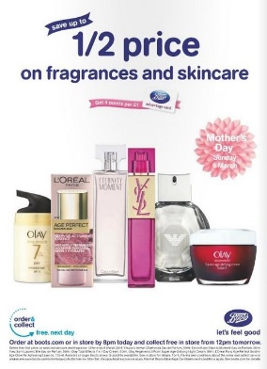
Example 2: Dillard’s is advertising for a Calvin Klein in magazine.

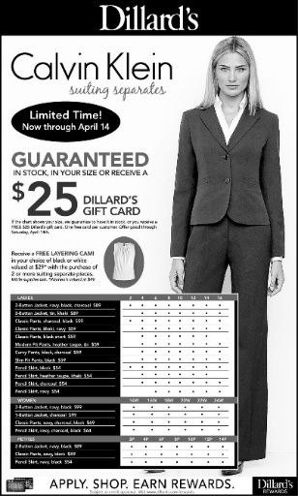

- Analyze the advertising campaign by a fashion designer in a newspaper and fashion magazine. Do they have a high fashion image or popular appeal? Do you feel that the advertisements were effective? Do they use photography or artist illustrations? Write a report and produce the images of the campaign.

I specificly chose these two add from Vouge USA fashion magazine April 2018 issue because they represent two different cultures and they wanted the reader to see that clearly
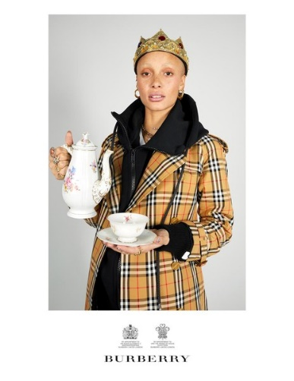

In Burberry add above, the British fashion house , wanted to add english reminder to the American reader, the crown that represnts the british monarchy and the tea pot and cup refering to British famous tea time. Their massage is we are british and royal elegence. Its also expensive and not in reach for every one , specially the very young generation. That’s reflect in the choise of older model. Also represnting a formal conservative vibes. The add was photographed and I think they can get a way with the crown and tea set because the add is adressing American consuremer. I wouldn’t like the idea if this was in a British vouge.

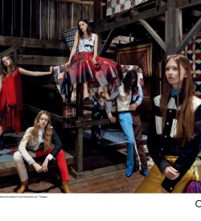

In Calvin Klein Add, the all-American company is representing their casual line in an old wild wet set; Colors also resemble the American flag.
The set convey a massage that says American, brave, and comfortable. Its more accessible budget wise to younger generations with lower income. Younger models pausing in a relaxed way and letting their hair down, free, young and strong. The advertisement is successful for its market target, younger people.
I would like to add a personal note. It is hard to find advertisements in newspapers at this part of the world. All major fashion companies are either using influencers to promote for their products. Alternatively, use Instagram to reach people.
In addition to that, the use of billboard advertising in Kuwait has increased drastically over the past two years.

- Visit local designer, evaluate the display techniques, both in windows and interiors, is the lighting used effectivly ? is the merchendise arranged effectively?

Chanel Boutique Kuwait

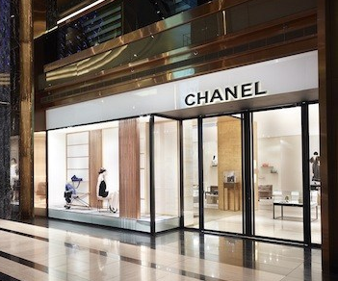
Big glass display windows outside the boutique illuminated very well by light fittings and displayed Chanel’s ready to wear line. Chanel famous bags and shoes completed the look. The display give the shopper a brief description of what they can expect when you go inside, prices were displayed Cleary in the window with each item’s description. The display of mannequins and products was relaxed and not cluttered.
Chanel Boutique Kuwait is a design product designed of celebrated New York based architect Peter Marino, and reflects Mademoiselle Chanel’s belief that “The most beautiful things are the simplest.
The store spans two floors and employs a neutral color palette of white and white, with touches of black throughout. Beige and white marble floors line the store, tweed sofas available for customers to lounge on, while sleek walls decorated with artworks by Peter Dayton and Robert Greene, as well as the brand’s most coveted bags, shoes, and accessories.
The ground floor is comprised of spaces dedicated to shoes and accessories, including Chanel watches and fine jewelry. The first floor, an elegant and modern space, displays Chanel’s ready-to-wear collections in addition to an intimate room is devoted to the label’s hottest accessories.
https://khaleejesque.com/2013/06/studio/chanel-opens-2nd-boutique-at-the-avenues-kuwait/

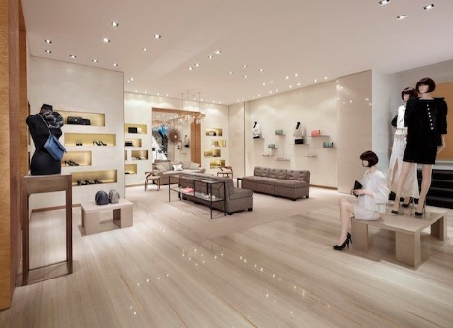
The light colored interiors added brightness and light to the boutique. A small seating area dedicated for waiting. In addition, the lighting is fitted and distributed all over the ceiling to provide a uniform light distribution. Task spot lights placed to highlight specific items such as clothes worn be mannequins
Some of the bags and fashion accessories placed inside glass tables. The boutique overall look was bright, organized, comfortable and accessible.

