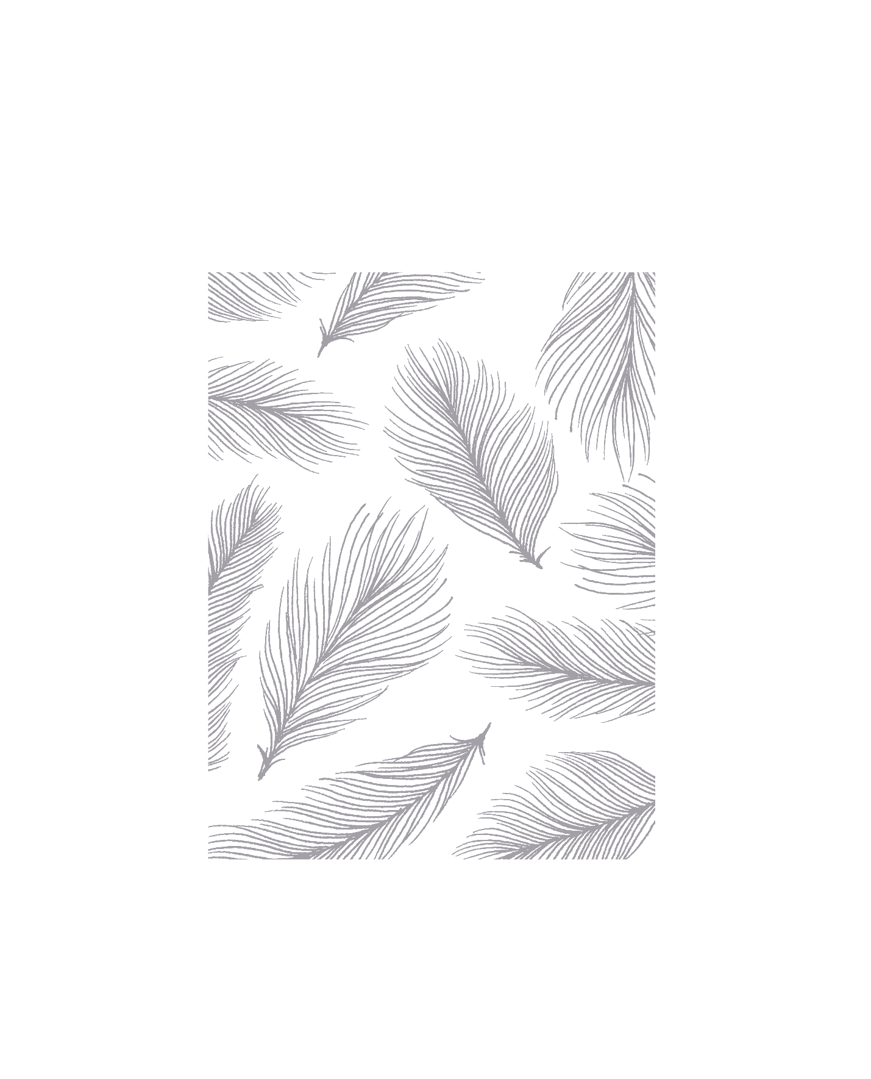
Ogechukwu Edith Shote
Student Number: 24750
Assignment Number: Assessment 1
Course Title: Diet & Nutrition

Assessment 1
Question 1 Multiple Choice Questions: (05)
- Nutrition is the process of consuming, absorbing and:
- storing nutrients
- using nutrients
- losing nutrients

- Proteins are involved in:
- a range of biochemical reactions
- maintaining ionic balances in the body
- growth, repair and general maintenance of the body

- Vitamins are important for:
- a range of biochemical reactions
- providing energy to the body c) growth and repair of the body

- An excess of only 200 calories per day for 10 days is likely to result in a weight gain of nearly:
- 0.5 pounds
- 1 pound
- 2 pounds

- One Kcal is approximately:
- 5.2 KJ
- 4.2 KJ
- 6.2 KJ

- People maintain a stable weight when their total energy intake balances their:
- total energy expenditure (TEE)
- basal metabolic rate (BMR)
- reference energy intake (REI)

1
An Overview of Nutrition
- Which of the followings BMI is considered healthy?
- 30-35
- 35-40
- 18.5-25

- When we are in energy balance, we:
- put on weight
- lose weight
- retain the same weight

- BMI between 30-35 is considered:
- normal
- overweight
- obese

- The formula for calculating BMI is:
- BMI= weight x height
- BMI= weight/kg
- Height/m
- BMI = weight/kg
- Height/m2
Q: 2: Short Questions
Each part carries equal marks
- The energy requirements are different for different people. Why?
This can be because of their age, gender, weight and activity level.
It can also be as a result of their type of diet. Someone that consumes lots of carbohydrate will have more energy than someone that consumes only vegetables.
- What is BMI, and how can it be calculated?
BMI {Body Mass Index} is a measure that allows us to check if we are at healthy weight range for a height range. BMI can be inaccurate in some people, especially young children and elderly people. It is also not very accurate in someone with high muscle bulk.
To calculate BMI: The weight [Kg] is divided by the square of the height [m²]. then divide that number once again by height.
$$BMI=\frac{Weight \left[Kg\right]}{\begin{aligned}Height \left[m^{2}\right] \\ \end{aligned}}$$
2
- Define whole foods, and also describe their importance in our diet.
Whole foods are foods that are consumed as close to their natural state as possible and are prepared in a way that retains enough nutritional value to support health. Example are carrot, cucumber, leafy greens, potatoes, Apples etc.
These foods can be picked and eaten raw, without passing through any process.
If we decide to make juice out of the fruits, such as Orange juice, the juice will not be whole food as it has passed through some processing. Because the fibre that slows down the sugar is no longer in the juice, the juice will then become high in sugar.

Whole foods are important in our diet because they are concentrated source of nutrients.
Most whole foods have natural fibre that aids digestions and help to slow down digestion
of sugar in our body.

An Overview of Nutrition

- What are refined foods? Are they nutritious? If not why?
Refined foods are those foods that have been processed. Most of their nutrient are lost during the process. Example, white rice. canned foods, they are not nutritious because they have lost most of their nutrients. This is because they end up using the body’s stored nutrients to produce the energy needed for digestion.
- What is basal metabolic rate? What is the difference between total energy expenditure (TEE) and Basal Metabolic Rate (BMR)?
Basal metabolic rate is the least amount of calories we need to burn in order to fuel essential bodily processes and keep our organs and tissues in working order.
This process can also continue even when we are inactive, for instance when we are sleeping or sitting down quietly, our bodies continue to burn calories through our heart beat or breathing.

The difference is that Basal Metabolic Rate [BMR] is the process that continues when we are sitting quietly or lie asleep such as breathing or beating of our hearts. While Total Energy Expenditure [TEE] is the extra energy needed to carry out everyday activities beyond the energy required for BMR.
TEE is also related to our brain activities, our age, environmental temperature [ for example, our metabolic rates are higher during the higher in cold weather to maintain body temperature]. Also diseases [ our metabolic rates increases when we have fever].
Pregnancy and Lactation can also affect TEE.

- What are micro-nutrients? Why does our body need them?
3
Micro-nutrients are those nutrients our body require daily in small quantities in milligrams to micro grams, they include certain Vitamins and certain minerals that allows the body to use macro-nutrients [ these are the nutrients our body require daily in large quantities, example, carbohydrates, some minerals and water.

Our body needs Micro-nutrients, because they help to keep us healthy
4
If we consume too much of these nutrients it may be harmful to the body, and if we do not consume enough, it will result in nutritional deficiency.

The body needs them because they help to release energy that are used to power other chemical reactions and cellular processes while energy is lost as heat.
An Overview of Nutrition
Case Study
Lucy (32) is a fairly active young woman, who works out in the gym several days a week. She has a stressful job. Her diet intake record also shows that her diet is healthy and balanced. Her BMI falls within the ideal range but her skin is very dry, and most of the time she feels tired and fatigued. She has been taking good care of herself and her diet, and takes appropriate rest also, but is greatly worried about these problems. Most of the time she does not feel fresh and is not enjoying her quality of life.
Questions:
- The reason for Lucy’s dry skin seems that:
  - she is not taking proper amount of vegetables in her diet
  - she is not taking proper exercise
  - she is not drinking enough water

- The reason for Lucy’s tiredness could be:
- her stressful job
- her physical activity
- dehydration

- What could be the best dietary advice for Lucy?
- She should take multivitamin supplement
- She should take more rest
- She should drink 6-8 glasses of water daily

4

