
Z

Assignment Cover Sheet

Student Name: | Phil Wood
Student Number: | 35108
Course: | Advanced Diploma in Operations Management Level 5
Assignment NO: | 9

Marking Criteria:
We expect the learners to write minimum one well expressed point in three lines against each allocated mark. This means one needs to write 15 lines with 5 well expressed points to get high grades for a 5 marks question.
For high grades use examples and illustrations where appropriate.
Assignment 9 – Quality Management

Q: 1.1 Outline the processes involved in project quality management.

As discussed previously, one of the four critical constraints to consider when managing a project is quality. Quality planning in conjunction with the rest of the project planning is important because it influences costs, scheduling and other factors. Without strong quality planning, a project carries an increased risk that the project sponsor or customer will not be satisfied with the results.

The process of ensuring that the project fulfils its obligations to satisfy the project needs is known as Project Quality Management. To ensure the project meets the quality objectives, quality standards have to be met as part of the process and performance needs to be measured and monitored to ensure this. Industry quality standards and guidelines such as ISO9000 and ISO10000 are generally used as the basis of the quality compliance framework.

There are 3 processes that form part of the overall quality management process of a project: Quality Planning, Quality Assurance and Quality Control. These are an integral part of the project management process and interface with each project lifecycle phase. This is shown below (see Fig.1).

Fig.1

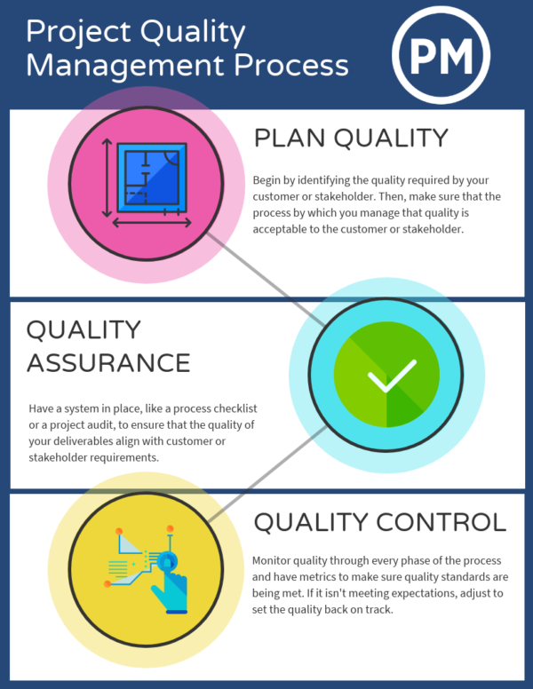
Project Life Cycle Phases
Execution
Monitor & Control
Planning

Q: 1.2 What are the main characteristics of project quality management?

The main characteristics of project quality management are:

- Customer satisfaction: overall objective of meeting all agreed customer requirements.
- Management responsibility: Buy-in and ownership of the management team to achieve goals and to provide necessary resource to achieve quality requirements.
- Prevention: proactive quality prevention planning within the project management process to avoid process failures and corrective actions.
- Kaizen technology: Kaizen culture and process adopted to apply continuous improvements to reduce costs and ensure consistency or project performance.
- Marginal analysis: to examine the additional benefits of process improvement compared to the additional costs incurred by that same activity. Used as a decision-making tool to help maximize potential profits and revenue.
- Plan-do-check-act (PDCA): the four-step problem-solving technique used to carry out change and improve business processes. This iterative cycle enables the project teams to avoid mistakes and improve processes.

Q: 1.3 What does the term ‘benefits and cost analysis’ mean? And how it is performed?

Cost-Benefit Analysis (CBA) is a process used to analyze a potential decision to determine if it is viable by considering both the benefits realized and the costs incurred if the decision is taken. Simply put this means that if the benefits outweigh the costs then it is viable, however if costs are greater than the benefits than it is not.

CBA is a widely known technique which can be used in many different types of decisions ranging from minor manufacturing process changes to major strategic business decisions. Examples of these could be deciding whether to introduce a new product or investing in new manufacturing equipment, or even whether to pursue a multimillion-dollar business acquisition.

From a quality management perspective, the CBA process can also be used as part of the project management activity whilst considering process, product or activity decisions. Project management is concerned with the costs of quality management activities versus the benefits realized from those activities. It is important not to invest time on quality activities which do not add value to the project, the customer or the business.

As part of undertaking a CBA process it is also important to understand if the benefits offered exceed the scope of the project or customers requirement. For example; a decision may be to introduce additional stability functionality to a product design at extra cost, which is aimed at providing a guaranteed extended product life of 5 years, despite the customer requirement specification only expecting a 2-year life and warranty period. Therefore, in this example it would be deemed that the extra cost of the product change is not viable because it adds no value to the project or customer. The project team should strive to deliver what was expected and not gold plate the process by adding extra functionality which drives up costs and alters schedules.

The 3 main steps for performing a CBA are summarized below and also shown in Fig.2):

Fig.2
Step 1: Compile lists: Conduct a brainstorm and compile a comprehensive list for all the costs and benefits associated with the potential action or decision.
Step 2: Give the costs and benefits a monetary value: Once you have two comprehensive lists of costs and benefits for the action, assign monetary values to each individual cost or benefit.
Step 3: Set up the equation and compare: Take the sum of the benefits (the sum of all the monetary values assigned to the benefits of the action) and the sum of the costs (all the monetary values of the costs of the action) and plug them into the CBA equation.

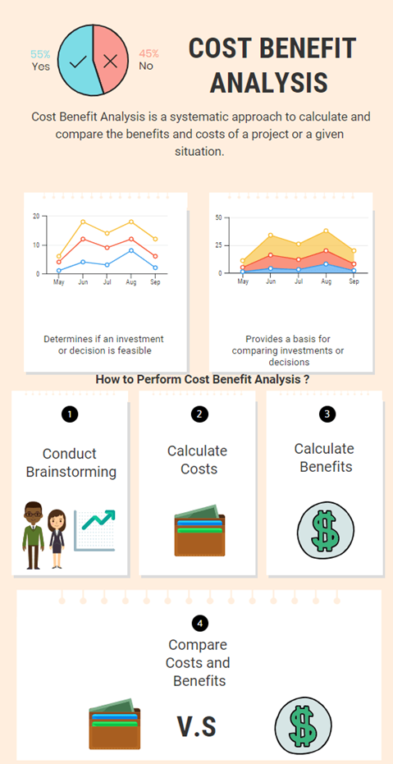

Q: 1.4 What is benchmarking?

Benchmarking is the practice of comparing business processes and performance metrics to industry bests and best practices from other companies. Dimensions typically measured are quality, time and cost. In project management benchmarking can also support the selection, planning and delivery of projects.

In quality project management the quality elements of a planned project would be compared to other projects within the same business or other organizations in the same industry. The objective is to evaluate differences and identify gaps, best practice and opportunities for continuous improvements in processes and corrective action implementation.

Q: 1.5 What is a flow chart? Discuss the Cause and Effect Diagram.’

A flowchart is a type of diagram that represents a workflow or process or how components in a system are related. Flow charts can be used in businesses for a variety of reasons such as managing cross functional business process, manufacturing, design and engineering processes and supply chain mapping.

In quality management they help project teams to identify where quality issues may occur and take action by being able to visualize and analyze the different process steps of the flow chart. Additional flow charts and diagrams can also be used in the quality management process to support the identification of the root causes of quality issues and corrective action implementation for prevention and to avoid recurrence of issues.

One technique used is a Cause and Effect Analysis and uses a cause and effect diagram also known as Ishikawa and fishbone diagram. This examines why something happened or might happen by organizing potential causes into smaller categories. It shows the relationships between the variables within a process and how those relationships may contribute to inadequate quality. An example of a cause and effect diagram is shown below (see Fig.3).

Fig.3
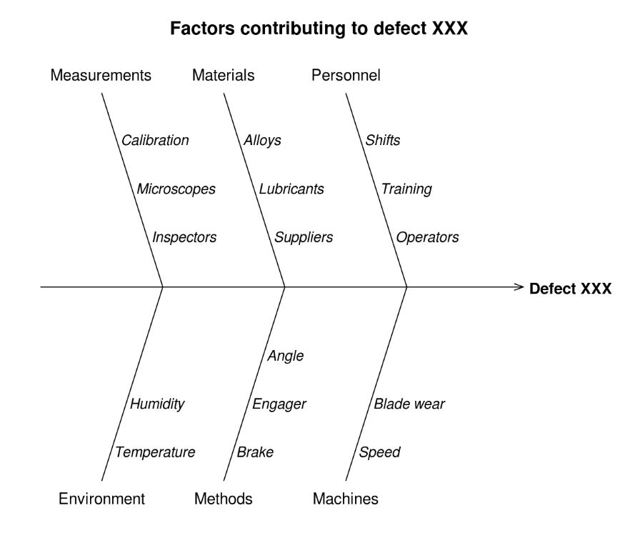

Q: 2. Discuss quality management plans. How will you complete quality assurance activities? How will you implement that plan as a manager?

Quality Management Plans

A quality management plan (QMP) can also be referred to as a quality system in business’s that work in an ISO9000 environment. In project management it is a document that describes how the quality policy is fulfilled by the project manager and the project team and describes how quality will be managed throughout the lifecycle of the project. It determines quality policies and procedures relevant to the project for both project deliverables and project processes, defines who is responsible for what, and documents compliance. Components of a QMP may include:

- Quality objectives
- Key project deliverables and processes to be reviewed for satisfactory quality level
- Quality standards
- Quality control and assurance activities
- Quality roles and responsibilities
- Quality tools
- Plan for reporting quality control and assurance problems

Quality assurance, quality control and quality improvements are three key elements that the QMP needs to address. Definitions of these are outlined below:

Quality assurance (QA): the work undertaken to apply the quality plan and is performed during the project lifecycle to evaluate the overall performance of the project. This is to ensure the project, product and deliverables meet the required quality standards.
Quality control (QC): results of any work undertaken are monitored to determine whether the required quality standards are met. Root causes analysis tools are used to determine corrective actions if needed. Results of the quality control process are used by the quality assurance process to determine if any changes are needed to plan.
Quality improvement: project performance is measured and evaluated throughout the cycle to identify continuous improvement opportunities. Corrective actions are applied to improve the project, product and deliverables if beneficial.

It is also to be noted for reference that in addition to the differences between QA and QC outlined above, there is a relationship hierarchy to be considered. To have QC you must first have in place QA which forms part of the overall Quality management system (see below Fig.4).

Fig.4

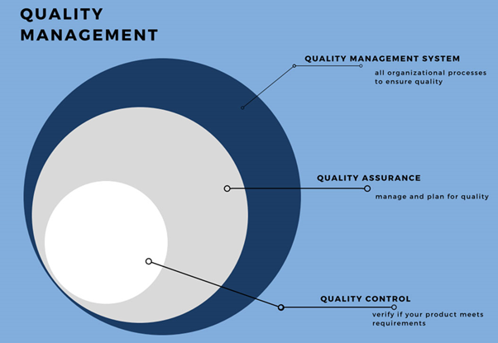

Quality Assurance

Quality Assurance (QA) is an activity focused on providing confidence that quality requirements will be fulfilled. Quality assurance comprises administrative and procedural activities implemented in the QMP or quality system so that requirements and goals for a product, service or activity will be fulfilled. QA activities are typically undertaken by the QA function in most organizations and it is an ongoing process throughout the entire cycle of a project. QA can be applied internally in a business to management and project teams or externally for customers of the project.

The primary focus of the QA process is to prevent mistakes and defects, avoid problems and make improvements within a project or when delivering products or services to customers. The iterative cycle shown below can be used for the QA process (see Fig.4).

Fig.4
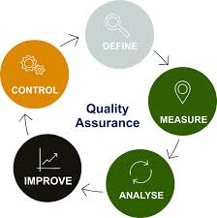

For the effective application and implementation of this QA cycle, the following inputs, methods, tools and techniques can be used:

Define:
- Define the project scope, process and key process inputs
- Understand deliverables and expected results of the project.
- Understand the metrics and units of measure that define project processes.
- Inputs required from the quality management plan (QMP) and project charter.

Measure:
- Establish and develop the measurement system and data.
- Evaluate project process, inputs and metrics and set the performance base line.
- Collect QC data measurement inputs for current performance results for project process and products.
- Undertake quality process audits to capture non-conformance
- Use benchmarking to compare performance.

Analyze:
- Analyze measurement data captured.
- Identify quality non-conformance, process failures and gaps.
- Identify, validate and select root cause for elimination.
- List and prioritize improvements and corrective actions needed.
- Use of tools and techniques, such as process flow charts and cause and effect analysis.

Improve:
- Verify and test solutions to problems.
- Identify solutions to eliminate root causes.
- Evaluate viability and benefits of changes.
- Implement approved corrective actions and improvements to project, process or product.
- Use of tools and techniques, such as brainstorming, change control systems, design of experiments, CBA and cost of quality (COQ).

Control:
- Embed changes to ensure sustainability.
- Monitor and track improvements made.
- QC to continuously measure and control processes.
- QC to capture data for further iterations of the QA cycle.
- Use of tools and techniques, such as statistical control, control charts, sampling and inspection processes.

Web page references:
Project Manager. Project Quality Management. Available at:
https://www.projectmanager.com/blog/project-quality-management-quick-guide

Project Management Skills. What is Quality Assurance. Available at:
https://www.project-management-skills.com/what-is-quality-assurance.html

asq.org. Learn About Quality. Available at:
https://asq.org/quality-resources/quality-assurance-vs-control

Student Statement:

By submitting this assignment, I confirm that this is my own work.

Student Signature | Phil Wood | Date | 27 Sept 2019

For Tutor / Assessor Use Only
Total Marks
Marks Obtained
Percentage / Grade

