
Assignment Cover Sheet

Student Name: | Simone Wilson
Student Number: | 16582
Course: | Interior Design Level 4 Diploma
Assignment NO: | 4

Marking Criteria:
We expect the learners to write minimum one well expressed point in three lines against each allocated mark. This means one needs to write 15 lines with 5 well expressed points to get high grades for a 5 marks question.
For high grades use examples and illustrations where appropriate.
Please insert your completed assignment ( in word format) here:

Simone Wilson
16582
No.4
Interior Design Level 4

Q.

  - In an interior design scheme when planning the rooms lighting should be taken into context as it is very important because each room looks different to each other in daylight and night also artificial lighting is used when the natural light isn’t there any more to provide the light needed, also natural light isn’t enough light too. A room has to be planned heedfully and colour needs to be taken into consideration as it links with lighting can both contribute to the overall atmosphere of the room. Both light and colour can make a dramatic difference to a space, light and colour are also linked with the amount of light that reflects off a particular colour can change the appearance slightly so it also needs to be an important factor. An interior designer will ensure that they know what colours to use and what light will be getting into the room in order to plan it accordingly. Also in a space where the light is it can make changes to how the room looks it can be a pro as well as a con for the room-for example it can make the good features stand out more and also eliminate the bad ones. Without one or the other, a space wouldn’t be complete so it is important they both link. The designer also has to consider how the room looks at each time of day before choosing the colours also the use for the room is to be considered too.
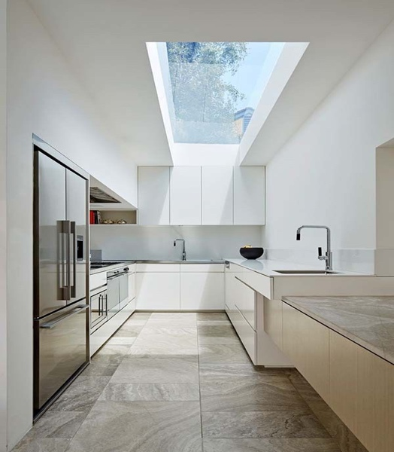

  - To maximise the height of a room that has a low ceiling you can first of all incorporate the use of curtain pelmets, however these would be placed just below the ceiling rather then where they are usually placed which is above the window top, this would then make the window appear much taller and therefore help to maximise the space and ceiling-the more light there is the more of an effect it will have on a room and the physical appearance. Also another change that could be made is to avoid using dark wallpapers because this makes the room look smaller and also with the ceiling being low it will have an effect on the space more too so as a result the designer would use vertically striped wallpaper(not horizontal paper)because this leads the eye up towards the ceiling with gives the illusion of more height. Thirdly another ceiling treatment which could be used in an interior design scheme is to ensure that the light in the room is best suited for the low ceiling, this would be fluorescent light bulbs that are cool toned which mimics daylight as they aren’t yellow and these are long lasting too but can also have a good effect on the size of the room.

  - A room can be further enhanced in a scheme by adding special and unique door treatments and also having the door contrast with the rest of the room, for example if a door was very modern then the décor would also be modern too. Also an interior designer can incorporate unique ideas and designs to customise the door for the client as well as incorporating the use of colour too, they can do this by; having the door painted the same colour or have it multiple shades darker or lighter. Also with door customisation it can beneficial for children too because their doors can be different than the others which includes having different designs and different shapes too, being shapes or animals could then link to theme of the room. Another way it can be further enhanced is by having a door that is cut out and the sections are glass as this creates a very antique looking door also it lets light into the room but it is normally frosted. If a door for example had crystal nobs you can apply this idea into the theme of the room and have mirrored furniture and accessories which would then develop the style further so it is present enough.
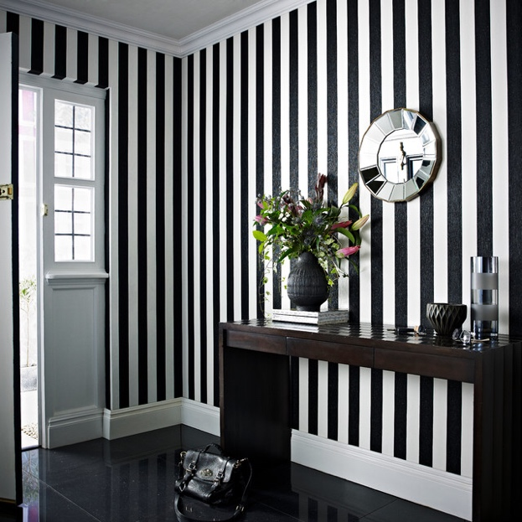

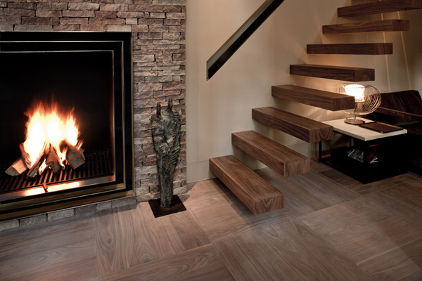
  - Flooring in an interior design project is very important, with the floor being such a large area or sometimes small it still has a certain amount of impact on the rooms appearance and the atmosphere that is given off too. With the floor needing to be comfortable it also adds colour and texture as well as it being durable so the designer needs to be able to have the flooring fitted up to a good standard and ensure the material that is chosen is durable. A lot of these elements need to be considered when deciding on the correct flooring because it needs to fit the purpose of the room as flooring is something that should last a long time and doesn’t require replacement often. A crucial element that should be considered is the; shape, size and style of the room because this determines the flooring type that is going to be used for the space which links to how the room is going to be utilised, e.g a bathroom floor is normally tiled flooring because it is easy to clean and needs to be suitable and put up with water steam and overall how humid the room can get. To get the flooring right the designer needs to consider if the space is going to be intimate or more open and spacious so the right colours and textures are used as well as the amount of the light that reflects into the room and how this would have an effect the flooring. For the architectural side it is important to have an idea about the exterior to know what is more suitable for the interior elements that would be included.

Q.
  - The orientation of a room is important when a design scheme is being put together because you need to know what is going to be used and where. Also it lets you get an idea of the amount of light that will be coming into the space. The orientation is to do with the layout of the room, after the designer knows the orientation of the room they figure out what needs to go where and also what room is going to be where, also the sunlight and the directions of the rooms is important because this determines where the rooms are and this helps to get the best use out of the room as it ensures that there is enough sunlight in the rooms where it is needed the most etc. This is a very important aspect to pay attention to because this makes sure that the building gets the best energy and that the building is cost effective too. It is one of the factors that needs to be taken into consideration way before anything else happens that the interior designer need to includes where windows are placed too.
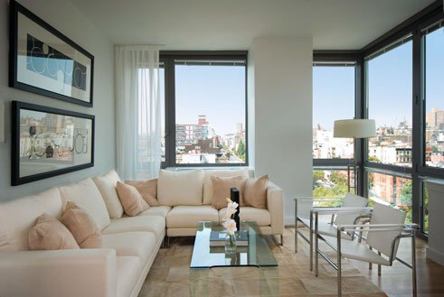
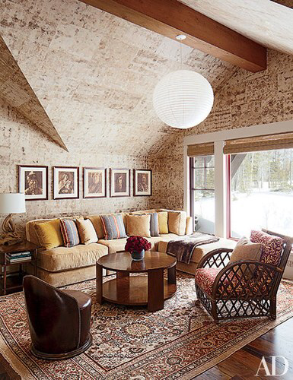
3.1. A Persian rug is a type of oriental rug(Persia). Firstly Persian rugs are considered to be the best of all the rugs, they are usually rich in colour and high in quality-they are very popular too they are mostly hand made so when they are they are priced highly because of the time that it would take to create the pieces. With these rugs the colours are vibrant the people that make them make sure then have intricate designs which are mailing floral. They are woven using wool and other luxury materials. Also Persian rugs are durable due to their high quality. They are pieces of art and each rug is made specially and with great attention to detail. Also some rugs are mad and then left over the years so as a result of this the value increases too, and the colour may become more richer too, they can last for hundreds of years as they are long wearing. Also depending on how many knots the rug has this can and the number of weavers that can also have an impact on the amount of time it takes for the rug to be made and also the size of the rug too and they are normally sorted accordingly to their design.

Student Statement:

By submitting this assignment, I confirm that this is my own work.

Student Signature | Simone Wilson | Date | 04/03/18

For Tutor / Assessor Use Only
Total Marks
Marks Obtained
Percentage / Grade

