
Assignment Cover Sheet

Student Name: | David Berks
Student Number: | 25275
Course: | Advanced Diploma in Construction Management Level 5
Assignment NO: | 12

Marking Criteria:
We expect the learners to write minimum one well expressed point in three lines against each allocated mark. This means one needs to write 15 lines with 5 well expressed points to get high grades for a 5 marks question.
For high grades use examples and illustrations where appropriate.
Human resource management involves the managing of all things relating to individuals and bringing out the best in those induvial to maximize output, productivity whilst looking out for the wellbeing and growth of the individual. In the past this has been the responsibility of the project management department, however in more recent times, the construction industry has moved in line with other industries and trends to develop a department dedicated to the human resources management. The type of function that the department will undertake will range from employees information systems, recruitment, inductions, training and development, employees welfare, industrial relations and maintenance of discipline. The range of activates is vast and the relevance in the construction industry has never been so important given that it is one of largest industries in the world. We have looked at materials, equipment, site set up but arguable none of this is important without the correct human / labour within the business. The type of individuals that come together in construction are very diverse from a labourer on £12 per hour to the Project Director on a £150k salary. The great thing about it though, is there is nothing stopping progression from the labourer to the project director, and there have been lots of examples where, with effective human resources support, this has happened.

Human Resource Department (HRD) is the development of employees working in the organization. As a subset of Human Resource Management (HRM) it aims at improving the skills, competencies, knowledge, behavior and attitude of people working in a specific organization. The main objective of the HRD is to improve, empower and strengthen the capabilities of staff. The main differences between HRD & HRM is that HRMD applies the management principles on a routine basis for the proper management of organizational employees. Whereas HRM refers to a continuous development funcation that is performed continuously with the intent of improving the performance of those working in an organization.

A table demonstrating the main differences is set out below;

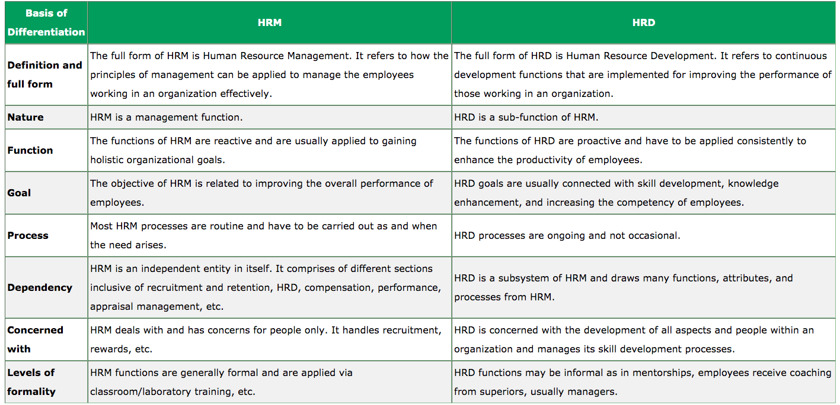

(2019) Difference Between HRM & HRD, Available at: https://www.stechies.com/difference-between-hrm-hrd/ (Accessed: 15th April 2020).

The intent of the Reward and compensation Policy aims to reflect;

- Pay and grading underpinned by job evaluation.
- Ensure that processes are transparent, and rewards and recognition are fairly and equitably applied.
- The need to encourage and enable people to perform to the best of their ability.
- The need to recruit and retain skilled, experienced and qualified staff in a competitive market.
- Create an environment of shared success and commitment.
- Demonstrate exceptional overall performance.

Policies can be based on three principles;

- Leadership – It is the responsibility of supervisors and leaders to take an active role in the performance management of their staff, to acknowledge and recognize the achievements of staff, to foster their engagement and to support their career development. Leaders should recognize the contribution by employees at all levels in relation to their opportunities to contribute.
- Accountability – Rewards and recognition must be applied fairly and equitably, care must be taken to ensure that no individual or group is inadvertently favored or neglected.
- Fiscal responsibility – Allowances and bonuses for outstanding performance.
Discipline is a set of rules prescribed by the organization for everyone to follow without exception. Managers are expected to set good examples for their subordinates in order to retain their respect. This means coming to work on time and being responsible when dealing with colleagues at work.
The aim of the disciplinary procedure is to help achieve and maintain the required standards of conduct, attendance and job performance, with procedures that apply to all employees and are fair and consistent.

MGS states Discipline ensures individuals behave in an acceptable way at the workplace and also adhere to the rules and regulations of the organization. Individuals who are disciplined are not only successful professionally but also in their personal lives. Disciplined employees are liked and appreciated by not only their superiors but also other fellow workers.
Prachi Juneja () Importance of Discipline and Punctuality at Workplace, Available at: https://www.managementstudyguide.com/importance-of-discipline-and-punctuality-at-workplace.htm (Accessed: 15th April 2020).

In terms of separation there are two types, voluntary and involuntary. Voluntary separation general involves Resignation, Voluntary retirement on medical grounds and voluntary retirement schemes.
Resignation – The reason for this could be a number factors, however the top 5 in 2020 were; No Progression, Low Pay, Recognition, Poor Leadership and Change of Career goals. Liz Stevens (2020) Top 5 Reasons Why Employees Leave Their Jobs in 2020, Available at: https://bestmoneymoves.com/blog/2020/01/29/top-5-reasons-why-employees-leave-their-jobs-in-2020/ (Accessed: 15th April 2020).

Involuntary Separation could been triggered based on the following reasons, Probation Period (Poor Performance), Termination based on Disciplinary Action. Also there is Compulsory Retirement, which could come into effect based on; Medical Grounds, Punishment of basis of disciplinary action, Loss of Confidence or Poor Performance

Working for a recruitment agency, I get to see first-hand the recruitment process in construction. There are two main type of recruitment process, contingent and retained. Contingent is when the client engages an agency or internal recruitment team to find them a suitable candidate, with payment of invoice on candidate starting in the role. Retained approach is when the client pays upfront for the agency to find a suitable candidate.
Looking at contingent, once the suitable candidates have been put forward to the hiring manager, it will be a process of selection. Selection is the process of selecting the most appropriate qualified person for the role based on education, experience and cultural fit.
Manpower planning involves implementing policies, procedures and practices to deploy the right number of suitable people “in the right job at the right time.” This is easier said then done for many businesses due to the ever changing project demands within construction. Some construction businesses have a wide range of project demands that require different skillset, also considering the geographical location and where the staff are based. A way that some businesses support the plan is to engage with temporary staff who can be used where they don’t have permanent staff or indeed the permeant staff don’t have the skill set.
Often manpower planning is reactive, meaning it only starts when a project is commissioned. Techniques that could be used are planning pre project start, which would be a proactive approach or to plan ‘on the job’ when the project is in progress.
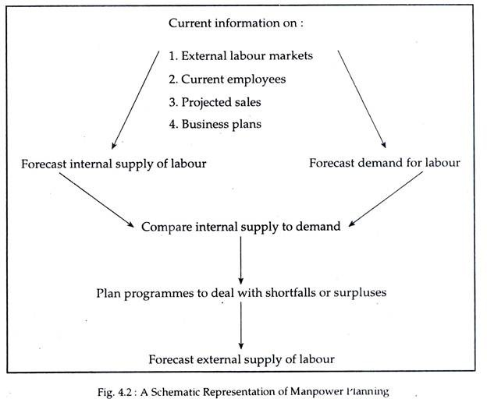

() Manpower Planning (MP): Meaning, Steps and Techniques | Manpower Planning, Available at: http://www.yourarticlelibrary.com/personnel-management/manpower-planning-mp-meaning-steps-and-techniques-manpower-planning/69314 (Accessed: 15th April 2020).

In the above representation the key techniques used are center around Forecasting. Short Terms, Long Term whilst the art of balancing the demand and supply of the manpower is key to the success.

The forecasting of manpower is usually based on the pipeline of projects and the demand that it could bring. An equation of success rates could be applied to bids to become better at forecasting over time.

References

(2019) Difference Between HRM & HRD, Available at: https://www.stechies.com/difference-between-hrm-hrd/ (Accessed: 15th April 2020).

Prachi Juneja () Importance of Discipline and Punctuality at Workplace, Available at: https://www.managementstudyguide.com/importance-of-discipline-and-punctuality-at-workplace.htm (Accessed: 15th April 2020).

Liz Stevens (2020) Top 5 Reasons Why Employees Leave Their Jobs in 2020, Available at: https://bestmoneymoves.com/blog/2020/01/29/top-5-reasons-why-employees-leave-their-jobs-in-2020/ (Accessed: 15th April 2020).

() Manpower Planning (MP): Meaning, Steps and Techniques | Manpower Planning, Available at: http://www.yourarticlelibrary.com/personnel-management/manpower-planning-mp-meaning-steps-and-techniques-manpower-planning/69314 (Accessed: 15th April 2020).

Student Statement:

By submitting this assignment, I confirm that this is my own work.

Student Signature | 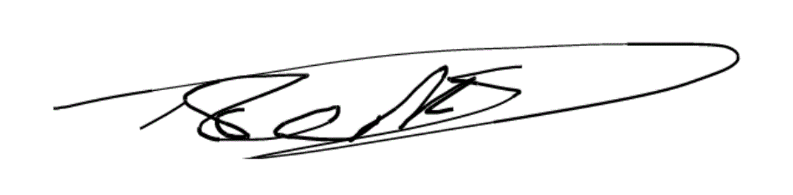 | Date | 15th April 2020

For Tutor / Assessor Use Only
Total Marks
Marks Obtained
Percentage / Grade

