
Assignment Cover Sheet

Student Name: | John Baker
Student Number: | 22719
Course: | Advanced Diploma in Construction Management Level 5
Assignment NO: | 9

Marking Criteria:
We expect the learners to write minimum one well expressed point in three lines against each allocated mark. This means one needs to write 15 lines with 5 well expressed points to get high grades for a 5 marks question.
For high grades use examples and illustrations where appropriate.
1. Answer the Following Questions: (18)
i. Outline the various elements of purchasing with the help of suitable case examples.
The main objective of purchasing is to ensure the availability of all ingredients for a project from start to finish without interruption. Purchasing high quality items at a low price ensures that the final product will be of a high quality and cost less. The purchasing function must be carried out using prescribed procedures such that items are of the highest quality, sourced from the right source at the right price, obtained at the right time in the right quantity using the right mode of transport and delivered to the right place.

ii. What are the main objectives of purchasing?
The Fundamental Objectives of Purchasing are as follows:
i. Maintaining
ii. Minimizing
iii. Prevent duplication
iv. Maintaining proper quality standards
v. Obtain valued for money in terms of obtaining lowest price items at the highest quality and functionality
vi. Helps to maintain organisation’s competitiveness by purchasing materials at reduced prices.

iii. What are the various prerequisites for becoming a good purchase manager?
The purchasing manager is responsible for reducing lead time for purchasing items. This is usually facilitated by having prior knowledge of lead time information for all items and taking practical steps to reduce the time it takes to place the order until it arrives and become ready to be used (i.e. the lead time). Provision should be made for emergency situations, such as an interruption in the delivery process due to floods or labour strikes. This implies making a rush purchase or buying more than what is needed but this must be considered carefully and only in emergency situations.

iv. What are the objectives and functions of stores?
The general definition of as store is simply where materials are kept to be used later during the course of construction. A store can be defined as a place for:

- Receiving raw materials, components, tools, equipment and other items and account for them
- Providing adequate and proper storage and preservation to the various items
- Meeting the demands of the user departments by proper issues and account for the consumption
- Minimizing obsolescence, surplus and scrap through proper codification, preservation and handling
- Highlighting stock accumulation, discrepancies and abnormal consumption and evolve effective control measures
- Ensuring good housekeeping so that material handling, material preservation, stocking, receipt and issue can be done adequately
- Assisting in verification and provide supporting information for effective purchase action

v. Describe the general criteria adopted for the layout of stores.
i. The design should make for easy identification of items
ii. Stored items should be easy to retrieve from the facility
iii. Design of layout should allow free movement of people and equipment
iv. Layout should facilitate preservation of materials from dust, moisture, chemicals etc.
v. Excellent lighting system
vi. Layout must make provision for effective fire-fighting
vii. Space should be available for toilet, maintenance and repair areas, safe wiring systems etc.
viii. The most economic layout should be arrived at after extensive analysis of alternative designs
Height of store must provide sufficient space to aid vertical movement:
ix. All major functional areas should be properly marked out and labelled. Areas for bulk storage, inspection section, receiving bay should all be clearly identified.
x. Racks, pigeon holes, bins are suitable for individual items
xi. It is best to fix the racks to the walls. Alternatively you may use revolving racks with castors
xii. Secure locking systems should be provided for expensive items
xiii. Ideally, trucks and lorries should be packed against the wall of the receiving bay to allow for easy loading and unloading of items using suitable ramps
xiv. Large doors and sufficiently-spaced columns are best
xv. High security measures should be in place
xvi. Security personnel should be present to prevent theft and store facility should be close to a police station
xvii. Excellent communication between departments concerned with storage issues should be encouraged for seamless operations
xviii. Training should be provided to personnel on how to use fire-fighting equipment effectively

vi. Differentiate between stock valuation and verification.
There is a distinct difference between the two terms "valuation" and "verification". Valuation is the monetary equivalent of the stock or material in hand whereas verification is the determination or quantification of the material in stock and checking its deviation from the figures shown in the books.

Valuation becomes necessary to assess the assets of the company for sale, determining insurance cover to be taken, during acquisition and mergers, get an idea about the difference between book and actual depreciation etc. Since the procurement price or sale price of a material does not remain constant, it is necessary to valuate the stocks regularly or during specific occasions. For example, if the price of an item in inventory which is required for producing something has gone up during its storage period, selling it by basing its selling price on the past purchase price can mean lesser margins. Similarly, if the price has gone down during the stocking period, selling it at a higher price can mean being outpriced by competition.

Since valuation methods can increase or decrease assets, companies occasionally resort to manipulating the valuation methods to present rosy or drastic pictures as the case may be. For instance, the gross profit is the difference between net sales and costs of production. Since materials cost is a part of production, the valuation basis can determine whether the company is going to have profits or losses. Frequent unauthorised changes are illegal. Under the companies act, a change in the method of valuation has to be approved by the Board of Directors of the company and must be reported alongwith the effect of changes in the profitability due to the changes in method of valuation duly certified by the auditors

2. Discuss the different stages of "material procurement cycle". (6)
When items pass quality checks, they are dispatched to the warehouses or stores for storage. The end-use department may request for the item following store system procedures. All stages in the material purchasing system can be classified as a “ Material Procurement Cycle”.
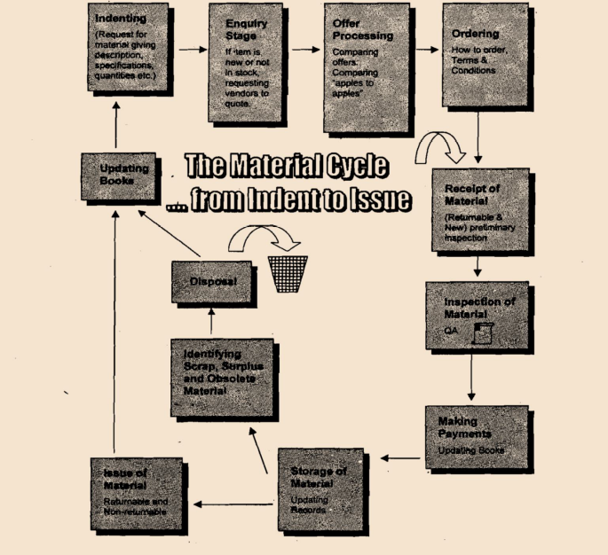

3. Explain the various tendering system used for ordering the material (6)
This method of procurement is prevalent in the private sector. The objective of this tender system is mainly to encourage fair and competitive pricing and to discourage favouritism or nepotism in procuring items. Nepotism usually occurs when the terms and conditions or the specifications seem to favour one particular vendor. Loading is done to eliminate nepotism by comparing all advantages and disadvantages of purchasing a specific item from vendors in terms of cost and productivity. For instance, a machine which is more expensive may be many times productive that a less costly one. Detailed specifications would ensure objectivity and eliminate suspicion of nepotism.
There are 3 methods of tendering to choose from:
i. Open tender
ii. Limited tender
iii. Single tender

Open Tender
The process begins with the publishing of Notice Inviting Tenders (NITS) in major newspapers and Trade Journals. The tenderers are expected to purchases the tender documents which contain the terms and conditions, as well as the specifications of the project. There is also an option to submit a technical or commercial bid during the process. Tenderers are expected to provide quotes and meet all contractual obligations or a certain minimum technical specification with regards to the terms and conditions. If any deviations occur in the quantity of supply or with the terms and conditions, then this would have to be discussed to arrive at an agreeable solution.
Costly items with high technological content which require global tenders are financed by international financial institutions like the IMF (International Monetary Fund). To ensure a smooth tender process, clear and simple language must be used for this type of tendering. Also, a comprehensive checklist should be prepared before embarking on this global order.
The main problem present by the open tender method is that of the ‘rogue bidder’ who quotes very low prices to win the contract only for him to attempt to renegotiate terms for an increase in payment once the buyers have committed a lot of investment to the project.

Limited Tender
This type of tender is designed to solve the ‘rogue bidder’ problem. It requires having a limited number of bidders who meet certain pre-defined specifications. Precautions must be put in place so that genuine bidders are not disqualified or the criteria for qualification do not favour one particular bidder. Limited tender produces reduce lead times.
Simple Tender
This type of tender is ideal for proprietary items but should be avoided to prevent unfair pricing or blackmail. It may, however, be useful when frequent repeat orders are required in order to reduce lead time during contract negotiations.

Student Statement:

By submitting this assignment, I confirm that this is my own work.

Student Signature | J Baker | Date | 20/08/2018

For Tutor / Assessor Use Only
Total Marks
Marks Obtained
Percentage / Grade

