
Assignment Cover Sheet

Student Name: | Doreen Ntalo
Student Number: | 32621
Course: | Advanced Diploma in Hotel Management-Level 5
Assignment NO: | ASSEEEMENT #1

Marking Criteria:
We expect the learners to write minimum one well expressed point inthree lines against each allocated mark. This means one needs to write 15 lines with 5 well expressed points to get high grades for a 5 marks question.
For high grades use examples and illustrations where appropriate.
Please insert your completed assignment ( in word format) here:

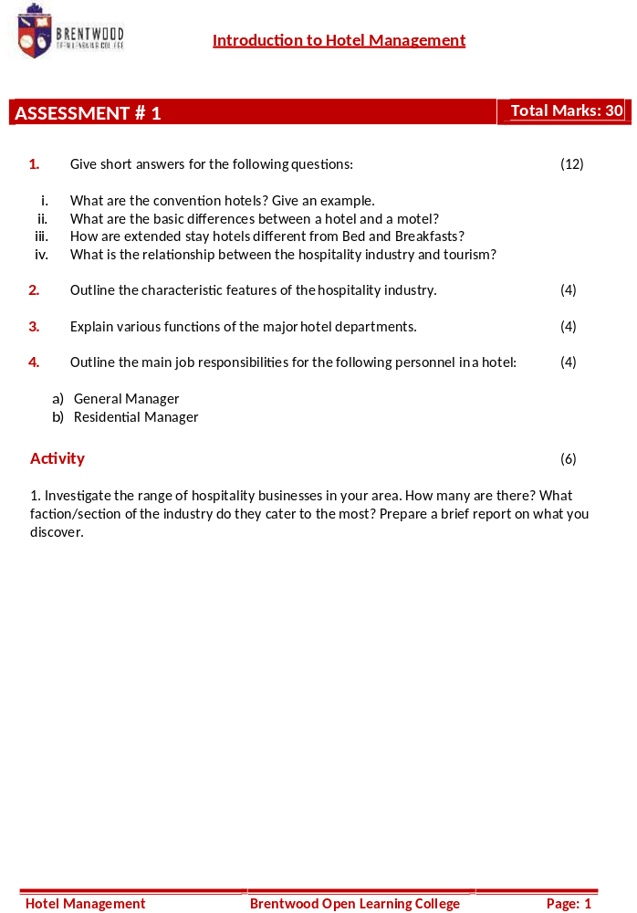

Student Statement:

By submitting this assignment, I confirm that this is my own work.

Student Signature | Doreen Ntalo | Date | 16 April 2019

For Tutor / Assessor Use Only
Total Marks
Marks Obtained
Percentage / Grade

Doreen Ntalo
32621
Assessment #1
Page: 1
1.
- These are hotels that provide a large quantity of rooms with a 24-hour room service for accommodation, extensive meeting and function space for holding conventions. They also have banquets within and around the hotel complex, in-house laundry, business centre, airport shuttle service and are often in close proximity to convention centres. For example; Imperial Royale hotel Limited- Kampala, Uganda

- Hotels provide… lodging, usually meals, entertainment and various personal services for public whereas Motels… provides lodging and parking in which the rooms are usually accessible from an outdoor parking area.
- Hotels provide more amenities whereas Motels only provide basic facilities.
- Hotels are expensive whereas Motels are cheap
- Hotels have better security whereas Motels may have security issues since rooms are accessible from the outside.
Difference Between Hotels and Motels [online.]. Available at: pediaa.com [Accessed: 28 June, 2016]
- Extended stay hotels are properties that cater to customers who stay for an extended period and offer full kitchen facilities, shopping services, business services and limited housekeeping services whereas Bed and Breakfast hotels are family owned private properties whose owner lives near the premises and rents out rooms to overnight customers where the paid accommodation typically includes breakfast.

Doreen Ntalo
32621
Assessment #1
Page: 1
1.
- The hospitality industry consists of hotels, restaurants, transportation and leisure activities… [which provide accommodation, food and drinks, travel and fun activities which are] basic services needed for the tourism industry. Relationship Between Tourism & Hospitality [online]. Available at: https://study.com/academy/lesson/relationship-between-tourism-hospitality.html [Accessed:22 March, 2017]
2.
- Product-service mix
- Two-way communication
- Relationship building
- Diversity in culture
- Labor intensive
3.
- Engineering; responsible for maintaining the physical plant of the hotel such as electricity, plumbing, air conditioning, heating and elevator systems; and for overseeing all mechanical and technical conditions of the hotel.
- Security; responsible for implementing procedures which aim at protecting the safety and security of hotel guests, visitors, hotel employees and the hotel itself. Examples include monitoring surveillance equipment, patrolling the hotel premises and maintaining security alarm systems.
- Human Resources; responsible for hiring, orientation, training, wages and benefit administration, labor relations, employ relations and staff development.

Doreen Ntalo
32621
Assessment #1
Page: 1
- Food and Beverage; provides food and beverage services to the hotel guests and visitors through a variety of outlets and facilities/ services. Examples include lounge, bar, coffee shop, restaurants, banquet service, room service… and cake shop.
- Sales and Marketing; involves generating new business for the hotel, coordinating advertising, as well as promotions and public relations activities aiming at enhancing the hotel’s image.
- Accounts; can guide the hotel to an increasing profitability through better control and asset management. Also responsible for monitoring all of the financial activities of the hotel. Examples include overseeing accounts receivable, accounts payable, payroll, and cost control systems of the hotel; keeping records of assets, liabilities and financial transactions of the hotel. Et al.
4.a)
- Providing leadership to the management team;
- Coordinating the work of all departments;
- Participating in the formulation of hotel policies and strategies;
- Leading the hotel staff in meeting the financial, environmental and community responsibilities;
- Assuming full responsibilities for the overall performance of the hotel.

Doreen Ntalo
32621
Assessment #1
Page: 1
4.b)
- Holding a major responsibility in developing and executing plans developed by the owner(s), the general manager and other members of the management team;
- Checking on operations, providing feedback and offering assistance when needed;
- Completing, reviewing and summarizing statistical reports and sharing them with the general manager;
- Assuming responsibilities for the daily operations and management of the hotel.

Doreen Ntalo
32621
Assessment #1
Page: 1
Activity
- Uganda has over 3000 hotel establishments with over 20,000 and 30,000 rooms and beds respectively. UGANDA HOTEL SECTOR OUTLOOK, CHALLENGES AND PROSPECTS [Online]. Available at: https://ugandasafariportal.wordpress.com/2014/06/25/uganda-hotel-sector-out-look-challenges-and-prospects/ [Accessed: 25 June, 2014]
[Faction/section catered to most is Accommodation and Infrastructure]Uganda’s hospitality industry recovering [Online]. Available at: https://observer.ug/component/content/article?id=29746:ugandas-hospitality-industry-recovering- [Accessed: 21 January, 2014]
Building hotels has yet again become trendy. Industry players say the renewed interest in the hospital sector is driven by the growth in Uganda’s economy.” Continued economic growth will see increase in business travel in the country as long as ‘brand Uganda’ continues to market itself on the international stage, the tourist numbers should grow as well,” Danny Bryer, the director sales, marketing and revenue Protea Hospitality group said... Stuart Cook, the head of Protea hotels in Uganda, said: “Protea hotel has been running at high occupancies since it first opened; so, building a new wing is a necessity.
According to the protea hospitality group’s 2013 Africa pipeline study, Uganda could increase its room occupancy by 54% depending on planned projects…
Balagadde, the executive director of Uganda Hotel Owners Association, feels that much more should be done in terms of infrastructure …

