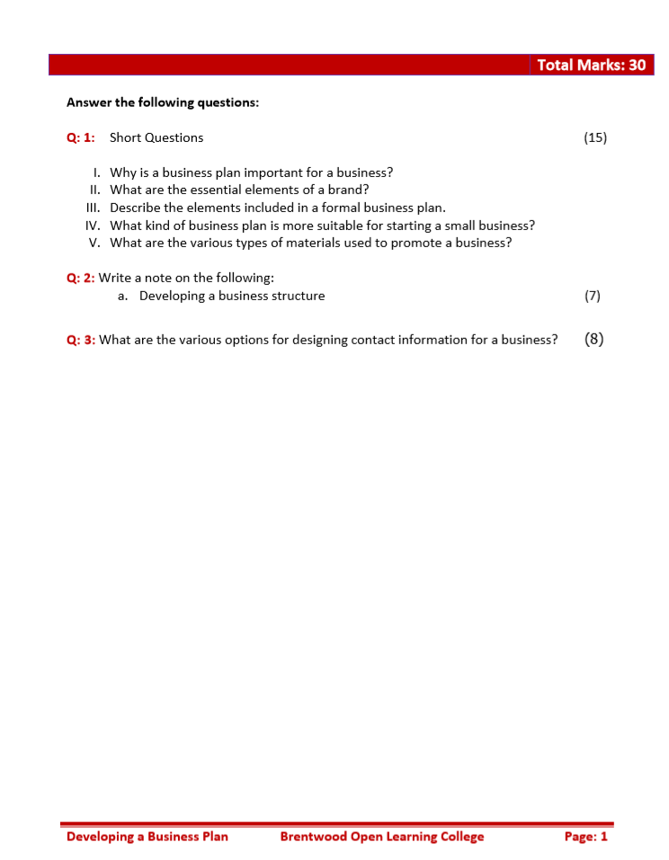
Q: 1: Short Questions

- Why is a business plan important for a business?

The business plan take a close look at many aspects of plan and commit to them. It will clarify the business and expose any issues that will need to be resolved before the business is launched.

- What are the essential elements of a brand?

Company name ,Slogan Logo

- Describe the elements included in a formal business plan.

Executive summary
Table of contents
Company description
List of products and services
Market analysis
Organizational structure
Operations plan
Marketing and sales strategy
Financial projections
SWOT analysis (strengths, weaknesses, opportunities, and threats about several aspects of the plan)
Glossary (helpful if audience is not familiar with industry jargon)
Supporting details (such as logos, graphic representations, and charts

- What kind of business plan is more suitable for starting a small business?

The One-Page Plan
This type of plan usually includes Company description ; List of products and services ; Marketing and sales strategy ;Financial projections

- What are the various types of materials used to promote a business?

Business cards
Stationery
Website
Social media pages
Leave-behinds for clients (packets of information that contain boilerplate information about business and services, and include space for project estimates and other client-specific information)

Q: 2: Write a note on the following: a. Developing a business structure
Most consultants start out with themselves as the sole employee of their business. They will use the title in between of (President ; CEO; Principal; Chief Consultant • Director • Owner ).However, depending on the type of consulting business, they may have other full-time consultants, employees, contractors, or freelancers are step by step added.
Q3: What are the various options for designing contact information for a business?
A smartphone with e-mail and Internet access, text messaging capabilities, and support for video calls is essential. conference call services, virtual assistants, and answering services could also be used.
The business should also have a fax number and mailing address or at least postal Box Internet faxing is easy and cheap, and can often be accessed from any computer
The website should have business own domain name, as well as several e-mail addresses with that domain name.

