
Assignment Cover Sheet

Student Name: | Rebecca Lahney
Student Number: | 29357
Course: | Certificate in Bookkeeping Level 3
Assignment NO: | # 3

Marking Criteria:
We expect the learners to write minimum one well expressed point in three lines against each allocated mark. This means one needs to write 15 lines with 5 well expressed points to get high grades for a 5 marks question.
For high grades use examples and illustrations where appropriate.
Essay 3
1. What is the meaning of account payable and receivable? (5)
Account payable refers to “records used to keep track of debts owed by a company…and the actual debit of a business.” (Brentwood 2019, p. 2-3) This refers to either the general ledger liability account, bill paying department or the process of reviewing invoices and bills. (Averkamp 2004-19, p. 17) According to Averkamp (2004-19) the examples above are reconciled using a three way process, which compares; the vendor invoice, the company’s purchase order and the company’s receiving report. This is recorder in the ‘liability’ section within the balance sheet. (Averkamp 2004-19, p. 18) Whereas account receivable are monies a company is owed; these records capture when a company has sold a product or goods, provided a service, or credit. (Averkamp 2004-19; Brentwood 2019) A company usually has a 10, 30 or 60 day limit, in which to settle debt or pay a line of credit. These entries are classified as ‘current assets’ and reordered thus e.g.: $1000.00 debit in ‘accounts receivable’ and $ 1000.00 credit in ‘sales revenue’. (Khan, S 2019)

2. What is ledger account explain with illustrations? (5)
EG: Account - Advertising expense, Date – 5 Jan, Description – newspaper adds, Post. Ref – p.20 (from Journal entry), Debit - $200.00, Balance $200.00 dr. (Tuft, B. 2019, 1:00/3:27)
[See image below]
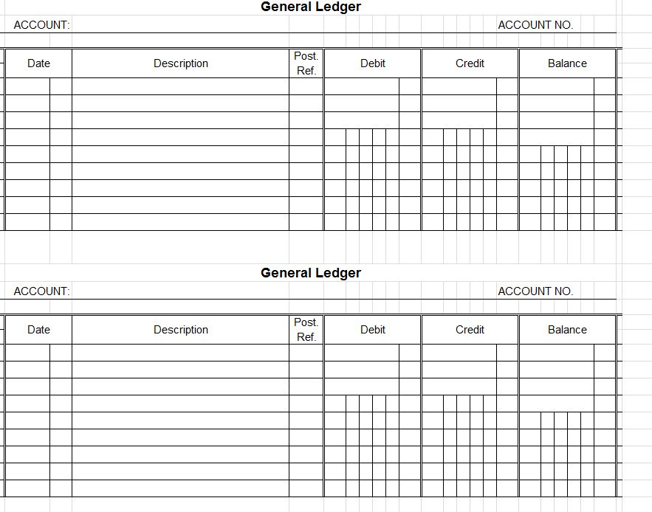
Figure 1
[Image by: http://exceltemplates.net/financial/budget/accounting-ledger-template/]
As seen in the above image, a ledger account contains a record of business transactions which is used to store, record and sort business transactions into a chronological order. (Averkamp, H. 2004-19, p. 3) It is a separate record within the general ledger that is assigned to a specific asset, liability, equity item, revenue type, or expense type. These entries are; transcribed into the General Ledger within the accounts page to which they pertain, allocated a post. Ref. and checked off the journal entries as completed or entered. This process is known as the second step in accounting which involves transferring ‘accounts’ from the journal into debit or credit within the general ledger. These records are ongoing and permeate into the next financial year. (Tuft, B. 2019, 1:22/3:27 )

3. How can you differentiate between the journal and ledger account? (5)
GENERAL JOURNAL (all transactions debit and credit as they occur in time).
GENERAL LEDGER (summarised, organised or reorganised data into separate accounts).
INVOICE (data to be processed and reordered).

Concept by: Larry Walther The General Ledger, March 13th 2010.
The above diagram demonstrates the flow, sequence of events and type of data reordered from an invoice, into the General Journal, then into the General Ledger.
The General Journal is a list of transactions (as they occur) in credit or debit form. Information goes from the General Journal (original entry) then periodically (daily, weekly or monthly) the entries are posted (or transcribed) to the General Ledger, onto the corresponding ‘accounts’ page for each type of account i.e. cash, advertising, wages etc.
The General Ledger data entries from the General Journal are reorganized into; date and consolable, legible and organized data which is collated and reordered dependent on type of account i.e. accounts receivable, inventory and so forth. (Brentwood 2019, p. 8; Walther, L. 2010)
What is reordered in the Journal vs. the Ledger……
General Journal | General Ledger
Original entry | Final collated entry
Daily entry | Entered periodically weekly or monthly
More information and specifics of transactions | Reordered per account, per page
Both credit and debit transactions | Only one entry

(Brentwood 2019, p. 7-8)

4. What is meant by petty cash book? (5)
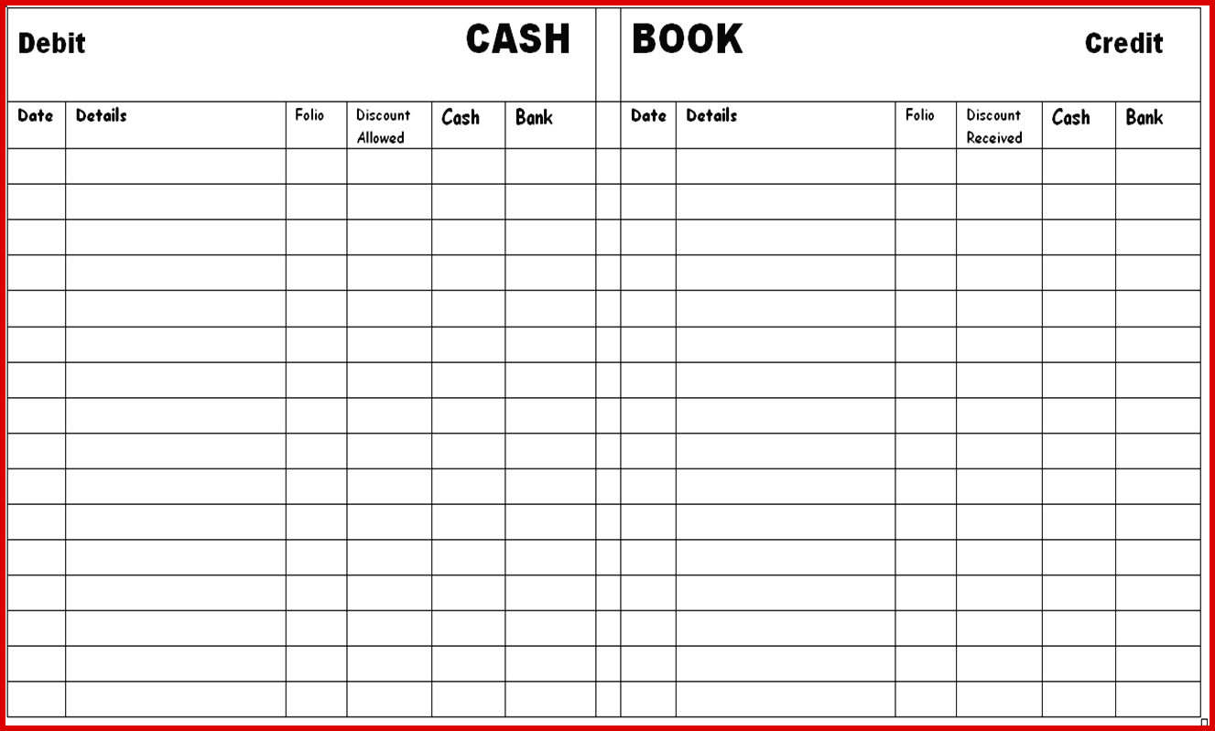

[Image soured at: https://www.ulyssesroom.com/template-ideas/008-accounting-ledger-format-beautiful-general-journal-entry-template-voucher-double-of]

The petty cash book example seen above is a record or short summary of outgoing cash expenses; used to account for small and infrequent amounts of money and reordered as a sub-division of journaling. (Prof. D. Alldridge, 2015) Such items reordered can include; postage, tea/coffee, stationery, services etc. Within the journal a double entry is required firstly a debited amount to ‘pretty cash fund’ i.e. $60.00 the second entry is a credit to ‘cash’. In effect, the company writes itself a cheque, then cashes it back into credit within the ledger. ( Prof. D. Alldridge 2015; Brentwood 2019, p.11-12) The left debit column records “cash value received” while the right column records “cash payments relating to petty cash”. (Brentwood 2019, p.11-12) Petty cash requires; applying and establishing a float or amount, approval from the Chief financial officer and a system of either ‘cash advance’ or ‘reimbursement’ of monies spent. (Prof. D. Alldridge 2015; Walther, L. 2010; Brentwood 2019)

5. What is meant by single and double entry system? How the entries are recorded using this method? (5)
DOUBLE ENTRY SYSTEM | SINGLE ENTRY SYSTEM
Follows defined rules and or norms | No specific rules
Dual entry system | Single entry only
Includes all transactions | Cash transactions with debtors and creditors
Complex | Simple

Single entry lists and records simple cash transactions, a short summary is prepared and amounts added and totaled at the end of each month.
Date | Description | Account | Amount
04/01/2018 | Office rental | 1962 | 3500.00
12/01/2018 | Material | 2010 | 800.00
18/01/2018 | Wages | 2223 | 2300.00
22/01/2018 | Electricity | 1298 | 560.00
MONTHLY TOTAL |  |  | 7.160

(Averkamp, H. 2004-19, p. 5-6)
Whereas the ‘T-Account’ is used as a visual aid to capture movement and expenditure of monies within a dual entry record.
(ACCOUNT)
Cash
No. (DEBIT) | No. (CREDIT)

Cash Common Shares
500,000 500,000

(debit to Cash account) (credit to Common Shares account)

Whilst following the formula = Assets = Liabilities = Owners Equity
Dr. (+) Cr. (-) Dr.(-) Cr, (+) Dr. (-) Cr.(+)

This system is designed and used for more complex accounting where a ‘double entry’ or (entry within two or more accounts) for each transactions is reordered, one a credit the other a debit. Double entry system uses three stages original records (journals or sub-journals), classification (leger accounts) and Summary (profit and loss balance sheet). (Averkamp, H. 2004-19, p. 5-6; CFI education inc. 2015)

6. What are the disadvantages of single entry system?
The disadvantages of the single entry system include; (1) prone to error and fraud as a second entry and trial balance is not required therefore entries are not checked for accuracy or authenticity. (2) Sources of profits and losses are not reordered this is viewed as impartial or incomplete accounting. (3) The accounting principles and rules are not followed in this type of accounting. In short, this system does not provide detailed entries needed for effective accounting within a large corporation or business. (Averkamp, H. 2004-19, p. 6-7; CFI education inc. 2015)

BIBLIOGRAPHY
Professor D. Alldridge, ‘Financial Accounting: Petty cash Account’, Jan 8th 2015, online video [Accessed: 3rd March 2019].

Averkamp, H., Accountingcoach.com Guide to Bookkeeping Chapter 4 & 10 [Online]. 2004-2019. Available at: https://www.accountingcoach.com/prosamples/GuidetoBookkeepingConcepts.pdf
[Accessed: 24th January 2019].

Brentwood Open Learning College., 664057922Unit 3 Keeping Track of Your Business.pdf, pp.1-12. www.bolconline.co.uk [Accessed: 28th January 2019].

Corporate Finance institute, A guide to understanding T Accounts [Online]. 2015. Available at: https:www. Corporatefinanceinstitute.com, CFI EDUCATION INC. [Accessed on: 09 March 2019].

Khan, S., Khan Academy - Introduction to balance sheets date [Video Recording]. 2019. https://www.khanacademy.org/economics-finance-domain/core-finance Created by Sal Khan [Accessed: 26th January 2019].

Tuft, B,. ‘How to post to the General ledger - accounting videos with brandy, 3:27.
Apr 28th 2016, [Accessed: 3rd March 2019].

Walther, L., ‘The General Ledger’, March 13th 2010, online video, viewed on YouTube at http://www.principlesofaccounting.com [Accessed: 29th February 2019].
Figure 1
Unknown, http://exceltemplates.net/financial/budget/accounting-ledger-template/ [viewed on 24/02/19]

Student Statement:

By submitting this assignment, I confirm that this is my own work.

Student Signature | Rebecca Lahney | Date | 10/03/2019

For Tutor / Assessor Use Only
Total Marks
Marks Obtained
Percentage / Grade

