
Assignment Cover Sheet

Student Name: | Michael (Mike) Sparkes
Student Number: | 29285
Course: | Advanced Diploma in Child Psychology (Level 5)
Assignment NO: | 08

Marking Criteria:
We expect the learners to write minimum one well expressed point in three lines against each allocated mark. This means one needs to write 15 lines with 5 well expressed points to get high grades for a 5 marks question.
For high grades use examples and illustrations where appropriate.
Please insert your completed assignment ( in word format) here:

Development of Language and Communication.

Assessment 8.
Student. Michael (Mike) Sparkes.

1.
i. I have already mentioned the famous psychologist, Benjamin Bloom, and his various researches into child behaviour and development. However, here, we are looking into his research on language development.

Bloom conducted his research on the development of language using 12 children. His findings show significant differences in the age that children started using their first words.

His findings showed that children will use their first recognisable or, put another way, adult term words, typically at the start of the second year. Obviously, as all children are different and develop at different stages, this is purely a guide and should not be taken as an exact timing. It was noted however, that some children that showed extraordinary abilities, started to speak from as early as 10 months old, where some children do not get their first word out until they are around 18 months old.

Those children that achieved language success within their first year, later indicated that they were smart in school awareness, academic and mental growth. It is a fact that there is a vast difference between children who demonstrate early vocabulary development and those children who will, and do, develop these mentioned skills in the later stages. As a general rule, a child, or children, that shows oral skills vast exceeding the norm, including spoken vocabulary and discussion are more intelligent and sharp in sight and sound approaches.

By the time the child reaches the age of five, it is said that he or she should have mastered the sentence structure and audio system of their chosen language and have within them, a large number of words. It is said that this development process is one of the most amazing in early childhood years.

1.
ii. What is Lexical Development?

Lexical development is the study of changes that occur in vocabulary knowledge over the course of childhood. It concerns the child’s first steps in the building of a vocabulary, how children of varying ages assign meanings to words and how these meanings can change in response to various experiences. I have given examples below.

It is a recognised fact that vocabulary size increases in line with the child’s age increase and as the child comes into different situations etc.

Observations show that children……

- Recognise and understand their first words around the age of 5 months.
- Start making their own words between the ages of 10-15 months.
- Possess a vocabulary of approximately 50 words by the age of 18 months.
- Possess a vocabulary of approximately 100 words by the age of around 21 months.

Advancing from 21 months, the Lexicon grows quickly making it impossible to fully calculate the exact number of words. It is said that a typical child of 6 year’s vocabulary is estimated to be somewhere around 14,000 words.

iii. By approximately the age of two, a child begins to form short sentences by putting different words together. What comes out of the child’s mouth is not always correct and came often be incomplete or incorrect as they have yet to learn how to everything in the right order. However, once the child has gained full control in making grammatically correct sentences, it is said that Morpho-Syntactic Development has taken place.

So what does Morpho-Syntactic Development mean?

Morphosyntax is the study of grammatical categories or linguistic units that have both morphological and syntactic properties within them.

The diagram below shows where Morpho-syntactic development appears in the overall development process.

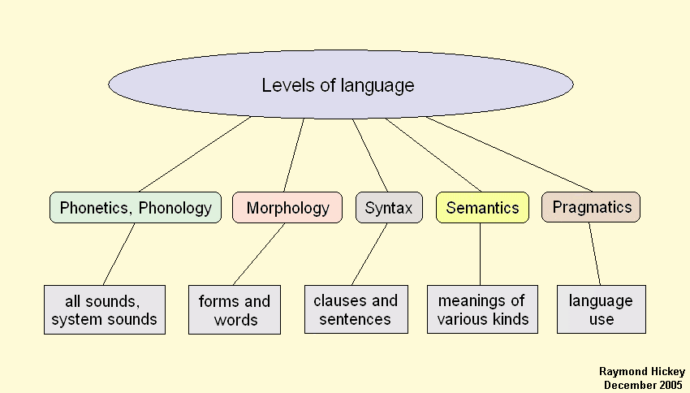

A brief breakdown of the most important areas of Morpho-Syntactic Development.

Complex sentences. Between the ages of 2-4 years. Children begin to use more difficult sentence structures. It is said that understanding comes before manufacturing as a child does not fully complete this process until about the age of 4

Language Development Importance. The most noticeable and so possibly the most important success to early childhood is the learning and so also the speaking of the language. Children are provided with the language tools to assist them and in turn this opens up new possibilities for public learning and sharing other experiences.

Importance of School life in Language Development. It is known that school plays a huge part in language development and none more so than in the early years, The child learns new words, new ways to use the language by listening and watching others. This tends to be more prominent in the first years of a child’s school life as the development is fastest at this point and thus, the acquisition of the language has a direct effect on the child’s future.

Language Impairment and Problems.

Of course, some children will not learn at the normal level and are slow by nature. Many will not participate in various activities that may help in their language development. These children that display poor language and learning skills are said to be facing language impairment.

Children lack the ability to read at a sufficiently adequate level show a lower level of academic performance than their peers. If a child possesses a language disorder, they may be unable to express their emotions and feelings which may lead to serious future issues in the socialisation process.

Other factors that will influence language development include the following.

- Social development / Verbal environment.
- Perception (i.e Observation and Understanding).
- Cognitive Processes.
- Conceptual Processes (Based on concepts)
- Linguistic Processes (Based on language)

For all the above, different researchers have different view points regarding the factors that influence language development. However, the majority of these researchers agree that these factors are interrelated, in other words, they relate and connect to each other in some way.

- Lisping. (also known as ‘unconventional articulation of the sibilants)

A ‘lisp’ is a speech defect that involves pronouncing an ‘S’ sound so it comes out of the mouth as a ‘th’ sound and a ‘z’ also as a ‘th’. For example, a person that has a lisp may say the word ‘sounds’ so it is heard as ‘thounds’. Saying the ‘s’ sound like a ‘th’ is quite typical amongst very young people and is quite often outgrown by the time the child reaches the age of about 7 years. Many conversation analysts consider lisping to be an aesthetic or artistic problem, rather than it being an actual or real language problem and often will treat it as such. In an attempt to stop or correct a lisp, the following should be considered.

- Try and discourage the child from sucking their thumb.
- Mouth respiration can encourage lisping so attempt to cure any colds, allergic reactions or nasal issues as quickly as possible.
- Offer the child the use of a straw when drinking cold beverages which will help build up lip strength. The blowing of bubbles or a reed device will often provide the same advantage.
- Help your child to make sounds with the help of their teeth. This helps to train the tongue to stay in the correct position to produce the desired sound.

- What is stammering?

Stammering, also known as stuttering, is a speech disorder in which the flow of the speech is disrupted by involuntary repetitions and prolongations of sounds, syllables, words or phrases as well as involuntary silent pauses or blocks in which the person who is stammering is unable to produce the correct sounds.

In a child, stammering is most common who are between 2 and 6 years of age. There are many schools that have been set up to help deal with the children facing this condition. It is often recommended that a course of treatment is given by speech therapists or pathologists should the condition continue for more than six months.

Again, to help to prevent stammering in children, there are a number of precautionary measures that parents can take. Below are a few examples of what can be done to prevent stammering.

Precautions to prevent stammering in children. Mainly administered by parents/primary care givers.

- Parents/care givers must speak slowly and precisely to a child who stammers as this will encourage the child to slow their speech down.
- Parents should listen with due care and attention thus to allow adequate time for a complete conversation.
- Parents should never criticise or tell the child off who stammers. This will shatter the child’s confidence and could cause the child to not work towards speaking better straight away or in the future.
- Parents should not force the child to complete the sentence, nor should they hurry them along and try to complete the sentence for them by re-empting their words. This will quite often confuse the child and may, at the very least, make them self conscious.
- Parents must allow the stammering child to express their feelings and needs. A stammering child is very often extremely aware of their difficulty. Any negative reactions from their peers or friends may make the child less verbal.

In time, and with love, support and training, many children who go through adolescence with a stammer learn to control it and will lead a perfectly normal life. With this in mind, and stammering should be addressed and treated as soon as possible.

- Factors that influence language development in Children.

There are many factors than can, and do, influence language development in a child. Below are a number of examples of this and why it can have a small, or indeed, large, influence on how a child develops speech and language.

- Stimulation. In other words, talking and playing with the child. If a child has plenty of stimulation, for example when playing with the child, they are spoken to and given the opportunity to interact in role play or a board game that requires speech from the players etc, then they will start to develop skills as to when it is appropriate to respond rather than just talk over others and learn how to control their excitement and enjoyment of the game. It may also involve outings such as going to the park where they start to interact with others and learn how to know when it is their turn on a particular piece of apparatus etc. However, the child that does not have this type of interaction, such as they are left in front of the TV with a program or a DVD, then they tend to just sit and watch, without making any noise as the television does not ask questions or interact with the child other than to show what is going on beyond the screen. This, in later life, may lead the child to become shy, introverted and without full speech developed as they have not been given the opportunity to fully interact with others.

- Delayed general development (‘global development delay’). This is mostly physical development, for example, fine and gross motor skills, cognitive development and also balance etc. However it can and often will lead to speech problems due to issues in the brain. The brain will take considerably longer to process the information and therefore will take time in which to feed that information through to the speech process. Any child with this type of disability will need slow and precise instructions, often ‘chunked’ so they are able to understand what is being asked of them. They will also take longer in which to verbally respond and so it is imperative that the adult, or child that is feeding that information, gives the child time to be able to process and fully respond. The instruction may have to be given more than once before it is fully or partially understood. A child with this type of disability will take considerably longer to learn words and be able to put them into a recognisable sentence or conversation.

- Specific difficulty in language learning. This could be for a number of reasons. One reason may be because the child’s parent/s or care givers do not talk to each other very much in the home, live on their own with the child or argue with each other. All these factors can play a huge part in how a child chooses to, or chooses not to communicate. For instance, if the child’s parents sit on their mobile devices whilst at home, the child may think this is the norm and do the same, or they may just sit quietly. If the parents argue a lot, the child may well take themselves off to their bedroom and do something on their own, again, this will hamper the development of speech as the child has no one to interact with and therefore, no one to learn from. The same can be said for poor reading and writing skills as this can and will often then prevent the child from carrying out activities such as reading out aloud as they do not understand or recognise part of the text and therefore are unable to speak it. They may also prefer to carry out physical activities from an early age which does not require a lot of speech. All the above will have an effect on how a child develops their speech.

4. Medical problems. I have already covered lisping and stammering, which in my opinion does not constitute a medical problem. For this example, I am using the term ‘cleft palate’. A cleft palate is the opening in the roof of the mouth due to the failure of palatal shelves to come fully together from either side of the mouth and fuse during the first months of development as an embryo. The opening of the palate permits communication between the nasal passages and the mouth. A cleft palate can occur alone or in association with a ‘cleft lip’

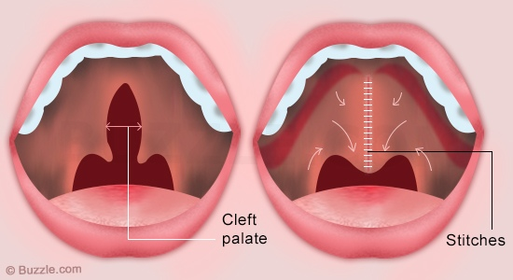

The above images show the cleft palate (left hand side) and the surgery needed to reconstruct the mouth to allow adequate speech.

The correction of a cleft lip or palate will often take a number of surgeries over a number of years while the child is growing and therefore speech therapists may well be employed to assist the child in being able to speak and communicate as well as possible whilst this process is going on.

- Hearing problems. One of the things most of us take for granted is being able to hear ourselves speak, let alone hear someone else speak. For a child with hearing problems, this can be incredibly difficult. If a child can partially hear, he or she may well either repeat back slowly what they have heard, or they may respond slowly and precisely, often in a monotone voice as they are concentrating on what they are saying. A profoundly deaf person, especially one that has been deaf from birth may not speak at all, and instead completely rely on sign language as they have not developed the ability to speak and instead simulate ‘speech’ by opening and closing their mouths with just forced air coming out. Either way, hearing problems will have a profound effect on speech and language, as the brain in some ways has to be ‘retrained’ to allow a certain amount of speaking to occur.

5. Changes in a child’s environment. Environment, or home, is a comforting place for a child and in the early years they establish this as a ‘safe place’. Quite often, due to work or a change in circumstances, the family may need, or have to, move home. This can be a huge upheaval for a young child, especially if they are being moved away from friends or close family. It is the responsibility of the parents to discuss the situation with the child if they feel he or she is mature enough to understand, or at the very least make sure they are aware of what is going on and continue to communicate with the child so that they don’t feel ‘left out’ and possibly become introvert or show signs of anxiety or mild depression. Communication/talking is the key when anything like this is going on as the child has more chance of adapting to any new surroundings without too much trauma if they are encouraged to talk to the family members about what is going on in their mind.

6. Inadequate opportunity for speech. This can be for a number of reasons and can lead to a huge under development of speech and language if not addressed in the correct manner. Quite often, if a child is the youngest sibling and there are other older brothers or sisters, the youngest child can become the ‘babied’ sibling where everyone talks for him or her and they are not allowed to ‘have their own opinion’ or thoughts. It can be something that the child sees as normal and so their speech becomes under developed as they feel they don’t have to talk for themselves as someone else will speak for them. It can also happen if there is a more dominant sibling in the household that tends to talk over everyone else and so becomes the ‘centre of attention’ If this is also not addressed and corrected by the parent or care giver then the child that is on the receiving end of the dominance may feel that there is no point in trying to speak because they will not be heard or indeed recognised as having their own thoughts and opinions.

Of course, there are many more factors that can have an influence on the development of language in a child, but in my opinion, the above listed ones are very much in the fore front.

- Language development stages in children.

As it has been mentioned many times already in various assignments I have written, all children develop differently and at different times. However, as a guideline, I have listed below with explanations, the various different stages of language development.

- At 6 months of age, a child should be able to respond quickly to their name, replies by turning their head and eyes to human voices without visible hints and also respond in a suitable way to friendly and angry voice tones.

- At 12 months of age, a child should be able to use one or words with meaning which may be an incomplete sentence. A child of this age should also understand basic instructions, especially if hints through voice or physical action are shown to him/her. Should also now be able to understand the social value of using words.

- At 18 months of age, a child should now possess a vocabulary of between 5 and 20 words, which will mainly consist of nouns. Repetition will now be coming into play and a child should now be repeating a word or phrase heard, over and over again.

- At 24 months of age, a child will now be able to name a number of objects which will be common to there surroundings. This may be objects around the house or their own toys for example. 75% of what a child says should now be in a logical sequence or bare some logic to what they say. Noun and verb combinations should now be coming into play and there will also be a certain amount of confusion between ‘my’ and ‘mine’ /the child should now be able to respond correctly to short requests like “show me your nose” (or other parts of the head etc). Vocabulary should be around the 150-300 words by now, however there may be signs of uncontrolled volume and pitch.

- At 36 months of age, a child should now be able to use the pronouns, I, you, and me correctly and may be able to use some plurals and past tenses in a correct way. Should also now know and be able to recognise and possibly name the main parts of the body. Three word sentences should how be handled with ease and vocabulary should be up to around 900-1000 words. By now, about 90% of what the child says should be intelligible and should also be able to reason out certain questions like “ what must you do when you are……….?”. Knows and answers questions about his/her sex, name and age.

- At 48 months of age, a child should know names of familiar animals, recognise objects in pictures in picture books or magazines and also recognise colours. They should also be able to repeat a four digit code when they are given slowly and will also be able to repeat words of four syllables. Will be able to understand such concepts as longer, larger when a contrast is presented. Much repetition of words, phrases, syllables and also sounds.

- At 60 months of age, as well as all the above being fine tuned, the use of adjectives and adverbs will be in spontaneous use. Number usage will be recognised with the ability to count to 10, recognise numbers of 4 or more and will also have the master of all vowels and some consonants. Speech will be nearly grammatically correct and will have the ability to recognise the difference between morning, afternoon, night, day, after, later, while, tomorrow, today and yesterday. The child will now know his or her age and the speech should now be completely understandable in spite of spme joining up problems.

- At between 6-7 years of age, the child should be able to do the following.

Completely logical and socially useful speech.
Tell a connected story about a picture, seeing relationships between objects and happenings.
Have a strong grasp on most if not all, of the consonants, voiceless th, ch, wh, and the soft ‘G’ as in the name George or Gerry.
Have the ability to handle opposites easily, for example, girl-boy, man-woman, flies-swims, blunt-sharp, short-long, sweet-sour, big-small…etc.
Tell basic time to the quarter hour.
Read simple book passages and the ability to write many words.

9. By the time the child reaches the age of 8, he or she should be able to relate stories about events that occurred in the past. They should also be able to use complex and compound sentences with some ease. All speech sounds, including consonant blends, should be established and reading should now be undertaken with some considerable ease. The child should also now be able to control his or her voice pitch, volume and rate and should be able to write simple compositions.

Student Statement:

By submitting this assignment, I confirm that this is my own work.

Student Signature |  | Date

For Tutor / Assessor Use Only
Total Marks
Marks Obtained
Percentage / Grade

