
Assignment Cover Sheet

Student Name: | Victoria Williams
Student Number: | 32146
Course: | Certificate in Beauty therapy and salon management level 3
Assignment NO: | 2

Marking Criteria:
We expect the learners to write minimum one well expressed point in three lines against each allocated mark. This means one needs to write 15 lines with 5 well expressed points to get high grades for a 5 marks question.
For high grades use examples and illustrations where appropriate.
Q1. Explain the different stages of the hair growth cycle?

Hair is contained in a tube shaped pocket called a follicle. There are two types of hair found on the body; Vellus and Terminal.

Vellus hair is soft, fine hair covering most of the body. Due to the follicles not being very deep, the hair appears to be straight. This type of hair grows slowly and will take about 2/3 months to return after waxing.

The Terminal hair is a much stronger hair, growing on the scalp, eyebrows, under arms and public region. These follicles grow deep down into the subcutaneous layer in the skin.

Hair growth is a continuous cycle with 3 important stages: Anagen, Catagen and Telogen.

Anagen is the active stage which helps the hair to grow from the bottom of its cuticle by cell division being fed by a good blood supply. The follicles grow deep down to gain the nourishment through the dermal papilla. When new hair fibres grow they push out the old fibres. New hair fibres grow, it

Catagen is the transition phase. The dermal papilla starts to break away so the lower end of the hair detaches from the blood supply making the follicles shrink and the hair starts to become loose.

Telogen is the resting stage, which concludes the final phase of the hair growth cycle. This phase can last for several weeks but will result in hair fibres being loose enough to easily pull out.
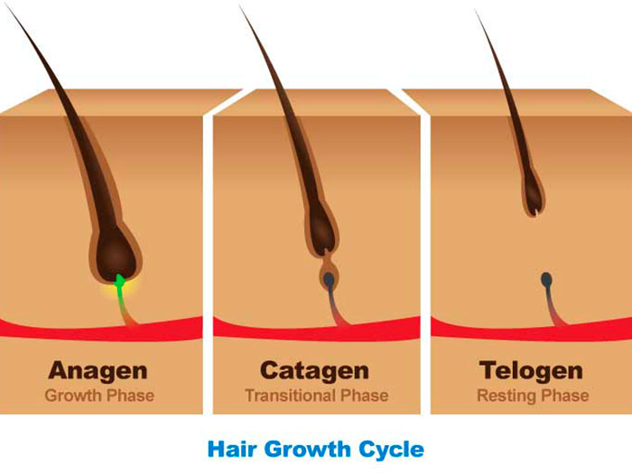

Q2. Briefly explain different functions which the skin performs in our body.

The skin is the largest organ in the body. It can mould to different shapes, stretch and harden. It performs varies functions to keep our bodies healthy and is an effective communicator.

The 3 main functions of skin are protection, regulation and sensation. The skin acts as a waterproof jacket to protect the body from dirt, bacteria and injury. Its helps to regulate our temperature by releasing sweat from the glands to cool itself down. Also, the skin senses hot or cold and responds to pain and pressure.

Skin consists of 3 layers; the epidermis, dermis and subcutaneous layer. Each layer plays a vital role in maintaining a healthy body.

The epidermis is the upper level of skin. It consists mostly of dead cells that are continually flaking off. Main function of the epidermis is to protect the deeper living structure from harmful effects of external environment.

The dermis is the inner level of skin. It contains protein fibres that allow the skin to expand. Main functions of the dermis are to give flexibility and strength. This network must remain strong or signs of aging will establish.

The subcutaneous layer is fatty tissue and is the deepest level of skin. Main function of this layer is to protect muscles, bones and organs from damage. It provides insulation against cold and energy if the body needs it.

Q3. Referring to nail structure, briefly describe the following: a. MATRIX, b. LANULA, c. NAIL WALL, d. The CUTICLE.

Formation of the nail is similar to skin.

THE MATRIX is also known as the nail root. It is located under the cuticle at the base of the nail. Cells are grown and replaced in this area so the natural nail can form. The cells produced in the matrix will determine the quality and strength of the nail. Shape and size of the Matrix determines the thickness of the nail.

THE LANULA is located at the base of the nail. It is the visual part of the matrix. It appears as a white half-moon. The Lanula is a delicate part of the nail structure and can be easily damaged. If damaged, it would cause the nail to have deformities. The Lanula can be found on all nails but is clearer on others. It can be an indicator of a person’s health.

THE NAIL WALL is the folds of skin overlapping the sides of the nail. The structure of the wall is to protect the nail plate and matrix from infection.

THE CUTICLE is the tissue found at the base of the nail. It forms a barrier to protect the matrix against germs.

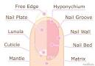

Q4. How does massage affect blood flow?

Blood is pumped round the body by the heart. It transports several substances around the body. It takes oxygen from the lungs to body cells and takes carbon dioxide back from the cells to the lungs. It also supplies nutrients to cells. Good Blood circulation is vital for blood to perform its functions correctly.

Massage can effect poor blood circulation by speeding up the flow of blood through the veins. This helps with the metabolic waste being carried away. The increase in blood flow stimulates the flow of lymph, which takes toxins away. General swelling will be reduced by massage as fluids are removed from the area quicker.

Massage helps cell renewal as blood flow increases. It helps bring oxygenated blood and nutrients to the cells so will help in cell growth and repair.

Student Statement:

By submitting this assignment, I confirm that this is my own work.

Student Signature |  | Date

For Tutor / Assessor Use Only
Total Marks
Marks Obtained
Percentage / Grade

