
Assignment Cover Sheet

Student Name: | Sherin Mariyam Thomas
Student Number: | 7239
Course: | Diploma in Fashion Design Level 4
Assignment NO: | 4

Marking Criteria:
We expect the learners to write minimum one well expressed point in three lines against each allocated mark. This means one needs to write 15 lines with 5 well expressed points to get high grades for a 5 marks question.
For high grades use examples and illustrations where appropriate.
- For a thin figured people it is best to choose materials which do not cling to the body. Shiny materials increase the appearance of size. It is best if the lines of the silhouette are not continuous. Use ruffles and tucks to achieve an effect of horizontal movement in the lines of a dress. Using a wide girdle will make the wearer appear with less height and light colors on a garment will make the wearer appear stouter.

Suitable for the thinner figure:

- Lustrous materials, except if the person is too angular
- Loose clothing
- The silhouette of the dress shown as broken, rather than a long beginning line
- Materials that stand out somewhat from the figure
- Short collars
- Sleeves gathered in too tight
- Horizontal movement in the lines of the dress
- Broken lines and curved lines
- A soft, full line of drapery in the waist
- Patch pockets
- Wearing a cap
- Hats with low crowns

Unsuitable for the thinner figure:

- Severe straight lines
- Angle in the lines of the dress
- Long, narrow skirts
- Flat, tight waists
- Sleeves so short that the bones of the arm are conspicuous
- High hats
- Stiff trimmings like wings or standing out from the hat

Horizontal stripes are suitable for dressing a thin person. Because horizontal stripes makes a thin person looks wider. Wear a fit and flare style where the stripes are tighter on the relatively small part of the body and loose on the larger part.

- When a person has a large waist and/or hips that are out of proportion to the rest of the figure, then he/she should dress in a way that moves the interest away from that area.

Suitable

- Built-out shoulders
- The interest kept at the face and away from the waist and hips
- Long skirts which add height
- Hats of average size or even slightly larger

Unsuitable

- Broad panel effects
- Sashes or wide girdles
- Small hats

The design technique for a large waist and/or hips person should focus on the head region. The head should be made a centre of interest and therefore the dress/garment should be designed so it moves the eyes towards the head. And above suitable things are applied to the dress/garment and make the dress in a way that moves the interest away from that area.

- The person with a stouter figure has a different set of designs to use or avoid. The use of soft materials with a duller coloring and not a shiny surface are better suited to stouter figures.
Dresses or other garments that are too tight should be avoided by those with a stout figure as these would only emphasize the figure. Creating a vertical movement through the use of certain devices will result in the eye travelling up and down rather that across from side to side.

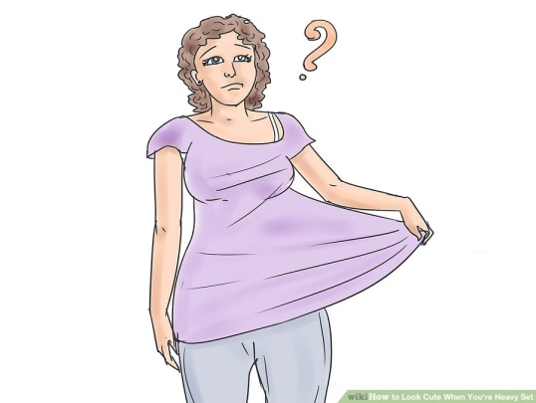

A person with a stouter figure should avoid wearing a dress which is too tight for him/her and extremes in dress. These would include very long or very short skirts, very tight sleeves, or the flowing variety. What is desirable is a long V line to the neck.

Suitable for the stouter figure

- Choosing one material or color throughout the garment and do not break it up into separate parts
- Vertical movement in the lines of the dress
- The use of transitional lines in the dress rather that extreme curves or angles
- Dull surfaced fabrics
- Soft yet not clinging fabrics
- Dull colors in large areas
- Black, or very dark colors if the silhouette is good. If the outline of the figure is poor, its best to use dark colors to reduce size, but not so dark that they will call attention to the silhouette
- If the figure is ‘normal’ then the use of an unbroken silhouette is desirable
- The use of a long diagonal line at the waist is the idea for a stout figure, as long as the diagonal is not directed too far out toward the hips as this will widen the waist and hips
- Semi-fitted, not tight effects, in the dress as a whole, and molded to the hips with some fullness below
- Ensuring emphasis is on the dress up and down the centre front; with the principle highlight at the throat and, if possible, a secondary one at the bottom of the skirt
- Panels of moderate width such as pleats, panels, etc. that begin above or below a point where the figure is large
- Reasonably long skirts
- Skirts that flare a little in the centre front with a straight silhouette
- A normal waist line or slightly above or below it
- A narrow belt or no belt at all
- Slim, long set-in sleeves
- Normal armhole, or a bit higher if the shoulders are broad
- Sleeves that are slit vertically to show the length of the arm and only a portion of the width
- Simple neck lines, preferably long lines and long collars
- Short jackets the same color as the skirt
- Moderate sized hats or hats that imply an upward movement
- Hats with irregular lines in the brim and a rather high crown
- Hats with transitional lines rather than extreme curves or angles
- Hair dressed high

Unsuitable for the stouter figure

- Any stiff or lustrous fabrics or taffetas
- Large or conspicuous surface patterns or plaids
- Heavy, bulky fabrics
- Fabrics that take round lines
- Bright colors in large areas
- Unnecessarily full, long garments
- Foundation garments that produce bulges above and below the garment
- Very full or very tight garments
- Ruffles
- Horizontal movement in the lines of the dress
- Exaggerated curves or angles (the curves repeat the lines of the figure and the angles contradict them, therefore both call attention to the size)
- Very wide or extremely narrow panels
- Panels, pleats or overskirts that spread or flutter as one walks
- Pleats, panels, or any trimming ending or starting a point where the figure is large
- Very narrow lines of trimming
- Flared skirts all around
- Thin piping
- Fluffy fichus
- Hats or dresses with large circles
- Short skirts
- Yokes on skirts
- A high waist line, since it makes the waist appear broader
- A very long waistline which makes the upper part of the figure too heavy for the lower part
- Belt or sashes which are noticeable in width or in color
- Tight-fitted or flowing sleeves
- Transparent sleeves
- Kimono sleeves which give an effect of breadth and looseness under the arm
- Ribbons or trimming extending or hanging from the sleeves
- Sleeves ending at an unusual width on the figure
- Wide, light cuffs on a dark dress which will make the eye travel across the figure and add width
- Tight or short collars
- Short jackets that contrast with the skirt
- Strange or very conspicuous shoes
- Slender, high-heeled shoes.
- Small, big, round or flat hats
- Round hats
- Hats with long lines or brims drooping on both sides
- Contrasting colors and values in hats, hose, and shoes
- A low or broad style in hair dressing
- Tight, small waves or “brushy” hair
- Thin or small pieces of jewellery
- Tiny trimming o hats and dresses
- Very small accessories

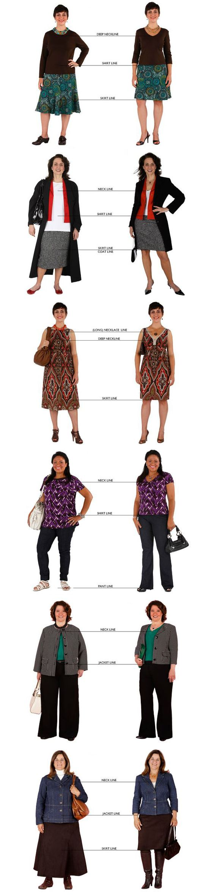

- When designing a dress for a person with round shoulders , the following suitable things should consider

- Set-in sleeves
- Shoulder seems should be about one-inch back of the normal shoulder line
- Collars that seem to straighten the curve of the back. Have the collar long enough to hang loose from the neck to below the highest point of the curve, or have it short enough to fill in the space between the neck and the beginning of the curve. Build out the waistline be allowing the waist to be full and loose in order to fill in below the prominent curve. This can be done using a panel which hangs from the neck to the waist, turning back under a loose belt, or by the use of a bolero jacket.

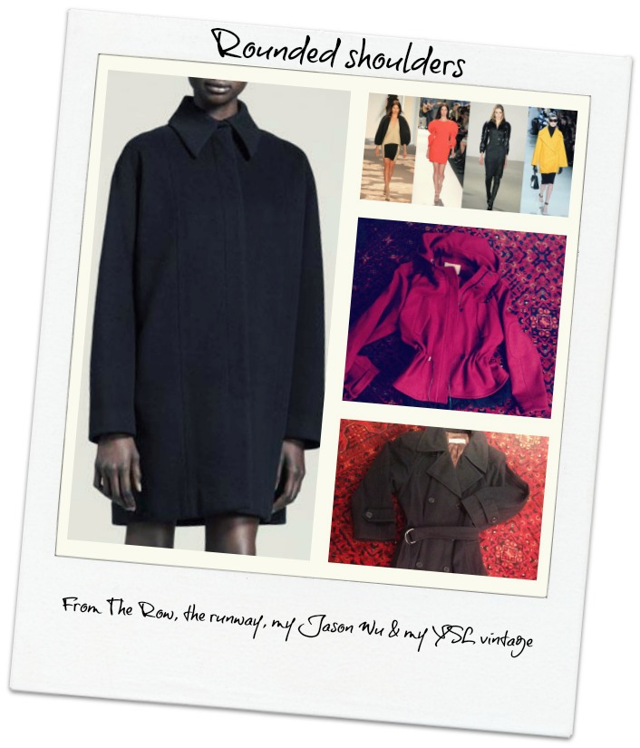

When designing a dress for a person with round shoulders , the unsuitable have to notice
- Collars ending at the curve of the back
- Collarless dresses that come in tight at the waistline
- Raglan or kimono sleeves
- A hat with a long, dropping brim in the back that forms a continuous line between the crown and the curve of the shoulders

ACTIVITY

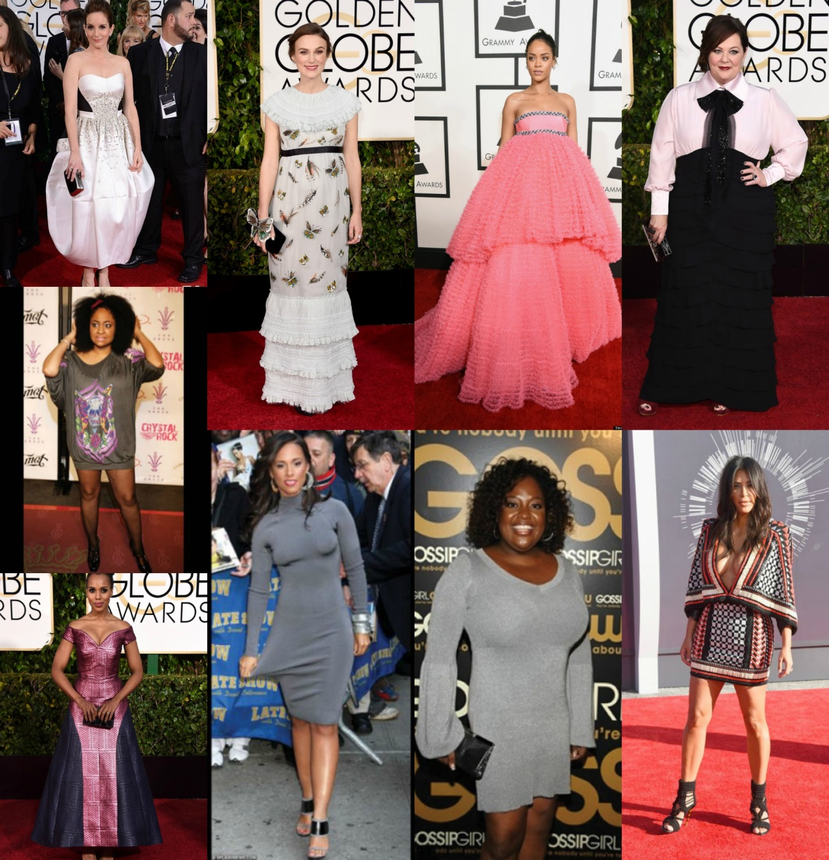

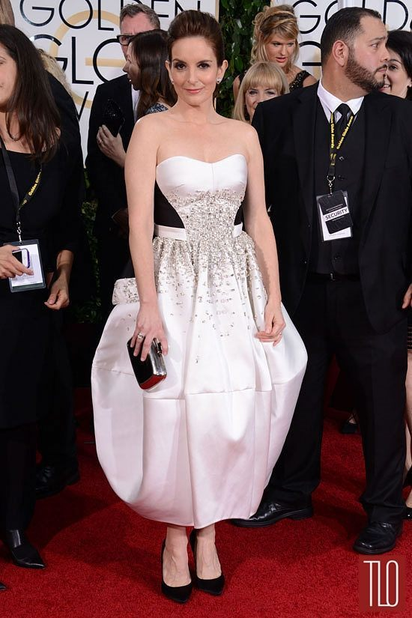
Tina Fey opted for is a rather daring monochrome, tulip shaped dress. However this dress fail’s to show off Tina’s petite figure and in fact adds rather too much volume to her hips and legs, unbalancing her frame. This skirt shape coupled with the ankle grazing length all serves to make Tina Fey’s lower body look much wider than it is. For the positive note, the black detailing and beading around the waist and bodice looks stunning.

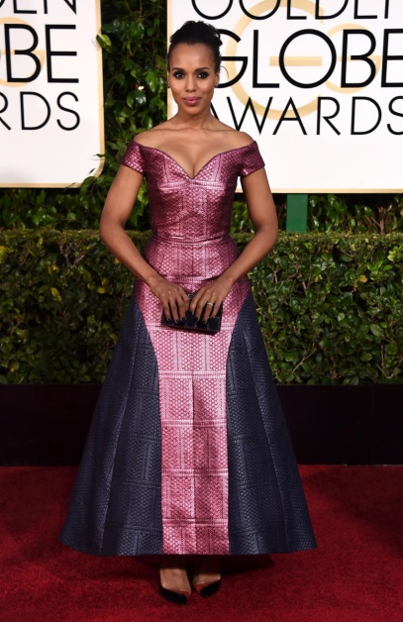
Kerry Washington’s golden globe gown has some stunning detailing, with the cut around the bust forming a very flattering sweetheart neckline, however the length and shape of the skirt threatens to undo all that good tailoring work above the waistline. The skirt is just a little too wide around her ankles unbalancing her lower body with her shoulder width. Something that is tailored in a softer and more flowing fabric would have worked better here.

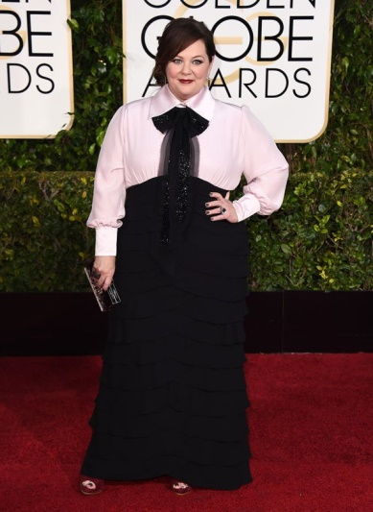
Melissa McCarthy has made the mistake many ladies with an apple shaped body make: completely trying to cover it up. The ruffled skirt also adds extra volume to her curvy figure and the oversized bow and high collar draws the attention away from her waist and up to her bust making her appear wider than she really is. Melissa would have looks lovely in something more fitted and flattering, drawing attention into her waist and maybe even showing off a little leg to help give her that hourglass shape.

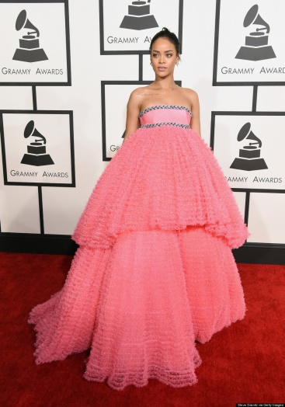
Rihanna wore too much fabric. This cupcake style gown doesn’t do anything to show off her slim curvy figure. The skirt of her dress has way too much volume, especially around her hips and with ruffled layers thrown in there as well, this dress is just way too unflattering.

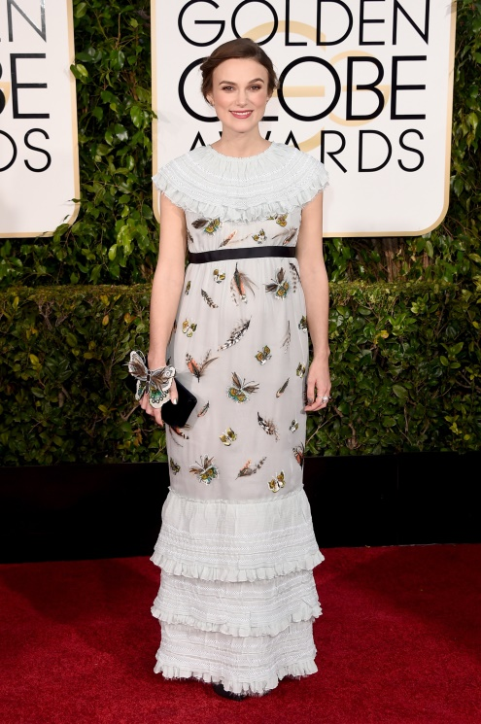
Kiera Knightly opted for a vintage style, the color suits her skin tone beautifully; the loose, unstructured style of this gown does little to define her figure. More fitted style will suit her.

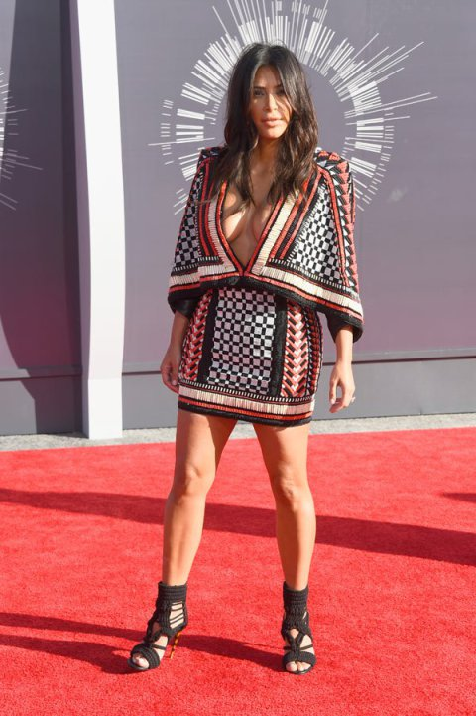
Kim Kardashian wore a beaded dress which looks too for her figure. The dress itself is gorgeous, but she was showing too much and almost drowned in the largeness of the sleeves. She is already a very short, and this dress didn’t help, especially paired with the high ankle heels, which resulted in her legs even shorter. This dress can be pulled off a bit better with someone who has more height.

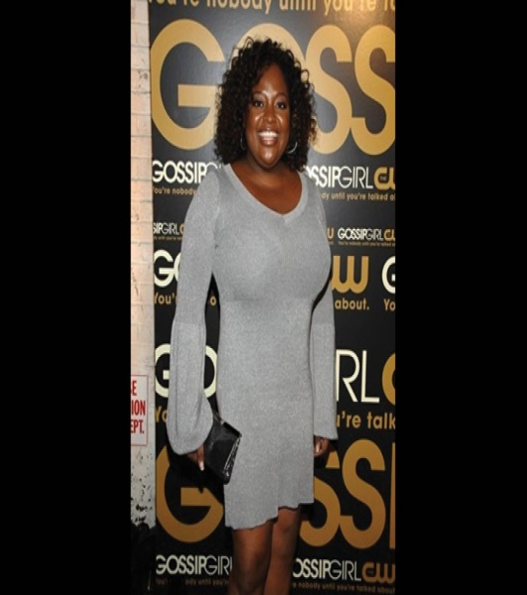
Sherri Shepherd dress is not the right fit for her apple figure. The fabric is too clingy and because of that, the top accentuates heaviness. For an apple –shaped figure, avoid low shorts or pants, high-cut shirts, or any fabric length that cut off below or above middle. Draw attention to the bust. Wearing an A-line dress, V-necks, plunging necklines to lengthen the body and draw attention to the bust.
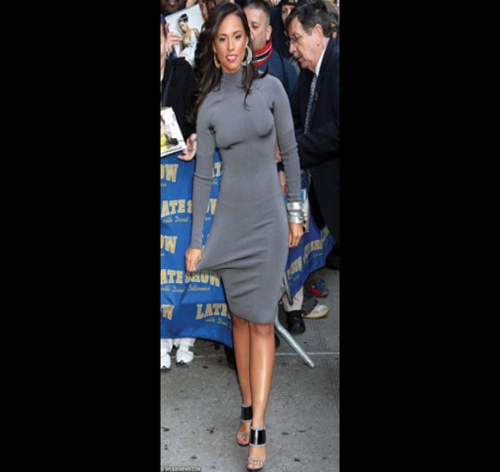

For a pear shaped figure, this dress is not suitable. For this figure, look for dresses that nip in at the waist and slightly flare out over hips and thighs. This dress is too tight for the figure.

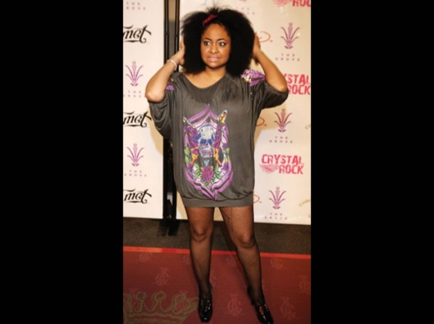

Raven’s Symone’s dress choice adds pounds to her waist. For a slimmer look, the actress should have cinched her waist with a cute belt to create curves.

Student Statement:

By submitting this assignment, I confirm that this is my own work.

Student Signature | SHERIN MARIYAM THOMAS | Date | 1/6/2017

For Tutor / Assessor Use Only
Total Marks
Marks Obtained
Percentage / Grade

