
Assignment Cover Sheet

Student Name: | Nicoleta Ionescu
Student Number: | 31009
Course:
  Advanced Diploma in Diet and Nutrition Level 5
Assignment NO: | 1

Marking Criteria:
We expect the learners to write minimum one well expressed point in three lines against each allocated mark. This means one needs to write 15 lines with 5 well expressed points to get high grades for a 5 marks question.
For high grades use examples and illustrations where appropriate.
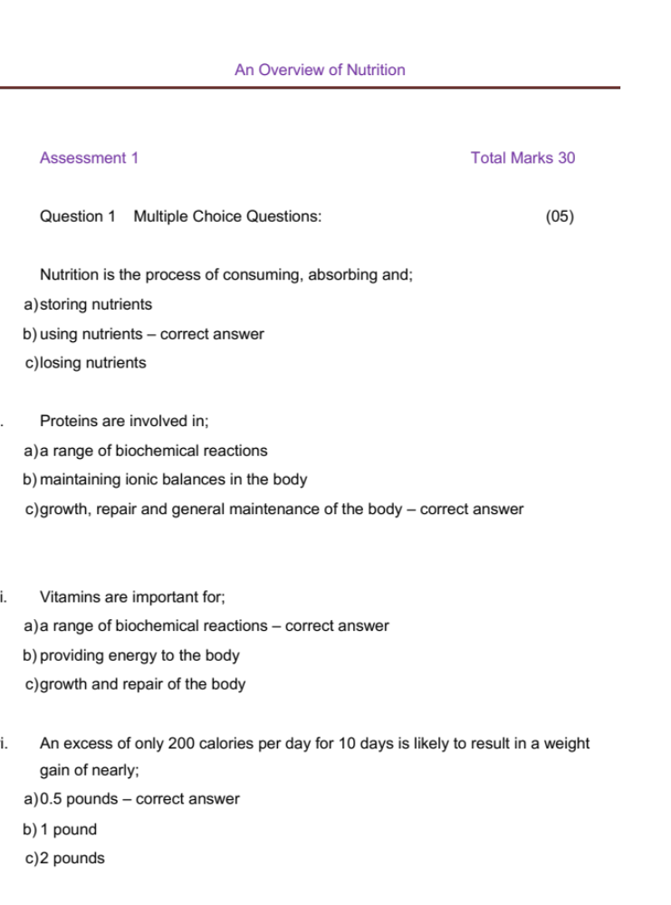

Student Statement:

By submitting this assignment, I confirm that this is my own work.

Student Signature | Nicole IOnescu | Date | Friday, 22 February 2019

For Tutor / Assessor Use Only
Total Marks
Marks Obtained
Percentage / Grade

