
Assignment Cover Sheet

Student Name: | Andrew Holt
Student Number: | 29320
Course: | Level 2 Travel and Toursim
Assignment NO: | 4

Marking Criteria:
We expect the learners to write minimum one well expressed point in three lines against each allocated mark. This means one needs to write 15 lines with 5 well expressed points to get high grades for a 5 marks question.
For high grades use examples and illustrations where appropriate.
1 What is the difference between full service and low cost service
One of the biggest recent changes in aviation has been the rise of low-cost carriers; budget carriers characterised by lower fares and fewer frills than those offered by superlative ‘legacy’ carriers. More often than not, travelers booking with low-cost carriers forfeit the quintessential luxuries they experience with full-service airlines such as complimentary meals, loyalty programs and the option of tiered seating classes.
Characteristics of low-cost carriers
- Low fares (although smart buying and use of inflexible fares can produce similar fares from legacy carriers).
- Strict use-it-or-lose-it rules, especially with the cheapest tickets.
- Ancillary fees: Expect to pay for ‘extras’ like luggage, meals, seat selection.
- Secondary airports: Don’t be surprised if you have to use secondary airports for some of these services. For example, Scoot doesn’t fly to Brisbane, but uses the Gold Coast instead.
- No loyalty program: Your travellers generally won’t earn points for their trips.
- No airport lounges: While the airlines don’t have airport lounges, some travellers with memberships to lounges may be able to use those. For example, Qantas Club members can use that lounge if they’re on a Jetstar flight.
- Single-class cabins: While the original LCCs had only economy class seating, some airlines in this category now have a few ‘business class’ seats or charge more for rows with extra leg room, like exit rows.
- Online booking: The LCC model is based on direct bookings, but increasingly, these carriers are being forced to make their inventory available through the traditional distribution channels.
- No corporate deals: Don’t expect to be able to negotiate incentives or discounts on published fares.
- Limited interline arrangements, which make it less convenient when doing multi-stop trips on different carriers.

Characteristics of full service carriers
- Generally higher fares, although airline economics means that even legacy carriers have to offer discounts to keep their planes full.
- Special corporate deals, across the board discounts and route deals, especially if you can guarantee the airline the lion’s share of your bookings.
- More inclusions: Expect the fare to include luggage allowance and inflight meals or snacks.
- More extensive routes because they don’t have to chase the most popular leisure destinations.
- Airport lounges: Corporate programs often include lounge access which is generally offered with premium fares.
- Loyalty programs: Your travellers will earn points for each trip, which is useful to reinforce compliance, but can be a distraction if they are members of different programs.
- Alliances: Most legacy carriers belong to one of the global alliances or have codeshare arrangements with other legacy carriers, ensuring a more seamless experience when travelling internationally.
- Multi-class cabins: Travellers will have a choice between economy, premium economy and business class. Some airlines still have first class on some routes.

For many people the cost of transport is an important factor. Not many people can afford to travel first class on planes or trains and have to travel economy class. Often trains running at peak times are much more expensive than those running at less popular times such as weekends. Very often, travel booked at short notice is much more expensive than that booked a long way in advance. Some coaches can offer travel for as little as £1 if the journey booked a long way in advance. Taxis are very convenient and provide direct travel, but are much more expensive than public transport.

One of the biggest changes in air travel in recent years has been the relentless rise of budget airlines in the United States. Budget air travel has been particularly important as an agent of change in domestic travel, encouraging a surge in demand for tickets and making flying low cost a more common activity for American travelers.

When the time comes to book your flights, whether a short-haul or long-haul journey, the chances are you will be presented by options that include legacy full-service airlines and budget airlines. At this point travelers will make decisions based on price, convenience and comfort. Consider how budget airlines compare with full-service airlines before booking your next flights.
What are full-service Airlines?

Considered the more traditional version of air travel, full-service airlines typically offer passengers in-flight entertainment, a baggage allowance, drinks and in-flight hot meals, blankets and pillows included in the ticket price. Examples in American carriers include American, Delta and United.
What are cheap airlines?

Low-cost airlines operate to offer cheap flights without compromising on service or safety. Rather than offering higher priced tickets that include luggage weight allowances, budget airlines often offer a small carry-on amount.

Additional charges may be included in your ticket price if you choose to include more baggage. Also, budget airlines often require customers to pay extra for food and drinks which can be purchased on-board.

This approach allows fliers to decide what services they want to include after paying for their seat. Budget airlines in the United States include:

Allegiant Air
Frontier Airlines
JetBlue
Southwest Airlines
Spirit Airlines
Sun Country Airlines
Virgin America
Choosing the right airline

Flying low cost involves comparing the widest array of fares on the route you have selected. Skyscanner allows you to see the best prices available in real-time to find the best deal. Then, travelers should check what is included with their ticket before completing their purchase.

Some travelers choose a full-service airline despite the fact that the ticket price is more expensive. This could be related to a number of factors. Many legacy airlines are part of international networks which can make transferring between flights easier.

Some travelers value a large baggage allowance as one of the most important factors when they travel. Others simply enjoy the enhanced level of hospitality and service that they experience on this type of price. To emphasize the difference, some full-service airlines have invested in new Aircraft and premium Services for added luxury in the air, which appeals to fliers, particularly on long-haul routes.
Meanwhile, budget airlines also operate a modern fleet of comfortable aircraft and concentrate on offering a quick turn-around, on-time flights and options to add further aspects to your ticket when you have secured your seat.

In terms of a direct comparison, a seat on a budget airline flight will be remarkably similar to a seat on a full-service airline flight. It’s what happens during the flight and what you can bring onboard that will highlight differences. Luckily, as both types of airlines compete to win new customers, there is increasingly more opportunities to find a deal on cheap flights

A full service airline typically offers passengers in-flight entertainment,checked baggage, meals, beverages and comforts such as blankets and pillows in the ticket price. The seats generally have more recline than a low-cost carrier as well as more leg room.

A low-cost carrier or low-cost airline (occasionally referred to as no-frills, budget or discount carrier, and abbreviated as LCC) is an airline that is operated with an especially high emphasis on minimizing operating costs and without some of the traditional services and amenities provided in the fare, resulting in lower fares and fewer comforts.

Air travel is the most popular method of travel for United Kingdom tourists making visits abroad and the importance of air travel continues to grow. In order to understand air travel in the United Kingdom it is necessary to understand the relationship between airports and airlines. Both are commercial operations aiming to make a profit. Airports make a profit by charging organisations such as restaurants to use the space in departure lounges. Airlines make a profit through carrying passengers, whereas airports make a profit by charging airlines to land on the runways and make use of the airport facilities. These are known as landing charges. London Heathrow is one of the world’s busiest airports and handles nearly 70 million passengers each year. At Heathrow the major airlines are the established ‘full service’ carriers such as British Airways, BMI and Virgin Atlantic. At other UK airports the users include the low-cost airlines such as Ryanair and easyJet. The differences between ‘full service’ and ‘low cost’ airlines are becoming less clear as the nature of the airline industry changes. Traditionally, major airlines such as British Airways and Air France were known as ‘flag carriers’ and may have been publicly owned. Today these airlines are owned by private sector organisations. All major airlines such as British Airways and Ryanair operate a scheduled service. This means that there is a published timetable which the airline follows for a period of time. Aircraft fly on scheduled routes no matter how many passengers are carried. One of the most significant developments in air travel over the last twenty years is the emergence of low cost or budget airlines. Of these, the largest operators are Ryanair and easyJet. The growth of Ryanair and easyJet over the last decade has been phenomenal. The low- cost airlines have been so successful that they have forced the established full -service airlines to change their operational practices in order to compete. On popular short haul routes to destinations such as Paris and Barcelona, the prices charged by traditional airlines may be similar to those of the low- cost carriers. Low cost airlines do not fly on long haul flights to the USA and other destinations outside of Europe. Low cost carriers have also had an impact on the operations of other travel and tourism organisations. More travelers are now able and prepared to book their flight directly with the carrier rather than using travel agents. Furthermore, airlines have been responsible for self - packaging which is where the traveller books their own flights, accommodation and other transport, rather than buying a traditional package holiday. In addition, the number of passengers carried by cross-channel ferries has declined as more flights are available to destinations in Europe.

Top 10 full Service Airlines 2019

1 |   Turkish Airlines(TK)  Turkey4.22  - Comfort  - Check-in  - In-flight  - Value for money | Turkish Airlines has always been my preferred choice. An excellent airline!
2 |   Emirates(EK)  United Arab Emirates4.17  - Comfort  - Check-in  - In-flight  - Value for money | The Emirates company is excellent in treatment, service, quality, punctuality, order and professionalism.
3 |   Aegean Airlines(A3)  Greece4.16  - Comfort  - Check-in  - In-flight  - Value for money | Great flight! It's fantastic that you get a free meal and drinks, which is becoming very rare in an airline now. This makes the experience different from the rest and I will be flying with Aegean Airlines again!
4 |   Air Corsica(XK)  France4.15  - Comfort  - Check-in  - In-flight  - Value for money | Nothing to say. Everything was perfect!
5 |   Aerolíneas Argentinas(AR)  Argentina4.04  - Comfort  - Check-in  - In-flight  - Value for money | Flight was in time with good and friendly service onboard.
6 |   Finnair(AY)  Finland3.96  - Comfort  - Check-in  - In-flight  - Value for money | Great service. I'll be definitely traveling with you again!
7 |   Swiss International Air Lines(LX)  Switzerland3.95  - Comfort  - Check-in  - In-flight  - Value for money | Smooth and trouble free. Good on board and ground service. I would fly Swiss Air again!
8 |   Middle East Airlines(ME)  Lebanon3.93  - Comfort  - Check-in  - In-flight  - Value for money | Amazing experience!
9 |   Aeroflot(SU)  Russia3.91  - Comfort  - Check-in  - In-flight  - Value for money | Very nice flight with very friendly crew. Nice, clean & quiet aircraft with pretty quick check in.
10 |   Etihad Airways(EY)  United Arab Emirates3.88  - Comfort  - Check-in  - In-flight  - Value for money | Awesome! So far one of the best companies I've traveled with

The 10 best low-cost airlines in the world

Follow @BiNordic

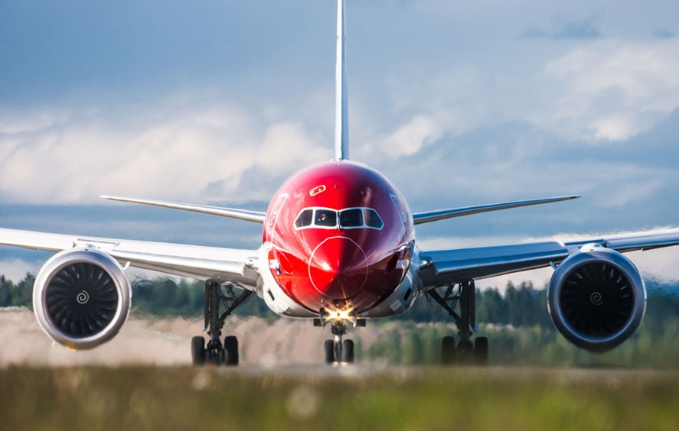
Norwegian Press
This week, leading consumer aviation rating agency Skytrax, named AirAsia the best low-cost airline in the world for the ninth consecutive year.
The Sepang-based company was presented with the award at a ceremony during the 2017 Paris Airshow.
"We take the world champion title seriously and we will strive to continue to improve for both our guests and shareholders," AirAsia CEO Tony Fernandes said in a statement. "Over the last 15 years we have created a great brand and over the next 15, we want to move towards One AirAsia, a truly (Southeast Asian) airline."
The Skytrax rankings are based on the impressions of 19.87 million travelers from 105 different countries. The survey, which covered more than 325 airlines, measured 49 parameters ranging from boarding procedures to seat comfort to the quality of service.
Here are the 10 best low-cost airlines in the world, according to the results of the Skytrax survey.

10. IndiGo
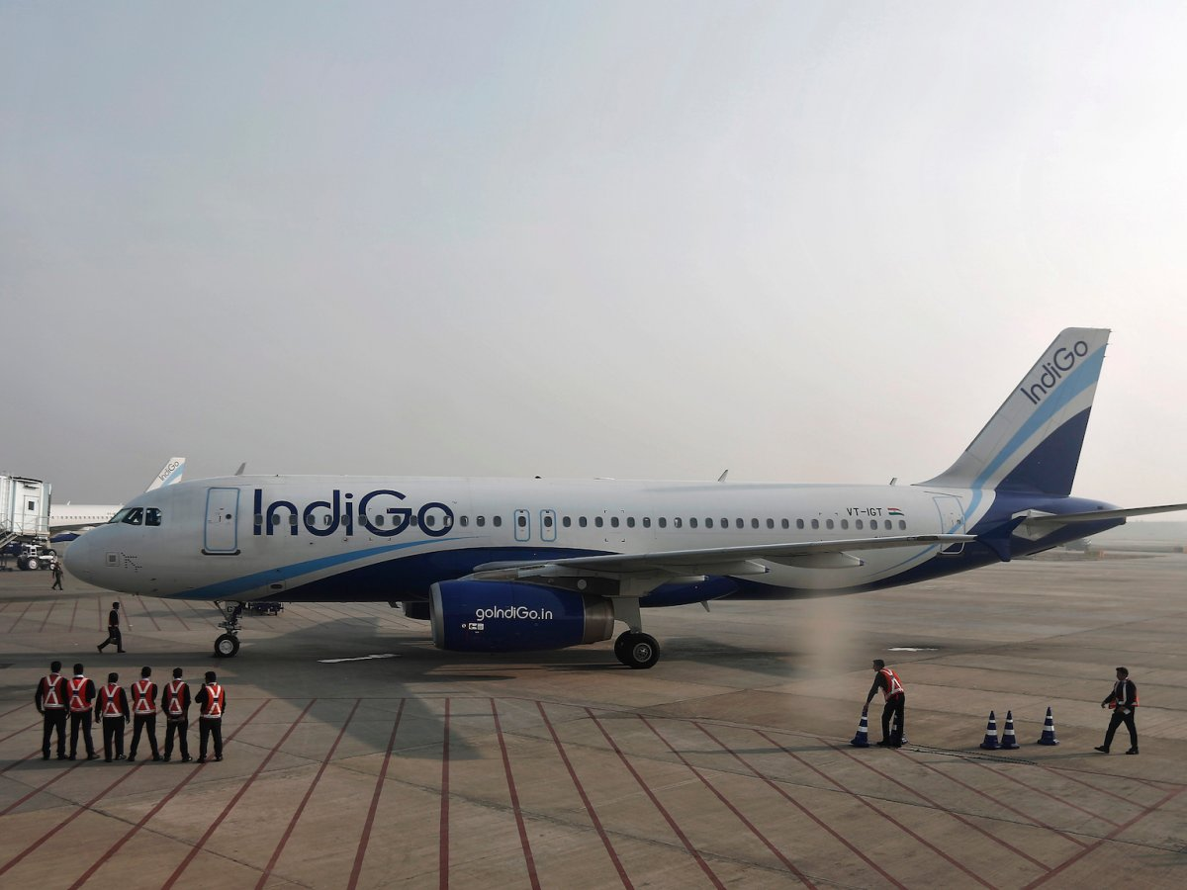
REUTERS/Adnan Abidi
Previous rank: 8
Why it's awesome: The New Delhi-based airline burst on the scene in 2006 and quickly became one of the best low-cost carriers in Asia. The airline operates a brand new fleet of more than 100 Airbus A320 jets. With more than 400 Airbus jets on order, IndiGo is one of the quickest growing airlines in the region. Reviewers on Skytrax praised the airline for its great cabin service and good value for money.
For the eighth consecutive year, IndiGo has been named Best Low-Cost Airline in Central Asia / India.
See additional airline information at Skytrax.

9. Southwest Airlines
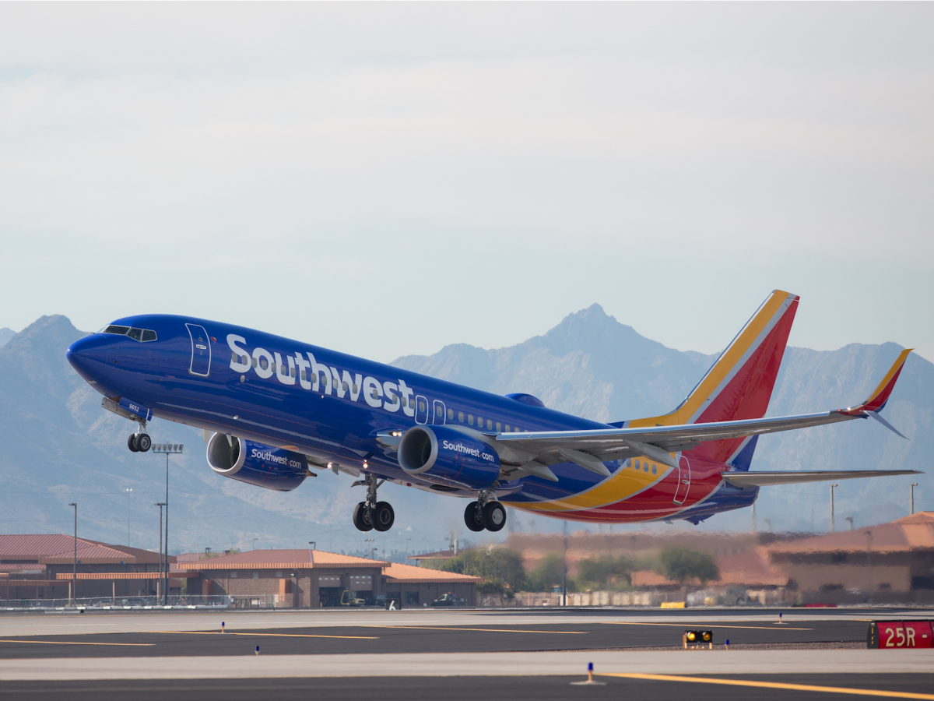
Southwest
Previous rank: N/A
Why it's awesome: With more than 700 Boeing 737 jets in its fleet, Southwest is one of the largest airlines in the world. Over the past four decades, Southwest has earned a reputation for delivering low-cost flights with a smile. More recently, the company's free checked bag policy has earned it considerable praise from the flying public.
See additional airline information at Skytrax.

8. Azul Brazilian Airlines
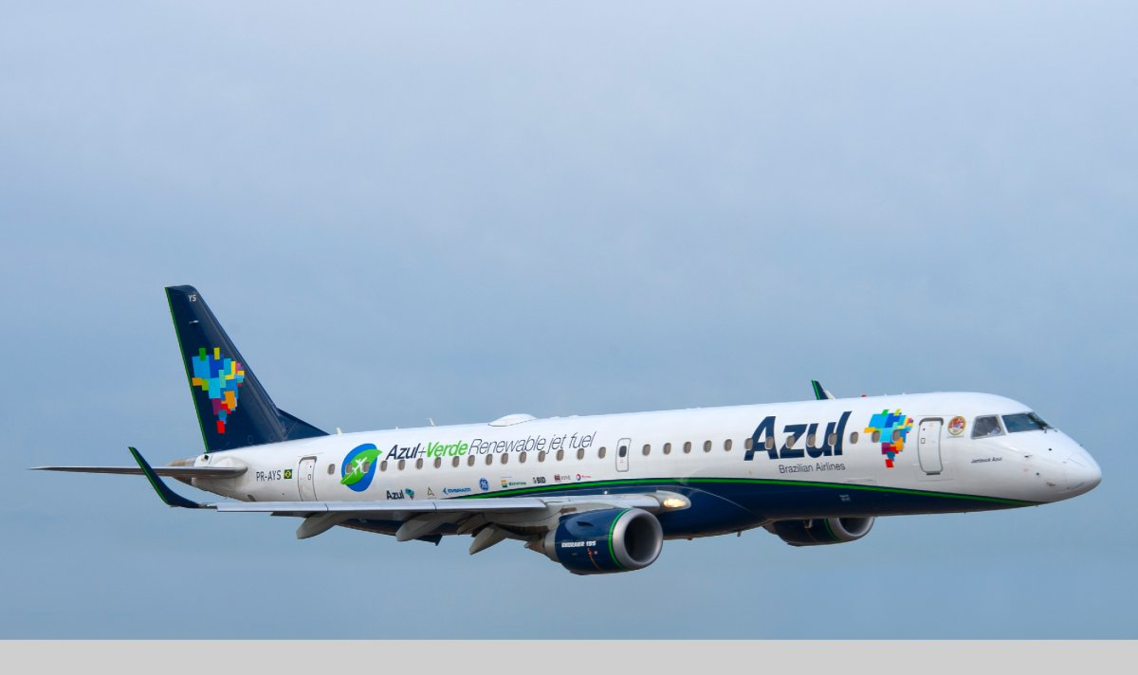
AP
Previous rank: 10
Why it's awesome: Azul Brazilian Airlines is the latest brainchild of JetBlue and WestJet co-founder David Neeleman. The Sao Paolo-based airline operates a fleet of new Airbus, ATR, and Embraer airliners mainly on routes within Brazil. Its Airbus fleet now operates to limited destinations in the US and Europe.
In addition to a top 10 finish, Azul also picked up the awards for Best Low-Cost Airline in South America and Best Airline Staff in South America for the second year in a row.
See additional airline information at Skytrax.

7. AirAsia X
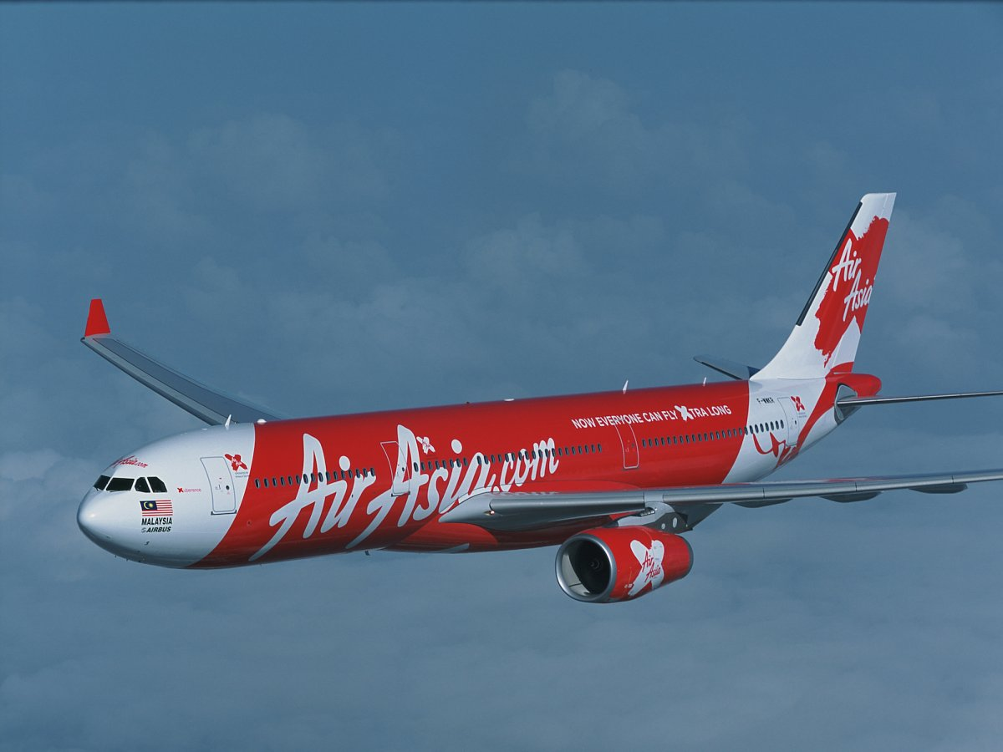
Airbus
Previous rank: 6
Why it's awesome: AirAsia X is the long-haul subsidiary of Malaysia's low-cost mega airline AirAsia. The airline's fleet of Airbus A330-300 jets are outfitted with both premium and economy cabins and operates throughout Asia.
In fact, the low-cost airline's premium service garnered AirAsiaX with the Skytrax awards for World's Best Low-Cost Airline Premium Cabin and World's Best Low-Cost Airline Premium Seat for a second consecutive year.
See additional airline information at Skytrax.

6. Jetstar Airways
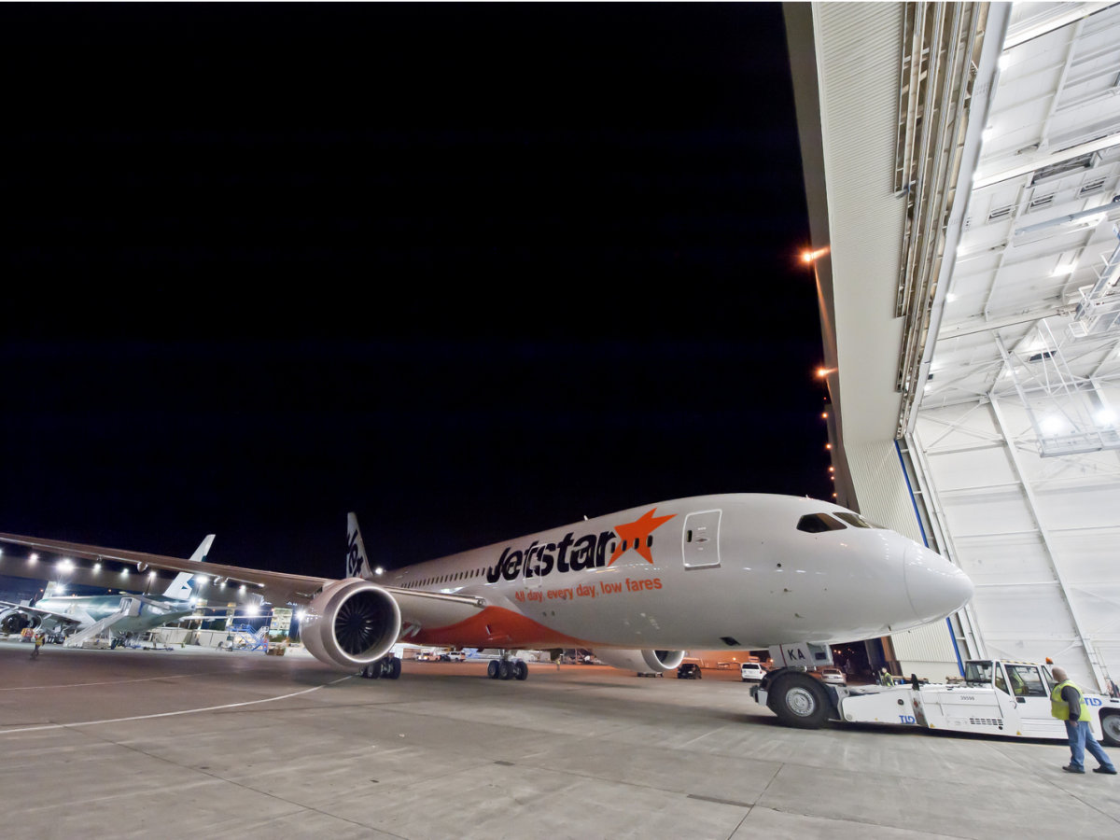
Flickr/Jetstar Airways
Previous rank: 5
Why it's awesome: JetStar Airways the low-cost subsidiary of Australia's national airline — Qantas. The Melbourne-based airline operates a fleet of Airbus A320 and Boeing 787 Dreamliners. Skytrax reviewers praised the airline for its quality cabin service and good value for money.
For the sixth year in a row, Jetstar has been named Best Low-Cost Airline in Australia & Pacific.
See additional airline information at Skytrax.

5. Virgin America
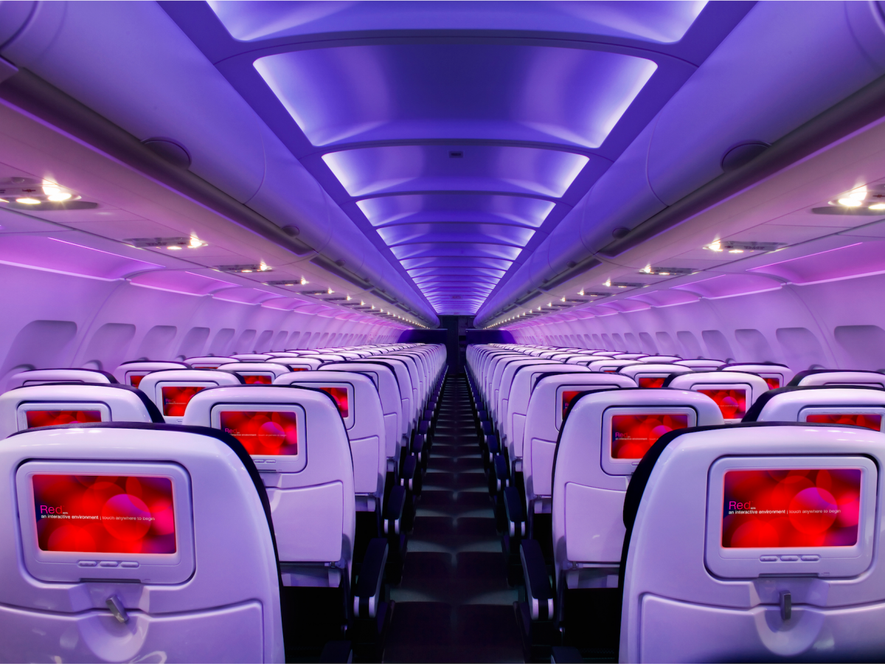
Virgin America
Previous rank: 2
Why it's awesome: Even though Virgin America is no longer the best low-cost airline in North America, it remains one of most beloved carriers in the skies. The San Francisco-based boutique carrier offers the style and high-quality service expected from a Virgin-branded company, but with the competitive prices of a low-cost carrier. In 2016, the company was sold to Alaska Airlines for $2.6 billion. The brand is expected to disappear by 2019.
See additional airline information at Skytrax.

4. EasyJet
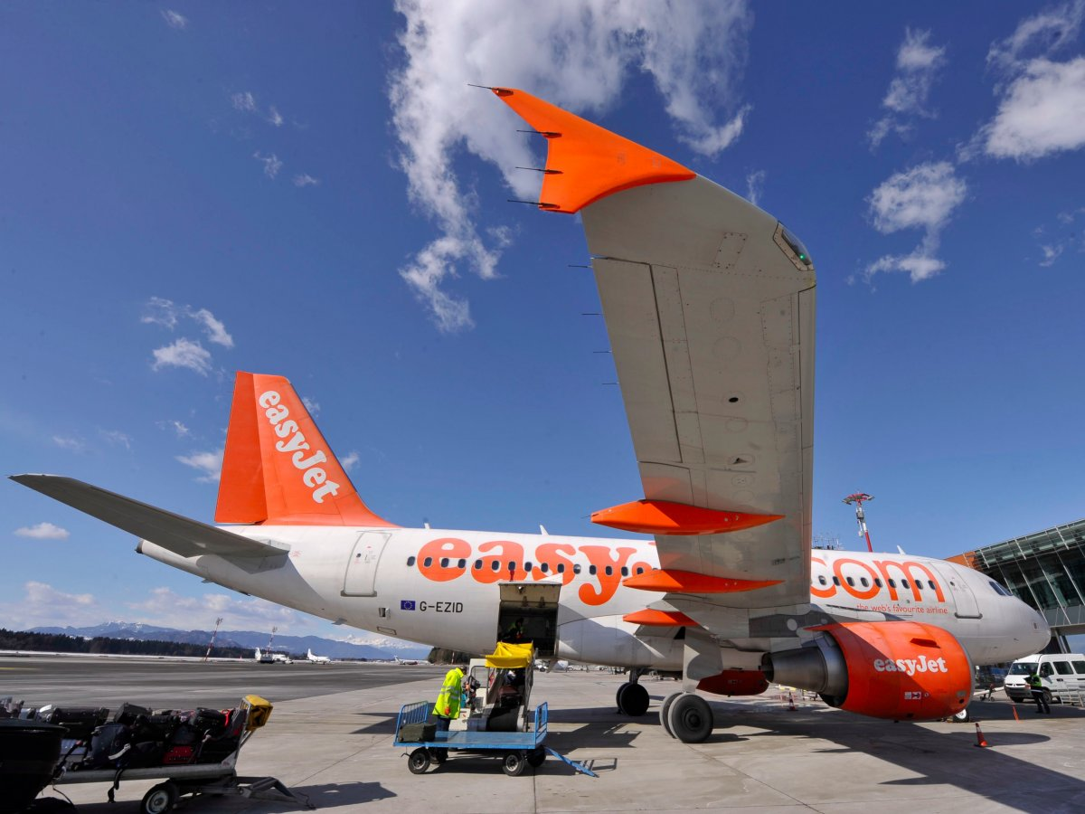
REUTERS/Srdjan Zivulovic
Previous rank: 4
Why it's awesome: Over the past two decades, easyJet and its no-frills, low-cost approach has helped it become one of the world's leading budget airlines. The airline's fleet of more than 230 Airbus jets fly to roughly 800 destinations throughout Europe.
Reviewers on Skytrax praised the airline for its solid service and low prices.
See additional airline information at Skytrax.

3. Jet Blue Airways
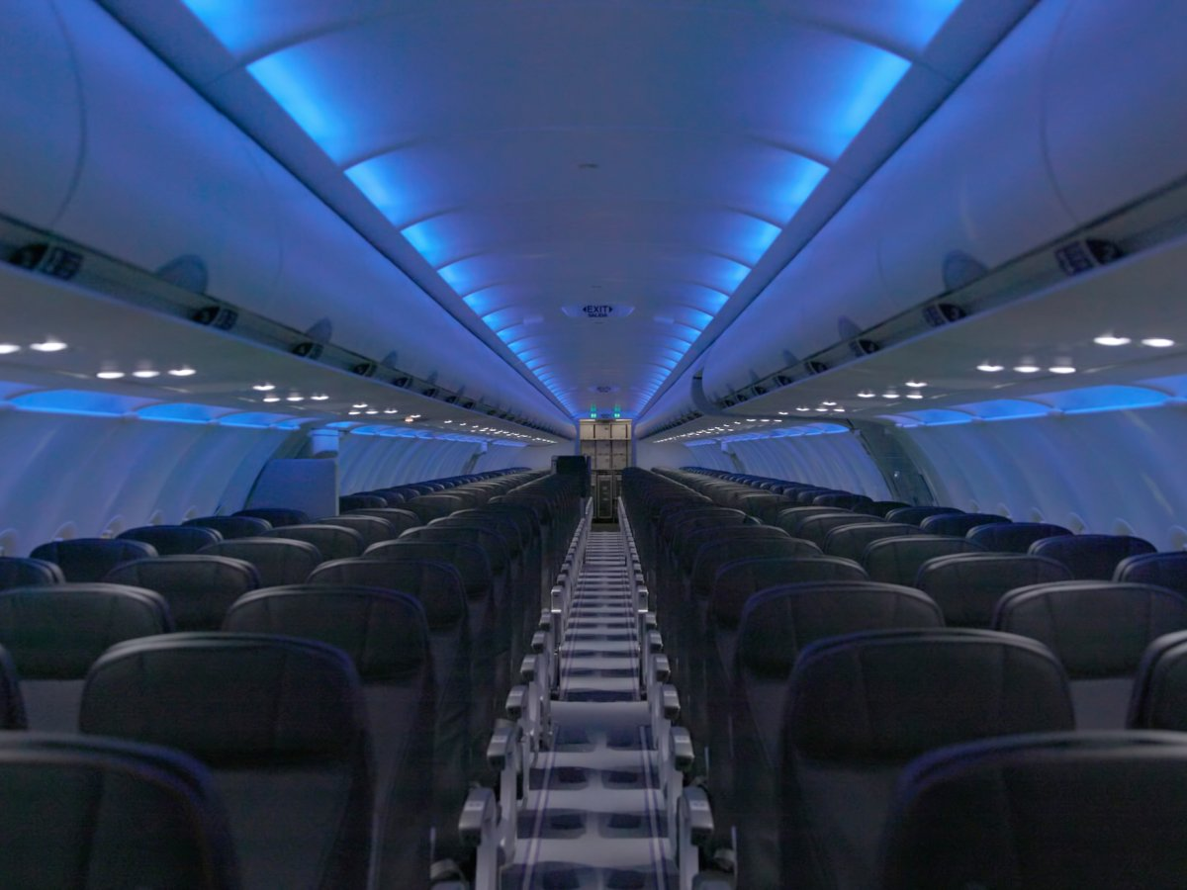
JetBlue
Previous rank: N/A
Why it's awesome: Since its inception in 1998, New York-based JetBlue has helped raise the standard of service and amenities for low-cost carriers in the US. The airline's signature mood lighting, friendly service, complimentary satellite TV along with free food and snacks make it an industry leader economy flying. In fact, at 34 inches of pitch, JetBlue's Airbus A320 fleet has the roomiest economy seats in the US.
See additional airline information at Skytrax.

2. Norwegian
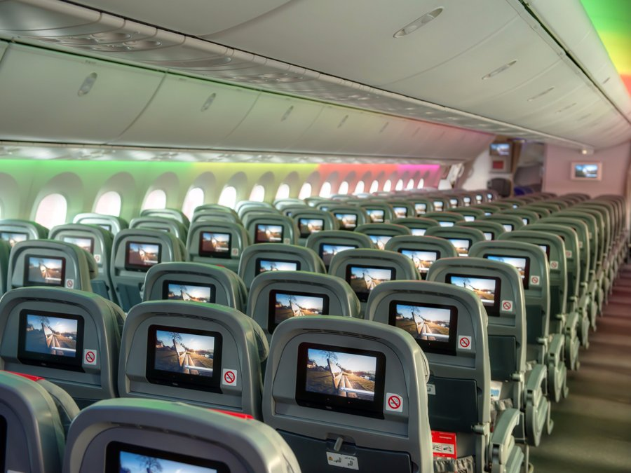
Norwegian
Previous rank: 3
Why it's awesome: Norwegian Air is one of the most aggressive and controversial airlines in the world. The low-cost carrier had drawn the ire of its US competitors by proposing a plan to operate trans-Atlantic flights using an Ireland-based subsidiary. The airline's critics claim that such a move would allow Norwegian to flaunt Norway's strict labor laws and use Ireland as a flag of convenience. Norwegian has denied these accusations. Regardless, Norwegian CEO Bjørn Kjos has won US government approval to launch ultra-low-cost trans-Atlantic flights from smaller airports in the Northeastern part of the country.
Controversy aside, the airline remains beloved by its customers. Norwegian has been named Best Low-Cost Airline in Europe five years in a row. In addition, the company is once again the World's Best Long Haul Low-Cost Airline.
See additional airline information at Skytrax.

1. Air Asia
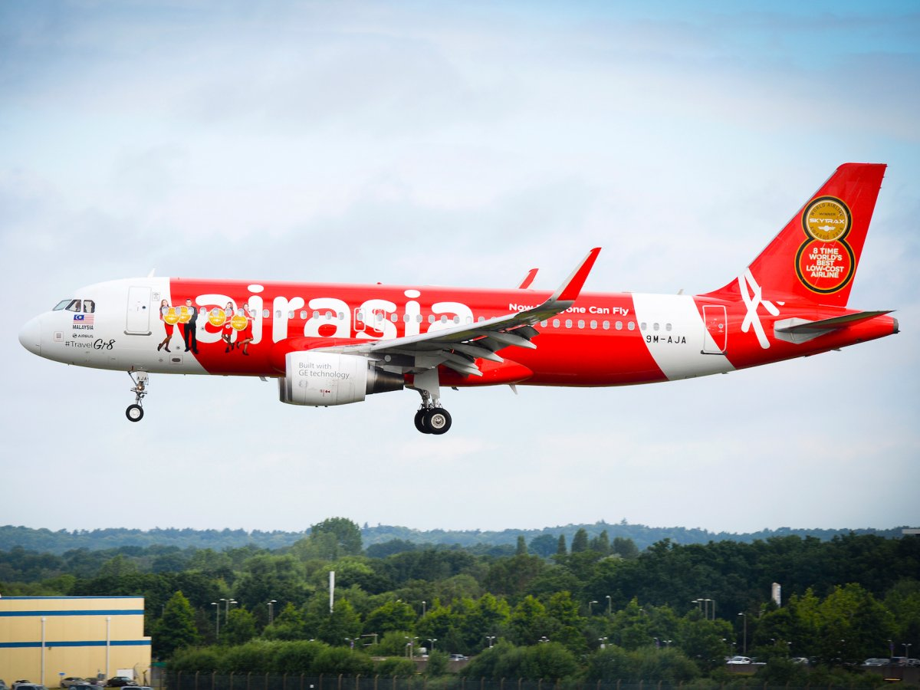
Airbus
Previous rank: 1
Why it's awesome: For the ninth year in a row, AirAsia has earned the title of World's Best Low-Cost Airline. CEO Tony Fernandes and his team have done a miraculous job over the past 15 years to turn a small, failed, state-owned airline in one a multi-national aviation juggernaut.
Reviews of AirAsia on Skytrax praise the airline for its responsive customer service, friendly cabin crew, and efficient operation.
See additional airline information at Skytrax.

2 Identify some important issues Which are crucial for deciding organising structure

Although most companies build organizational charts that outline personnel, titles and a clear hierarchy of who reports to who, an organizational chart is not the same as organizational structure. Organizational charts rely on people and the positions they fill, and can frequently change. On the other hand, organizational structure is based on a company’s vision and long-term goals, and is much more likely to be considered “set” once it’s built. If changes do occur, they are likely to be the result of a new mission, a rebrand or another major shift within an organization. They are, therefore, not taken lightly. Sound organizational structure is vital to all facets of a successful business.

Viewed broadly, organising includes the provision of physical facilities, capital and personnel. Organisation can be defined as two or more people working together in coordinated manner to achieve group results. It is the objective of your company and its resources which ideally determine the nature and structure of your organisation. Organisation is primarily responsible for the execution of the plan proposals and to achieve the stated objective of the company. Some of the major costs in transport service are: • Fuel, • Repairs and maintenance, • Depreciation and Interest, • Insurance and Taxes, • Wages and salaries, and • Miscellaneous expenses. Proper budgeting, control on expenditure and all possible efforts to generate income are essential prerequisites of efficient management. Another important aspect in organisation is (defining and delegating responsibility and authority. In case of tourist transport management this would include: • identification of the mode of transport, • allocation of duty to driver, cleaner and other supervisory staff defining their duties and / responsibilities, • liaison with various agencies, • maintenance of vehicles, etc. Organisation basically helps in achieving the desired goal through well-coordinated efforts of various individuals or groups. In order to get the desired result the following should be kept in mind: • What tasks are to be done? • Who is to do what, when and for how long? • How the tasks are to be grouped? • Who is to report to whom and where? In fact all operations of tourist transport have to be constantly monitored. It must be remembered that in transport operations the service is being simultaneously produced and consumed. Hence, in case of
any breakdown or failure if instant remedial action is not taken the image and goodwill of your company goes down.

Airline organization structure depends on the size of the airline and whether it's a publicly-traded company. Those that sell shares of stock all feature common organizational characteristics. In general, large airlines push workload responsibilities and accountability down to various departments. These often go by names such as flight operations and maintenance, for example. Usually, an airline manages everything through a board of directors and a chief executive officer.

A large commercial airline is a complex entity. U.S. airlines often feature operations at hub airports that are fed by flights from hundreds of smaller stations. These stations send passengers to those hubs. Once there, passengers then go on to other destinations on other flights. The typical commercial airline flies millions of passengers per year to points all over the globe.

Most commercial airlines feature a chief executive officer (CEO) who oversees the operations of the company. A board of directors, with a chairman, usually meets regularly with the CEO and his subordinates. The CEO often has a chief financial officer (CFO) and a chief operating officer (COO) to assist him. Working beneath this trio are executive vice presidents (EVPs). These EVPs oversee broad-based organizations such as airline operations and flight operations.

Broad-based airline organizations divide responsibilities up among a number of less broad-based departments. They do this because aspects of an airline can be complex and technical. Examples of such complexity include flight operations and aircraft maintenance activities. An airline is also highly regulated by the federal government. Airlines usually manage it all by pushing accountability down to front-line managers. This is done through EVPs, senior vice presidents, vice presidents and so on down to the manager.

Most commercial airlines maintain control over daily operations through front-line managers and their subordinate supervisors. These supervisors oversee small groups of rank-and-file employees while managers may be responsible for several or more supervisors. You can trace a line, then, from the most junior employee loading an airplane right up to the CEO. As with almost any large organization, strategic business activities turn into tactical business activities the farther one moves down from the CEO.

Most commercial airlines feature a classic top-down organizational structure on paper. Many operations within an airline, though, count on the success of other operations within that same airline. A pilot won't be able to fly without enough flight attendants, for example. Because of this, it isn't unusual to see a manager or director from one operational unit work directly with a manager from another. In fact, they do this regularly to solve many different daily operational issues.

3 discuss the relationship between environment transport operations

The relationship between transport and environment is paradox in nature. From one perspective transportation is categorised in two areas, passenger transportation which consists of all transport of individual, refers to all forms of public and private transport of commuters, passenger baggage transport whether scheduled or unscheduled. The second category of transportation is freight movements meaning the movement of raw materials, of work in progress, finished goods from supplier to consumer and of returns of used and new products back to supplier. Freight movement is also consists of movement of agricultural products (food, fertilizers) and animals. Freight movement is progressively intermodal and multimodal and makes use of local, regional, national and international operations. Transportation causes a considerable amount of harmful emissions, which causes problems that become harmful and costly to the society and environment. According to EU analysis 35% of freight transport accounts for eight percent of external transport cost to the GDP in European Union (EEA, 2001). The transport sector contributes to 30 percent of the CO2 emissions in OECD countries. 32 percent of Co2 emitted is accounted for by freight transport, while passenger transport accounts for 48 percent of emissions of CO2. This share of transport emissions however increases yearly. In this paper I will be focusing on freight transport (goods and services) impact on the environment. Based on different mode of transport which includes air cargo, shipping, rail, trucking, pipelines and intermodal terminals, the effects on the environment are majorly air pollution, water pollution, noise, global climate concerns, accidents, land take and habitat fragmentation both for humans and animals. The effects of freight transport on the environment affects the interrelation of the environmental system which is between the following:-
- Atmosphere (air quality)
- Hydrosphere (water quality)
- Lithosphere (soil quality)
- Biosphere (living organisms)
In the process of defining the environmental impacts of freight movement, three components could be considered:
Firstly the environmental stressors which include pollutants, noise, or exotic and toxic species are released in natural ecosystems. Each tone of goods transported adds an additional stress on the environment.
The cumulative amount of stress placed on the environment depends on the quantity of goods and the destination and distance they are transported. The total stress can be calculated as the quantity of goods times the distance carried multiplied by the stress per tonne. In addition the mode of transportation used is also put in to consideration.
The total stress is also determined by the nature of the receiving environment. Visible characteristics such as physical ecosystem characteristics, how populated is the area affected, and how critical or endangered species in the receiving ecosystem will determine the willingness to avoid the impact and payments.
This paper will be focusing more on the first component primarily to the other two components, with a little attention to the third component.
The Green Movement has made an impact in the West especially in countries like Germany where the tourist before going on a holiday may like to:
a. Choose the travel operator after asking environmentally related questions OLI what the company is doing to reduce environmental impact, Choose the right travel methods like public transport, cycling, trekking instead of hiring a car, or Travel to well known destinations out of season.
A successful transporter has to be careful in fulfilling the standards set by the environmental activists and tourists; the difference nowadays is getting blurred between the two.

The environmental impact of transport is significant because transport is a major user of energy, and burns most of the world's petroleum. This creates air pollution, including nitrous oxides and particulates, and is a significant contributor to global warming through emission of carbon dioxide.

The relationships between transport and the environment are multidimensional. Some aspects are unknown and some new findings may lead to drastic changes in environmental policies. Historically, transportation was associated with a few negative environmental impacts. For instance, the setting of large navies of sail ships was responsible for a level of deforestation in Western Europe and North America from the 16th to the 19th centuries. Urbanization in the 19th century and the reliance on horses created problems concerning the disposal of manure. Further, industrialization and the development of steam engines lead to pollution (e.g. sooth) near ports and rail yards. It is however only in the 20th century that a comprehensive perspective about the links between transportation and the environment emerged, particularly with the massive diffusion of transportation modes such as the automobile and the airplane. At the same time, manufacturing and marketing concepts such as planned obsolescence incited the design of modes such as the automobile and products (that are transported) that can continuously be replaced. The 1960s and 1970s were crucial decades in the realization of the negative environmental impacts of human activities and the need for regulations.
From an infrastructure perspective, the first comprehensive environmental regulation, the National Environmental Policy Act (NEPA), was set in 1970 and required all federal agencies of the US government to make environmental impact assessments of their actions. Since an agency such as the Department of Transportation is an important provider and manager of transportation infrastructure, this legislation had substantial impacts on how transportation is assessed to be linked with environmental issues. One clear consequence was the growth in the length and the complexity of approving transport infrastructure projects to insure they meet environmental standards. Opponents of a project could also use the regulatory framework to delay, or even cancel its construction and on occasion change its design parameters (e.g. size). An unintended consequence was that the complexity of environmental regulations tend to impair innovations and incite current providers to keep existing infrastructure and facilities for the concern to trigger an uncertain environmental review with a new project.
From an operational perspective, the Clean Air Act of 1970 set clear air quality standards and expectations for both stationary (e.g. a power plant) and mobile (e.g. an automobile) sources of air pollutants. For transportation, it immediately set emissions standards from a list of acknowledged pollutants such as carbon dioxide, volatile organic compounds and nitrogen oxide. The outcome was a rapid decline of air pollutant emissions by the transportation sector. The Clear Water Act of 1977 provided a similar regulatory environment concerning water pollution and the ability to build infrastructures over wetlands.
The 1990s were characterized by a realization of global environmental issues, epitomized by the growing concerns between anthropogenic effects and climate change. Transportation also became an important dimension of the concept of sustainability, which has become a core focus of transport activities, ranging from vehicle emissions to green supply chain management practices. These impending developments require a deep understanding of the reciprocal influence between the physical environment and transport infrastructures and yet this understanding is often lacking. The main factors considered in the physical environment are geographical location, topography, geological structure, climate, hydrology, soil, natural vegetation and animal life.
The environmental dimensions of transportation are related to the causes, the activities, the outputs and the results of transport systems. Establishing linkages between environmental dimensions is a difficult undertaking. For instance, to what extent carbon dioxide emissions are linked to land use patterns? Furthermore, transportation is embedded in environmental cycles, notably over the carbon cycle where carbon flows from one element of the biosphere, like the atmosphere, to another like the ecosphere, where it can be accumulated (permanently of temporarily) or passed on. The relationships between transport and the environment are also complicated by two observations:
- Level of contribution. Transport activities contribute among other anthropogenic and natural causes, directly, indirectly and cumulatively to environmental problems. In some cases, they may be a dominant factor, while in others their role is marginal and difficult to establish.
- Scale of impact. Transport activities contribute at different geographical scales to environmental problems , ranging from local (noise and CO emissions) to global (climate change), not forgetting continental / national / regional problems (smog and acid rain).
Establishing environmental policies for transportation thus have to take account of the level of contribution and the geographical scale, otherwise some policies may just move the problems elsewhere and have unintended consequences. A noted example are environmental policies in advanced economies inciting the relocation of some activities with high environmental externalities (e.g. steel making) in developing economies. This transfer the problem from one location to another. Still, such as transfer usually involves new equipment and technologies that are usually less impacting. Even if an administrative division (municipality, county, state) has adequate environmental enforcement policies, the geographical scale of an environmental impact (notably air pollutants) goes beyond established jurisdictions.
The str
strategies.

Student Statement:

By submitting this assignment, I confirm that this is my own work.

Student Signature | AHOLT | Date | 4/3/2019

For Tutor / Assessor Use Only
Total Marks
Marks Obtained
Percentage / Grade

