
Assignment Cover Sheet

Student Name: | Lauren Frances Hayward
Student Number: | 29401
Course: | Certificate in Beauty Therapy and Salon Management Level 3
Assignment NO: | 1

Marking Criteria:
We expect the learners to write minimum one well expressed point in three lines against each allocated mark. This means one needs to write 15 lines with 5 well expressed points to get high grades for a 5 marks question.
For high grades use examples and illustrations where appropriate.
26.01.2018
Lauren Frances Hayward
29401
Assessment 1

- What is the purpose of maintaining health and safety policy for a salon?

There are a variety of purposes of maintaining health and safety policy for a salon- the main being that it is a legal duty to ensure the health, safety and welfare of employees, clients, visitors and any others who may be affected by salon activities. This legal duty is in accordance with the Health and Safety at Work Act 1974. It keeps employees and general public safe in terms of health, safety and hygiene practices; and provides guidelines for safe working practice as therapists and for colleagues.
It is a reflection of the beauty industry; the salon you may work in; and/or a therapist’s individual reputation as an important and professional service to the public.
Employers must also protect the 'health, safety and welfare' at work of all their employees, as well as others on their premises, including temps, casual workers, the self-employed, clients, visitors and the general public. Employers are responsible for keeping the workplace safe. Under the Occupational Safety and Health Act, employers must inform employees of safety standards, provide training, eliminate or reduce hazards, and supply protective equipment. They must perform tests in the workplace and maintain accurate records.
It is the legal duty of both employers and employees to maintain these standards. Everyone has a duty to follow this, and if a business is found to be negligent, it can be prosecuted. It covers the storage and use of equipment, training, adequate facilities and maintaining a working environment that is free from risks to health.
Carrying out full consultations with clients will also ensure that any potential contra-indications are highlighted, and that you have gained consent, medical information, and provided adequate protection for their health and safety. A contra-indication is a condition which could prevent or restrict a treatment, such as: viruses, such as colds, cold sores, warts; bacterial infections such as impetigo, boils, conjunctivitis, sties; fungal infections such as ringworm; undiagnosed lumps or swelling; broken bones; or known sensitivity or allergy to products:
“If you cause harm to your client, or put her at risk, you will be held responsible and you will be liable to prosecution, with the possibility of being fined.” (Nordmann,2004, p. 5)
Whilst it may never be possible to prevent accidents, everyone has a responsibility to try to make the workplace as safe as they can.
It is important to have the highest standards of health, safety and hygiene at all times. If this was not maintained, we would have:
- dirty workplaces
- unprofessional employees
- unsafe equipment
- illness and cross-infection
- accidents and injury
- Poor reputation resulting in loss of business or closure.

There is a great deal of legislation, and you must be aware of your responsibilities and rights as a beauty therapist. It is important that you obtain and read thoroughly your workplace policies, duties and responsibilities on gaining employment or work experience within a salon- as well as those upon setting up your own business or becoming self-employed within the beauty industry.

- What is the importance of personal appearance for a beauty therapist and why?

Personal appearance as a beauty therapist is important to maintain a level of professionalism, example, and advertisement for self or the company you are employed by.
Personal appearance also includes personal hygiene and physical health. Personal hygiene is important to show that you are adopting good hygiene practice for safe working with clients and infection control. Clean hair, nails, teeth, body and clothing can illustrate this, and also means that you are pleasant to be in close proximity to. Beauty therapy involves working physically close to clients, and they will not return to your business if they have been offended by your body odor, bad breath, or an unclean appearance.
Following all hygiene practices in line with the skills gained in the industry means you are ensuring that clients will receive a high quality service, and are less likely to have adverse reactions to treatments. This is called infection control, and is a vital part of the role of a beauty therapist. Hygiene is defined within the online Cambridge Dictionary (2019) as: “conditions or practices conducive to maintaining health and preventing disease, especially through cleanliness.” It shows that you have completed and followed health, safety and training guidelines to a high standard- denoting a much higher level of professionalism.
Physical health is also important as a benchmark of good practice in the beauty therapy industry. Showing clients and colleagues that you are aware of and follow healthy nutrition, hydration, sleep, and exercise as intrinsic to personal appearance and good health- means that you can give well-informed advice to support treatments and maximize outcomes for individuals.
Demonstrating knowledge of natural and appropriate make-up techniques- in line with skin tone, facial shape, and day-to-day presentation as a beauty therapist- should be considered important also for your professionalism.

Appropriate clothing provides two elements of importance for a beauty therapist: firstly, a professional and well-presented appearance, and secondly, for health and safety requirements.
Clothing should be clean, smart, comfortable and practical for your role. Most beauty therapists will wear a tunic or salon dress, as it is different from everyday wear, and prevents your own clothing from getting dirty or damaged; shows good hygiene practice; and has a professional appearance to either promote the salon you work for, or your own business.
In line with clothing, appropriate footwear should be considered as just as important for following health and safety procedures, as well as being practical and professional-looking for your role.
See example below for appropriate clothing and presentation for a beauty therapist:
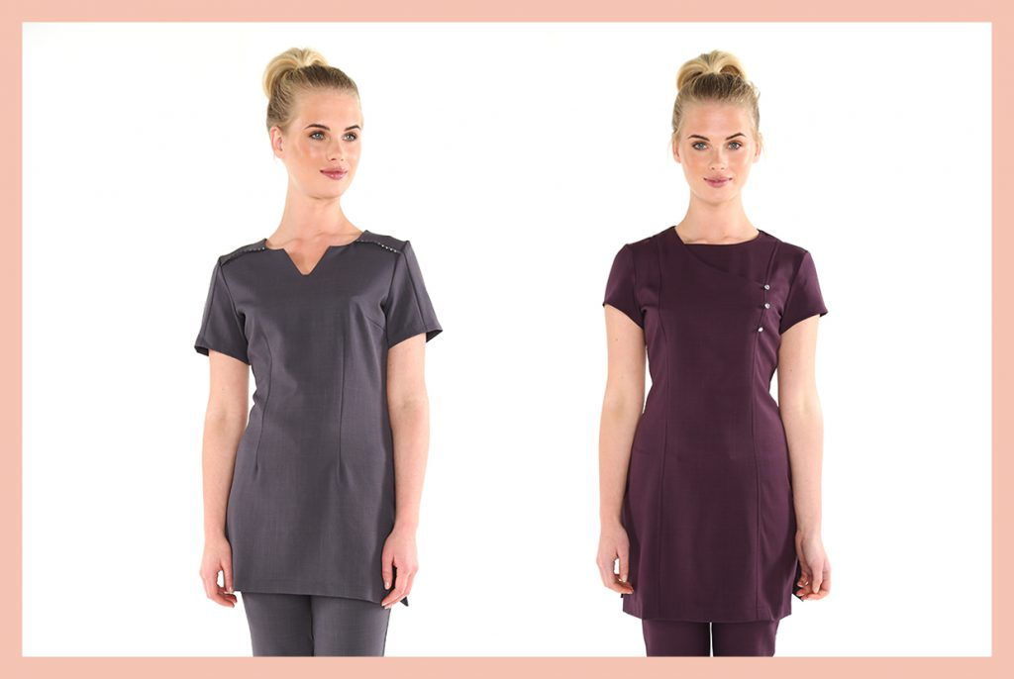

Finally, your personal attitude towards clients is also of the upmost importance for a beauty therapist: you are either reflecting the values of the business you work for, or your own. Your approach towards clients and/ or colleagues should be warm, welcoming, positive, polite, caring and professional. Conversations should remain non-invasive to a client’s or open to your own private life, but remain focused and interested in their general life and wellbeing. This will commence and maintain positive relationships with individuals that you come into contact with, and enable a pleasant atmosphere- one that will ensure clients return to you as part of a business, or as an individual.

- Briefly describe how your skin and make-up should look so a client is not put off but feels confident that she is getting treatment from a person who knows what she is doing?

Skin should be healthy in complexion, illustrating a thorough daily skin-care regime is practiced. Drinking enough water, and having the correct diet and amount of exercise- as well as sleep will ensure your skin appears in the best condition it can. Using the correct skin-care cosmetics to suit your skin type, will not only promote a better complexion, but also your knowledge of skin-care to clients and colleagues or employers.
Make-up should be kept appropriate and attractive, and in line with what suits your skin tone and face shape. Make-up should be applied properly to demonstrate knowledge and skill, as well as show a professional appearance.
Utilizing a healthy skin-care regimen, combined with professional make-up as a beauty therapist will enable you to give advice to clients with confidence; the client to take on board your advice; and therefore create a positive client/therapist relationship, experience, and outcome.
Below is an appropriate example of make-up for a beauty therapist. It is generally the consensus that a natural-looking make-up effect is suitable, rather than more ‘dramatic’ make-up:

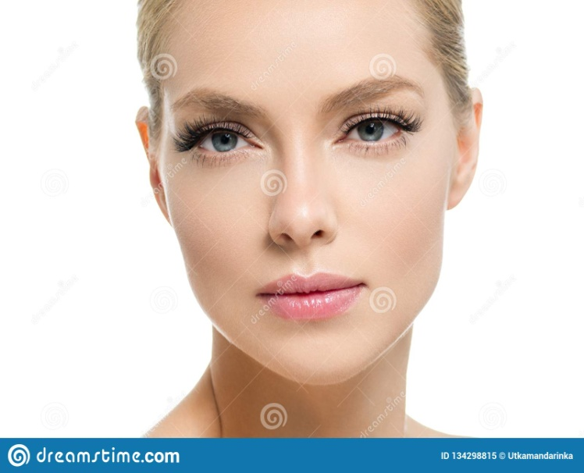

To conclude, a beauty therapist’s skin and make-up should reflect the professionalism of the individual- highlighting training, skill, technique, knowledge and personal wellbeing. This creates the correct atmosphere for consultation with clients, and successful outcomes.

Student Statement:

By submitting this assignment, I confirm that this is my own work.

Student Signature | L. F. Hayward | Date | 26.01.2019

For Tutor / Assessor Use Only
Total Marks
Marks Obtained
Percentage / Grade

