
Assignment Cover Sheet

Student Name: | Vedanshee Mehta
Student Number:
Course:
Assignment NO: | 01

Marking Criteria:
We expect the learners to write minimum one well expressed point in three lines against each allocated mark. This means one needs to write 15 lines with 5 well expressed points to get high grades for a 5 marks question.
For high grades use examples and illustrations where appropriate.
Q1: What are the principles of design ?
Answer:
The principles of design are very useful to create any garment design. This principles works as a guidline for the designer and makes it esay to create the design. This principles are not only theoretically explained but are also used while creating any garments. These would help the designer to make their garments attractive and appealing.
Generally, there are five basic principles of design. They are as follows:
1.Balance
2.Emphasis
3.Harmony
4.Proportion
5.Rhythm

- BALANCE
Basically, balance in the designing world shows the stability and the steadiness of the garments. Balance is one of the important principle for the designing of the garments as it shows the poise of the garments. The human body is symmetrical in shape hence it uses a centre for designing the dress. The designer uses one centre point and then create the appropriate garments. For designing of the garments generally the concept of mirror image is used as the human body is same from both the sides. The center does not mean that it should be the actual center it can be any imaginary center also. One can decide the center point on its own but then both the sides from that center point must be balanced properly.
Balance is again divided into three types. The flow chart below shows the division of the balance into three parts.

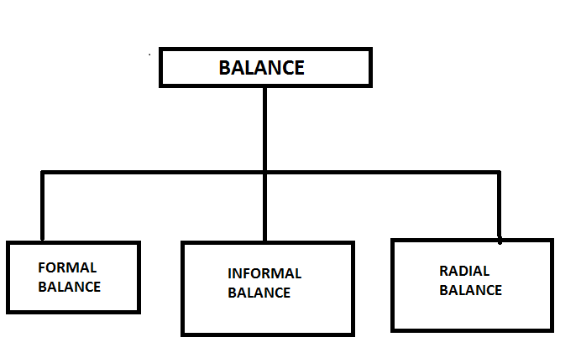

Formal balance :
In these type of balance the decoration on bothe the side is equal and well balanced. Formal balance is also known as symmetrical balance. Here, the objects in the garment must be excat the mirror image of any one side of the garment. Though the formal balance must not be that interesting but the formal balance are used in creating the designs for the sports clothes or the street dresses.
The picture shown here is the best example of formal balance in design.

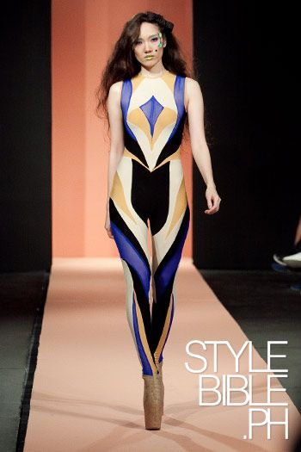

- Informal balance:
Informal balance is created when it is in the arbitrary form. Informal balance are more likely to be seen attractive and appealing rather than the garment created using the formal balance. In the informal balance the designs or the decorations which are larger and attractive are palces far away for the center point of the garments. Garments created using the informal balance can not only be seen effective but also attractive. Generally informal balance are used to create afternoon and evening gowns. If there is any irregularities in the shape of the body then the use of informabalance is the best way to correct it.
The figure given below shows the informal balance in the garment.
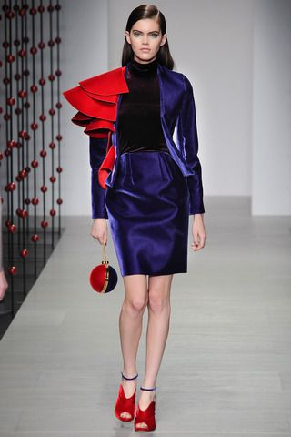

- Radial balance:
Radial balance is created through the us of the major parts of the garments starting from the center point. Radial balance are often seen on the necklines of the garments. These type of design is generally found in the expensive clothes because of the intricate features of the radial balance.

The figure shown below is the best example of radial balance.

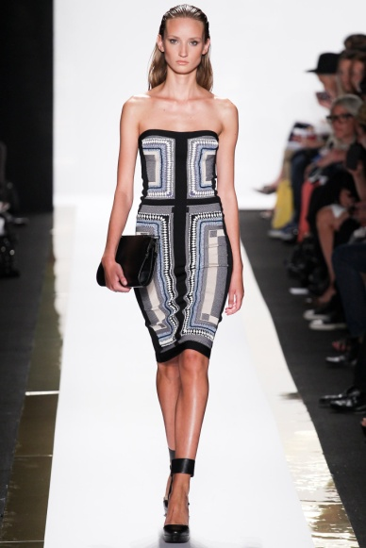

2. EMPHASIS

The simple meaning of the word emphasis is to concentrate or can say center of attention. In the world of designing, while creating any garment the designer must first decide the area where he/she wants the attraction or the attention of the viewers. The area will act as an eye-catch area, compared to any other areas of the garment. There should be only one interest area in the garment so that the eye of the viewer first sees that particular area of the garment. If there exist more than one area of interest in the garment then it would create confusion. Use of spotty designs for the details such as pockets can also create distraction. It would be better to eliminate these distractions. By doing so the design features can be strengthen and the garment would also look more attractive.

It is important to be careful that the design does not emphasis awkward parts of the body.
The figure given below gives the example of emphasis in fashion designing.

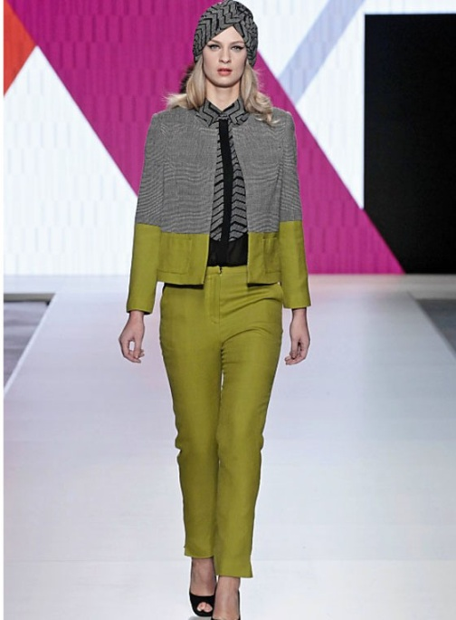

Here the use of unusual textures is done and thus we can see the concept of emphasis in the given garment.

- HARMONY/UNITY :
It can be said that harmony is an attractive visual unity. Harmony and unity are both linked with each other. It can be achieved when al the parts are related and arranged in an orderly manner. Harmony is achieved when unity and variety both are combined.
Unity in clothing design :
Good designs needs harmony between shape and form. Harmony is used in order for the garments to be comfortable to the person wearing the garments. Fitting well is also needed in harmony.
In order to harmonise shapes And spaces, it is necessary for the collars,cuffs, sleeves etc to be in accordance with the main forms of the garment.

- PROPORTION/SCALE :
While designing any garment proportion is one of the most important principle. proportion must be considered as it is the pleasing interrelationship of the size of all the parts of the garment.
As a general rule, uneven proportion is more interesting. The garments will look shorter and wider when all the parts of the garments are divided equally.
Generally the uneven proportion makes the wearer look slimmer and taller.

Here in the figure the combination of long jacket and short skirt is done which is an uneven proportion.
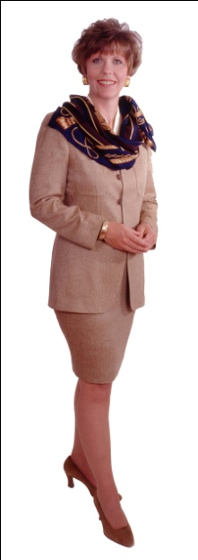
- RHYTHM (REPEATION) :

In fashion designing the term rhythm refers to organized movements. Generally it is the pleasing arrangements of the elements in the garment which allows the eye to easily move on the cloth.

It is created by gradation, opposition,transition or by the radial assembly of certain parts of the design and fabrics. Achieving rhythm is created by repeation or regular repeats of shapes, buttons, pleats, laces, colours etc.
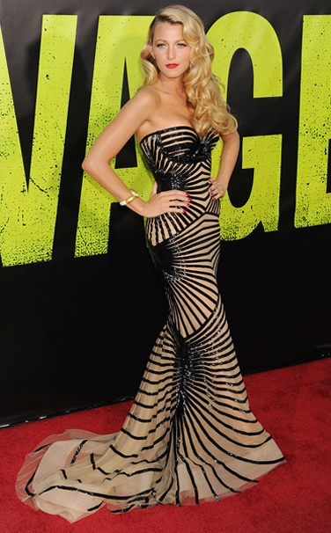

The above figure is an example of the rhythm in the garment. Here the same pattern is being repeated in the garment.

Q 2: how is the formal balance achieved in dress designing?
Answer:
Balance is the element that shows poise an stability of the dress. usually formal balance is also known as an symmetrical balance. in formal balance the center point is decide first and then the rest of the designing and decoration is dine on the garments. formal balance re achieved when the dress have excatly the mirror image of any one side of the dress. formal balance are used to show dignity in the garments. it also gives formality to the dress. both the upper area and the lower area must be equally used in order to have an formal balance. formal balance are generally used to create garments like the sports dress or the street dresses. even though the gaqrments created by the use of formal balance are not much interesting but it is uesd to create some garments and they are attractive as well as appealing too.
The figure given below shows the formal balance in the garment.
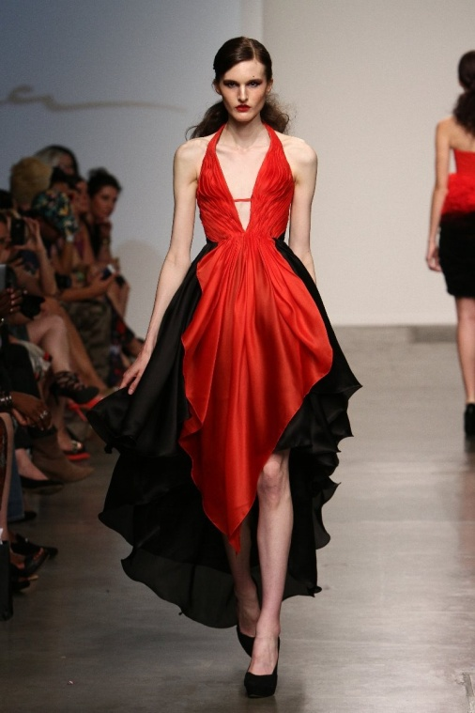

In the above figure there is formal balance created in the garment. It is equal from both the sides and hence it also shows the dignity in the garment.

Q.3 What is the relationship between the elements and the principles in fashion designing ?
Answer:
While creating any garment art element plays an important role in creating the design. It makes the garment attractive and elegant . elements and principles are adaptable and must be interrupted in the current fashion setting. Elements in the fashion designing consists of the line, texure, colour and shape arrangements which then are used to make the garment. While the principles of design are the degrees that govern how the elements can be used in creating the garment.

The elements in fashion design consists of the following things :
- Line
- Form
- Shape
- Texture
- Colour

On the other hand the principles of the fashion design consists of the following things :

- Balance
- Emphasis
- Harmony
- Proportion
- Rhythm

By the combination of both the elements and the principles of the fashion designing one can create a perfect garment as per the requirement.
The elements are reffered to as ‘plastics’ in art language. These is because the can be adapted and used easily as per therequirement of the designer to create garments.

Q 4: define the following terms
classic, fads, interrupted cycles, recurring cycles, traditional fashion adaption and reverse adaption.

1. classic : classic in the fashion industry means any thing that can be used for a long period of time is known as classic. garments that are lomg lasting types are called as the classic or the basic garments. the classic garments include the T-shirts, denims, skirts, shirts, pants, etc which are usually in fashion all the time. slight modification can be done on these garments but they can be used in our daily life also. thus, this type of garments are known as classic garments. they can be worn to suit different ocasssions. at somme times, it would be the promotable fashion, but whether it is in or out, it will always be the part of the fashion industry. classic are the fashion which are for long periods that is from past to present and even in the future it will always remain a part of the fashion scene.

2. fads : a fad in a fashion means it will capture the attentions of the people for some period of time and the it would be not in fashion after that period of time.hence, it can be said that the phase of fads will not last for the longer period of time that is it will faze out just as quickly as it came. generally, for these reason the fad fashion is also called as short-live fashion. because of these the designer can suffer a great loss as well it can earn profit also if the new arrived fashion is accepted by the people. usually these type of fashion is accepted by a very small amount of people. the best example of these style is the term we call as 'hippy'. these people have their own fashion, hairstyles,way of life, etc. another reason why these fashion is not accepted by the people is that not everyone can afford these type of clothings.

3. interrupted cycles : Sometimes, the retailers and the manufacturers do not want to keep making or stocking certain mechandise because it will soon lose its popularity and thus consumer buying can be halted ahead of time. At sometimes, social upheavel or economic crises may also inturpt the fashion and thus can stop the progress of the fashion cycle. these type of cycle which interupt the upcoming fashion or the fashion in trend is known as an interuptted cycles.

4. recurring cycles : recurring cycle means sometimes it happens that the fashion which is being faded after some period of time is again seen in the market. these repetation of the fashion is known as recurring cycle in the fashion world. sometimes, the designers go into the past to grab some ideas for creating the new garments, then the old fashion is again seen in the market but not the same as it was earlier. some changes are being made according to the new fashion and the the garment is being created. these type of adaption of the old fashion by making changes in the style, fabrics, decorations, etc is known as the recurring cycle. the silhouette of the garment may be same but there may be change in the fabrics or in the styling of the garments.

5. Traditional fashion adaption : In the fashion industry the designers always try to give their customers something new and extraordinary. thus they hav to take risk to create any new designs, as it is not necessary that all the customers will purchase and adapt the new fashion or the garment which is beiong created. the adaption will be done on the basis of the needs of the consumers. If a top designer displays any new arrivals to the public it is not necessary that all will adapt that fashion. it is not possible as everyone cannot afford the fashion with that ease. Traditional adaption theory is founded on the premise that high fashion is expansive. because of these reason the new fashion is available to only small group of people first. after then the retailers and seller will get the garments and the the lower group of people will adapt these fashion for some period of time. lastly these fashion is taken by the discount houses where they keep these fashion in the displays and later the popularity of that particular fashion fads. thus, these type of adaption is known as the traditional fashion adaption.

6. Reverse adaption : generally, the fashion flows from the high priced designers to the retailers and the sellers and then finally in the public shops. but in some cases it is not so. certain times it happens that the local public creates its own fashion and the it is carry forward to the designers in the fashion industries. These type of flow of the fashion is known as the reverse addaption of the fashion.

Student Statement:

By submitting this assignment, I confirm that this is my own work.

Student Signature |  | Date | 12/12/2017

For Tutor / Assessor Use Only
Total Marks
Marks Obtained
Percentage / Grade

