Matt Ensor

Q1 - What is Internet Marketing?
A: Internet Marketing is a Marketing tool that businesses can use to sell or promote their products and services over the internet. Internet marketing is not a complete solution but should be used as part of a company’s overall marketing strategy. There are different internet tools available which are both free e.g. Facebook and paid e.g. e-bay will help drive traffic, leads and sales.

Examples of Internet Marketing:
Direct Selling Websites: Online retailers Curry’s/PC World
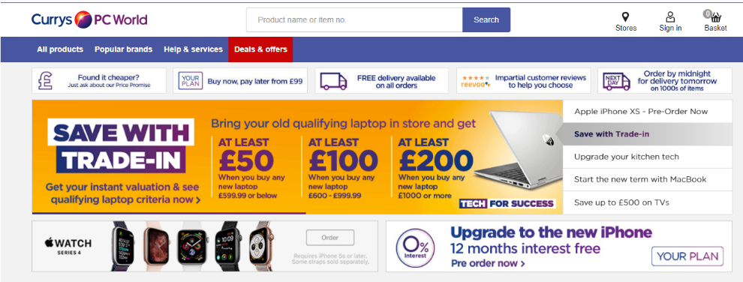

Sellers Ratings
Influence driven Marketing: E-bay Retailer
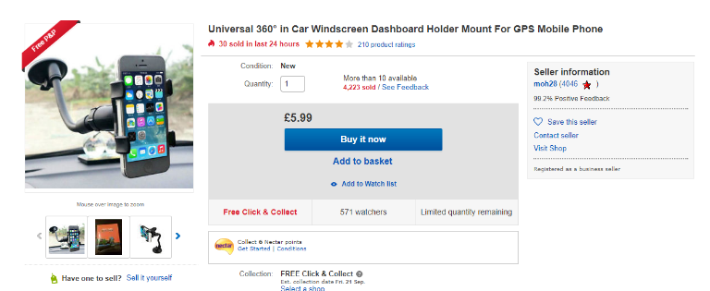
Look at our feedback
Units Sold
% positive feedback

Q2) Outline effective strategies for internet marketing and give short description for each of them?

Website
A website is a collection of web pages or documents that are accessed through the Internet. When someone gives you their web address or you type in or Google a company, it generally takes you to the companies’ website's home page, which should introduce you the business and products and services they offer.

Paid Advertising
Pay-per-click (PPC), also known as cost per click (CPC), is an internet advertising model used to direct traffic to websites, in which an advertiser pays a publisher (typically a website owner or a network of websites) when the ad is clicked.

Social media
Social media marketing (SMM) is a form of Internet marketing that utilizes social networking websites as a marketing tool. The goal of SMM is to produce content that users will share with their social network to help a company increase brand exposure and broaden customer reach.

Search Engine Optimizations
Search engine optimization is a methodology of strategies, techniques and tactics used to increase the number of visitors to a website by obtaining a high-ranking placement in the search results page of a search engine (SERP) — including Google, Bing, Yahoo and other search engines.

Email Marketing
Email marketing is one segment of internet marketing, which encompasses online marketing via websites, social media, blogs, etc. It is essentially the same as direct mail except that instead of sending mail through the postal service, messages are sent electronically via email.

Q3) Describe different stages of the marketing process?
- Consumer and Market Analysis
Who is our customer, how do they buy the products, what do look for and expect from the company.

- Analysing yourself and the competition
What can we offer/what can our competition offer?

- Analysing distribution channels
Best format to sell our products – our website/distributor/popular sales sites

- Creating a marketing plan
Create an all-encompassing plan which includes the on-line and traditional formats
Product – what is it and what does it do
Price – is the price point competitive and deliver the correct GM
Place – where are we selling it from
Promotion – how are we selling the product
Packaging
What tools /platforms/budget do I need to succeed
Set date to review performance to marketing plan

- Implementing the Plan
Employ a third-party company / action within company

- Review and Revise
Review performance of marketing plan and revise

Q4) Outline the steps involved in the marketing cycle.
- Consumer and Market Analysis
- Analysing yourself and the competition
- Analysing distribution channels
- Creating a marketing plan
- Implementing the Plan
- Review and Revise

