
Assignment Cover Sheet

Student Name: | Simon Tickner
Student Number: | 31842
Course: | Certificate in Advanced Skills For Practical Trainer Level 3
Assignment NO: | 2

Marking Criteria:
We expect the learners to write minimum one well expressed point in three lines against each allocated mark. This means one needs to write 15 lines with 5 well expressed points to get high grades for a 5 marks question.
For high grades use examples and illustrations where appropriate.
Please insert your completed assignment ( in word format) here:

1. Short Questions: (20)
I. What are the different ways to use technical media in order to aid learning process?

There are many different methods the trainer can utilize to help embed the learning process. Technical media is a great way to bring variety to the training and help each learning style to embed the training. For example, using video or YouTube clips can help visual learners process the information and by discussing their thoughts, work through generalizing steps. Another form of media could be podcasts, these can be useful to include subject matter expert’s points of view, or as part of on-boarding, allowing executives to introduce the brand and welcome new starters. The trainer can advise of further reading, provides suggestions for self-directed learning or discussion points for the next session. You can also ask them to read a policy or process and highlight key parts for discussions. eLearning is another option, delegates can complete before, during or after to blend the learning. Technical media can encourage self-directed learning, which improves learner engagement.

II. How are adult learners different from young learners?

Adult Learners are independent and solutions orientated, self-directed learning theory states that allowing the adult learners to create their own learning path will increase their engagement. Young Learners need a clear direction and classroom management by contrast. You Learners also need shorter sessions with a variety of activities in order to maintain their engagement. Adults however, can focus for longer times on limited topics, using limited resources.

Adult learners are more impacted by self-esteem than young learners and may be apprehensive about committing to activities or questioning, whereas young learners will get involved more openly, helping with the processing, generalizing and applying stages. The learning environment will need to be physically and psychologically comfortable for adult learners to get involved. Adult learners will have a pre-defined set of values, ideas and understanding of their role, the trainer will need to align to these beliefs as much as possible so that the adult can focus on the learning instead of how the information conflicts with their perspective. Adult learners needs to be motivated to learn, this means that there needs to be a purpose for the adults learning, the training has to help them achieve at work or in their own life. Adult learners have a wealth of life experience to bring to the training, helping with the generalizing and processing stages that young learners will not yet have.

III. What are the copyright rules to consider when developing a customised training
programme?

Copyright exists so that creators of content can dictate how their content is used and allows compensation for its use.

If you purchase the content, you should check the licencing agreement carefully to understand your usage rights and rights to publish the content and within what limits.

You should always ask permission to modify and publish copyrighted content, the author may also need to sign off any additions to the content.

IV. How can you avoid an over planned and over prepared training session?

Over-planning and preparing can cause issues such as initially spending too much time on the preparation instead of time focussing on the content creation and delivery. You can safeguard from being too over-prepared by setting a time limit to your preparation.

However, being over-prepared to a certain extent can be beneficial. By being over-prepared, you will feel more confident in your delivery, increasing learner confidence in you and engagement.

The trainer can prepare by understanding group mechanics where possible. If the trainer knows the delegates are mainly visual learners, they can adapt activities to suit, if there are people who take over in the class, the trainer can think of ways to challenge the behaviour without impacting their morale.

For timing, the trainer can run through the session in a timed format prior to delivery to have a better understanding on the sessions timings. They could record this to evaluate pace and emphasis, or use historic sessions as an estimate.

The trainer can also plan in extra activities in case the session begins to go too fast, or to appeal to different learning styles.

V. What are the numerous options you will consider when designing your own training
materials?

As a trainer, you wont always need to design the training yourself, there are companies that can create this content for you, saving time but it can be costly and may come with copyright restrictions. However, I am going to focus on the options when creating content for yourself.

If you want to research, edit, test and implement the training yourself, it can take a significant amount of time but it can be completed in 5 ways; Needs analysis, Research, Check gaps, Prepare and deliver and review.

Alongside standard classroom facilitation, the trainer can also utilise technological media such as e-learning, podcasts and further reading to promote self-directed learning.

2. Outline the steps involved in designing a customised training programme. (10)

Creating a customised training programme is a time consuming process but when done correctly, gives you a great amount of flexibility in how you achieve the learning objectives required.

First, you need to complete a needs analysis to determine what the actual needs of the training are. There are seven main versions of needs analysis; Organisational analysis which looks at business needs, objectives and values. Person analysis which looks at the people involved in the training, their pre-requisite skills, and learning styles. Next there is work or task analysis, that looks at the training needed to complete the desired task. Performance analysis which focuses on the desired standards of the work and whether or not the training will actually improve this. Content analysis researches policies, processes, regulations and the law in order to ensure that the training does not conflict with these materials. Training suitability is the next stage of analysis as not all problems will require a training intervention, sometime communications may be enough. Finally, there is a cost/benefit analysis which looks at the expected return of investment.

Once needs analysis has been completed, the trainer can research the topic being trained by interviewing subject matter experts, conducting web searches on the topic, checking social media such as LinkedIn for articles or YouTube for videos and reading books.

The next consideration is whether the designed content actually covers what it needs to and will meet the learning objectives. To do this, the trainer will need to check over the learning objectives and read through the content in order to be able to establish whether all relevant topics are covered and at the right level.

Once this has been done, the trainer will need to prepare for the session, such as flipchart work, highlighting key words and adding imagery and colour to highlight key elements. Printing hand-outs in preparation for the session, setting up the room, using the chairs and tables to maximize room and focus on the training being delivered. Making notes on the session plan such as highlighting key points or annotating movement around the room and actually delivering the training.

Once the training has been delivered, the trainer will need to evaluate the success of the training and consider how to modify the training for future use. Alongside adjustments from their own observations, the trainer should also consider the learners experience. One way to do this is with Kirkpatrick’s four levels of evaluations; Reaction, Learning, Behaviours and results (below).

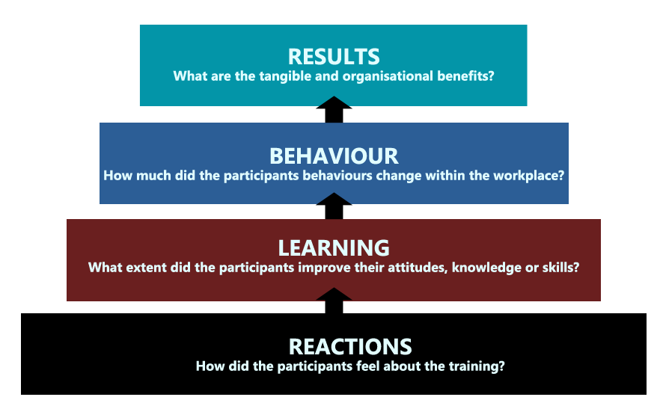

An example of two evaluation forms are below, they are colour coded alongside Kirkpatrick’s four levels of evaluation. The first evaluation is designed for straight after the training and the second evaluation for a month afterwards, to see how the training has actually benefitted the participants once back in the role.





For Kirkpatrick’s results stage, the trainer will need to look into the actual outcomes of the training instead of relying on a questionnaire. The trainer can look at retention levels, quality improvements or morale improvements.

An example of designing a customized training session is below. In the example, the organization has noticed that quality scores amongst its staff are not improving and when investigating further, team leaders are not providing effective coaching to their team members. The below is the planning of creating a coaching session.

Needs Analysis

Organisational Analysis

Company goal – To be the number 1 provider
Company Values - Customer first
- Strive to improve

Requested by – the operational leader has requested this training based on feedback from advisors, customer complaints and call quality scores.

Solution – Training will be the best solution as communications are not sufficient and demonstrating investment in the management team can aid morale company wide.

Person Analysis

Target – management

Skills – Mixed competency levels, some have basic knowledge of coaching, others have intermediate knowledge but do not utilise this knowledge due to time restrictions.

Task Analysis

Actual task – Coaching

Purpose – Improve call quality and customer outcomes

Challenges – Short time frames for training due to call levels

Performance Analysis

Observations – lack of structure for coaching, insufficient coaching methods

Training – models and behaviour training required

Content Analysis

Role Profile – Their KPIs are impacted by team performance, coaching will help them achieve this.

Cost/Benefit Analysis

Cost

8 x Team Leaders £12.70/hour – totalling – £101.60/hour
1 x Learning and Development Specialist £13.50/hour
Estimated training duration – 14 hours (2 days) £101.60 + 13.50 x 14 = £1,611.40
Room costs - £250 a day = £500

Total costs – 2,111.40

Benefits

Estimated complaint reduction by 5% within 6 month period
Increase in call quality scores – 10% increase in call quality scores within a 6 month period
Morale boost
Aligning the behaviours with company values
Customer retention, estimated £62,000 per annum
Employee retention, estimated £130,000 per annum

Identified Learning Objectives

- Explain the GROW model
- Demonstrate effective coaching in a roleplay environment
- List alternatives to long coaching sessions when time is limited

Research

Coaching
- Researched via YouTube, Mind Tools, Blogs.
- Attended leadership events to understand best practice across multiple businesses
- Spent time with management to identify key coaching strengths and weaknesses

Check for gaps

The trainer will now need to create realistic coaching scenarios and activities for roleplay and observation exercises on good coaching. The trainer will need to establish if the training material meets the outlines learning objectives. By the end of the session, will managers be able to explain the GROW model? Do the scenarios allow the management team to effectively demonstrate their coaching styles and understanding of the coaching models used? Did the training discuss alternatives to long training sessions such as using instant feedback techniques or 10 minute speed coaching sessions? Does the training take the learners through the learning cycle and utilize different learning styles to achieve the objectives?

Prepare

The trainer will now need to design some basic PowerPoint, ensuring that the majority of the focus is on facilitated discussion and activities instead of reading from a screen as this will need to be an interactive session. The trainer can utilize multiple flip charts and can prepare set flips for objectives, structure, a ‘car park’ and key phrases that can be used in coaching. The trainer will need to create and print handouts ready for the sessions and also set up the room effectively. To do this, they will need to decide on a seating arrangement that will allow for collaboration and discussion, whilst maintaining a formal and safe environment. Once completed, the trainer will need to deliver.

Evaluate

The trainer can now evaluate the training using a multitude of methods. They can use the evaluation forms from before to gauge learner responses. Utilize department morale surveys to see if agent and manager morale has changed after the training. The trainer can use MI to follow call quality results and customer complaints percentages to evaluate if they are on track to their targets. Once evaluated, the trainer will need to complete a Performance In Review with operations to see what went well and what can be improved in order to be more effective next time.

Student Statement:

By submitting this assignment, I confirm that this is my own work.

Student Signature | Simon Tickner | Date | 12/03/2019

For Tutor / Assessor Use Only
Total Marks
Marks Obtained
Percentage / Grade

