
Assignment Cover Sheet

Student Name: | Stephen Bates
Student Number: | 25991
Course: | Diploma in Construction Management
Assignment NO: | 09

Marking Criteria:
We expect the learners to write minimum one well expressed point in three lines against each allocated mark. This means one needs to write 15 lines with 5 well expressed points to get high grades for a 5 marks question.
For high grades use examples and illustrations where appropriate.
- Answer the following questions: (18)
  - Outline the various elements of purchasing with the help of suitable case examples.
The various elements of purchasing simply put, are what do we need, who will provide it, how much it cost, where and when we require it.

The procurement team of a business will understand what items a business needs and when they are required. This may be a new item or an item that needs reordering.

Once the need has been identified, the procurement team needs to identify a supplier who can meet those needs. In the case of a re-order, it is often the case that there is an existing supplier who is consistent in delivering items in the quantities needed, with consistent level of quality, to the right place, on time and at the best value for money.

In the case of new items, it may be the case that the procurement team may have to look outside of the existing supply chain. In that case, the procurement team will have to consider how they will arrive at the right choice of supplier. This can be achieved by examining/reviewing the suppliers who tender to supply.

Information that can be reviewed could be:
- Historic data and previous relationships
- Vendor rating
- Purchase research
- Are the prospective suppliers considered to be reliable?
- Do they have the capacity to deliver consistently high-quality materials?
- Will they provide the business value for money?

EU and UK Procurement Regulations may require the procurement team to open the tender to supply internationally, within Europe or globally rather than using preferred domestic suppliers

Business will always need to seek materials of the right specification at the best price this will always be a factor when choosing the right source of materials/items. Determining what should be paid for materials or items can be gleaned from historic data for the same or similar items. New items will need a breakdown of the fixed and variable cost of an item to determine the cost structure and its subsequent price point.
The procurement team will ultimately choose a supplier from the list of tenders, who can reasonably supply items at the lowest cost or may negotiate with a supplier they wish to work with if that is a better option.

Once the supplier has been selected, a purchase order can be submitted. Usually consisting of a series of indents for each individual item to be included within the purchase order. An indent typically details:
- Name of the item
- Description of the item
- Item code (if it is a standard item)
- Quantity of the item
- Detailed specifications
- Date/time by which the item is desired
- End user location where the item is to be delivered
- Indent originator's name (for coordinating delivery or for clarifications)
- Other related information
- Signature of the authority

Right quality
The indent will supply the detailed specification of the materials to be supplied and this will for the benchmark for appraisal once the items have been received from the supplier.

Right time
Lead times can have a major impact on project delivery. Lead time analysis will
Need to be carried out to understand the feasibility to reduce lead times by effective ordering to ensure there is no interruption to delivery if there is any direct (e.g. labour issues) or indirect (e.g. natural disaster) interruption to the materials supply.

Right Quantities
The quantities of materials that will need to be ordered for each project are normally specified within the bill of materials. However, it is normal practice for a number of projects using standardised items to have items included in a bulk order to help reduce the price, though discounts from the supplier.

Right Place
Bulk orders however, can have an impact on getting the ordered materials to the right place on time. Transportation is a major cost element for materials. This is why the procurement team are responsible for securing the best terms and conditions from the supplier. The terms and conditions agreed will determine the level of fiscal risk to the supplier or purchaser as set out by the International Chamber of Commerce Incoterms 2010. For example, if the terms and conditions agreed are:
- Ex Works (EXW), the cost and risk of transporting the goods to the right place at the right time are 100% those of the purchaser who will collect the items from the factory and transport them to site themselves. (Purchaser, high risk, lower transportation cost)
- Free on Board (FOB) the suppliers obligations terminate at the port of departure and the purchaser collects the goods from the port of entry and completes transportation to site (Purchaser, medium risk, medium transportation costs)
- Delivered at Place (DAP) The supplier obligations and risk terminate at the agreed point of delivery. (Purchaser, low risk, higher transportation costs)

The differing terms and conditions used will incur differing transportation costs to the business

Case Study
If we look at elements of purchasing working together, an example we can case study is the procurement of steel to be used in the next generation of military fighting vehicles for the British Army in 2015

The MOD procurement team selected a supplier from Sweden to provide the specialist steel required for the vehicles. This was reported in the press citing a need for British steel in British military vehicles.

In response, the Defence Minister at the time with responsibility for procurement, Philip Dunne, revealed in written Parliamentary answers that the 589 new armoured vehicles for the Army are being built using "specialist" steel from Sweden. "Steel for key defence programmes is sourced from a range of suppliers," "Steel for key defence programmes is sourced from a range of suppliers," he said. [Right choice of supplier], “It is the responsibility of prime contractors to obtain the steel required to complete Ministry of Defence programmes at a competitive cost, [Right Price] within time constraints [Right time] and to the required quality [Right Time]. "Under European and UK procurement regulations, the MoD could not contractually mandate the use of particular suppliers. (Little, Daily Express, 2015).

As you can see from the example, the decisions made on the choice of supplier were based on the elements of purchase outlined above.

Reference:
Daily Express website https://www.express.co.uk/news/politics/615083/British-Army-vehicles-Royal-Navy-built-foreign-steel
Alison Little, 28 Oct 2015 What are the objectives and functions of stores?

  - What are the main objectives of purchasing?
What are the main objectives of purchasing?
The main objectives of purchasing are:
- To decide whether or not to make or buy materials based on competitive supplier availability and existing capital/capability to manufacture in house
- To maintain an uninterrupted flow of materials to site to ensure there is minimal risk to the project timeline. A means of achieving this is to review and negotiate the suppliers lead times.
- Maintaining most advantageous inventory levels to assist in reducing operational costs from storage.
- Minimizing long term or surplus stock, obsolescence, which can affect the profitability of a business
- To improve the value for money by purchasing materials of the best or better specification through robust supplier selection, standardisation, value analysis or negotiation. This will contribute to the competitiveness of the final product price and of the business when bidding for future works
- Ensuring the purchasing of materials of the correct specification. The indent for any item on the purchase order will need the correct level of detail to guarantee the supplier provides materials/items to the required specification.
- To develop adequate procurement policies to assist in maintaining the organisation’s competitiveness
- To develop and maintain good relations with suppliers. Maintaining cordial relationships with suppliers can lead to offers of reduced prices, discounts on future orders/re-orders or advice on suitable alternatives if an item is not available so not to affect the delivery time line
  - What are the various prerequisites for becoming a good purchase manager?
Every purchase by any organisation is unique, the purchasing manager may be working in many differing markets each with their own contrasting constraints, with many different personalities, inconsistent business models or legal systems. As such, the prerequisites of a good purchase manager will vary slightly between business models but the basics would be:

- Negotiation, communication and relationship building skills
A key set of skills prerequisite in securing the best contract in favour of the organisation.

The purchase manager needs to be a fluent communicator at all levels and be able to persuade suppliers to provide beneficial services/costs. The suppliers when they tender, will likewise desire to achieve the best outcome for their organisation. As a result, if a purchase manager does not have competent communication skills and is unable to clearly articulate information and actively understand what is being returned an advantageous deal will possibly be lost to the business

The ability to build and manage relationships is key to successful negotiation to get the best of any given situation and satisfy the business needs

- Analytical and decision-making skills
The purchase manager needs to base their decisions on the pros and cons between multiple suppliers. These strategic decisions will be based on analysis based on the current supplier market, historic price of materials, ability of suppliers to meet consistent levels of quality, lead times and other factors

- Problem solving skills
Availability of items on the open market, changes in product specification or design, unexpected activities at stores or site level can have a catastrophic impact on a company’s ability to deliver a finished product. Every situation will be unique with varying constraints including markets and personalities. A good purchase manager will need to have the level headedness and resilience to be able to deal with such unanticipated demands

- Change management
The purchase manager will regularly review the operations they are responsible for to seek efficiency improvements or cost saving that will benefit the profitability and competitiveness of the business

- Detail orientated
The purchase manager will be responsible for a large part of the business budget and as such, they will need the ability to spot the smallest of discrepancies that could result in a financial impact on the business

- Leadership skills
The purchase manager will need to demonstrate a solid skill set and desire to excel at purchasing and achieving the best for the business. With the ability to inspire, coach and lead to gain the best from the team.
  - What are the objectives and functions of stores?
What are the objectives and functions of stores?
The objectives of a stores are:
- To ensure an uninterrupted supply of materials/items of the correct specification to site to prevent delays in the project timeline
- To maintain the flow of materials from receipt to issue to minimize storage costs
- To prevent over/understocking of materials/items leading to production delays or additional costs
- To maintain effective control of materials/items to avoid losses from damage, deterioration, carelessness, fire loss or theft
- To meet the demands of the end users on site particularly when meeting unplanned demands from site that will affect delivery

The function of any stores will vary from organization to organization. However, there are four common functions required for a store to operate effectively. These form a stores function cycle and are:

Figure 1: Stores function cycle

- Receiving
  - Receipt of raw materials, components, tools, equipment and other items from suppliers
  - Checking quality of received items and rejecting those not up to specification
  - Confirming on time deliveries
- Storage and preservation
  - Accounting for received items
    - Auditing
  - Avoid losses from damage, deterioration and carelessness
  - Safeguarding and maintaining the materials until they are required on site
    - Protecting goods stores against fire, loss, theft.
  - Managing stock to prevent under/over stocking to aid in cost reduction
    - Prevention of long-term storage leading to obsolescence.
- Issue
  - Ensuring material flow of the correct materials, to specification, to the right location at the right time to meet the demands of end users
  - Maintaining records to identify any abnormal usage of items
    - Peaks and troughs analysis
    - Drawing attention to identified overstocking
- Re-ordering
  - Re-ordering of issued items with sufficient lead time to maintain required stock levels to meet demand from site(s)
  - Providing supporting data for the purchasing team to action effective ordering to aid in providing an uninterrupted flow of materials/items
  - When ordering for multiple sites in bulk to aid in reducing costs, taking into account sites approaching completion that will have less demand after items have been issued

  - Describe the general criteria adopted for the layout of stores.
There are many criteria that can be adopted for the layout of stores. As a result, it is useful to gather them in accordance within three classes; safety, functionality and security.

As with every other function within an organisation, safety of employees is the overriding consideration within any store’s operational layout.

- The design of any store’s layout should allow unimpeded free movement of people and equipment to minimise any level of risk of accident or injury as a result of normal operations as much as is reasonably practicable. Sufficient space needs to be made available where vehicles are manoeuvring and where practicable separate pedestrian walkways need to be set out and clearly marked
- In large centralised stores, autonomous vehicles may be in use to lower costs of staffing and reduce the risk of accidents or injuries. Where it is reasonably practicable, these need to be separate from pedestrian areas and clearly marked
- Adequate lighting needs to be provided in the workplace and were possible, secondary lighting should be in place in the event of the primary lighting failing and resulting in a risk to health and safety
- Space should be available within the footprint of the building to provide for welfare facilities for staff/visitors
- All major functional areas should be properly marked out and signed
- Any storage system, racks, pigeon holes, bins etc., must be suitable for individual items in terms of size and weight to prevent the risk of storage collapsing
- Where reasonably practicable, it is safest to fix storage racks to the walls using appropriate anchors. Ideally free-standing racks should be anchored to the floor to reduce the risk of collapse from the forces placed on them from moving items
- Layout must make provision sufficient fire points with the appropriate extinguishers and escape routes that are clearly marked. Ideally, all staff should be trained how to use fire-fighting equipment effectively
- Signage and safety information must be clear and appropriate

The functionality of the store needs to be planned to allow the flow of materials/items to be as efficient as practicable.
- The most ergonomic layout should be determined to allow a clear flow of materials/items through the facility from reception to issue
  - Ingress and egress points should be clearly marked and controlled
  - The receiving bay should all be clearly identified and needs to be of sufficient size to allow loads to be laid out and checked before preparing for issue or storage without causing congestion
  - Receiving and outgoing loading docks should be kept separate to prevent cross mixing of the loads
  - Doors need to be large enough to allow for ease of loading and unloading vehicles
  - Height of store must provide sufficient space to aid vertical movement:
- The design should make for easy identification of items though the use of signs and labels and allow for easy retrieval
- Space needs to be available in the layout for maintenance and repair areas of items in storage and for any equipment/vehicles used
- The size of the store needs to be considered for growth.
  - Is the store footprint sufficient to allow for future growth or will further facilities need to be acquired?

Stores may, at any given time, contain goods valued at thousands if not millions of pounds. Some of the smaller items can be the most expensive and their size lend themselves to misappropriation. As such, sufficient security measures need to be in place to prevent the loss of stock which can have an impact on the business’ viability to compete for business
- Due to the value of stock within a store, the security measures adopted should be appropriate to minimise the risk of loss to theft
- High value items should be secured in a separate high security and carefully controlled
- Security personnel should be present to prevent theft and appropriate facilities provided within the layout

  - Differentiate between stock valuation and verification.
Completing verification and valuation of stocks of materials, equipment and other items warehoused in stores is completed as part of an inventory audit of the stores records to account for what is on the shelf, where it is, what may be missing, if there is over or understocking and the capital value of all items.

Verification and valuation differ from each other and is necessary to understand the differences between them.

Stock verification
Stock verification is an audit process that satisfies the existence of assets and permits the capital value of materials, equipment and other items recorded in the store’s inventory to be calculated once complete.

The objectives of validation are:
- To confirm all items to assist in providing a correct valuation
- To confirm ownership and title of assets
- Confirm existence of assets as detailed in the inventory and their location
- Detect any errors or criminal activity
- To confirm the effective operation of any internal controls relating to:
  - Acquisition
  - Utilisation
  - Disposal
- To ensure all materials, equipment and other items are recorded in the stores inventory
- Check that the correct levels of materials, equipment and other items in stock are sufficient to meet demand without compromising project timelines
- Identify any shrinkage from wastage, damaged, long term unused stock, theft or fraud

The physical existence of materials, equipment and other items are measured against the inventory
Verification can also be utilised to control quality by
- Recording the condition of items
- If any compounds are past their shelf life or use by dates
- Identify any obsolete items in stock
- Identify any unnecessary items in stock
  - Items that have deteriorated, expired, become obsolete or no longer required can be disposed of in line with company procedures

Stock valuation
As items are verified, valuation can be carried completed. The value of materials, equipment and other items are used to calculate the total level of capital in stock. It is not permissible to value stock without verification as an inaccurate valuation of inventory, surplus, degraded or absent will be made.

The objectives of the valuation are:
- To confirm value of inventory
  - Identifies the effect of the capital value on the competitiveness of the organisation
  - To be recorded against the company balance sheet
- Identify theft or fraud

Valuation will take into account:
- Value of stock on the shelf confirmed as per the inventory
- Value of items on the shelf not on inventory
- Value of any missing goods
- Value of disposals

- Discuss the different stages of a "material procurement cycle". (6)
The material procurement cycle will commence with the identification of need for any material, equipment or item. This identification of need can come from any part of the business, be it from site following use of existing stock, a new contract, a revision to an existing contract or an identified shortfall in stock from the stores.

Once a need has been identified, the procurement process can commence. This is the responsibility of the procurement/purchasing team. If the indent is for a new contract or an item not previously purchased, the organisations tender process is followed to seek an appropriate supplier who can deliver the quantities and quality within the required timelines. If the indent is for a re-order, this can go straight to an existing supplier unless the price requires re-negotiation before an order is placed.
Payment is made in line with the terms and conditions agreed with the supplier.

Goods delivered become the responsibility of the stores until issued to site. If the materials are required immediately by site, they can be dispatched from the supplier or from the reception area once quality checks have been carried out. If stores are not required to be dispatched to site immediately, they are stored appropriately and preserved until required for use on site.

Periodical reviews of materials within the stores will identify those items that are scrap, surplus to requirement or obsolete. These items will be disposed of in accordance with the company policies. It is preferable that any surplus or obsolete goods are returned at cost or sold on to reduce the impact on capital.

Items issued to site, are confirmed that they are as per specification and stored locally until they are used. This is normally only for a few days due to limited space available to many sites

Record keeping of all activities is carried out across the board be all departments. This will allow analysis for future purchasing, stock management and recording use on site to correctly cost out the project on completion. This process will identify any inefficiencies, areas when profit can be improved, shrinkage due to error, theft or fraud and restart the cycle identifying any further need.

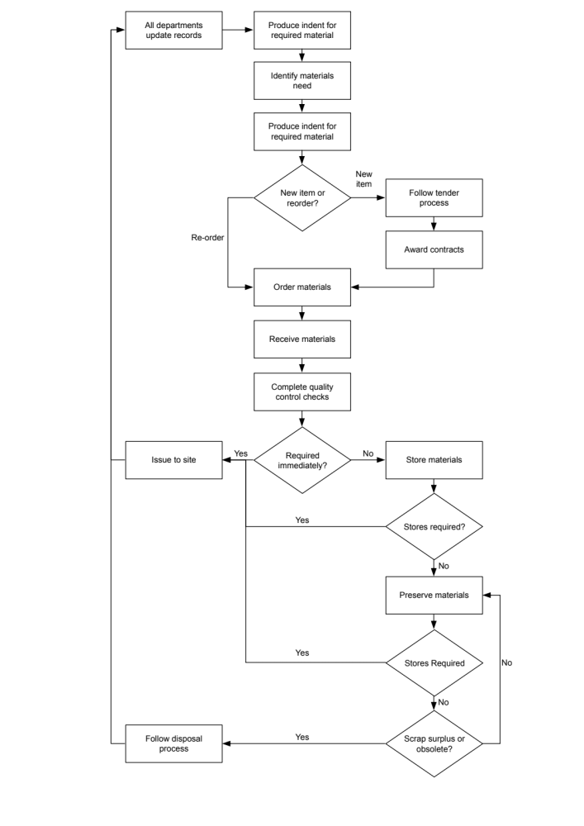
Figure 2: Example of a materials procurement cycle

- Explain the various tendering systems used for ordering the materials. (6)
When seeking suitable suppliers for materials, equipment or other items, it is normal for an invitation to tender is sent to suppliers directly in writing or indirectly through advertising the need by the publication of a Notice inviting Tenders (NITS) in the press or in trade magazines.

The purpose of a tender is not to seek the lowest price but to seek the most suitable organisation by applying a number of pre-determined criteria to find a supplier that will provide:
- Value for money
- Competitive pricing
- Consistent levels of quality
- Reliability
- Flexible and responsive. Particularly, adaptability in the event of any unforeseen issues
- Added value to the competitiveness of the business when seeking new work

There are a number of methods for seeking tenders:
- The open tender
With an open tender, there are no restrictions on who can submit a tender.
Suppliers are notified of a requirement to supply materials, equipment or other items through Notices Inviting Tenders (NITS) or invites to tender, placed in the press or trade magazines.

Suppliers who express an interest in tendering in line with the requirements of the published invitation to tender, are provided the full details of the requirements in the form of tender, including:
- Latest date for submitting a formal tender
- Detail of requirements
- Detailed technical specifications
- Design drawings
- Details of delivery milestones
- Other service level agreements
- Contract terms and conditions

Armed with this information, prospective suppliers will submit tenders to supply the required items including:
- Pricing
- Specification availability with suggestions of alternatives matching minimum requirement
- Delivery schedules
- An outline of their commercial viability, competencies and experience.
- Any required risk assessments and method statements (RAMS)

Suppliers are required to submit all required information and are evaluated against the chosen pre-selection criteria. Once this process has been successfully completed, the contract is awarded.

Where there are large numbers of respondents, multi-stage tendering may be utilised. At each stage of the tender process, suppliers are culled who are not suited to the specific contract requirements until the best supplier is determined.

A risk of working with the open tender process is that of the rogue bidder. These are suppliers who quote at the lowest possible, sometime non-profitable price to win contracts. Once embedded within the contract, they attempt to renegotiate payment terms to gain an increase over the tender bid. This is one reason why it is not always best practice to accept the lowest price tendered.

- The limited tender
To tackle the issue caused by the incidence of rogue bidders, some organisations use a limited tender process. Essentially, this is similar to the open tender process but instead of wider advertising of to the wider community, invites to tender are sent to a limited number of preferred bidders who have demonstrated the can meet a pre-determined series of criteria. Sometimes utilised wit companies the organisation has worked with previously.

Care needs to be taken in this process to avoid suitable suppliers are not excluded from the process or that the process does no positively discriminate towards a specific supplier.

- Single tender
Invitation to tender to only one supplier is termed ‘single tender’. This may be due to there being only a single supplier that is capable of meeting the requirement, or that competitively tendering will not provide value for money.

However, while they are useful in particularly specific cases, single tenders should be avoided in case the risk of unfair pricing, blackmail or bribery can be implied.

Student Statement:

By submitting this assignment, I confirm that this is my own work.

Student Signature | STEPHEN JOHN BATES | Date | 10/03/19

For Tutor / Assessor Use Only
Total Marks
Marks Obtained
Percentage / Grade

