
Assignment Cover Sheet

Student Name: | Marie Pearce
Student Number: | 29465
Course: | Introduction to Logistics Management
Assignment NO: | 5

Marking Criteria:
We expect the learners to write minimum one well expressed point in three lines against each allocated mark. This means one needs to write 15 lines with 5 well expressed points to get high grades for a 5 marks question.
For high grades use examples and illustrations where appropriate.
- What are the main aims and functions of Warehouses?

- Providing storage at the key point with in the supply chain.
- Providing safe and secure space for goods.
- Maintaining all products in good condition with minimal damage.
- Carryout all necessary activities efficiently but cost effectively.
- Controlling all movement of stock effectively without error.
- Receiving all goods quickly and efficiently, putting them away without error.
- Picking, packing and dispatching goods efficiently.
- Being able to store a wide range of materials.
- Being flexible enough to deal with stock level changes.
- Rotation of stock base on fifo.
- Safe working environment compliance with all regulations.

- What is the difference between Public & Private Warehouse?

Private Warehouses are owned or leased for their own supply chain, wares a public warehouse make money by charging a fee to use their space.

- Explain the advantages of Public Warehouse.
Storage facilities can be available at a desired location as and when required, and at per-agreed price. Skilled and knowledgeable warehouse persons can be supplied when the business does not have any and consolidating load with other organization, can decrease your transport cost.

- What are manual warehouse.
These are warehouse that store goods on shelves or bins and people will go around and pick them from the shelves to pack. Manual warehouse are for small items that are light enough to lift without electrical equipment.
V. what are automated warehouse.
Automated warehouse are efficient, fast, flexible and reliable. They allow for improved warehousing and goods distribution and optimum material flow. With automated storage systems, using High speed stacker cranes, AGV’S or narrow aisle pickers. However, the this requires a very high investment to implement.

Vi. What are the main materials used for packaging?

Plastic, wood, cardboard and metal

2.Outline the activities that take place in a warehouse.
Typical warehouse activities include putting items away, moving items inside or between warehouses, and picking items for assembly, production or shipment

3.Describe, in detail, the general layout of a warehouse.

The general layout of a warehouse must cover the following needs, making the most of the space available, reducing the handing of goods to a minimum, providing easy access to the stored product and having the highest rotation ratio possible. Offering maximum flexibility in the positioning of products and controlling the amounts stored. The following layout must be perfectly defined when designing a layout, the loading and unloading areas, reception area, storage area, picking area and despatch area. The type of product that you will be storing also determines the layout of the warehouse.

Types for layout

Storage
Goods out
Goods in

Controls and systems

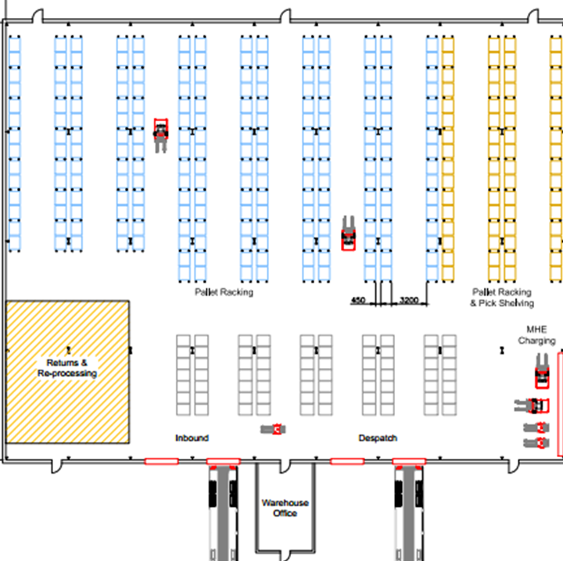

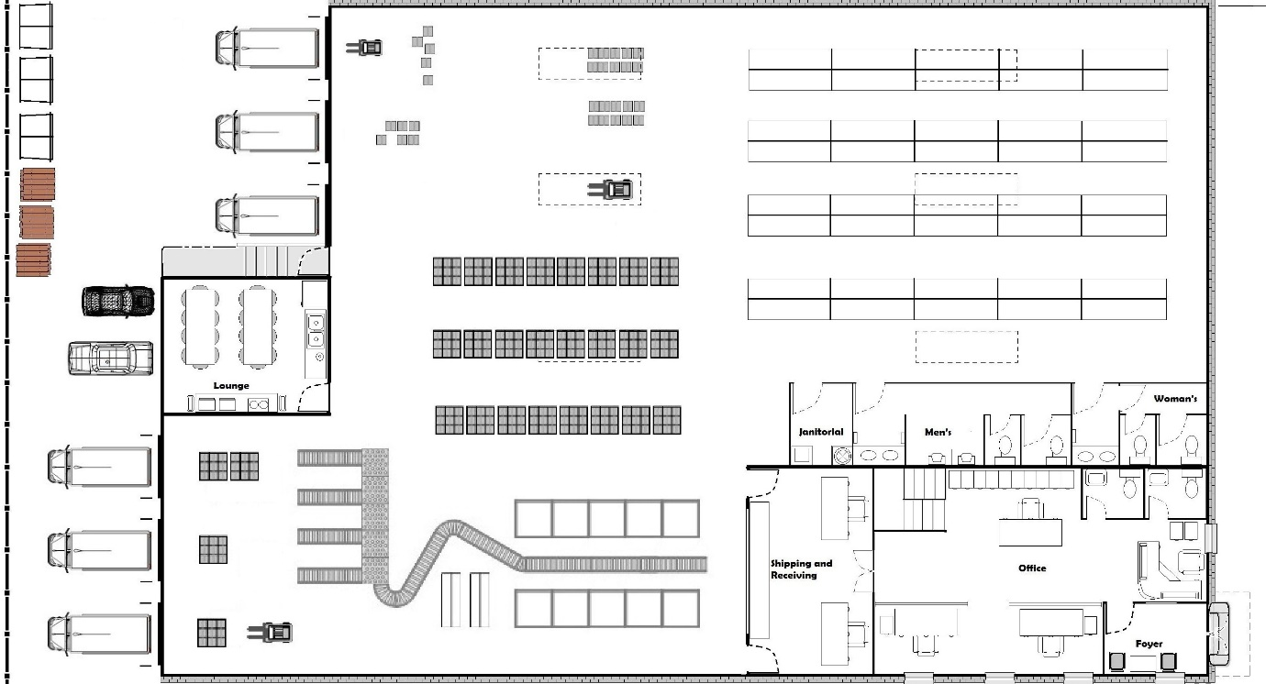

Student Statement:

By submitting this assignment, I confirm that this is my own work.

Student Signature | Marie Pearce | Date | 01/03/2020

For Tutor / Assessor Use Only
Total Marks
Marks Obtained
Percentage / Grade

