Name: Laura Jelley
Submission date: 19 June 2018

Q1: Short Questions

- How would you create a workplace wellness committee?

In order to have a successful workplace wellness program, I need to acquire “buy-in” from the Executive Management Team (Board members) as they facilitate strong links to the rest of the organisation. Establishing a broad committee will offer diverse perspectives and should include those from a variety of geographical locations. It may also be necessary to assemble a sub-committee who can promote the mission and purpose of the wellness program to a wider audience.

- Define workplace organisation culture.

The workplace organisation culture encompasses the attitudes, values and beliefs that shape the organisation. They may be written in a Company document or form part of a cultural understanding and heavily influence employee morale, productivity and health. It is the workplace culture which determines employee satisfaction and engagement as well as being a factor in employee stress levels.

- Outline the different aspects included in the elements of organisational culture.

- Management style
- Communication skills
- Leadership capacity
- Work / life balance
- Perception of fairness
- Workload
- Autonomy
- Feeling appreciated
- Social support

- Describe the ICE method.

Performing a “needs analysis” identifies the needs and wants of employees in terms of wellness. In order to assess if the organisation would benefit from a wellness programme, you should consult the ICE method:

Isolate the problem

Consult with appropriate stakeholders to assess the effects the problems are having on the organisation

Evaluate all options and set up an action plan that meets organisational needs. Then you will need to assemble the support you will need

- When is a wellness program inappropriate?

The workplace environment will heavily influence the success of a wellness program. Employees will need to be motivated and engaging to be enthused by the program. Both employees and the company must hold health and safety in high regard to eliminate incidents of illness or injury. Open conflict among teams to include middle-management and executive members will negate a wellness program being appropriate. Finally, if an Employee Engagement Survey demonstrates there are multiple contributions to low scores, this will also render a wellness program inappropriate.

Q2: Discuss the benefits of workplace wellness programs

Wellness programs improve employee health behaviours by installing motivation, skills and social support. By changing health behaviours, the health risks reduce which in turn reduces the number of employees with chronic disease. These contribute to reducing health care costs.

There are many reasons why employees have low productivity for example, they may be unsure of what it is they are supposed to be doing, may be tired or distracted. However, one of the main causes of presenteeism is poor health. Tying into the first point, wellness programs that focus on helping employees have good health behaviours will eventually have an impact on productivity. Overall, a wellness program can lead to being responsible for the reduction in employee absenteeism.

When recruiting for new employees, a major selling point to prospective candidates is a wellness program. These days, employees not only look for the right salary but concentrate on the environment they may be joining and how the existing employees are valued. A Virgin Health Miles / Workforce survey found that nearly 87% of employees said they consider health and wellness offerings when choosing an employer. Wellness programs have a powerful influence on an organisation’s retention rate as they help to keep employees loyal. Organisations will retain their workforce if it is content.

If you take Maslow’s need hierarchy, the top of the pyramid shows qualities humans would like to have once their basic needs have been met (see below). By providing your workforce with a wellness program, you are demonstrating your respect and trust for them and that you want them to be successful. This boosts morale and further enhances an employee’s working life.

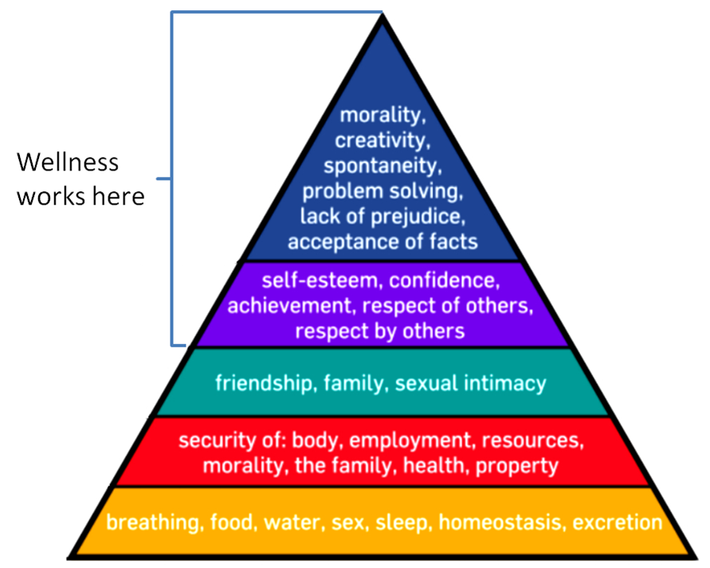

Q3: Describe the GO-PARSE model for effective reading

Get Organised – gather the tools needed to be fully prepared to digest the information. Notepads, laptops, pens, highlighters will all make for effective summarising.

Preview – Take time to understand the layout of the text and where you will get your information from. Identify sections of importance to eliminate time wasting.

Ask – Think of questions to ask when reading each piece of information as this will enhance your understanding of the text; why, when, where, who, how?

Read – Take time to read and interpret the text fully. It can help to read aloud and highlight keys words and phrases.

Summarise – Making notes in your own language will help you retain the information and understand it clearly. Avoid copying the text word for word as this the information will blur.

Evaluate – Make decisions and assumptions based on the evidence you have sourced. Use this stage to answer the questions you may have wanted to ask when you first read the text.

References
- Brentwood college study materials: Unit 1 Need of Workplace Wellness Programs
- “The 7 Best Reasons to have a Wellness Program: Benefits of Wellness” by Dr Steve Aldana – 6 March 2018: www.wellsteps.com/blog

