
Assignment Cover Sheet

Student Name: | Josephine Durosinmi-Etti
Student Number: | 31121
Course: | Advanced Diploma in Business Management Level 5
Assignment NO:

Marking Criteria:
We expect the learners to write minimum one well-expressed point in three lines against each allocated mark. This means one needs to write 15 lines with 5 well expressed points to get high grades for a 5 marks question.
For high grades use examples and illustrations where appropriate.
- Change management
Change management is the discipline that controls the way we organise, equip and support people to effectively embrace change to drive the success and results of the organisation.
While all changes are distinctive and all individuals are unique, decades of research show that there are actions we can take to encourage people in their transitions. Change management provides a structured approach to help people in your organisation move from their current states to their future states.

There are three levels of change management.
- Management of individual changes.
Although it is the natural psychological and physiological reaction of human beings to resist change, we are quite resistant creatures. In times of change support us, we can be wonderfully adaptable and successful.
Individual change management requires an understanding of how people understand change and what they need to change effectively. It also requires knowing what will enable people to make a successful changeover: what messages they should hear when and by whom, when is the best time to teach someone a new skill, how to teach people to demonstrate new behaviours and what changes "Stick "in someone's work. The management of individual change is based on disciplines such as psychology and neuroscience to apply feasible structures to individual change.
After years of studies on how people experience and are influenced in times of change, Prosci has developed the ADKAR model for individual change.

ADKAR Model is a goal-oriented change management model that drives individual and organisational changes. Created by (Jeff Hiatt, 2006) ADKAR is an acronym that represents the five tangible and concrete results that people must achieve to achieve a lasting change: Awareness, Desire, Knowledge, Action and Reinforcement.
Outlining the objectives and results of a successful change, the ADKAR model is a useful tool for planning change management activities, giving leaders the ability to make changes and support employees during the change.

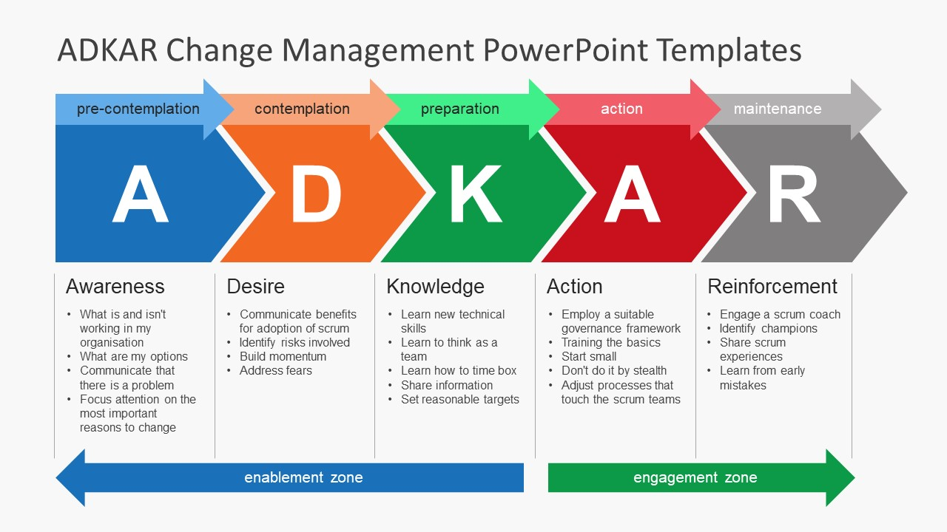

Management of organisational/initiative changes.
While the change occurs at the individual level, it is often impossible for a project team to manage change individually. The management of organisational or initiative changes provides us with the steps and actions that should be taken at the project level to support the hundreds or thousands of people interested in a project.
Organisational change management involves identifying first groups and people who will have to change as a result of the project and how they should change. Therefore, organisational change management involves the creation of a customised plan to ensure that relevant employees receive the awareness, leadership, training and training they need to change successfully. Driving successful individual transitions should be at the centre of organisational change management activities.

Organisational change management is complementary to project management. Project management ensures that the project solution is designed, developed and delivered, while change management ensures that the project solution is adopted, adopted and used.
Ability to manage business changes.
Business change management is a fundamental organisational skill that offers competitive differentiation and the ability to adapt effectively to the changing world. A capacity to manage business changes means that effective change management is merged into the organisation's functions, structures, processes, projects and leadership skills. Change management processes are applied consistently and effectively to initiatives; leaders have the skills to guide their teams through change and employees know what to ask for success.
The result of a business change management capability is that people adopt change more quickly and effectively and organisations can react quickly to market changes, take strategic initiatives and adopt new technologies more swiftly and with less impact on productivity. However, this capacity is not random and requires a strategic approach to incorporate change management into an organisation.

- Three phases of the change cycle
Lewin's three-stage theory of change is commonly known as Unfreezing, Changing, Refreezing (or freezing). It is possible to take these steps at quite complicated levels, but I do not think it is necessary to be able to work with the theory. However, keep in mind that the theory has been criticized for being too one-dimensional.
The world has changed since the model was initially offered in 1947, but Kurt Lewin's model remains exceptionally relevant. Many other modern models of change are based on Lewin's 3-stage model. I am going down an intermediate road, and I am giving you enough information to make you dangerous ... and maybe a little more to whet your appetite!
Then, three phases. Release, change, freeze. Let's look at each of these. (Connelly, 2016).

- Unfreezing:-
The unfreezing phase is probably one of the most significant phases to understand in the world of change in which we live today. This stage is about preparing for the change. It implies reaching a point of understanding that change is necessary and preparing to move away from our current comfort zone.
This first stage consists of preparing ourselves or others before the change (and ideally create a position in which we want the change).
The more we feel that change is compulsory, the more urgent it is, the more motivated we are to make the change. True? Yes of course! If you understand procrastination (as I do!), Then you would recognise that the closer the deadline is, the more likely you are to take action and start working!
With the deadline comes a kind of reward or punishment linked to work. If there is no deadline, the desire to change is less than the need to change. There is much less motivation to make a change. If there is no urgency or reason to change, most of us will do nothing! (Kurt Lewin, 1947)

- Change
(Kurt Lewin 1947) Was also mindful that change is not an incident, but rather a process. He called that process a transition.
The transition is the internal movement or the journey we make in reaction to a change. This second stage occurs when we make the necessary changes.
People are "thawed" and are moving towards a new way of being.
That said, this phase is usually the most difficult since people are not sure or even afraid. Imagine jumping in bungee or parachute. You may have swayed yourself that there is a great advantage for you to leap, but now you are on board looking down. Scary things! However, when you do it, you can learn a lot about yourself.
This is not an easy time, as individuals are learning about changes and need time to understand and work with them. The transition is a process that occurs within each one of us. There are no established time limits because each one of us is different.
Support is essential here and can be in the form of training, training and waiting for slip-ups as part of the process.
Using role models and agree to people to develop their solutions will help the process of change. It is essential to continue communicating a clear picture of the desired change, and the benefits so that people do not lose sight of where they are going.

- Refreeze
(Kurt Lewin, 1947) Denotes to this stage as freezing, although many people refer to it as "refreezing". As the name suggests, this phase is about stabilising stability once the changes have been made. Changes are acknowledged and become the new norm. People form new relationships and feel comfortable with their routine. This can take time.
At this point, people often laugh and tell me that there is practically no time for this "freezing" phase. Moreover, this is indeed what attracts criticism of the Kurt Lewin model.
What does Kurt Lewin mean by 'Freeze'?
In today's world, the next new change could happen in weeks or less. There is no time to settle into contented routines. The rigidity of freezing is not adapted to the current thinking about the change since it is a continuous process, sometimes chaotic, in which great flexibility is mandatory.
Prevalent thought has moved away from the concept of freezing. Instead, we are urged to think of this final phase as more flexible, perhaps as a smoothie or a soft ice cream, instead of a rigid, frozen block. In this way, 'Defrosting' for the next change could be more natural.

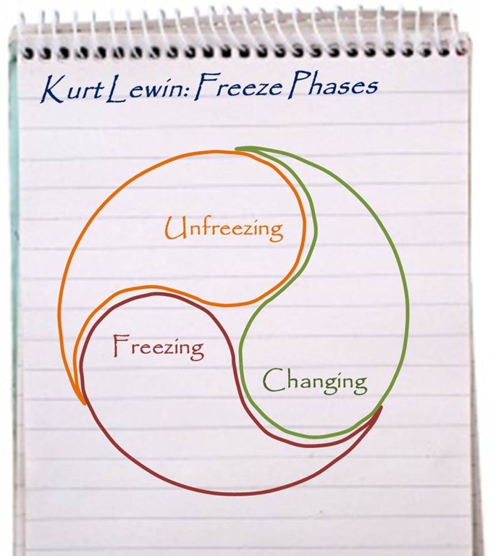

- Human reactions to change
Everything is subject to changes. Our lives, the communities and societies in which we live and the organisations we work for are affected by the waves of change. Some are gradual, others traumatic; Some are of our creation, many are beyond our control. The effects of the global recession, genetic engineering and the Millennium transition involve changes of unknown scale and complexity. All these changes can generate stress for both individuals and companies.

Coping with stress and change have constantly been fundamental problems for human survival and evolution. The psychological and cultural coping mechanisms have evolved for both tasks. However, most of the theories and practices of organisational change focus on motivation, performance and organisational agendas for change. Less attention has been given to psychosocial contexts for individuals. Change strategies can prevent or improve the natural psychological transition process that allows people to adapt to change and transform their lives. This is where the psychology of transition comes into play.
(Adams J, Hayes J, Hopson B. Transition 1976)

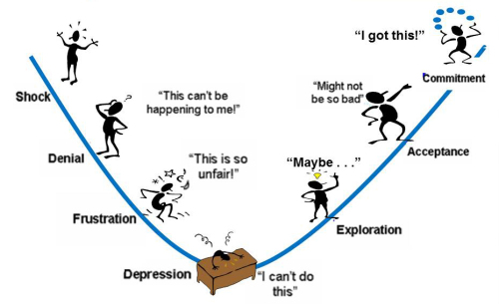

There are typically three ways in which people react to change:

• Be inactive.
This is the kind of homeowner who discovers that they have a dripping roof, but they just lean back, singing the song "It never rains in Southern California", hoping it will. They resist change and choose to be rejected. If I do not solve the problem, it is not there. It will not happen to me, so I will continue to take care of my business. Alternatively, they face an attitude and say: it is not right. Why do I? In any case, do not get ahead and get stuck. They are choosing the payment later than now, the focus and payment will do so.

• Be reactive.
The owner starts frantically calling the local roofers and feels the pressure to make a quick decision. They do not have all the necessary data, but still, decide to eliminate their immediate stress and concerns. It is an instinctive reaction. It is the individual who discovers that he could lose his jobs, go crazy, visit 30 job agencies and have a new job the following Monday, but not exactly what suits his skills or talent.

• Be proactive and positive.
A few months ago, the owners accepted the age of the original roof and began to do the homework. They sought advice from all their friends and neighbours, searched the rooftop materials online during their free time and began interviewing rooftop experts suggested by others. They prepared a budget and began saving for the new roof, which must be implemented before the rainy season starts. They focused on what they could do, focusing on positive results and taking action.
The ideal way to deal with change is to be proactive because you feel more in control. Moreover, the more we feel we have control over the situation, the less stress and frustration we feel. It does not matter if it is a roof, a divorce, a professional renewal or a diet when we take responsibility for the change; the trip feels more comfortable and ends up being more rewarding. (Carlson 2015)

References
Hiatt, J. (2006). What is the ADKAR Model?. Available: https://www.prosci.com/resources/articles/what-is-change-management. Last accessed 01st Apr 2019.

Kurt Lewin, (1947). "Frontiers of Group Dynamics", Human Relations, Volumes 1, pp. 5-41 (I added the emphasis). Last accessed 01st Apr 2019.

Connelly, M. (2016). The Kurt Lewin Change Management Model.Available: https://www.change-management-coach.com/kurt_lewin.html. Last accessed 01st Apr 2019.

Carlson, C. (2015). The 3 Ways People React to Change. Available: https://www.success.com/the-3-ways-people-react-to-change/. Last accessed 01st Apr 2019.

Adams J, Hayes J, Hopson B. Transition (1976) Understanding and Managing Personal Change, Martin Robinson, London, 1976, pp 3-25.

Student Statement:

By submitting this assignment, I confirm that this is my own work.

Student Signature | Josephine D Etti | Date | 02/04/2018

For Tutor / Assessor Use Only
Total Marks
Marks Obtained
Percentage / Grade

