
Assignment Cover Sheet

Student Name: | Doreen Ntalo
Student Number: | 32621
Course: | Advanced Diploma in Hotel Management-Level 5
Assignment NO: | ASSESSMENT # 8

Marking Criteria:
We expect the learners to write minimum one well expressed point in three lines against each allocated mark. This means one needs to write 15 lines with 5 well expressed points to get high grades for a 5 marks question.
For high grades use examples and illustrations where appropriate.
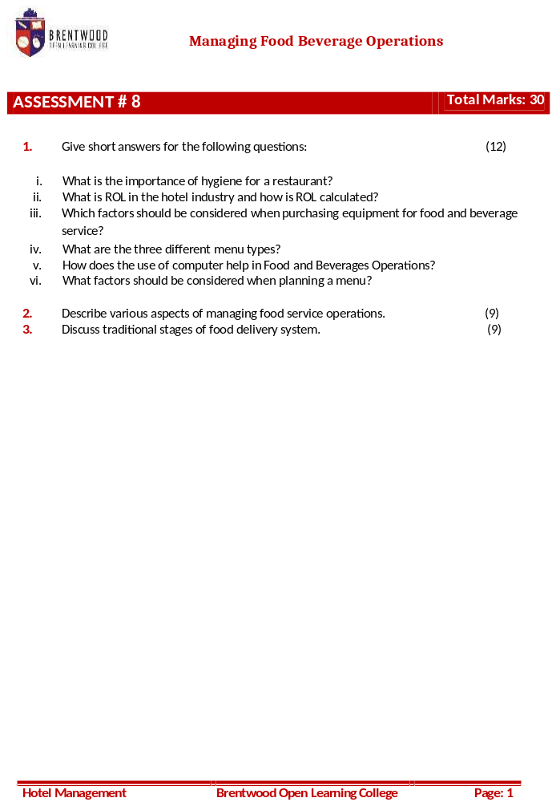

Student Statement:

By submitting this assignment, I confirm that this is my own work.

Student Signature | Doreen Ntalo | Date | 27 July 2019

For Tutor / Assessor Use Only
Total Marks
Marks Obtained
Percentage / Grade

Doreen Ntalo
32621
Assessment # 8
Page: 1
1.
- Hygiene is extremely important for any restaurant because the reputation of the restaurant is dependent on its hygiene and its menu. The employees are constantly in contact with the food and the equipment needed to prepare it and therefore being that the main source of food contamination comes from elements, such as; the nose, mouth, skin, fingernails, hair, respiratory tract and eyes, general hygiene is very important.
- ROL refers to Reorder Level that is to say the level at which the next order is placed as by the purchasing team.
It can be calculated using the formula: (W x L) + S = …
Where;
W- Is the average usage rate,
L- Is the lead time,
S- Is the safety stock (buffer or minimum)
- Factors considered when purchasing equipment for food and beverages service include the following:
- Flexibility of use;
- Type of service offered;
- Type of customer;
- Design;
- Colour;
- Durability;
- Ease of maintenance;
- Stackability
Doreen Ntalo
32621
Assessment # 8
Page: 1
- Costs and funds available;
- Availability in the future – replacements;
- Storage;
- Rate of breakage, e.g., for China;
- Shape;
- Psychological effect on the guests; and
- Delivery time.
- The three different menu types are:
- À la carte Menu,
- Table d’hote Menu, and
- Carte du jour.
- The use of computers in the Food and Beverages operations help as:
- It improves guest service;
- Streamlines handling of paperwork and data;
- Improves control over day- to- day operations;
- Generates complete and timely reports;
- Reduces costs of paper supplies;
- Increases sales revenue;
- Increases employee productivity;
- Reduces clerical staff;
- Reduction of repetitive tasks; and
- Helps in maintaining current sales and expense data file.

Doreen Ntalo
32621
Assessment # 8
Page: 1
- The major factors that affect menu planning include:
- Customers’ food preferences;
- Type of food service outlet and the budget available for the outlet;
- The customer food habits;
- The availability of raw materials is essential since seasonal items are easily found, while exotic items can be difficult to produce. The viability of the menu depends on the availability of the ingredients; and
- The physical facilities and equipment available play a role in menu planning. The type and quantity of equipment available are also a deciding factor in selection of menu items.
2. There are different aspects in managing food service operations and these include:
- Food Purchasing:
According to John Stefanelli, the food service purchasing involves the following:
Developing specifications;
Preparing an approved suppliers list;
Determining the appropriate order size; and
Establishing appropriate receiving and storage procedures.
The first step is specifications since it involves cost and control guidelines. Appropriate specifications have to be developed for each item bought from outside suppliers. This helps in evading any misunderstanding among concerned parties. Typically the manager produces an approved suppliers’ list. This helps to guarantee a consistency in quality and cost and also controls the activities of the buyer…

Doreen Ntalo
32621
Assessment # 8
Page: 1
- Managing food production system:
Food production is the centre of the food service industry. Classification of the menu begins the food production system…
Even though the menu is the core of the food service industry, the ingredients are the essential element of the food produced. This is where the usefulness of the recipe standardization comes in. It is the most significant tool existing to control costs and safeguard product consistency and quality.
Production consistency in a food item can be achieved by accurate record of ingredients, amounts and methods of combining and cooking the item…
- Food service Hygiene:
Hygiene is extremely important for any restaurant because the reputation of the restaurant is dependent on its hygiene and its menu. The employees are constantly in contact with the food and the equipment needed to prepare it. Main source of food contamination comes from elements, such as; the nose, mouth, skin, fingernails, hair, respiratory tract and eyes. The staff must be trained to ensure that they maintain a high standard of personal hygiene. Next the equipment to be used must be considered. The cleaning area must be kept clean, to make sure about the food service hygiene…

Doreen Ntalo
32621
Assessment # 8
Page: 1
3. The traditional stages of Food Delivery System have eight distinctive stages and these are:
- Storage – refrigerated or ambient storage of material
- Preparation- activities, such as peeling, cutting and so forth
- Production (cooking) - methods such as, frying, roasting and so forth
- Holding – storage between production and consumption
- Service – style of delivering dishes/ meals to consumers
- Dining – consumption of meal by consumer in setting
- Clearing – removal of equipment/ food debris
- Dish wash – cleansing of soiled equipment
Some unique features of the traditional system are:
- Strong difference between the front and back of the house;
- Customers are restricted to the front of the house; and
- All the various activities occur on the same premises.

