
Assignment Cover Sheet

Student Name: | Michele Di Lisa
Student Number: | 22864
Course: | Certificate in Project Management (Level 1)
Assignment NO: | 2

Marking Criteria:
We expect the learners to write minimum one well expressed point in three lines against each allocated mark. This means one needs to write 15 lines with 5 well expressed points to get high grades for a 5 marks question.
For high grades use examples and illustrations where appropriate.
- What are priority quadrants? How do these matrix help in selecting projects? 10
The priority quadrant is a visual reference that helps in demonstrate our priorities. Draw two bisecting lines. One is for a high payoff vs. a low payoff. The second bisecting line is for difficulty vs. ease of doing a project. Each project is assigned to the appropriate quadrant.
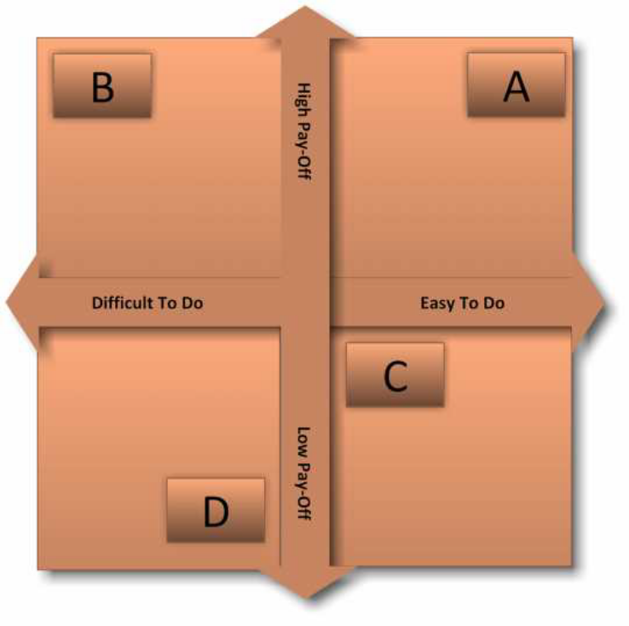
The projects priority is showed in the above images and it seems to be quite easy to select the projects priority as follows: A, C, B, D.

Other examples of matrix are the Priority Matrix and the Brainstorming Diagram.
Moreover, a target chart can help you identify the biggest priorities in your project and help you see how to achieve your goals, as showed below:

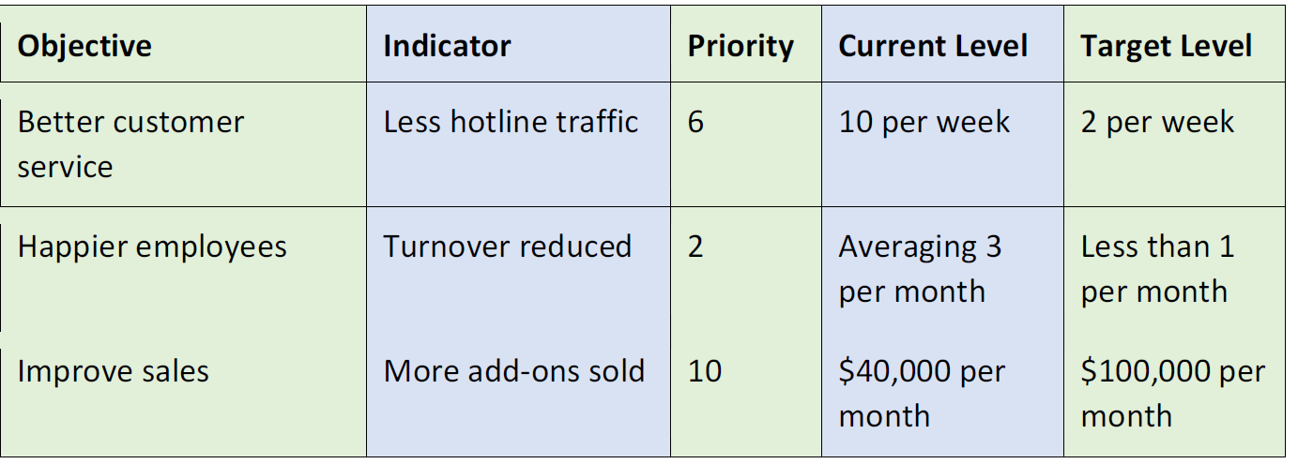
First, we list our objectives. These are the items that, if achieved, will mean the project has been successful. After that we add indicators, priority (0 to 10), current level and target level (i.e. the target to be achieved).

- What is SPIRIT? How it is used for setting goals? 10
SPIRIT is used for setting goal importance, which is important for a project’s success. The project manager should be able to clearly describe the outcomes, deliverables, and benefits of goal setting to stakeholders and end users.
Setting goals should make sense and be memorable. SPIRIT is used for this purpose; it stands for:
- Specific: Project goals should clearly outline the criteria you will use to evaluate your success in a particular project (i.e. time, costs and resources) to achieve the desired outcomes.
- Prizes: Celebrate when you accomplish a goal. If the goal is long term, you can have prizes when various milestones are achieved.
- Individual: All members of a team need to be motivated and involved in goal setting. might be useful to keep a goal chart on the wall.
- Review: Project goals also need to be reviewed periodically to make sure you have consensus as you move from stage to stage in a project.
- Inspiring: Goals should be high but achievable.
- Time-Bound: Deadline for the goal must be clear to team members.
- Two Additional Criteria: goals must be agreed upon and come with clear responsibility.

Student Statement:

By submitting this assignment, I confirm that this is my own work.

Student Signature | Michele Di Lisa | Date | 31/07/2018

For Tutor / Assessor Use Only
Total Marks
Marks Obtained
Percentage / Grade

