
Assignment Cover Sheet

Student Name: | KEVIN MARK HILL
Student Number: | 6508
Course: | CONSTRUCTION MANAGEMENT
Assignment NO: | UNIT-4

Marking Criteria:
We expect the learners to write minimum one well expressed point in three lines against each allocated mark. This means one needs to write 15 lines with 5 well expressed points to get high grades for a 5 marks question.
For high grades use examples and illustrations where appropriate.

QUESTION 1
What is an environmental impact study?
Environmental impact assessment (commonly referred to as environmental impact statement (EIS) process) is used to ensure environmental management is considered as part of the approvals process for all development proposals that require assessment by local government or have the potential to harm the environment. Developmental activities are accompanied by some positive, as well as some negative effects on the surrounding ecosystem. It is therefore imperative for developers to consider factors which affect the environment during the early phase of planning. Site developers must take note of the following factors:-
- Air quality
- water quality and quantity
- solid wastes
- noise, radiation from nearby radio-active sources
- hazardous conditions
- energy supply and natural resources depletion
- Protection of the environmentally critical areas i.e., flood plans, wet-lands beaches, mangrove, unstable soil etc.
- Land use in coastal areas
- Redevelopment in built up areas
- Density and congestion mitigation
- Neighbourhood character and continuity

What is the basic criterion for judging the suitability of the site for construction?

As premium locations become harder and harder to find, developers are turning to locations that were previously considered to involve a larger proportion of risk.
All sites involve some level of risk , however the factors that affect the suitability of a site for all types of building, are as follows:-
- Availability of physical resources, such as a suitable and sufficient water supply, a suitable and sufficient electrical supply, material supply
- Climatic considerations such as temperature, humidity, solar radiation, rainfall and wind.
- Physical factors, such as the contours of the site and the nature of the soil, proximity to water courses, proximity to a paved roads, water table, presence of existing structures, trees, etc.
Note
It’s also worth taking a look at you’re access and the proximity of your neighbor’s.
Specifically think about churches, shopping malls and the obvious issues they bring.
Schools specifically bring their own issues and pick up and drop off times, will cause congestion nightmares with parents trying to park in any available location.
Trees also can have preservation orders and remember a broad leaf tree roots can spread 30m in a quest to locate water.

Please refer to the Photograph inserted at the end of question 1. It is the Carlton Savannah Hotel in Cascade Trinidad 2006. You will see the on the upper left a concrete delivery waiting to unload. This is parked adjacent to a road bridge which was unable to take the axel loading of an 8 cubic meter truck. As a precaution we provided a support system onto a concrete raft which was installed in the dry season. This is a clear example of a significant cost, which should have been noticed at site inspection and allowed for in the tender.

What is topographic data about

Topographic data is information about the elevation of the surface of the earth. Two such data types are commonly used with GeoPads. The first is the data that represent the information typically found on a topographic quadrangle map, such as contour lines, roads, streams, railroads etc. For simplicity, this first category of data will be referred to as digital topographic map data. The second are grids of data, for which each cell in the grid represents the elevation at a certain point on the earth. This data is commonly referred to as Digital Elevation Modules or DEMs

Topographic Survey are used to identify and map the contours of the ground and existing features on the surface of the site, or slightly above or below the surface
For example, trees, buildings, streets, walkways, manhole, utility poles, retaining walls, etc.
The purpose of the survey is to serve as a base map for the proposed design. It may be necessary to show perimeter boundary lines and the lines of easement on or crossing the property being surveyed, in order for the designer to accurately show zoning and other LA or agency requirements.
Visual inspection is used to study the basic land form of the site and data is available on Ordnance Survey Maps, from local authority searches, historical data, parish records etc.
The topographic survey will be used as the base print for all the completed design layout drawings. So it is essential that sufficient funds are allocated to this activity to ensure that all significant data is recorded and therefore allowed for within the proposed design.

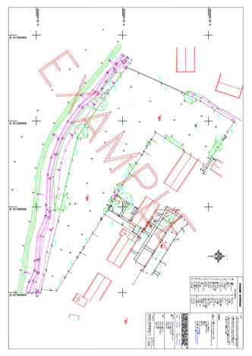

An example of a typical topographical survey

What type of building should be constructed on rocky sites?

My answer to this, is that all types of building can be constructed on rocky sites as long as engineering considerations have been allowed for in the design and that you ensure that you have carried out a suitable soil investigation.
The main requirements of the foundations of any structure are as follows;-
- Transfer the buildings load to the ground (Bedrock has the highest safe bearing capacity of all soil types)
- Anchor the building against wind and seismic load
- Isolate the building from frost heave
- Holds the building up from moisture
The only issue I can see with rocky and semi-rocky sites is the presence of ground water. Water can travel through fishers and cracking and cause issues for primary and secondary sewage, or water treatment plants as well as ingress into basements and below ground living areas. This could also be an issue if you were considering tunneling or caisson installation for a dam or power station perhaps. However as stated above moisture and ground water will have been considered in item 4 of the foundation design.
.
With regard to quarries, as the sole purpose of a quarry, is generally to provide stone/rock. Then clearly its necessary to site on a selected rocky location

Semi-rocky sites

At present high rise building are constructed in some places, on semi-rocky soils. It leads to the load increase on the soils and the foundation depth as well. Under these conditions pile foundations on geological Lower Permian deposits are the most effective and sometimes the only possible type of foundation.
It is known that semi-rocky soils depend on the rate of water saturation and cementation. Therefore piled foundations tend to lose their strength properties under damping. However these factors are all considered in the design of the foundations and are included in item 1 above

Note

I do not necessarily agree that piling is the most cost effective, for semi-rocky soil. I think that, driven or bored piles, would have limited use in a location where the presence of obstructions could be limitless. Maintaining a setting out tolerance would be almost impossible, even if you have some sort of piling rig that is able to drill through solid rock obstructions. Furthermore piling is 2 or 3 times as expensive as a traditional type spread foundation, under normal installation conditions. As long as a safe bearing capacity of say 3000 PSF could be achieved, then that would be far more cost effective method to use traditional spread foundations.

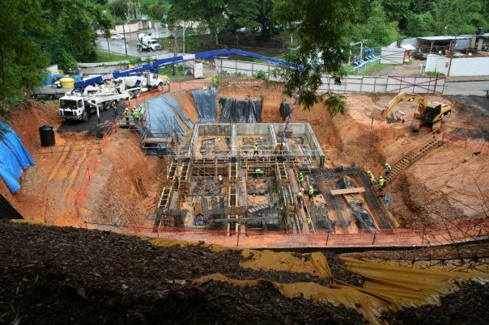

The picture, (above) is of the Carlton Savannah Hotel in Cascade Trinidad 2006 during rainy season. Foundations and basement cut from semi-rocky and rock, soil using a spread type foundation. The site was cut into the lower slopes of the Northern Mountain Range to provide more space, from that provided by the acquisition of the Pelican Pub and squash court.
The picture is taken from the boundary of the adjourning property (Hilton Ho

QUESTION 2

Give the classifications, under which the following buildings fall.

Buildings are normally classified, based upon occupancy and the method of construction employed. Developmental controls, rules and building bylaws are strictly based upon the occupancy criteria: therefore, the occupancy is crucial for planning and design purposes

- Museum D1 (Public services)
- Hospital C2 (Residential)
- Hotels C1 (Hotels, hostels and dwelling houses)
- Public Library D1 (Public services)
- Department Stores A1 (Shops and retail outlets)

Many buildings may have multiple occupancies. These are referred to as “mixed” occupancies and the different parts will be required to meet the building codes for those specific areas.
An example of this might be a department store with an underground car park. In this example both sections would have different classifications

Student Statement:

By submitting this assignment, I confirm that this is my own work.

Student Signature |  | Date | 03.04.2017

For Tutor / Assessor Use Only
Total Marks
Marks Obtained
Percentage / Grade

