
Assignment Cover Sheet

Student Name: | Lynn Starling
Student Number: | 30337
Course: | Diploma in Business Administration Level 4
Assignment NO: | Assignment 10 – Customer Relations

Marking Criteria:
We expect the learners to write minimum one well expressed point in three lines against each allocated mark. This means one needs to write 15 lines with 5 well expressed points to get high grades for a 5 marks question.
For high grades use examples and illustrations where appropriate.
Assignment 10 – Customer Relations
Q1 i. Explain various techniques for assessing customer response.
Customer satisfaction surveys
The customer satisfaction survey is a fairly standard approach for collecting data/information regarding customer happiness. You ask questions how satisfied they are, this can be with or without follow up questions.
3 Variations are:
In App Surveys
You integrate a feedback button within your website, with generally one or two questions. This method has the highest response rate, mainly due to the fact they are asked for their opinion whilst still being engaged by your business, i.e. on the website. They are especially useful to measure some satisfaction metrics.
Post Service
This focuses on the satisfaction of a particular service or product the customer has received. You can after the delivery has taken place, while it is still fresh in the customers mind request the feedback. It can be undertaken in numerous ways. Email support, with a rating embedded in the email. Live chat, with a rating view that appears once a chat has ended. Over the phone, however this takes up more of the customer’s time and they might not be happy to share unfiltered opinions or give their time quite so freely. In some cases, you can have a face to face touch point with the customer, after service for example, in a restaurant. In this scenario you could collect instant feedback using a tablet.
Email Surveys
Email surveys are good for in depth insights regarding client satisfaction. Although they have low response rates between 10% & 15%, they do allow the client to take their time answering multiple questions.
Customer Satisfaction Score (CSAT)
This is the most standard satisfaction metric, asking the customer to rate your business according to their satisfaction your CSAT score is then the average rating of the responses. The scale typically ranges between 1-3, 1-5 or 1-10. A larger range is not always better, due to cultural differences in how people rate their satisfaction. For example an American is more likely to rate amazing or terrible, whereas a Japanese will use fine or not satisfactory. It important tap be aware of this with in international customer base. Simpler scales are more robust to cultural differences & more suited for capturing service quality. For example Ikea uses a simple emoji based CSAT question throughout its stores, on a number of questions for example waiting times, product availability etc. The charm of CSAT metric comes from its directness. The downside, is that satisfaction is hard to estimate, even for the customer. It is directed at a sentiment, which is fleeting and also dependent on moods.
Net Promoter Score (NPS)
This measures the likeliness of a customer referring you to family or friends. It is a very popular way of measuring loyalty. Clients are asked how likely they are to recommend your business from 1-10, 1 being not at all to 10 being very likely.
Its strengths are that it is not about emotion of satisfaction, but about the intention of referring. Which is much easier to answer. It cuts down to the question of whether the product or service is good enough to put your reputation on the line. Calculating an NPS score is easy. Take the percentage of respondents who fall within the positive (10-9) and subtract the negative (0-6). A benefit of NPS is that it directs your customers attention towards referring, an option that they might not have thought about or considered previously.
Customer Effort Score (CES)
Customer are not asked for satisfaction or the likely hood of referral, but for the effort it took to get their issue resolved – generally on a scale 1 being very low effort to 7 being very high effort. The aim to lower the average score.
Social Media Monitoring
This has an immense impact on the relationship between customers and business. Social media offers an outlet and the possible potential to reach millions of people. Because of this, it is the perfect place to hear what your customers are thinking, if you have the right tools to track this sentiment i.e. Facebook, or twitter, but also quora, yelp, rant & rave or trust pilot.
ii. Discuss the role and function of policies and procedures in meeting customer requirements.
Together policies and procedures provide a roadmap for day to day operations and are an essential part of any business. They ensure compliance with various laws and regulations, give guidance for decision making and helping to achieve conformity across a business with multiple sites. However, these policies and procedures will not help if your employee’s don’t follow or use them. Employees do not always like the idea of having to follow rules. But policy implementation is not just a matter of arbitrary forcing employee’s to do things they might not want to. Following policies and procedures is good for both employees and the business.
Policies and procedures keep operations from developing into chaos. When everyone is following policies and procedures the business can run smoothly. The structures and teams operate as they are meant to, mistakes are quickly identifiable and dealt with. The business will use time & resources effectively. Consistency in practise is also right for employees individually. They know what they are responsible for and what is expected of them, and what they can expect from the team and its leaders freeing them to do jobs with confidence and excellence. When employees follow procedures, they perform tasks correctly and provide consistent customer service. Enhancing the business, which in turn improves reputation, also following policies and procedures reduces workplace accidents and incidents ultimately leading to a safer workplace.
iii. What is the role of quality management in meeting customer needs?
Quality management and its requirement for continuous improvement plays a vital role in ensuring that customer focused businesses identify and address core customer needs. Businesses are reliant upon their clients for their existence and well-being and should recognise all existing and potential customer needs, meet those requirements and strive to surpass expectations by following quality management processes across the business. Steps in applying these can include
Understanding customer needs and expectations this is essential across all aspects of a business, from initial production design, production, pricing, delivery to after sales support, along with any other business function which impacts upon customer relationships. Understanding what customers require, continuously adapting to suit those change needs and improving quality of service is an excellent route for effective quality management.
Balanced approach among customers and stakeholders
Customer are not the only parties who have a role or interest in a business. Other interested parties are employees, suppliers, partners, owners, shareholders, the local community, government and regulators, all who form a collective group of stakeholders. Understanding their needs and balancing with customer needs ensures a more complete approach to exceed expectations, a great level of service and understanding areas for improvement.
Communicating these needs and expectations through the business.
Both customer and stakeholder needs should be communicated to ensure that all employees fully understand the expectations and requirements. This ensures that from the most junior to senior employee, in all functional areas, are committed to striving towards meeting these expectations. It plays an important role in an affective quality management process.
Monitoring Customer Satisfaction and acting on results
This is imperative to any business no matter what size or industry. Both positive and negative feedback should be carefully monitored, and acted upon accordingly to allow customers to know that their input is valued. Feedback should be seen as a way to aid continuous improvement and should be addressed quickly.
Managing customer relations – this is by far the most important aspect of a customer focused organisation. It is essential to maintain and grow relations with clients and stake holders and being fair and honest at all times. Be it in a specific employee or department who deals with customer relations. Transparency & integrity plays a vital role in effective relations. In this way a business’s able to work towards effective quality management as genuinely customer focused business.
iv. A happy customer is a reliable customer and a reliable customer means profit. Keeping in view this statement, point out some ways which one might gain customers trust.
Before customers buy from you, they need to be able to trust you. They need to trust that your messages are accurate, that what you are selling matches what you say it is, and that if anything should go wrong you will support them. The problem is, trust can’t be established quickly or via gimmicks; businesses who have lost consumer trust know this all too well. Trust cannot be forced and it cannot be tricked out of people.
Improve Security
Ensure your customers feel safe when they shop with you. Even if you are not selling your product through e-commerce platforms, customers will still be visiting your website, and the safety they feel while there can play a significant role in how much they trust your business.
Be socially active (and visible)
Being active on social media helps in a numbers of ways, you build visibility for your brand, you attract more followers, and you find that the followers you do attract have a better feel for your brand. The more frequently you expose this side of your brand the faster you will be able to build that trust. One of the strengths of building visibility via social media is the flexibility you have: you can spend your time syndicating on site content, engaging with new & previous followers, posting images and video or updating customers with news and information. The key is to be active & present on a social platform.
Under-Promise and Over-Deliver
Consumers don’t trust brands nearly as much as they used to, and one reason for this shift is customers feeling like they have been lied to. Any customer feels as though he or she has been deceived or manipulated in any way they will more likely part company with the brand responsible. It is your interest to under promise and over deliver when it comes to customer expectations. If it takes for example a week to ship a product, inform your customer it takes two weeks. If a product will last ten years then claim it will last eight that way, you will never run the risk of breaking your promises with the majority of customers. Go all out for customer service.
Trust becomes fragile when customers have an issue with something. If they experience a problem and receive prompt, helpful and memorable customer service, they will think you are a reliable brand. On the flip side, if you mess up you will lose a customer forever and most likely experience a dip in your reputation. Don’t turn to just the most cost efficient way to resolution, make sure your customers feel heard and appreciated, and go out of your way to ensure they are happy.
Make your brand more personal
It helps to make your brand more personal, in your marketing and advertising as well as in regular interactions with clients. Don’t use scripts and formulaic responses, encourage staff to engage customers as real people. A small change makes your company appear less formally corporate and can change customers impressions for the better.
Communicate more
Don’t leave customers in the dark. Though there is such as thing as over communication, as a general rule, the more you engage with your customers, the better. This is true especially if you are working one to one with customers. Be open and transparent about goals and processes, acknowledge when things go wrong. Due to the fact that if you are caught withholding details or neglecting to communicate information any trust that you have built will be lost.
Always be available
It is vital that your brand is always available, for people who need it. On landing pages include a contact number or instant chat option as this makes people feel safe knowing should they have any issues you are easily contactable.
Building trust does not come easily, and won’t always be straight forward but these strategies take you in the right direction. From there on your most powerful strategy is consistency. The more consistent you are, the more loyal you customers become making your reputation stronger.
v. What is meant by CRM? Which type of information does it include?
CRM stands for Customer Relationship Management. Its technology used to manage interactions with customers and potential customers. CRM systems help a business improve its customer service experience. When talking about CRM three things spring to mind –
CRM as technology – often in the cloud that teams use to record report and analyse interactions between the business and its customers.
CRM as strategy – this is a philosophy about relationships and management.
CRM as a process – this is a system adopted to nurture and manage relationships.
The information a CRM tool holds can vary between businesses. For example my employer Calor Gas uses a CRM system called Salesforce. Within this system the information held is variable between departments & sites. Departments such as customer services can see information relevant to them such as Name, delivery address, order information, sales forecasting, pricing, telemetry readings i.e. how full the customers tank is and they can add notes regarding any form of contact be it calls in our outbound, email etc. They can take payments, see invoices, credit and other financial information such as direct debits etc. A major factor with gas supply is if the customer is a domestic or commercial customer, are they bulk or on cylinders, as this impacts who deals with delivery. The can also see interactions from other departments such as engineering or tank transfers.
Distribution can see information more specifically filtered for that particular role as there is no requirement for pricing structures to be displayed. The information for distribution is name, delivery point, size of tanks and number of tanks on site, commercial or domestic (as commercial sites can utilise larger vehicles as they have larger gas storage). They need information that enables them to schedule deliveries efficiently and effectively ensuring the customer doesn’t run out of gas. They also need to know if the customer is on stop for non-payment, if there has been any previous issued with deliveries such as overgrown tank compound, vehicle accessibility (does the vehicle need to be a small truck). All this information enables each department to have access to information that is tailored & relevant to their specific job role. Information can also be accessed about the customer are they vulnerable, are they A VIP customer. If it is a delivery to a farm (usually chicken farms) do they have chicks hatched? A CRM can be more or less what you want/need it to be.
vi. Design and complete a satisfaction survey.
Are you satisfied with the level of service | Yes or No
Are your Energy Bills Understandable | Yes or No
Do you feel valued as a customer | Yes or No
Do you feel our pricing is fair | Yes or No
Do you feel we value our customers | Yes or No
Are you happy with any contact with us | Yes or No
Do you have any further comments to add

I completed the following survey, relating to my banking service
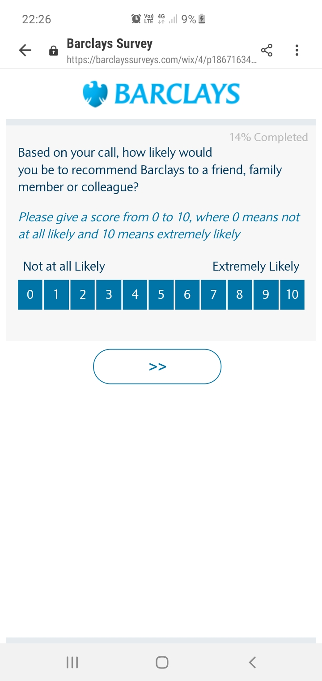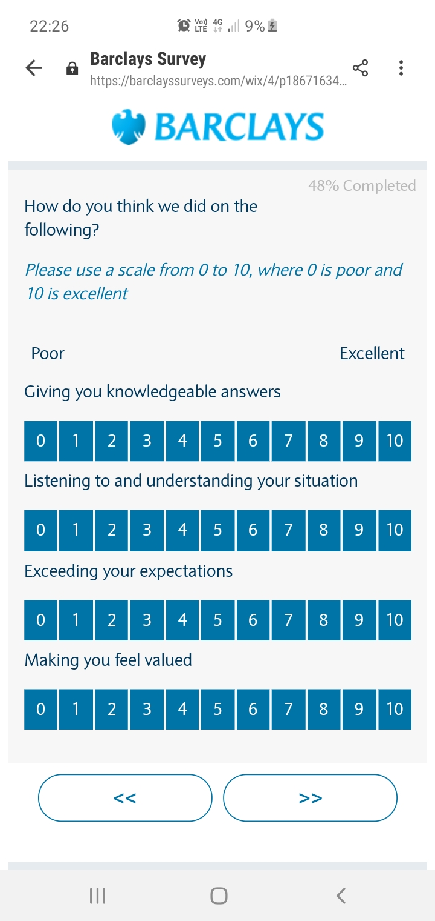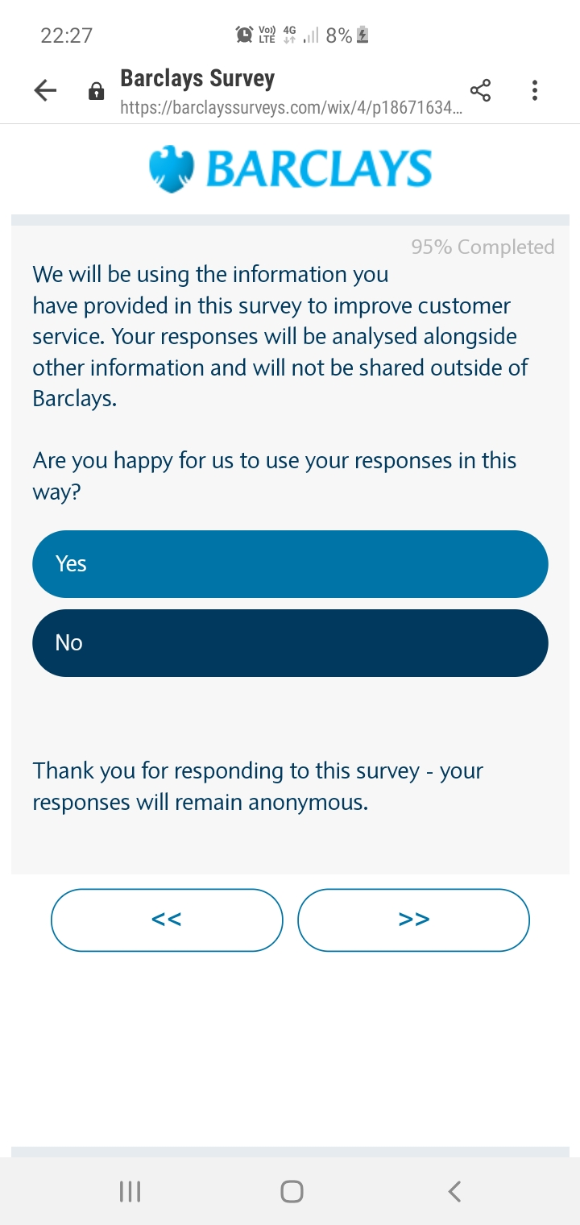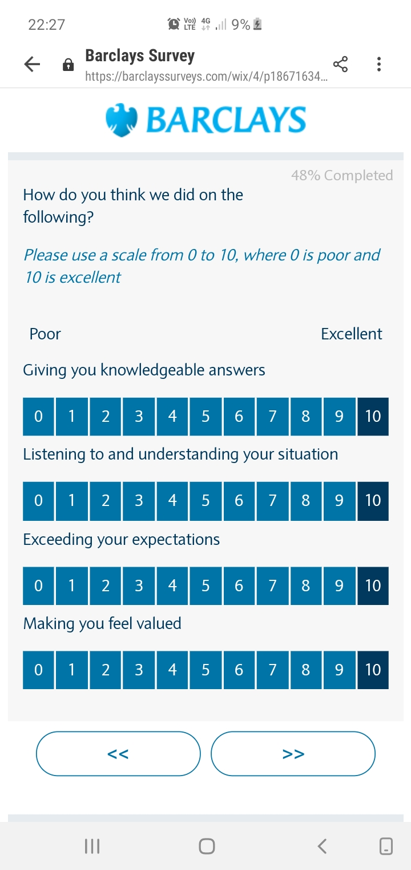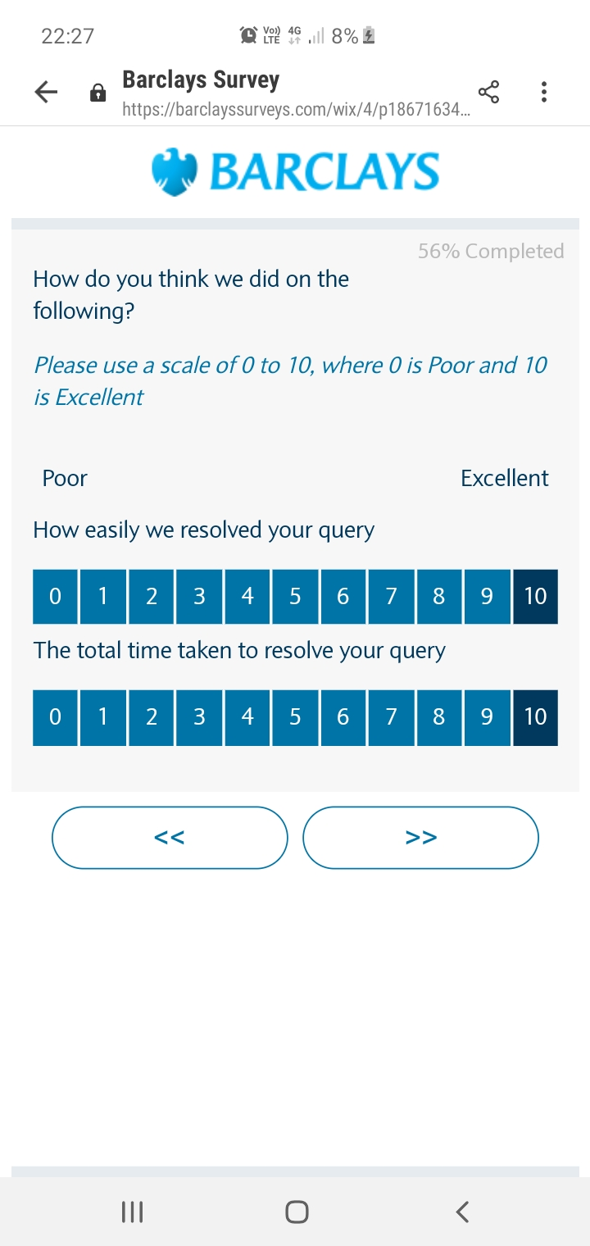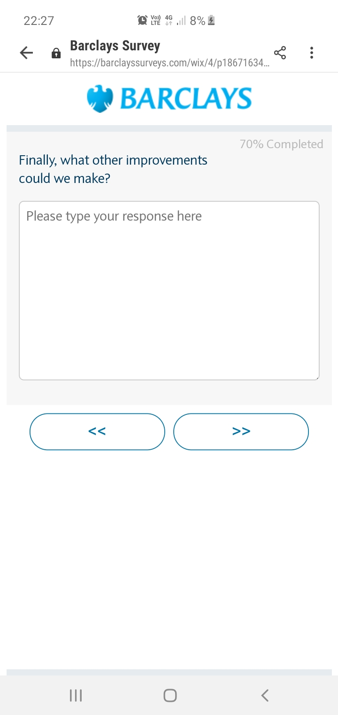

Vii. Review the success of a completed survey.
There are three elements that can lead to failure or success of a survey
The survey is complicated or confusing.
To Fail – questions are double barrelled or measure two different things. Both negative & positively worded statements are used in the survey. Different rating scales are used. These types of questions provide mixed results, as participants will interpret the questions differently.
To Succeed – The survey should be easy to read, understandable, simple and straight forward. Ensure responses are confidential, and will not result in any backlash from senior leaders. Be honest from the start about how long the survey will take, any longer than ten minutes, and you are in jeopardy of non-completion. Limit your survey to roughly fifteen questions.
Survey results are not fed back to respondents
To Fail – The longer you wait to get results into the hands of stakeholders, the more the assumption that they contain bad news or even worse no results are published.
To Succeed – Get results back as soon as possible. For example no more than thirty days after reviewing the data collected.
There is no follow up on feedback
To Fail – The number one contributor to survey fatigue is setting a pattern that those surveyed learn they have wasted their time and actions are not taken as a result.
To Succeed – Communicate the results to your team & stakeholders. Share plans on how you plan to follow up on the feedback
Case study
- How important is it for them to classify the centre’s users?
It is extremely important to classify users, as this information will show not only the demographics of users in general, but also what equipment is used and by whom and when. Also what age groups are using the gym, what equipment and at what times they are using the facilities. Also they can use gender to flag when females/males use the services and can cater for their specific needs i.e. women only sessions or OAP groups.
Customers use a gym for all kids of reasons, no two customers are the same. That said you will still be able to find commonalities between them, do they want to slim, compete, regain health or figure. Depending on the answer you can then take a specific approach with their training.
- Explain why these sorts of data are helpful.

The various information gained can help the business in a variety of ways as it will show where they are failing & what they do well. Do they need to increase membership, should this be targeted to a specific demographic? For example running a spin class during school hours, the demographic being mothers who can attend when their children are in school. They can tailor classes to specific common needs, advertise when the gym is less likely to be busy & so on.

It is really a matter of finding out –

Who – Who is using the facilities
When – When are they used?
Why – Why are they being used?
How – How are they being used

Then you can formulate strategies and activities to suit.

Student Statement:

By submitting this assignment, I confirm that this is my own work.

Student Signature | Lynn Starling | Date | 26/06/19

For Tutor / Assessor Use Only
Total Marks
Marks Obtained
Percentage / Grade

