
Assignment Cover Sheet

Student Name: | Gabriela Harris
Student Number: | 23363
Course: | Diploma in Human Resource Management
Assignment NO: | 4

Marking Criteria:
We expect the learners to write minimum one well expressed point in three lines against each allocated mark. This means one needs to write 15 lines with 5 well expressed points to get high grades for a 5 marks question.
For high grades use examples and illustrations where appropriate.
1. Give short answers to the following questions: (18)

- What should be the objectives of an effective training programme?

At the point when an episode happens, the remedial activity is frequently preparing, all the more preparing and still additionally preparing. We spend a fortune on preparing each year and in each industry. The initial segment covers preparing, organization and administration of the preparation. The second part characterizes parts and duties and frameworks the preparation needs investigation forms. Further, it traces techniques for building up the program, for example, plan, improvement and usage, and how to quantify the accomplishment of a program and guarantee it accomplishes expected results. The third piece of the standard covers the necessity for the progressing improvement and upkeep of instructional classes.

So where to begin? Making a viable preparing program includes eight objectives.

1: Make a business case

An oversight security individual regularly make when attempting to dispatch any new activity is neglecting to construct the business case. Organizations are good to go to profit. Any new program or use should be considered with regards to the general estimation of the activity to the business. Leading money saving advantage examination or building up a formal business case to decide the monetary advantage of directing preparing is an unquestionable requirement.

2: Develop targets and learning results

Targets and learning results depict what students will have the capacity to know and do post-preparing. The learning results ought to likewise build up the depicted criteria by which the preparation will be judged a win. The preparation targets and learning results ought to be lined up with a representative's position competency profile and, at the abnormal state, with the association's business objectives and mission.

3: Develop content and instructional outline

The best instruction and preparing techniques for a specific circumstance should be utilized. In the present work world, a mix of offbeat online instruction combined with hands-on preparing in the work environment may give a superior, more savvy and available arrangement than customary classroom learning. Include to this some the-work preparing that utilizes a component of mentoring and training and ideal instructional conveyance might be accomplished. Numerous other conveyance strategies are accessible and ought to be viewed as, for example, video, video-conferencing, online classes and other PC based preparing apparatuses.

4: Access inward and outer assets

Conveyance of the preparation can be given utilizing in-house assets or an outer expert. In-house coaches cost less in light of the fact that their pay has just been represented in the organization spending plan. An in-house mentor may likewise give greater adaptability and will bring more prominent comprehension of the issues driving the requirement for preparing, however it is conceivable to discover outside advisors who are more talented and cleaned speakers. Utilizing an outer asset may make "simply enough" detachment between the current issue and the mentor to keep the discussion in the classroom at a goal level.

5: Develop instruction and preparing materials

The instruction and preparing materials created for the course should be precisely lined up with the targets and learning results. The learning exercises need to permit students the chance to apply the standards learned in the classroom. To be compelling the educator must comprehend the group of onlookers, the organization culture and the history behind the requirement for the preparation. It is settled that grown-ups learn uniquely in contrast to more youthful understudies and understanding the difficulties of grown-up instruction and preparing will enhance preparing adequacy.

6: Transfer learning, aptitudes and capacities

The student must have the chance to instantly apply the learning and aptitudes picked up in the work environment and show new capacities. Hindrances that may avert quick and powerful application must be recognized and evacuated if the program is to be effective. A steady program that incorporates mentoring and training by administrators and chiefs is imperative. The general adequacy will be expanded if the new abilities are upheld by work and assignment perception process with support.

7: Evaluate adequacy

That which completes estimated gets. Assessing the adequacy of the instruction and preparing is basic. Estimation underpins, and ideally approves, the business case that was made in help of the preparation. The aggregate cost of the preparation is anything but difficult to gauge, yet it is critical to likewise quantify take-up and member fulfillment. Take-up can be estimated by having students take post-preparing tests and exhibit learned aptitudes and capacities. Employment perception can likewise be utilized to evaluate abilities advancement. Students can offer their criticism utilizing course assessment frames. More mind boggling techniques for assessment may incorporate utilizing slacking markers, for example, decreased occurrence and harm information, as proportions of execution change.

8: Undertake consistent change

The last advance in any such procedure is to attempt constant change. The changes may incorporate modifying and refreshing the instruction and preparing materials, altering the time assigned to classroom hypothesis and work site functional preparing, and notwithstanding tweaking the educator conveyance and informing. In many cases how learning is estimated should be balanced after some time to build the estimation of the estimation results. The discoveries from the assessment procedure should be utilized to roll out important improvements to the goals and learning results, content and instructional outline.

- How are training needs are assessed in an organization?

Leading a preparation needs evaluation is the initial phase in making a focused on preparing and advancement program inside your association. In the present post we will look at three sorts of evaluations that you can perform to find your association's preparation needs.

1) Organizational evaluation:

This sort of appraisal investigates the adequacy of the association in general and recognizes any disparities. It is utilized to reveal the abilities, information and aptitudes that are required by the organization to connect any holes. Authoritative appraisals additionally consider outer factors, for example, the economy, natural arrangements, mechanical advances and changing workforce socioeconomics. These appraisals figure out where preparing is required, how it will be led and when. Authoritative evaluations answer two basic improvement arranging questions:

Where in the association is preparing required?

Will the preparation be powerful if executed (fill the holes)?

2) Task evaluation:

The errand appraisal accumulates data about a specific employment work or word related gathering. This examination recognizes the key undertakings, capabilities and abilities required to play out the activity and no more proficient level. Utilizing sets of responsibilities, expertise examinations and occupation stock surveys these appraisals are utilized to find particular preparing needs. This kind of examination is especially valuable if an association is moving toward another path or experiencing rebuilding. Once more, the appraisal is utilized to decide whether there are any holes between existing capabilities and those required for enhanced execution. Errand appraisals answer the accompanying arranging question:

What aptitudes or potentially practices must be procured in this activity work?

3) Individual appraisal:

The individual evaluation centers around a specific worker to find how well they are performing. This kind of appraisal decides the person's current aptitudes and capabilities, their learning style and limit with regards to new work. The individual examination recognizes who inside the association requires preparing and what sort of preparing is required. 360 degree assessments are helpful as individual evaluations as they recognize the worker's qualities and zones for development concerning abilities, aptitudes and practices. The individual appraisal frames the reason for the production of a redid preparing and advancement plan for the worker. These appraisals answer the accompanying key improvement questions:

Does the representative have the essential aptitudes?

What preparing is required for the representative to procure the important abilities?

Do you utilize any of the above preparing needs evaluations? Do you discover them accommodating in making your improvement programs? Remark and let us know.

iii. Outline the essential steps involved in training process.

Training is one of the most profitable investments an organization can make. No matter what business or industry you are in the steps for an effective training process are the same and may be adapted anywhere.

If you have ever thought about developing a training program within your organization consider the following four basic training steps. You will find that all four of these steps are mutually necessary for any training program to be effective and efficient.

STEP 1: ESTABLISHING A NEEDS ANALYSIS.

This step identifies activities to justify an investment for training. The techniques necessary for the data collection are surveys, observations, interviews, and customer comment cards. Several examples of an analysis outlining specific training needs are customer dissatisfaction, low morale, low productivity, and high turnover.

The objective in establishing a needs analysis is to find out the answers to the following questions:

- “Why” is training needed?
- “What” type of training is needed?
- “When” is the training needed?
- “Where” is the training needed?
- “Who” needs the training? and "Who" will conduct the training?
- “How” will the training be performed?

By determining training needs, an organization can decide what specific knowledge, skills, and attitudes are needed to improve the employee’s performance in accordance with the company’s standards.

The needs analysis is the starting point for all training. The primary objective of all training is to improve individual and organizational performance. Establishing a needs analysis is, and should always be the first step of the training process.

STEP 2: DEVELOPING TRAINING PROGRAMS AND MANUALS.

This step establishes the development of current job descriptions and standards and procedures. Job descriptions should be clear and concise and may serve as a major training tool for the identification of guidelines. Once the job description is completed, a complete list of standards and procedures should be established from each responsibility outlined in the job description. This will standardize the necessary guidelines for any future training.

STEP 3: DELIVER THE TRAINING PROGRAM.

This step is responsible for the instruction and delivery of the training program. Once you have designated your trainers, the training technique must be decided. One-on-one training, on-the-job training, group training, seminars, and workshops are the most popular methods.

Before presenting a training session, make sure you have a thorough understanding of the following characteristics of an effective trainer. The trainer should have:

- A desire to teach the subject being taught.

- A working knowledge of the subject being taught.

- An ability to motivate participants to “want” to learn.

- A good sense of humor.

- A dynamic appearance and good posture.

- A strong passion for their topic.

- A strong compassion towards their participants.

- Appropriate audio/visual equipment to enhance the training session.

For a training program to be successful, the trainer should be conscious of several essential elements, including a controlled environment, good planning, the use of various training methods, good communication skills, and trainee participation.

STEP 4: EVALUATE THE TRAINING PROGRAM.

This step will determine how effective and profitable your training program has been. Methods for evaluation are pre-and post- surveys of customer comments cards, the establishment of a cost/benefit analysis outlining your expenses and returns, and an increase in customer satisfaction and profits.

The reason for an evaluation system is simple. The evaluation of training programs are without a doubt the most important step in the training process. It is this step that will indicate the effectiveness of both the training as well as the trainer.

There are several obvious benefits for evaluating a training program. First, evaluations will provide feedback on the trainer’s performance, allowing them to improve themselves for future programs. Second, evaluations will indicate its cost-effectiveness. Third, evaluations are an efficient way to determine the overall effectiveness of the training program for the employees as well as the organization.

The importance of the evaluation process after the training is critical. Without it, the trainer does not have a true indication of the effectiveness of the training. Consider this information the next time you need to evaluate your training program. You will be amazed with the results.

The need for training your employees has never been greater. As business and industry continues to grow, more jobs will become created and available. Customer demands, employee morale, employee productivity, and employee turnover as well as the current economic realties of a highly competitive workforce are just some of the reasons for establishing and implementing training in an organization. To be successful, all training must receive support from the top management as well as from the middle and supervisory levels of management. It is a team effort and must be implemented by all members of the organization to be fully successful.

iv. List some job training techniques.

A portion of the helpful strategies and methods you can use for preparing representatives are: 1. Vestibule Training 2. Pretending 3. Address Method 4. Meeting or Group Discussions 5. Modified Instruction (PI) 6. Sound Visuals 7. At work Training 8. Reproduction.

These distinctive techniques can be extensively delegated:

(I) On-The-Job Training:

The preparation strategies that are connected in the work place can be alluded to as at work preparing.

(ii) Off-The-Job Training:

The preparation techniques that are utilized far from the work place can be named as off-the-work preparing.

A portion of the preparation techniques are new though others are change over the conventional strategies. These preparation systems speak to the medium of conferring abilities and information to workers.

The diverse strategies for preparing are as per the following:

1. Vestibule Training:

Here preparing happens far from the work put however utilizes every one of the types of gear, materials and techniques that looks like the really ones utilized in work execution. In this technique the real work conditions are reenacted in classroom. An extraordinary space is put beside the genuine creation zone and is outfitted with furniture like the real work put.

The upsides of this strategy are preparing process that happens without upsetting the progressing tasks. The students are not pressurized by anticipating that them should create while learning.

The drawbacks are—the cost engaged with this strategy is high. Facilitate it won't be conceivable to recreate the genuine weight that a worker faces amid the activity into this misleadingly made condition.

2. Pretending:

It is characterized as a technique for human cooperation that includes reasonable conduct in nonexistent circumstance. This strategy includes formation of practical circumstance in which the members accept and assumes the part of a particular identity in the circumstance.

This technique includes activity, amid and hone. The principle goal in this technique is the advancement of inter­personal relations and accordingly advances better between individual collaboration and attitudinal changes.

3. Address Method:

It is an immediate technique for guideline that includes a verbal introduction of data by an educator to a huge gathering of people. The teacher sorts out the material and offers it to a gathering of learners as talk. By rousing and making enthusiasm among the students this strategy can be made successful.

Be that as it may, when this technique is utilized in blend with other preparing strategies it very well may be exceptionally successful.

4. Meeting or Group Discussions:

In this strategy for preparing, a gathering of individuals unreservedly talk about and present thoughts, share and analyze the data or thought, test and assess them lastly makes determinations on different angles that contributes towards the change of occupation execution.

The principle favorable position of this technique is that there is the inclusion of the considerable number of members and there is two-way correspondence yet the accomplishment of this strategy relies upon the authority characteristics of the individual driving the gathering.

5. Programmed Instruction (PI):

In this technique for preparing there is no intercession of a coach. The topic to be educated is introduced in a progression of arranged consecutive units. Subsequent to perusing each part, the student must answer an inquiry concerning it for which criticism as right answers is given.

The benefits of PI are—it is self-guided, this technique offers much extension for rehearses as the examination materials are organized and independent.

There are a couple of confinements of this strategy. They are, however there is extension for learning through training, the extent of learning offered by other strategy is considerably more. This technique is costly and tedious.

6. Sound Visuals:

Varying media preparing strategies are utilized generally in nowadays. This strategy makes utilization of slides, overhead projectors, TV, video-tapes, sound tapes and movies. The principle preferred standpoint of this technique is that the nature of the introduction will stay level with for all preparation gatherings.

Further, the effect is better contrasted with alternate strategies like addresses, workshops. Be that as it may, this strategy constitutes a restricted correspondence and thus there is no degree for question elucidation for the members. Since the introductions are institutionalized, it may not take into account the particular necessities of the individual group of onlookers.

7. At work Training:

Here the preparation is led at the work site and in the contact of the activity. The mentor will's identity an accomplished specialist exhibits the activity on to how different undertakings are performed. This strategy is frequently utilized in modern preparing where the laborers really deal with the machine.

The upsides of this strategy for preparing are: it is less expensive; the viability of the preparation is high as it includes real showing and the learners really encounter the activity to be finished. The inconvenience is that, since the preparation procedure happens in the work spot, on the machines, it will influence the smooth working of the generation.

8. Recreation:

In this strategy for preparing the gear or methods of the real occupation is copied to make a practical basic leadership condition for the learners. The best case of this is the airplane reproduction. The pilots experience this preparation. The flying machine contacts are mimicked with the goal that the pilots under preparing feel as if they are really flying the air ship.

The benefit of this preparation strategy is that the aftereffect of the choices the students make are accounted for back to them with a clarification of what might have happened had they really been made in the work put. This maintains a strategic distance from expensive mix-ups. Be that as it may, this technique is extremely costly.

v. How do training programmes benefit an organization?

A portion of the advantages of preparing workers for an association are as per the following:

(I) Economy in Operations:

Prepared staff will have the capacity to improve and temperate utilization of materials and equipment's. Wastage will be low.

What's more, the rate of mishaps and harm to hardware and gear will be kept to the base by the very much prepared workers. These will prompt less cost of creation per unit.

(ii) Greater Productivity:

A very much prepared representative generally demonstrates more noteworthy efficiency and higher nature of work-yield than an untrained worker. Preparing builds the aptitudes of the workers in the execution of a specific occupation. An expansion in the abilities for the most part increments both amount and nature of yield.

(iii) Uniformity of Procedures:

With the assistance of preparing, the best accessible strategies for work can be institutionalized and made accessible to all representatives. Institutionalization will make abnormal amounts of execution administer instead of the exemption.

(iv) Less Supervision:

In the event that the workers are given appropriate preparing, the obligation of supervision is reduced. Preparing does not dispense with the requirement for supervision, but rather it lessens the requirement for definite and steady supervision.

(v) Systematic Imparting of Skills:

An efficient preparing program lessens the learning time to achieve the adequate level of execution. The representatives require not learn by experimentation or by watching others and sit around idly if the formal preparing program exists in the association.

(vi) Creation of Inventory of Skills:

At the point when absolutely new aptitudes are required by an association, it needs to confront extraordinary challenges in business. Preparing can be utilized in spotting out promising men and in evacuating deserts in the determination procedure. It is smarter to choose and prepare representatives from inside the association as opposed to look for the talented workers from outside sources.

(vii) Higher Morale:

The resolve of workers is increment on the off chance that they are given appropriate preparing. A decent preparing project will form representatives' demeanor to accomplish bolster for authoritative exercises and to acquire more prominent participation and reliability. With the assistance of preparing, disappointment, protests, non-appearance and turnover can be diminished among the representatives.

vi. What is the difference between training and development?

Worker preparing and advancement is an irreplaceable piece of human asset capacity and administration. Both the exercises go for enhancing the execution and profitability of the workers. Preparing is a program sorted out by the association to create learning and abilities in the representatives according to the necessity of the activity. On the other hand, Development is a sorted out movement in which the labor of the association learn and develop; it is a self-evaluation act.

In preparing, the representatives are granted specialized learning and aptitudes identified with the specific occupation and weights on enhancing the capacities of every laborer. Interestingly, improvement is a kind of instructive process which centers around the development and development of the administrative work force. Look at the article given underneath, that illustrates the contrast amongst preparing and improvement, in forbidden frame.

Preparing is a procedure in which the students get a chance to take in the key abilities which are required to carry out the activity. Learning with acquiring is known as preparing. It encourages the representatives to comprehend the entire occupation prerequisites.

The significant contrasts amongst preparing and advancement are as under:

Preparing is a learning procedure for new workers in which they become more acquainted with about the key aptitudes required for the activity. Advancement is the preparation procedure for the current representatives for their inside and out improvement.

Preparing is a transient procedure i.e. 3 to a half year, yet improvement is a ceaseless procedure, thus it is as long as possible.

Preparing centers around creating expertise and information for the present place of employment. Dissimilar to, the improvement which centers around the building information, comprehension and abilities for defeating with future difficulties.

Preparing has a restricted extension; it is particular occupation situated. Then again, improvement is vocation situated and subsequently its extension is nearly more extensive than preparing.

In preparing, the students get a coach who educates them at the season of preparing. As opposed to improvement, in which the chief self-guides himself for the future assignments.

Numerous people all things considered go to the preparation program. Improvement is a self-appraisal methodology, and consequently, one individual himself is in charge of one's advancement.

2. Activity (12)
The subsequent stage in the preparation procedure is to make a preparation structure that will help manage you as you set up a preparation program. Data on the most proficient method to utilize the system is incorporated into this segment.

Preparing Program Framework Development

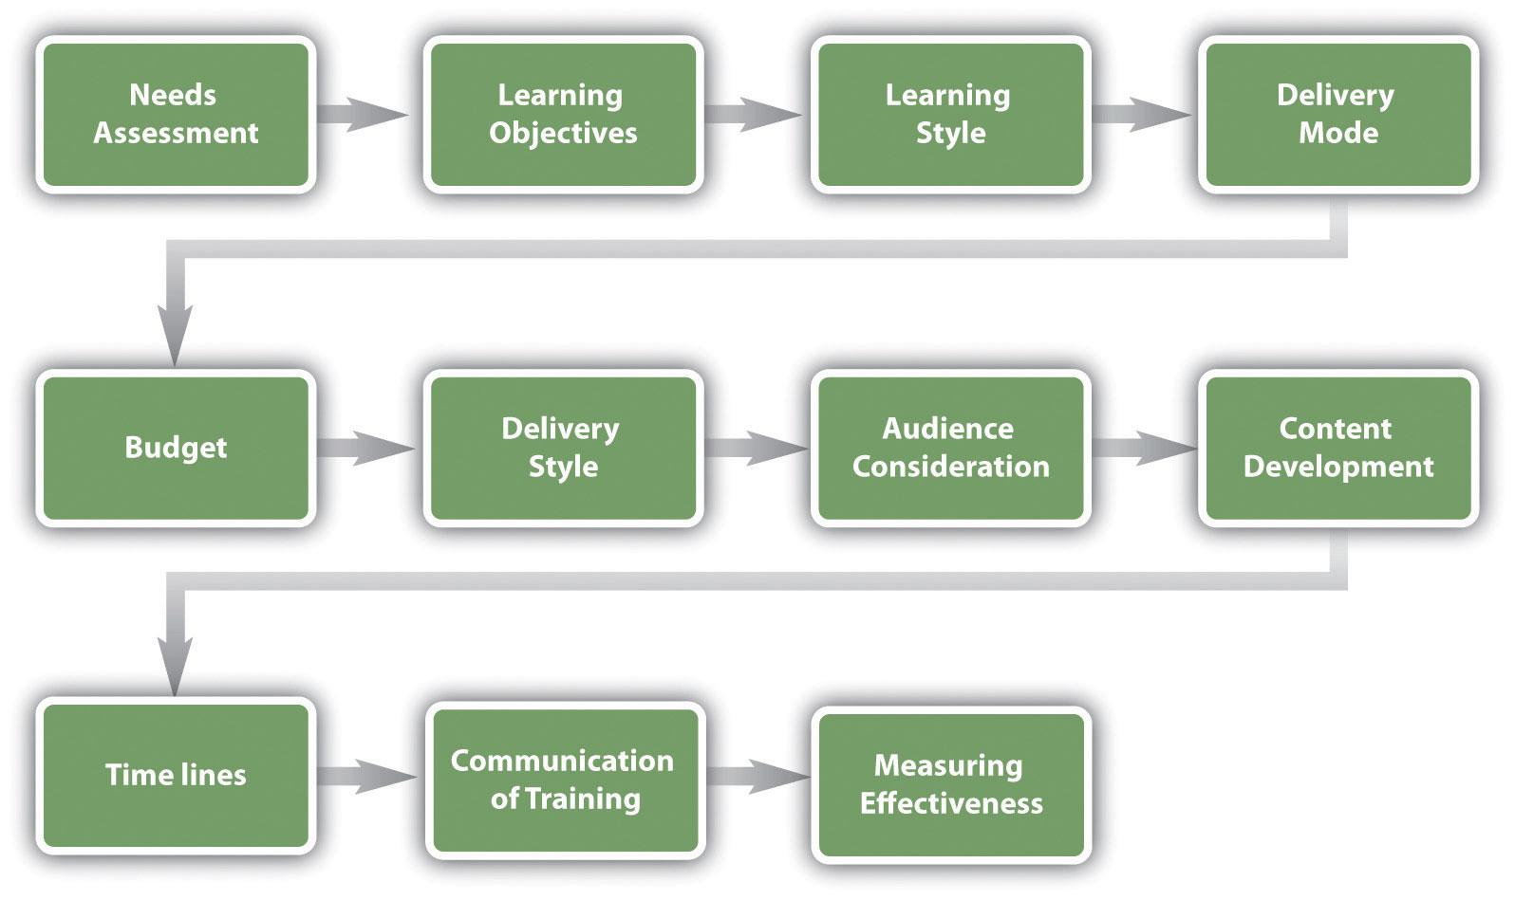

When building up your preparation plan, there are various contemplations. Preparing is something that ought to be arranged and created ahead of time.

Preparing Program Development Model: needs appraisal; learning destinations; learning style; conveyance mode; spending plan; conveyance style; gathering of people thought; content advancement; courses of events; correspondence of preparing; estimating viability

The contemplations for building up a preparation program are as per the following:

- Needs evaluation and learning targets. This piece of the structure improvement solicits you to consider what kind from preparing is required in your association. When you have decided the preparation required, you can set learning goals to quantify toward the finish of the preparation.

- Thought of learning styles. Making a point to educate to an assortment of learning styles is critical to improvement of preparing programs.

- Conveyance mode. What is the most ideal approach to communicate as the need should arise? Is online preparing more fitting, or ought to tutoring be utilized? Will vestibule preparing be utilized for a segment of the preparation while work shadowing be utilized for a portion of the preparation, as well? Most preparing projects will incorporate an assortment of conveyance strategies.

- Financial plan. What amount of cash do you need to spend on this preparation?

- Conveyance style. Will the preparation act naturally paced or educator drove? What sorts of talks and intuitiveness can be created in conjunction with this preparation?

- Group of onlookers. Will's identity part of this preparation? Do you have a blend of parts, for example, bookkeeping individuals and advertising individuals? What are the activity obligations of these people, and how might you make the preparation important to their individual employments?

- Content. What should be instructed? In what manner will you arrangement the data?

- Courses of events. To what extent will it take to build up the preparation? Is there a due date for preparing to be finished?

- Correspondence. In what manner will workers know the preparation is accessible to them?

- Estimating adequacy of preparing. In what capacity will you know whether your preparation worked? What ways will you use to gauge this?

Human Resource Recall

Would you be able to think about a period where you gotten preparing, yet the facilitator did not associate with the group of onlookers? Does that ever occur in any of your classes (obviously not this one, however)?

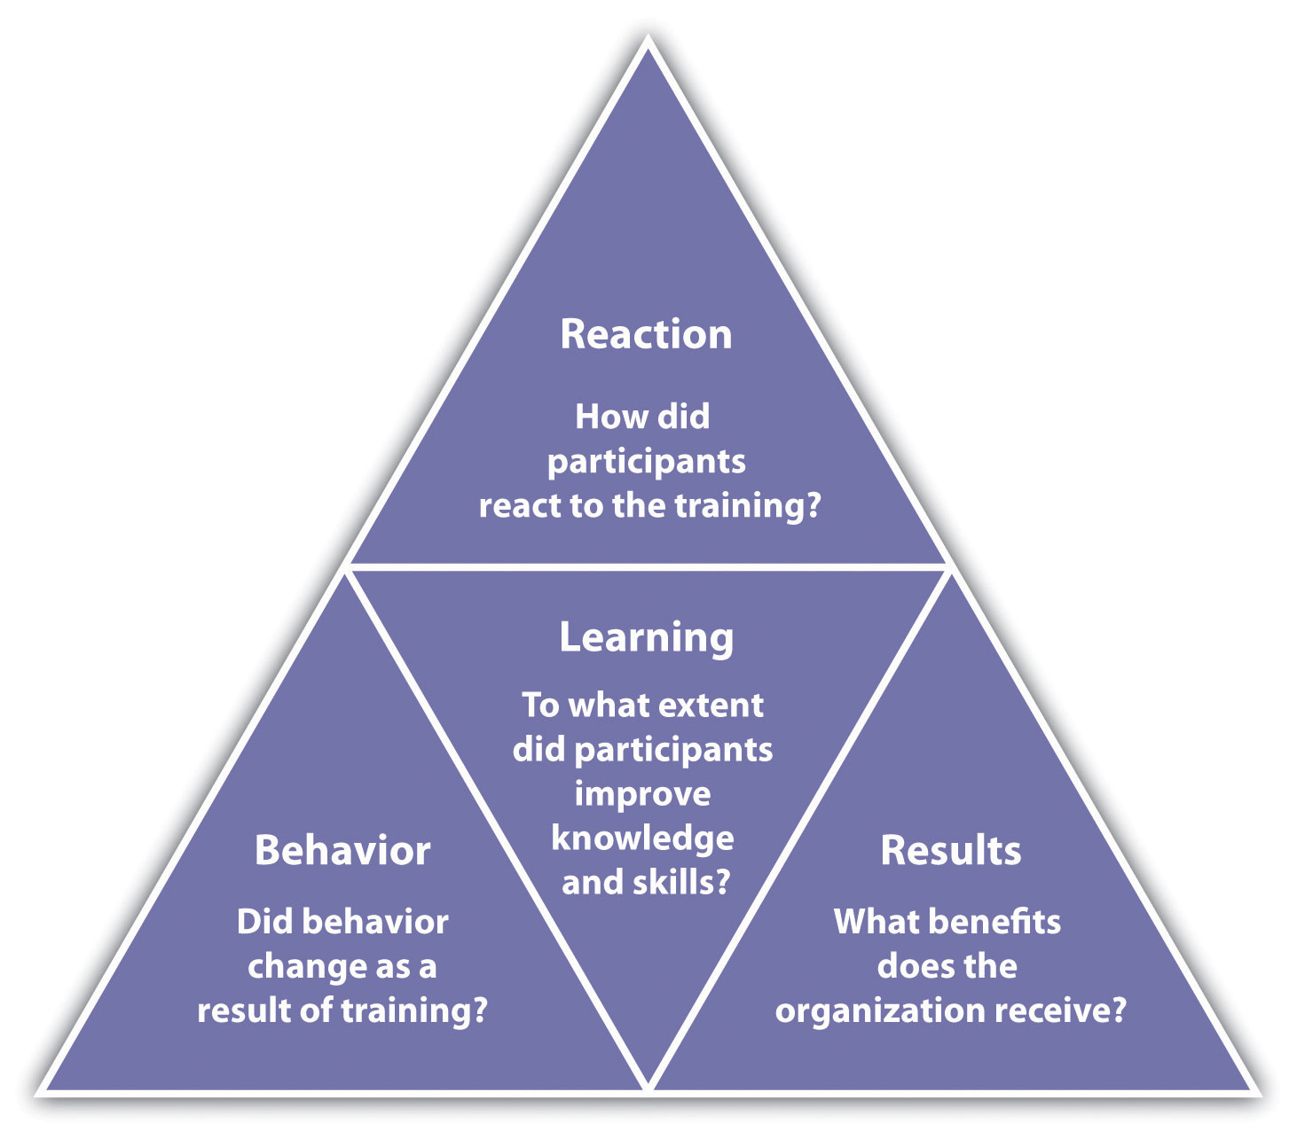

Needs Assessment

The initial phase in building up a preparation program is to figure out what the association needs as far as preparing. There are three levels of preparing needs appraisal: authoritative evaluation, word related (errand) evaluation, and individual evaluation:

Hierarchical evaluation. In this sort of necessities appraisal, we can decide the aptitudes, information, and capacities an organization needs to meet its vital goals. This sort of appraisal considers things, for example, changing socioeconomics and innovative patterns. In general, this kind of evaluation takes a gander at how the association all in all can deal with its shortcomings while advancing qualities.

Word related (assignment) appraisal. This kind of evaluation takes a gander at the particular errands, aptitudes information, and capacities required to do tasks inside the association.

Singular appraisal. An individual appraisal takes a gander at the execution of an individual worker and figures out what preparing ought to be proficient for that person.

We can apply each of these to our preparation plan. To start with, to play out a hierarchical appraisal, we can take a gander at future patterns and our general organization's vital arrangement to decide preparing needs. We can likewise perceive how employments and enterprises are changing, and knowing this, we can all the more likely decide the word related and singular evaluations.

Inquiring about preparing needs should be possible through an assortment of ways. One alternative is to utilize an online instrument, for example, SurveyMonkey to survey representatives on what sorts of preparing they might want to see advertised.

As you survey execution assessments turned in by your chiefs, you may see an example creating demonstrating that workers are not meeting desires. Thus, this may give information with respect to where your preparation is deficient.

There are likewise kinds of preparing that will probably be required for an occupation, for example, specialized preparing, wellbeing preparing, quality preparing, and expert preparing. Each of these ought to be seen as partitioned preparing programs, requiring an individual system for each sort of preparing. For instance, a representative introduction system will appear to be altogether unique from an in-house specialized preparing structure.

Preparing must be attached to work desires. Any preparation created should exchange straightforwardly to the aptitudes of that specific worker. Evaluating the HR vital arrangement and different employment investigations may enable you to perceive what sort of preparing ought to be produced for particular occupation titles in your association.

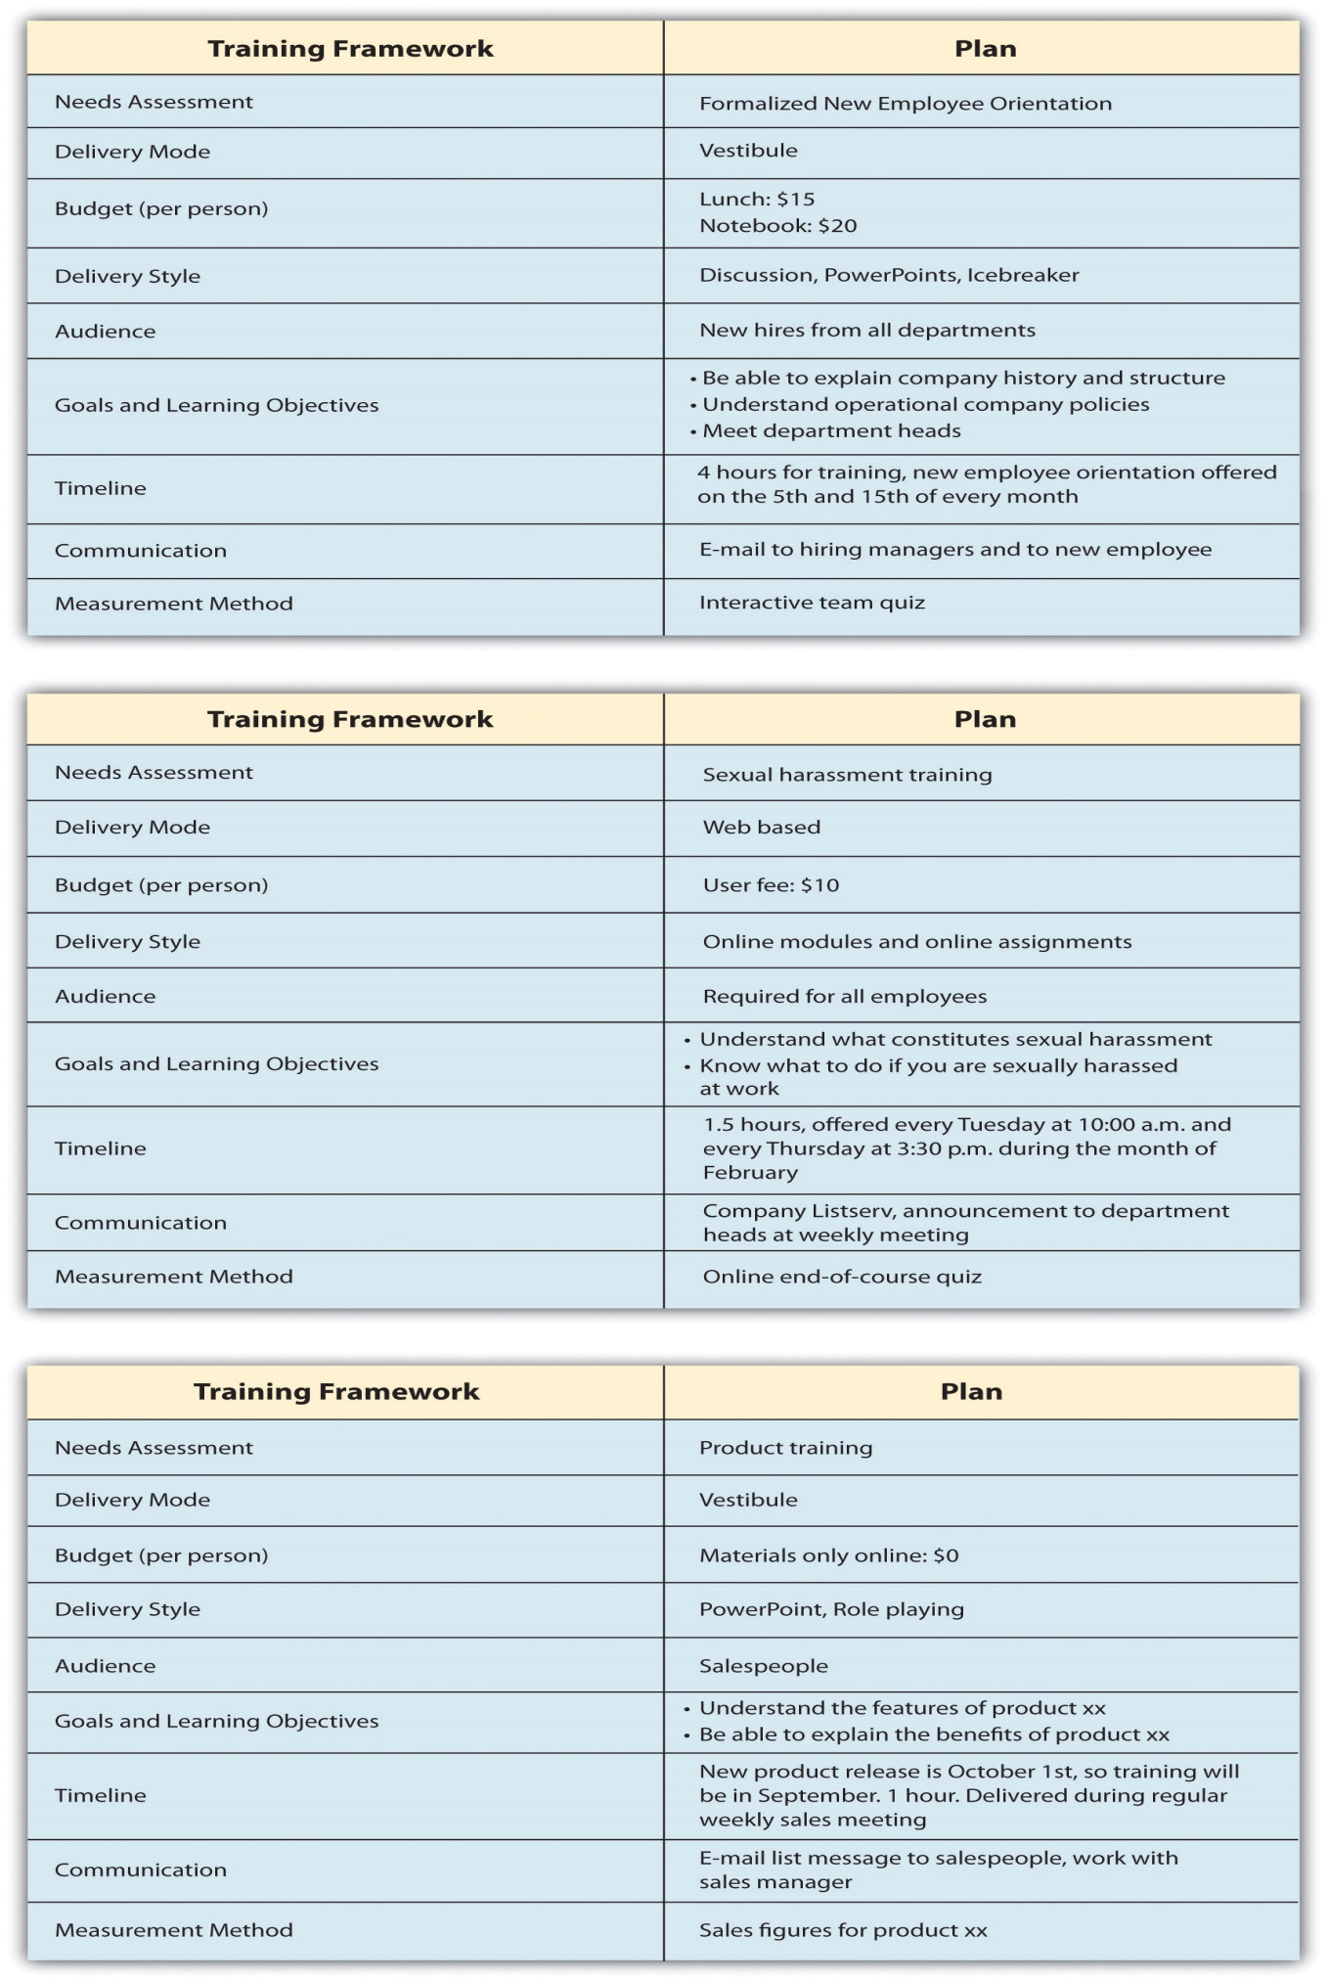

Learning Objectives

After you have figured out what kind of preparing ought to happen, learning destinations for the preparation ought to be set. A learning objective is the thing that you need the student to have the capacity to do, clarify, or show toward the finish of the preparation time frame. Great learning goals are execution based and clear, and the final product of the learning target can be detectable or estimated somehow. Cases of learning destinations may incorporate the accompanying:

- Have the capacity to clarify the organization strategy on lewd behavior and give cases of inappropriate behavior.

- Have the capacity to demonstrate the correct method to take a client's request.

- Play out an assortment of client needs examinations utilizing organization programming.

- Comprehend and use the new cost following programming.

- Clarify the wellbeing technique in taking care of synthetic compounds.

- Have the capacity to clarify the sorts of correspondence styles and procedures to viably manage each style.

- Show morals when taking care of client protests.

- Have the capacity to viably delegate to workers.

When we have set our learning goals, we can use data on learning styles to then decide the best conveyance mode for our preparation.

Learning Styles

Understanding learning styles is a vital part to any preparation program. For our motivations, we will use a broadly acknowledged learning style show. Ongoing exploration has demonstrated that grouping individuals into learning styles may not be the most ideal approach to decide a style, and the vast majority have an alternate style contingent upon the data being educated. In an investigation by Pashler et al., the creators take a gander at bent and identity as key characteristics when learning, instead of characterizing individuals into classifications of learning styles. Remembering this, we will deliver a typical way to deal with learning styles straightaway.

A viable coach endeavors to create preparing to meet the three distinctive learning styles1:

- Visual student. A visual student for the most part has a reasonable "picture" of an ordeal. A visual student frequently says things, for example, "I can perceive what you are stating" or "This looks great." A visual student is best achieved utilizing designs, pictures, and figures.

- Sound-related student. A sound-related student learns by sound. A sound-related student may state, "On the off chance that I hear you right" or "What do you find out about this circumstance?" The sound-related student will learn by tuning in to an address or to somebody disclosing how to accomplish something.

- Sensation student. A sensation student learns by creating emotions toward an affair. These kinds of students have a tendency to learn by doing as opposed to tuning in or seeing another person do it. This sort of student will frequently say things, for example, "This feels right."

- Most people utilize in excess of one sort of learning style, contingent upon what sorts of data they are preparing. For instance, in class you may be a visual student, however when figuring out how to replace a tire, you may be a sensation student.
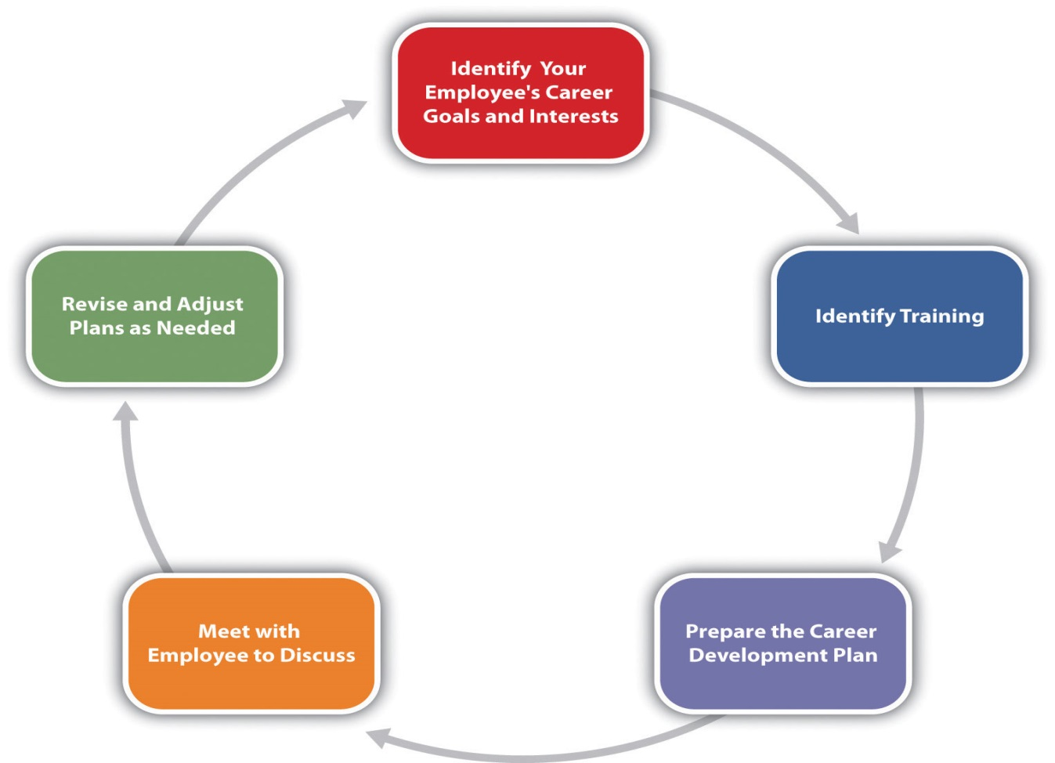
Conveyance Mode

Contingent upon the kind of preparing that should be conveyed, you will probably pick an alternate mode to convey the preparation. An introduction may loan itself best to vestibule preparing, while lewd behavior preparing might be better for online preparing. While picking a conveyance mode, it is critical to consider the gathering of people and spending tightening influences. For instance, Oakwood Worldwide, a supplier of transitory lodging, as of late won the Top 125 Training Award for its preparation and advancement programs2. It offers in-class and online classes for all partners and continually add to its course list. This is a noteworthy enlistment and also maintenance device for its representatives. Indeed, the organization credits this program for holding 25 percent of its workforce for a long time or more.

Student Statement:

By submitting this assignment, I confirm that this is my own work.

Student Signature | Gabriela Harris | Date | 29\8\2018

For Tutor / Assessor Use Only
Total Marks
Marks Obtained
Percentage / Grade

