
Cv
Assignment Cover Sheet

Student Name:
  Susan Kurian Samuel
Student Number:
  5377
Course:
  Diploma in Business Administration (Level 4)
Assignment NO: | #4

Performance Management

ASSESSMENT # 4

- Outline the main tasks that a performance management team is expected to perform
The tasks that a performance management team is expected to perform are

1 Goal Setting: This is the process of motivating employees by establishing effective and meaningful performance targets. It has become an effective tool for the practice of human resource management and an over-all performance system approach.
A goal is a performance-driven target that an individual or group seeks to accomplish at work. Specific goals have found to be more effective than vague, or general goals such as “do your best”, as well as no goals at all because it results in higher performance delivery.
2. Leading and Coaching: Leading and coaching are recognized as powerful tools for learning and development. The leadership style chosen influences the manner in which the leader communicates with the team. This affects the degree of control which the leader exercises especially in decision making with the team. Like leading, coaching can also be used to train workers. It is still appropriate for people willing to take on a task. It is an appropriate means of improving employee participation at work..
Coaching is the process by which you help a colleague to explore ways of tackling problems to change their prospective on work issues leading to an improvement in their ability to perform.
3. Delegation: Delegation is the act of giving responsibility to another person for the completion of a task for which you are generally accountable. It involves giving that person the authority to carry out the task without constantly referring back to you for approval or clearance. The employer can evaluate the performance of his or her workers by observing the way they handle their duties. In this way, one can easily correct and dictate other means of completing given assignments. Therefore, it improves performance and workers’ output.
4. Mentoring: mentoring is concerned with the long-term acquisition and application of skills in a developing career by a form of advising and counseling. It has been described as a form of professional intimacy in which the mentor and the mentee form a relationship that lies somewhere in the middle of the colleague and friend. Mentoring promotes the organization’s vision, values, and strategies and the organization at large
5. Performance Appraisal: Appraisal has been long considered as a way of appreciating someone’s input in a given activity. Performance Appraisal is indispensable to ensure performance improvement. People generally have
an intense desire to know how they are doing. They engage in feedback seeking behavior.
6. Punishment: Punishment is one of the most used but least understood and badly administered aspects of behavioral management. It is commonly thought to be the reverse of reinforcement but equally effective in altering behavior
7. Rewards: A reward is a positive reinforcement that develops employee behaviour. Organizational reward systems are beneficial to behavioral performance management in an organization
- Money as Reinforce: The theory and principles of reinforcement explain that money can indeed be a powerful reinforcement.
- Non-Financial Rewards: Informally providing contingent recognition and attention (and praise, if genuine) tend to be very powerful reinforces for most people.
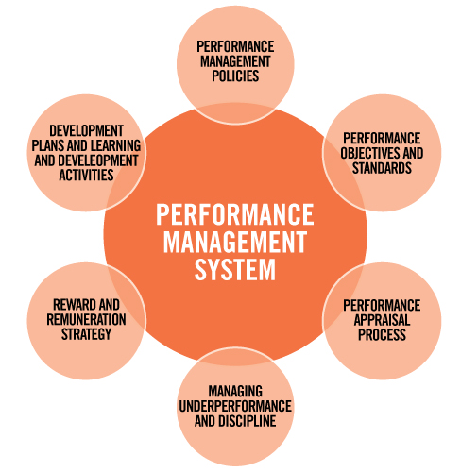

- What is the relationship between motivation and personal effectiveness?
‘A great man is the one who can make a small man feel great, and perform great’.The man greatness is simply determined based on his motivational skills. Motivation is the word derived from the word ’motive’ which means needs, desires, wants or drives within the individuals. It is the process of stimulating people to actions to accomplish the goals. In the work goal context the psychological factors stimulating the people’s behaviour can be the desire for money, success, recognition, job-satisfaction, team work, etc. One of the most important functions of management is to create willingness amongst the employees to perform in the best of their abilities. Therefore the role of a leader is to arouse interest in performance of employees in their jobs. The process of motivation consists of three stages. A felt need or drive, a stimulus in which needs have to be aroused and when needs are satisfied, the satisfaction or accomplishment of goals. Therefore, we can say that motivation is a psychological phenomenon which means needs and wants of the individuals have to be tackled by framing an incentive plan. In the general motivational process, there is a need, drive and a particular goal. There are two types of motivation. Extrinsic motivation from outside, often from rewards and Intrinsic motivation within the individual based on sense of achievement, curiosity, interest and pride.

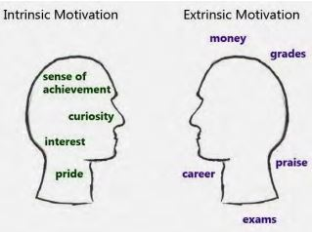

Personal Effectiveness The motivational skills of a person give rise to his effectiveness. Let’s look into what effectiveness means? The word ‘effectiveness’ differs significantly from the word ‘efficiency’. Effectiveness means ‘doing the right thing’ and efficiency refers to ‘doing things rightly’. Both are almost appearing to be synonymous, but indeed there are a couple of differences. Any way for human beings, we normally use the terminology of effectiveness. Efficiency is a terminology generally used for machines. Here are some glimpses of personal effectiveness.

iii. “The good managers must possess effective problem solving and conflict resolution skills”. Discuss.
Managers need to possess effective problem solving and conflict resolution skills because managers come across different situations in the organization when they have to compete for scarce resources, work with team members from different cultural backgrounds, and have conflicting goals to achieve. These are skills should a competent and good managers possess as these skills would help them to steer out of the way of difficult situations and emerge successful in reaching the organizational goals.
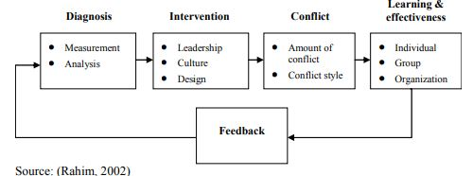

Conflict management suggests solving conflicts, instead of reducing, eliminating or limiting their duration.
. Conflict management process • Measurement • Analysis • Leadership • Culture • Design • Amount of conflict • Conflict style • Individual • Group • Organization Diagnosis Intervention Conflict Learning & effectiveness Feedback Source: (Rahim, 2002)
Diagnosis. The most important element of conflict management is problem recognition. Only in the case of recognizing the right problem, it is possible to make an effective intervention. In this stage, it is necessary to find out the number of conflicts in the organization, as well as to explore the relationship between affective and substantive conflicts and explore strategies which are used by managers and employees in solving these conflicts. The most important issue is to find out the cause of conflicts.
Intervention. After proper diagnosis, it is easy to find out, if any intervention (and what type of it) is necessary.. There are two types of intervention: the process approach and the structural approach.

Process approach. This approach assumes changing the intensity of conflicts and the style of handling conflicts (these styles will be presented later). In other words, by using this approach, managers try to match the styles of handling conflicts to different situations

. Structural approach. This approach assumes improving organizational effectiveness and changing organizational design. It attempts to manage conflict by altering the perceptions of the intensity of conflict at various levels
Learning and effectiveness. One of the major objectives of managing conflict in a contemporary organization is to enhance organizational learning that involves knowledge acquisition, knowledge distribution, information interpretation and preserving organizational memory. Individual learning is a necessary, but it does not represent an adequate condition for organizational learning. There must be processes and structures for transferring what is learned by individuals to the collective.

iv. ‘Rewarding is essential for motivation’. What type of incentives would be most
suitable for the following workers

- A cleaner
Using incentives to motivate your staff is important and should be considered an investment in not only retaining them as employees but generating a level of loyalty and performance that can help you grow your business.
- Employee Of The Month:
Employee of the month is quite literal- every month an employee is chosen by either the head of the company. This title reflects the employee’s work standards, punctuality, efficiency and exemplary service towards your customers and other members of your team.
The chosen employee is then rewarded by being given the title for that month which they can then put on their resume in the future as well as a potential bonus. This could be a monetary bonus, a gift voucher or even a paid day off! It really is up to your discretion! The employee of the month is the most popular method because it is a recurring event that happens every month which keeps staff motivated all year round!
Be careful not to play favorites with this and distribute the award (not necessarily evenly but it can’t go to the same person every month) or other employees will feel unappreciated. Giving this award to teams is another good idea to implement.
- Holiday Bonus:
Holiday bonuses are another popular method used by the best cleaning businesses. It is a once a year bonus for employees that is chosen around Christmas time. (Don’t worry if your staff aren’t Christian or Catholic and don’t celebrate the holiday, it’s simply a time of year that is easy to set as a date to award the incentive!)
A Holiday bonus may be given to one, or all of your staff members but may vary with each staff member. For example, if you award a small cash bonus to all of your staff you may give a ‘base amount’ to some staff members and then perhaps a little more to employees who have really excelled and exceeded expectations within the company.
This method works well because it ensures staff members have a target goal to work towards at the end of the year, meaning their work load cannot drop off at any stage!
.

Staff Functions:
Staff functions serve as a fantastic incentive for employees because they are a chance for everyone to let their hair down and connect on a more personal level. Some examples of a staff function could be a bowling night, a staff dinner at a restaurant, a sporting event.
Whatever the function, it really shows your employees that you value them and that if they continue to work well for the company they will be rewarded with a fun event!
Most important things to be considered are:

- Let them 'feel the love' The temptation among cleaning companies is to view their staff as commodities. ...
- Give recognition and reward. ...
- Show gratitude. ...
- Consistency is important. ...
- Don't let them down
Identifying incentives and encouraging staff is the key to successful business.

b) A salesperson

Strategies to Motivate Your Sales Team

1) Build trust with the people on your team.
The foundation of motivation is trust. If your team doesn’t trust you and doesn’t believe you have their best interests at heart, it’ll be difficult for them to feel inspired and driven by their work. When salespeople are unmotivated, you won’t be able to re-inspire them unless you have an open and honest conversation about their challenges and goals -- something that simply won’t happen without trust. It’s a vicious -- or virtuous -- cycle.
Managers have to create trust and then maintain it by engaging with their team in a consistent, nurturing fashion. The best way to build trust is to be completely transparent. Simply discussing trust can be a great way of starting off on the right foot.

2) Ask your direct reports how they like to be managed.
Always tell new team members three important things:
- Everybody’s personality is different.
- I want to be an effective manager for your work style and personality.
- I can modify my behaviour to fit your needs. How do you want to be managed?

3) Understand your direct reports’ personal and professional goals.
You can’t motivate someone unless you know what drives them. Understand what your direct reports each want to accomplish in their personal and professional lives. This will not only show you the type of person they are, but also give you insight into what things will motivate them the most.
Once you understand their goals, ask them the following questions:
- Are you motivated right now?
- What motivates you long term?
- What can you do to motivate yourself?
- How will I know if you are not motivated?
- What do you want me to do if you don’t appear motivated?
Even if it seems obvious, you always need to ask. If they can’t tell you the answers to these questions, give them 48 hours to figure it out. Forcing your reps to be self-reflective makes it more likely they’ll give you thoughtful answers, which will be better for you both in the long run.

4) Make sure they’re covering the basics.
A salesperson’s motivation always suffers when they’re not taking care of themselves. Your team’s results are influenced by -- may even depend on -- consistent sleep, exercise, and a healthy diet.

5) Set daily, weekly, and monthly goals.
Different salespeople are motivated in different ways. Some people are motivated by team-wide sales contests. Some are driven by quota achievement. Some are motivated by qualitative improvements. Some people are motivated by their impact on the organization. Some people are motivated by money.

6) Figure out where the issue lies.
There are two main aspects of motivation every sales manager must handle: Individual motivation, and group-wide motivation.

7) Let people pick their own rewards.
Salespeople always do a great job choosing prizes -- after all, they have the most insight into what they want! Plus, this makes your job easier.
8) Give great rewards.
Sometimes, you may need to give your salespeople some inspiration.:
- Prospect for them
- Buy them (and maybe a few friends) lunch or dinner
- Give them the full day off

c) A nurse
Staff motivation is a challenge for any organization, in any industry. But because of the high-stress nature and emotionally-charged events that nurses face every single day, motivational support along with interactive and proactive processes that focus on individuals and their environment is important.
Best practices should leadership follow to keep nurses motivated
1. Keep Calm: Keeping employees productive and effective during stressful situations is challenging, but it’s up to leaders to maintain order and inspire confidence. Stress is often created from the top down, as employees absorb the uncertainty they feel from their superiors. Make sure employees in leadership roles are able to keep calm in high stress environments.
2. Stay Positive: It’s easy to let a bad situation get the best of you, but a positive leader can keep people from shutting down.
3. Make Sure Employees Are Trained: The best way to ensure that employees are prepared to deal with unexpected circumstances is to train them. Not only will it lead to better outcomes, but it will reduce stress, since workers will feel equipped to face a difficult situation calmly. Since not every scenario can be addressed beforehand, give your staff a guiding set of core values or standards of behavior that will help them figure out what to do in uncertain times. Reinforce the training often so it’s not forgotten.
4. Keep Lines of Communication Open: Effective communication is key in every organization, but when stressful events take place, open communication is essential to keeping a positive and supportive environment..
5. Give Recognition: Healthcare workers have what can feel like a thankless job. They work long hours; they have to comfort fearful family members; and sometimes the outcome is negative despite their best efforts. It’s important to recognize and reward these workers for upholding your organization’s core values under times of duress.
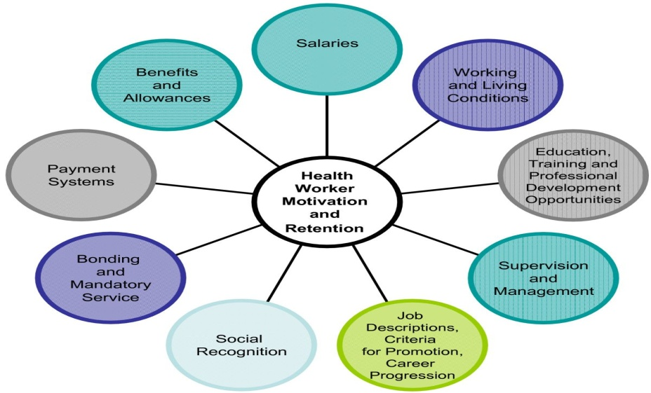

Planning" for i Strategies to motivate your sales team:
- Build trust with the people on your team.
- Ask your direct reports how they like to be managed.
- Understand your direct reports' personal and professional goals.
- Make sure they're covering the basics.
- Set daily, weekly, and monthly goals.
- Figure out where the issue lies.

d) A Shop Assistant

n 1. Play Wheel of Fortune
You know how it works—spin the wheel and pick a letter. If you pick a letter that's on the board, you get the corresponding amount on the wheel. If you solve the puzzle, you get to keep the cash and prizes you've accumulated.
Use whatever prizes make the most sense for your business. This can include clothing, gift cards, candy, beauty products, or food. You can use a cardboard circle, then create pie pieces with a marker and cut out colored pieces of cardboard with the prizes written on them to create a colorful wheel.
Other options for prizes might include non-cash rewards such as an additional (paid) 20 minutes for lunch break, a paid day off, a coffee shop gift card, and whatever else you can think of that would be relevant and appreciated by your retail staff. Be as creative as you can. Then, let your employees spin that wheel!

ce 2. Start With Smaller and More Realistic Goals
It's great to have massive goals, or, "reach" goals. Still, retail employees can lose motivation if they can't realistically meet those types of goals. Not every employee will be motivated by the same thing. So, it's important to focus on specific types of goals that can work well within specific contexts.
This can include breaking down larger goals into smaller ones that are much easier to reach. As your retail staff meets one goal, they build up the confidence to reach for the next level up. Also, with smaller goals—such as weekly goals—you keep your retail staff engaged with your sales incentive ideas.

3. Fishing for Prizes
Let your employees go fishing for motivating prizes. One of the easiest ways to motivate your retail staff is through sales incentive programs. Even with a limited budget, the end result is still positive. Employees are more motivated when they are rewarded and recognized for their work.

4. Pass that Buck
With this game, you can choose a daily goal and let everyone know when their shift begins. Maybe the goal is to sell more black t-shirts. The person who sells 20 black t-shirts gets $20. They then get to keep that $20 bill until the next person sells 20 black t-shirts

5. Pop that Balloon
Everyone loves blowing up balloons then popping them. Plus, balloons are affordable so get several bags full! Before you start inflating, write down prizes on scraps of paper. Stuff one piece of paper in each balloon and blow it up. Vary the prizes so that they range from small prizes to large prizes.

6. Have a Raffle
Having raffles are another option for sales incentive ideas. Start by setting measurable goals for each member of your retail staff. Each time they hit their target, give them a specific number of raffle tickets. When the contest is over, raffle off the prizes and pick winners at random.

7. Parking Pass Giveaway
Everyone wants to park right next to the entrance—it really is the prime spot. One of your sales incentive ideas can include prime parking as a prize. This might be a continual sales contest in the form of a monthly or quarterly contest.

8. Have Fun With Sports
Think about creating contests around some of their favorite sports. When it's football season consider a form of fantasy football.

9. Scavenger Hunt
This can be a competitive, fun and group-style of a sales incentive program. So, get your staff to work in teams. You might put together each team based on the strengths or specialties your sales staff has. Challenge each team to complete the goals on the list—such as selling over a certain dollar amount, selling to a certain number of new customers, or selling a specific number of different products

v. Some types of incentives are mentioned below; make separate lists for financial and non-financial incentives:
Good wages, bonus payments, good working environment, responsibility to make decisions, fringe benefits, promotion opportunity, being praised for good work, commissions varied and interesting work, extra payments for overtime, long-term contract, feeling challenged by the work.

Answer:

Financial incentives | Non-financial incentives
Good wages | good working environment
bonus payments | responsibility to make decisions
fringe benefits | being praised for good work
commissions varied and interesting work | promotion opportunity
extra payments for overtime | being praised for good work
commissions varied and interesting work | long-term contract
extra payments for overtime | feeling challenged by the work

Case Study: 5
John is a regional manager of a chain of stores that sell computer equipment and accessories, mainly based out of town in retail parks.
A new manager has been appointed to one of the stores, which employs 20 staff. This store is currently experiencing a number of challenges which John wants the new manager to address. Among these are the following:

- A growing absence problem among the store’s staff

Answer:

- b Create an employee attendance policy. ...
- Enforce your attendance policy consistently. ...
- Keep track of employee absences. ...
- Address unscheduled absences and no-show's immediately. ...
- Don't just treat the symptoms, discover the cause. ...
- Don't forget to reward good behavior.

- Deterioration in staff morale, largely due to the unpopularity of the previous manager, who left suddenly a month ago

Answer:

Merriam-Webster defines morale as “The mental and emotional condition (as of enthusiasm, confidence, or loyalty) of an individual or group with regard to the function or tasks at hand. A sense of common purpose with respect to a group.”
The best motivator is to make people feel that they are a valuable and worthy person and a valuable and worthy member of the team. Here are ways to do this.
- Connect
Employees need to feel there is a connection between themselves and management. That they share a common purpose and common goals. They need to know that management knows who they are, what is going on with their job and that management is their to help them when needed.
- Recognize
Employees want recognition and acknowledgment that their work has purpose and that it is appreciated. Never miss an opportunity to recognize when someone has done good work. Even a simple “Thank You” when an employee completes a task for you will help them see their work is appreciated.
- Challenge Your Employees
The drudgery of doing the same thing, day after day, year after year can cause a good employee to suffer low morale over time. While the employee may be filling a vital role in the work that they do, they probably will appreciate a new challenge or task.
- Deal With The Bad Apples
Problem or under performing employees can drain morale faster than anything. You must always take immediate action to deal with such issues before they become larger ones. Use progressive discipline to deal with problem employees.

Review current System
Sometimes low morale can be a sign of a dysfunctional system. If you have policies that are nearly impossible for the employee to follow, or are so strict they live in constant fear of losing their job, you have a system in place that can kill morale
Low morale in the workplace is an emotional issue for employees. It has many causes and must be dealt with immediately. Often poor leadership or poor management is the problem. Take steps to directly connect with your employees. Let your employee know you do know who they are, the work that they do and that you are always there to help them.

- Sales have been falling since a rival opened a store on the same site.
Answer:

Knowing who your competitors are, and what they are offering, can help you to make your products, services and marketing stand out. It will enable you to set your prices competitively and help you to respond to rival marketing campaigns with your own initiatives.
You can use this knowledge to create marketing strategies that take advantage of your competitors' weaknesses, and improve your own business performance. You can also assess any threats posed by both new entrants to your market and current competitors. This knowledge will help you to be realistic about how successful you can be.

4. The company has a formal appraisal process for all staff but the previous manager is known to have neglected this area. Based on the above issues, select which you think are the most appropriate objectives to be included in an annual performance management plan, and compile a suitable set of performance objectives for the newly appointed manager, complete with measures and time scale.
E4.4

PERFORMANCE APPRAISAL FORM

Review Period: to

Employee Name: Job Title:

Supervisor/Evaluator Name:

Reviewer Name:

Instructions
The purpose of this performance appraisal is to encourage employee development. It will be used to evaluate merit pay, opportunities for advancement and staff training and development. It is important to consider the employee’s level of demonstrated performance during the specified review period and how it relates to the definitions of performance ratings, as well as the degree of applicability to the job. Definitions for Performance Ratings and Importance to Job are provided below. In each case, select the performance rating that most closely describes the employee’s performance. If an employee earns a rating of Excellent, Needs Improvement, or Unsatisfactory, the Comments section must be completed.

Definitions of Performance Rating
(5) Excellent: Performance consistently far exceeds normal job requirements.
(4) Exceeds Expectations: Performance consistently exceeds normal job requirements.
(3) Meets Expectations: Performance meets job requirements.
(2) Needs Improvement: Performance does not meet job requirements; minor performance deficiencies.
- Unsatisfactory: Performance fails to meet job requirements; major performance deficiencies.

Definitions of Applicability to Job
  - Very Important: Essential to the performance of the job.
  - Important: Significant in the performance of the job.
  - Somewhat Applicable: Not essential to the performance of the job.
  - Not Applicable: Not required in the performance of the job.

1. Professional Knowledge – Applies technical or professional competency to work situations. |  |  | 5 | 4 | 3 | 2 | 1
2. Quality of Work – Applies job knowledge effectively and thoroughly. Demonstrates reliability and accuracy in work performance. |  |  | 5 | 4 | 3 | 2 | 1
3. Initiative – Identifies and resolves problems without prompting. |  |  | 5 | 4 | 3 | 2 | 1
4. Innovation/Creativity – Develops and implements new solutions, new procedures, concepts and designs and/or new applications of existing designs or procedures, demonstrating imagination and originality. |  |  | 5 | 4 | 3 | 2 | 1
5. Judgment – Makes well-reasoned and sound decisions, accurately interprets events and develops appropriate courses of action. |  |  | 5 | 4 | 3 | 2 | 1
6. Planning/Organization – Organizes time and resources effectively to achieve goals; sets appropriate priorities. |  |  | 5 | 4 | 3 | 2 | 1
7. Dependability – Meets schedules consistently including deadlines and project requirements. |  |  | 5 | 4 | 3 | 2 | 1
8. Written Communications – Writes concise, organized and clear  communications that meet appropriate objectives. |  |  | 5 | 4 | 3 | 2 | 1
9. Oral Communications – Conveys ideas persuasively, either speaking ad hoc or in a prepared presentation. |  |  | 5 | 4 | 3 | 2 | 1
10. Team Building – Cooperates with and supports others within the department and in other departments; works effectively with others to achieve Foundation goals. |  |  | 5 | 4 | 3 | 2 | 1
11. Productivity/Quantity of Work – Volume of work done in relation to the job performed. |  |  | 5 | 4 | 3 | 2 | 1
12. Customer Service – Procedures and attitude that effect external and internal customers. |  |  | 5 | 4 | 3 | 2 | 1
13. Leadership – Guides a group or an individual toward task accomplishment. Effective in getting work accomplished through  others. |  |  | 5 | 4 | 3 | 2 | 1
14. Development of Self and Staff – Coaches, counsels, and provides on-the-job development of staff; encourages career development; targets areas for own professional growth. |  |  | 5 | 4 | 3 | 2 | 1
15. Supervision – Directs personnel in a way that generates respect, loyalty and enthusiasm; is eager to enable staff to achieve successes; delegates effectively. |  |  | 5 | 4 | 3 | 2 | 1
16. Affirmative Action – Takes affirmative action in recruiting, hiring and promoting employees. |  |  | 5 | 4 | 3 | 2 | 1

Strengths and Areas for Development

- Identify employee’s strengths in the work place.

- Identify areas in which the employee could further develop performance.

- Identify goals and objectives for performance and development during the next 12 months.

Based on all previous measures of performance, the overall performance rating is:
Excellent Exceeds Expectations Meets Expectations Needs Improvement

Unsatisfactory

Signatures

In signing this form, the employee acknowledges that this appraisal has been reviewed with him/her and understands the supervisor’s expectations and comments.
I do not agree with appraisal
Employee Signature: Date:

Supervisor/Evaluator Signature: Date:

Reviewer Signature: Date:
Official’s Signature:
Supervisor/Evaluator/Reviewer Comments (optional)

Date:
444practices and everything you need for a sales comp

Student Statement:

By submitting this assignment, I confirm that this is my own work.

Student Signature | Susan.K.S | Date | 26/11/19

For Tutor / Assessor Use Only
Total Marks
Marks Obtained
Percentage / Grade

