
Assignment Cover Sheet

Student Name: | Eve Tafirenyika
Student Number: | 25471
Course: | Construction Management
Assignment NO: | 2

Marking Criteria:
We expect the learners to write minimum one well expressed point in three lines against each allocated mark. This means one needs to write 15 lines with 5 well expressed points to get high grades for a 5 marks question.
For high grades use examples and illustrations where appropriate.
-What are the general causes of project cost and time overruns?
The general causes of project cost usually route from type of project you are aiming for. e.g, bridges, highways, residential buildings, sports facility and factories and time overruns all rely on how the project goes, what it consists of when going through as it goes along, some of these factors are the site, size of project, purpose of build, design readiness , project organization and manner of project execution

-What are the main resources of project finance?
The main resources of project finances are through Public Banks, Commercial Banks, Bonds or Debentures, Suppliers Credit.

-Which processes are used in controlling phase?
This process ensures that everything is in the right order and is going to plan to complete the project. The list of things needed to be done in this phase are; The change of the Overall Scope, Risk Control, Schedule Control, Resources Control, Cost Control ,Contract Administration, Performance Reporting.

-What are the tasks undertaken in ‘project close-up phase’
The tasks taken in the project close up phase include; The contractor handling the project must take care of the maintenance after the project is finished and handed over. The operating instructions record must be correct along side with the drawings. Staff training for maintaining and building operations. Removal of unused and unwanted materials from the Site. Making final payment to the contractor and issuing a completion certificate.
After all these stages are completed the project team hands over the project to the client.

-What is the ‘Feasibility Study?’ And which areas does it cover?
Feasibility study, this determines the cost estimates and material requirements. The areas covered by this are economic analysis, technical analysis, market analysis, ecological analysis and financial analysis.

-What items are included in ‘Project Completion Report’
In the project completion report items that are included are; the work scope and the scheduling of the work through the project, the contracts executed, events that transpired that where important, contact details of equipment and material suppliers ,project costs, maintenance manual, minor defects noticed during handover and lessons learned and any problems during construction.

-What is a project? Describe different processes undertaken throughout the development of a construction project.
A project is the coming together or different activities to form one end result.
For the development of a project there are certain processes that take place;
You have the project Lifecycle which is arrangement of various phases of the project from start to finish. The time taken for this process is called the ‘lifespan
The diagram below breaks down the project Lifecycle
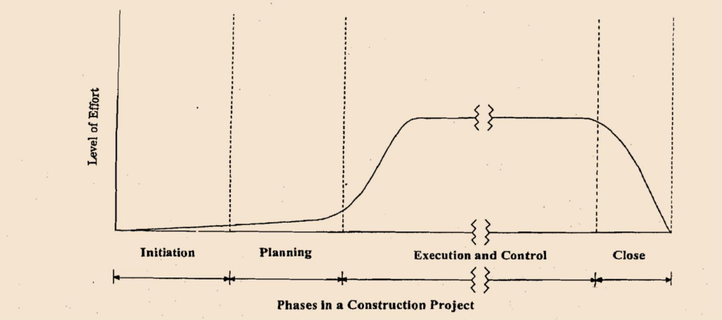

Product Lifecycle is the timing of when the project development starts and followed straight but the construction of facilities. The breakdown meaning of project -product lifestyle is basically the product that will be completed after the whole construction is complete.
Its important to know that product lifestyle also involves the project lifecycle.

The projects life cycle can be broken down into 3 phases ‘ The Pre Investment Phase, Investment Phase and Product Operations Phase’
The project phases are Cumulative effort, the Go ahead, Construction commences, Project Substantial completion and project Closure. As shown below in the diagram :
‘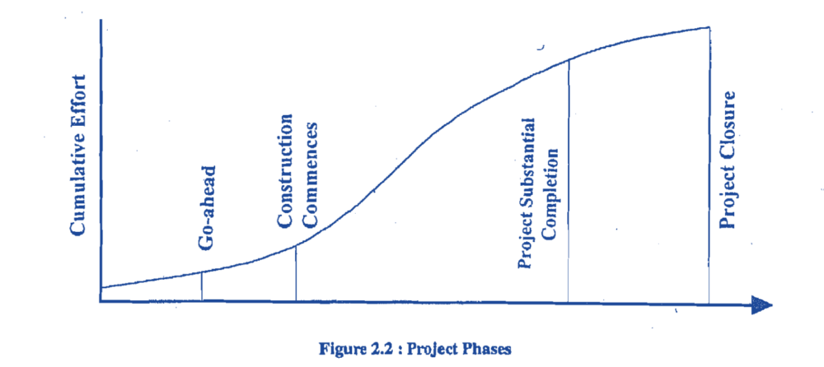
Project Initiation which is looking over the project as a whole. From this leads on to the Planning and Designing Phase which is a plan made to serve as a guide to the objectives of the project. Executing Phase and Control Phase is the organization and coordination of all the resources needed for the project.
After all this has taken place lastly follows the Closing Phase this is the last process where the client gets inspection checks over everything to ensure that the project has been correctly completed. is Examples of activities that occur during the closing phase are ‘Administrative Close, Contract Close Cut, Lessons learnt’ etc
When the project is complete there is other few things that have to be checked and reported back via a project report. For example ‘the scope of work and the schedules used to complete the works, the contract executed, important events that transpired, The maintenance manual, project costs, material and equipment suppliers, problems during construction, minor defects detected at the time of handing over’

These are the different processes undertaken throughout the development of a construction project.

Student Statement:

By submitting this assignment, I confirm that this is my own work.

Student Signature | Eve Tafirenyika | Date | 16/05/2019

For Tutor / Assessor Use Only
Total Marks
Marks Obtained
Percentage / Grade

